[Урок 1: Открываем окно 11](#_Toc492750016)

[Как работать с уроками 11](#_Toc492750017)

[Открываем окно 11](#_Toc492750018)

[Урок 2: Первый треугольник 13](#_Toc492750019)

[VAO 13](#_Toc492750020)

[Экранные координаты 14](#_Toc492750021)

[Шейдеры 17](#_Toc492750022)

[Компиляция шейдеров 17](#_Toc492750023)

[Наш Вершинный шейдер 20](#_Toc492750024)

[Наш Фрагментный шейдер 21](#_Toc492750025)

[Последние штрихи 22](#_Toc492750026)

[Урок 3: Матрицы 24](#_Toc492750027)

[Однородные координаты 24](#_Toc492750028)

[Матрицы трансформаций 24](#_Toc492750029)

[Введение в матрицы 24](#_Toc492750030)

[**В C++, используя GLM:** 24](#_Toc492750031)

[**В GLSL :** 25](#_Toc492750032)

[Матрица переноса 25](#_Toc492750033)

[**В C++, с GLM:** 25](#_Toc492750034)

[Единичная матрица 26](#_Toc492750035)

[**В C++ :** 26](#_Toc492750036)

[Матрица масштабирования 26](#_Toc492750037)

[**В C++ :** 26](#_Toc492750038)

[Матрица поворота 26](#_Toc492750039)

[**В C++ :** 26](#_Toc492750040)

[Собираем трансформации вместе 27](#_Toc492750041)

[**В C++, с GLM :** 27](#_Toc492750042)

[**В GLSL :** 27](#_Toc492750043)

[Мировая, видовая и проекционная матрицы 27](#_Toc492750044)

[Мировая матрица 27](#_Toc492750045)

[Видовая матрица 30](#_Toc492750046)

[Проекционная матрица 32](#_Toc492750047)

[Объединяем трансформации : матрица ModelViewProjection 36](#_Toc492750048)

[// C++ : вычисление матрицы 36](#_Toc492750049)

[// GLSL : применение матрицы 36](#_Toc492750050)

[Совмещаем все вместе 36](#_Toc492750051)

[Tutorial 4 : A Colored Cube 38](#_Toc492750052)

[Draw a cube 39](#_Toc492750053)

[Adding colors 40](#_Toc492750054)

[The Z-Buffer 45](#_Toc492750055)

[Tutorial 5 : A Textured Cube 47](#_Toc492750056)

[About UV coordinates 47](#_Toc492750057)

[Loading .BMP images yourself 48](#_Toc492750058)

[Using the texture in OpenGL 51](#_Toc492750059)

[What is filtering and mipmapping, and how to use them 56](#_Toc492750060)

[Linear filtering 56](#_Toc492750061)

[Anisotropic filtering 57](#_Toc492750062)

[Mipmaps 57](#_Toc492750063)

[How to load texture with GLFW 58](#_Toc492750064)

[Compressed Textures 58](#_Toc492750065)

[Creating compressed textures 59](#_Toc492750066)

[Using the compressed texture 60](#_Toc492750067)

[Inversing the UVs 62](#_Toc492750068)

[Conclusion 62](#_Toc492750069)

[Tutorial 6 : Keyboard and Mouse 63](#_Toc492750070)

[The interface 63](#_Toc492750071)

[Backface Culling 68](#_Toc492750072)

[Tutorial 7 : Model loading 69](#_Toc492750073)

[Loading the OBJ 69](#_Toc492750074)

[Example OBJ file 70](#_Toc492750075)

[Reading the file 72](#_Toc492750076)

[Processing the data 74](#_Toc492750077)

[Using the loaded data 75](#_Toc492750078)

[Other formats/loaders 76](#_Toc492750079)

[Tutorial 8 : Basic shading 76](#_Toc492750080)

[Normals 77](#_Toc492750081)

[Triangle normals 77](#_Toc492750082)

[Vertex normals 77](#_Toc492750083)

[Using vertex normals in OpenGL 77](#_Toc492750084)

[The Diffuse part 78](#_Toc492750085)

[The importance of the surface normal 78](#_Toc492750086)

[Beware of the sign 80](#_Toc492750087)

[Material Color 80](#_Toc492750088)

[Modeling the light 80](#_Toc492750089)

[Putting it all together 81](#_Toc492750090)

[Time for work 82](#_Toc492750091)

[Result 82](#_Toc492750092)

[The Ambient component 82](#_Toc492750093)

[Results 83](#_Toc492750094)

[The Specular component 84](#_Toc492750095)

[Final result 86](#_Toc492750096)

[*Tutorial 9 : VBO Indexing* 86](#_Toc492750097)

[*The principle of indexing* 86](#_Toc492750098)

[*Shared vs Separate* 87](#_Toc492750099)

[*Indexed VBO in OpenGL* 88](#_Toc492750100)

[*Filling the index buffer* 89](#_Toc492750101)

[*Extra : the FPS counter* 89](#_Toc492750102)

[*An FPS counter* 90](#_Toc492750103)

[*Tutorial 10 : Transparency* 90](#_Toc492750104)

[*The alpha channel* 90](#_Toc492750105)

[*The problem* 91](#_Toc492750106)

[*Usual solution* 92](#_Toc492750107)

[*Caveat* 93](#_Toc492750108)

[*Order-Independent Transparency* 93](#_Toc492750109)

[*The blend function* 93](#_Toc492750110)

[*Tutorial 11 : 2D text* 94](#_Toc492750111)

[*The API* 94](#_Toc492750112)

[*The texture* 95](#_Toc492750113)

[*Drawing* 95](#_Toc492750114)

[*Tutorial 12 : OpenGL Extensions* 98](#_Toc492750115)

[*Extensions* 98](#_Toc492750116)

[*ARB\_fragment\_program* 98](#_Toc492750117)

[*ARB\_debug\_output* 98](#_Toc492750118)

[*Getting an extension - the hard way* 99](#_Toc492750119)

[*Getting all extensions - the easy way* 99](#_Toc492750120)

[*ARB vs EXT vs …* 100](#_Toc492750121)

[*Designing with Extentions* 100](#_Toc492750122)

[*The problem* 100](#_Toc492750123)

[*Choosing the limit* 100](#_Toc492750124)

[*Conclusion* 100](#_Toc492750125)

[*Further reading* 101](#_Toc492750126)

[*Tutorial 13 : Normal Mapping* 101](#_Toc492750127)

[*Normal textures* 101](#_Toc492750128)

[*Tangent and Bitangent* 102](#_Toc492750129)

[*Preparing our VBO* 104](#_Toc492750130)

[*Computing the tangents and bitangents* 104](#_Toc492750131)

[*Indexing* 105](#_Toc492750132)

[*The shader* 106](#_Toc492750133)

[*Additional buffers & uniforms* 106](#_Toc492750134)

[*Vertex shader* 110](#_Toc492750135)

[*Tutorial 14: Render To Texture* 120](#_Toc492750136)

[*Render To Texture* 120](#_Toc492750137)

[*Creating the Render Target* 120](#_Toc492750138)

[*Rendering to the texture* 121](#_Toc492750139)

[*Using the rendered texture* 122](#_Toc492750140)

[*Going further* 124](#_Toc492750141)

[*Using the depth* 124](#_Toc492750142)

[*Multisampling* 125](#_Toc492750143)

[*Multiple Render Targets* 125](#_Toc492750144)

[*Tutorial 15 : Lightmaps* 126](#_Toc492750145)

[*Introduction* 126](#_Toc492750146)

[*A note on lightmaps* 127](#_Toc492750147)

[*The video* 127](#_Toc492750148)

[*Addendum* 127](#_Toc492750149)

[*Tutorial 16 : Shadow mapping* 128](#_Toc492750150)

[*Basic shadowmap* 129](#_Toc492750151)

[*Rendering the shadow map* 129](#_Toc492750152)

[Setting up the rendertarget and the MVP matrix 129](#_Toc492750153)

[*The shaders* 131](#_Toc492750154)

[*Using the shadow map* 132](#_Toc492750155)

[Basic shader 132](#_Toc492750156)

[Result - Shadow acne 134](#_Toc492750157)

[Problems 134](#_Toc492750158)

[*Shadow acne* 134](#_Toc492750159)

[Peter Panning 138](#_Toc492750160)

[Aliasing 139](#_Toc492750161)

[*PCF* 139](#_Toc492750162)

[*Poisson Sampling* 140](#_Toc492750163)

[Stratified Poisson Sampling 143](#_Toc492750164)

[*Going further* 144](#_Toc492750165)

[*Early bailing* 144](#_Toc492750166)

[*Spot lights* 144](#_Toc492750167)

[*Combination of several lights* 145](#_Toc492750168)

[*Automatic light frustum* 145](#_Toc492750169)

[*Exponential shadow maps* 146](#_Toc492750170)

[*Light-space perspective Shadow Maps* 146](#_Toc492750171)

[*Cascaded shadow maps* 146](#_Toc492750172)

[*Conclusion* 146](#_Toc492750173)

[*Tutorial 17 : Rotations* 146](#_Toc492750174)

[*Foreword: rotation VS orientation* 148](#_Toc492750175)

[*Euler Angles* 148](#_Toc492750176)

[*Quaternions* 148](#_Toc492750177)

[*Reading quaternions* 149](#_Toc492750178)

[*Basic operations* 149](#_Toc492750179)

[*How do I create a quaternion in C++ ?* 149](#_Toc492750180)

[*How do I create a quaternion in GLSL ?* 150](#_Toc492750181)

[*How do I convert a quaternion to a matrix ?* 150](#_Toc492750182)

[*So, which one should I choose ?* 150](#_Toc492750183)

[*Other resources* 150](#_Toc492750184)

[*Cheat-sheet* 151](#_Toc492750185)

[*How do I know if two quaternions are similar ?* 151](#_Toc492750186)

[*How do I apply a rotation to a point ?* 151](#_Toc492750187)

[*How do I interpolate between 2 quaternions ?* 151](#_Toc492750188)

[*How do I cumulate 2 rotations ?* 151](#_Toc492750189)

[*How do I find the rotation between 2 vectors ?* 151](#_Toc492750190)

[*I need an equivalent of gluLookAt. How do I orient an object towards a point ?* 152](#_Toc492750191)

[*How do I use LookAt, but limit the rotation at a certain speed ?* 153](#_Toc492750192)

[*How do I…* 154](#_Toc492750193)

[*Billboards* 154](#_Toc492750194)

[*Solution #1 : The 2D way* 154](#_Toc492750195)

[*Solution #2 : The 3D way* 155](#_Toc492750196)

[*Solution #3 : The fixed-size 3D way* 157](#_Toc492750197)

[*Solution #4 : Vertical rotation only* 158](#_Toc492750198)

[*Particles / Instancing* 158](#_Toc492750199)

[*Particles, lots of them !* 158](#_Toc492750200)

[*Instancing* 159](#_Toc492750201)

[*What’s the point?* 162](#_Toc492750202)

[*Life and death* 162](#_Toc492750203)

[*Creating new particles* 162](#_Toc492750204)

[*Deleting old particles* 164](#_Toc492750205)

[*Going further* 167](#_Toc492750206)

[*Animated particles* 167](#_Toc492750207)

[*Handling several particle systems* 168](#_Toc492750208)

[*Smooth particles* 169](#_Toc492750209)

[*Improving fillrate* 169](#_Toc492750210)

[*Particle physics* 170](#_Toc492750211)

[*GPU Simulation* 170](#_Toc492750212)

[*агульныя звесткі пра OpenGL* 170](#_Toc492750213)

[Introduction 171](#_Toc492750214)

[Prerequisites 171](#_Toc492750215)

[Structure 172](#_Toc492750216)

[Boxes 172](#_Toc492750217)

[Code 172](#_Toc492750218)

[Color hints 172](#_Toc492750219)

[OpenGL Function references 172](#_Toc492750220)

[OpenGL 173](#_Toc492750221)

[Core-profile vs Immediate mode 174](#_Toc492750222)

[Extensions 174](#_Toc492750223)

[State machine 175](#_Toc492750224)

[Objects 175](#_Toc492750225)

[Let's get started 177](#_Toc492750226)

[Additional resources 177](#_Toc492750227)

[Creating a window 177](#_Toc492750228)

[*GLFW* 178](#_Toc492750229)

[***Introduction*** 178](#_Toc492750230)

[**Getting started** 179](#_Toc492750231)

[Step by step 179](#_Toc492750232)

[Including the GLFW header 179](#_Toc492750233)

[Initializing and terminating GLFW 179](#_Toc492750234)

[Setting an error callback 180](#_Toc492750235)

[Creating a window and context 180](#_Toc492750236)

[glfwDestroyWindow(window); 181](#_Toc492750237)

[Making the OpenGL context current 181](#_Toc492750238)

[Checking the window close flag 181](#_Toc492750239)

[Receiving input events 181](#_Toc492750240)

[Rendering with OpenGL 182](#_Toc492750241)

[Reading the timer 182](#_Toc492750242)

[Swapping buffers 182](#_Toc492750243)

[Processing events 182](#_Toc492750244)

[Putting it together 183](#_Toc492750245)

[*OpenGL* 185](#_Toc492750246)

[Creating a window 185](#_Toc492750247)

[GLFW 185](#_Toc492750248)

[Building GLFW 185](#_Toc492750249)

[Our first project 187](#_Toc492750250)

[Linking 187](#_Toc492750251)

[OpenGL library on Windows 189](#_Toc492750252)

[OpenGL library on Linux 189](#_Toc492750253)

[GLAD 190](#_Toc492750254)

[Setting up GLAD 190](#_Toc492750255)

[Additional resources 191](#_Toc492750256)

[Want to help? 191](#_Toc492750257)

[Hello Window 191](#_Toc492750258)

[GLAD 193](#_Toc492750259)

[Viewport 193](#_Toc492750260)

[Ready your engines 194](#_Toc492750261)

[**Double buffer** 195](#_Toc492750262)

[One last thing 195](#_Toc492750263)

[Input 196](#_Toc492750264)

[Rendering 197](#_Toc492750265)

[Hello Triangle 199](#_Toc492750266)

[Vertex input 201](#_Toc492750267)

[**Normalized Device Coordinates (NDC)** 202](#_Toc492750268)

[Vertex shader 204](#_Toc492750269)

[**Vector** 205](#_Toc492750270)

[Compiling a shader 205](#_Toc492750271)

[Fragment shader 206](#_Toc492750272)

[Shader program 207](#_Toc492750273)

[Linking Vertex Attributes 208](#_Toc492750274)

[Vertex Array Object 210](#_Toc492750275)

[The triangle we've all been waiting for 212](#_Toc492750276)

[Element Buffer Objects 213](#_Toc492750277)

[Additional resources 217](#_Toc492750278)

[Exercises 217](#_Toc492750279)

[Shaders 217](#_Toc492750280)

[GLSL 218](#_Toc492750281)

[Types 219](#_Toc492750282)

[Vectors 219](#_Toc492750283)

[Ins and outs 220](#_Toc492750284)

[**Vertex shader** 220](#_Toc492750285)

[Uniforms 222](#_Toc492750286)

[More attributes! 225](#_Toc492750287)

[Our own shader class 228](#_Toc492750288)

[Reading from file 229](#_Toc492750289)

[Exercises 231](#_Toc492750290)

[***Textures*** 231](#_Toc492750291)

[***Texture Wrapping*** 233](#_Toc492750292)

[***Texture Filtering*** 234](#_Toc492750293)

[***Mipmaps*** 236](#_Toc492750294)

[***Loading and creating textures*** 237](#_Toc492750295)

[***Generating a texture*** 238](#_Toc492750296)

[***Applying textures*** 239](#_Toc492750297)

[***Texture Units*** 243](#_Toc492750298)

[***Exercises*** 246](#_Toc492750299)

[***Transformations*** 247](#_Toc492750300)

[***Vectors*** 247](#_Toc492750301)

[**Scalar vector operations** 248](#_Toc492750302)

[**Vector negation** 248](#_Toc492750303)

[**Addition and subtraction** 248](#_Toc492750304)

[**Length** 250](#_Toc492750305)

[**Vector-vector multiplication** 250](#_Toc492750306)

[***Dot product*** 251](#_Toc492750307)

[***Cross product*** 251](#_Toc492750308)

[***Matrices*** 252](#_Toc492750309)

[Addition and subtraction 252](#_Toc492750310)

[**Matrix-scalar products** 253](#_Toc492750311)

[**Matrix-matrix multiplication** 253](#_Toc492750312)

[**Matrix-Vector multiplication** 254](#_Toc492750313)

[***Identity matrix*** 255](#_Toc492750314)

[***Scaling*** 255](#_Toc492750315)

[***Translation*** 256](#_Toc492750316)

[***Homogeneous coordinates*** 256](#_Toc492750317)

[**Rotation** 257](#_Toc492750318)

[**Combining matrices** 258](#_Toc492750319)

[In practice 259](#_Toc492750320)

[GLM 259](#_Toc492750321)

[Further reading 263](#_Toc492750322)

[Exercises 263](#_Toc492750323)

[***Coordinate Systems*** 263](#_Toc492750324)

[***The global picture*** 264](#_Toc492750325)

[***Local space*** 265](#_Toc492750326)

[***World space*** 265](#_Toc492750327)

[***View space*** 266](#_Toc492750328)

[***Clip space*** 266](#_Toc492750329)

[**Orthographic projection** 266](#_Toc492750330)

[**Perspective projection** 267](#_Toc492750331)

[***Putting it all together*** 270](#_Toc492750332)

[***And then?*** 270](#_Toc492750333)

[***Going 3D*** 270](#_Toc492750334)

[**Right-handed system** 271](#_Toc492750335)

[***More 3D*** 273](#_Toc492750336)

[***Z-buffer*** 274](#_Toc492750337)

[***More cubes!*** 274](#_Toc492750338)

[***Camera*** 277](#_Toc492750339)

[***Camera/View space*** 277](#_Toc492750340)

[**1. Camera position** 277](#_Toc492750341)

[**2. Camera direction** 277](#_Toc492750342)

[**3. Right axis** 278](#_Toc492750343)

[**4. Up axis** 278](#_Toc492750344)

[**Look At** 278](#_Toc492750345)

[***Walk around*** 279](#_Toc492750346)

[***Movement speed*** 280](#_Toc492750347)

[***Look around*** 281](#_Toc492750348)

[**Euler angles** 281](#_Toc492750349)

[***Mouse input*** 284](#_Toc492750350)

[***Zoom*** 287](#_Toc492750351)

[***Camera class*** 288](#_Toc492750352)

[*Review* 288](#_Toc492750353)

[***Glossary*** 288](#_Toc492750354)

[*Lightning* 290](#_Toc492750355)

[***Colors*** 290](#_Toc492750356)

[***A lighting scene*** 292](#_Toc492750357)

[***Basic Lighting*** 295](#_Toc492750358)

[***Ambient lighting*** 296](#_Toc492750359)

[***Diffuse lighting*** 297](#_Toc492750360)

[**Normal vectors** 298](#_Toc492750361)

[**Calculating the diffuse color** 299](#_Toc492750362)

[***One last thing*** 302](#_Toc492750363)

[***Specular Lighting*** 303](#_Toc492750364)

[***Exercises*** 307](#_Toc492750365)

[***Materials*** 307](#_Toc492750366)

[***Setting materials*** 309](#_Toc492750367)

[***Light properties*** 310](#_Toc492750368)

[***Different light colors*** 312](#_Toc492750369)

[***Lighting maps*** 313](#_Toc492750370)

[***03.09.2017*** 313](#_Toc492750371)

[***Diffuse maps*** 313](#_Toc492750372)

[***Specular maps*** 316](#_Toc492750373)

[***Sampling specular maps*** 317](#_Toc492750374)

[***Exercises*** 319](#_Toc492750375)

[***Light casters*** 320](#_Toc492750376)

[***Directional Light*** 320](#_Toc492750377)

18/06/2017

<http://www.opengl-tutorial.org/ru/beginners-tutorials/tutorial-1-opening-a-window/>

# Урок 1: Открываем окно

*// спачатку разглядаюць арганізацыю праекта з openGL кодам //*

*// на гэтым кампутары ў мяне ўсё запрацавала, так што можна пачынаць вывучаць //*

## Как работать с уроками

К каждому уроку прилагается исходный код и все необходимые файлы данных, которые могут быть найдены в tutorialXX/. Тем не менее вы вряд ли будете изменять эти проекты, так как они даются для справки. Лучшим решением будет открыть playground/playground.cpp и изменять его так, как вам захочется. Если по каким-то причинам у вас его нет, то просто скопируйте код любого урока туда и все.

Мы предоставляем фрагменты кода в каждом уроке. Не стесняйтесь копировать эти фрагменты в playground, пока читаете и экспериментировать с ними - это хорошая практика, гораздо лучшая, чем просто читать готовый код или просто копировать его. *// цудоўны спосаб навучання //*

## Открываем окно

Наконец! Настало время кода OpenGL!

Хотя… Все уроки будут показывать вам низко-уровневый путь для тех или иных задач, таким образом вы будете видеть, что здесь нет никакой магии, однако открытие окна - задача скучная, поэтому мы будем использовать внешнюю библиотеку GLFW для этой работы. Если вы хотите сделать это сами, то вам необходимо использовать Win32 API в ОС Windows, X11 API в Linux, Cocoa API в Mac. Также вы можете использовать другие библиотеки, такие как: SFML, FreeGLUT, SDL и подобные (см. страницу [Ссылки](http://www.opengl-tutorial.org/?page_id=210)). *// у qt ёсць свае тыпы для гэтых мэтаў //*

Итак, поехали! Первое что мы делаем - это разбираемся с зависимостями. Нам необходимо базовый функционал для вывода в консоль:

*// Включаем стандартные заголовки*

**#include <stdio.h>**

**#include <stdlib.h>**

Далее нам необходим GLEW. Здесь есть немного магии, но перейдем к пояснениям позднее.

*// Включаем GLEW. Всегда включайте его ДО gl.h и glfw.h*

**#include <GL/glew.h>**

Мы будем использовать GLFW для обработки окна и клавиатуры, так что включаем его тоже.

*// Включаем GLFW*

**#include <GL/glfw3.h>**

Следующий заголовок не является необходимым в данный момент, так как является библиотекой трехмерной математики, но позже будет очень полезен. В нем нет никакой магии и если вы знаете математику, то вполне можете написать свой аналог. Что касается “using namespace glm”, то эта строка переводит пространство имен в glm, чтобы можно было писать “vec3”, вместо “glm::vec3”.

*// Включаем GLM*

**#include <glm/glm.hpp>**

**using** **namespace** glm;

Если вы скопировали код представленный выше в playground.cpp, то компилятор предупредит вас, что нет функции main(), поэтому добавим ее:

**int** main(){

В теле функции первым делом инициализируем GLFW:

*// Инициализируем GLFW*

**if**( **!**glfwInit() )

{

fprintf( stderr, "Ошибка при инициализации GLFWn" );

**return** **-**1;

}

Теперь мы можем создать наше первое OpenGL окно! :)

glfwWindowHint(GLFW\_FSAA\_SAMPLES, 4); *// 4x Сглаживание*

glfwWindowHint(GLFW\_OPENGL\_VERSION\_MAJOR, 3); *// Мы хотим использовать OpenGL 3.3*

glfwWindowHint(GLFW\_OPENGL\_VERSION\_MINOR, 3);

glfwWindowHint(GLFW\_OPENGL\_FORWARD\_COMPAT, GL\_TRUE); *// To make MacOS happy; should not be needed*

glfwWindowHint(GLFW\_OPENGL\_PROFILE, GLFW\_OPENGL\_CORE\_PROFILE); *// Мы не хотим старый OpenGL*

*// Открыть окно и создать в нем контекст OpenGL*

GLFWwindow**\*** window; *// (В сопроводительном исходном коде эта переменная является глобальной)*

window **=** glfwCreateWindow( 1024, 768, "Tutorial 01", NULL, NULL);

**if**( window **==** NULL ){

fprintf( stderr, "Невозможно открыть окно GLFW. Если у вас Intel GPU, то он не поддерживает версию 3.3. Попробуйте версию уроков для OpenGL 2.1.n" );

glfwTerminate();

**return** **-**1;

}

*// З дадзенай тэхналогіяй можна адразу ствараць прылажэнні //*

glfwMakeContextCurrent(window);

*// Инициализируем GLEW*

glewExperimental**=**true; *// Флаг необходим в Core-режиме OpenGL // у мяне ў кодзе няма такога радку //*

**if** (glewInit() **!=** GLEW\_OK) {

fprintf(stderr, "Невозможно инициализировать GLEWn");

**return** **-**1;

}

Скомпилируйте и запустите этот исходный код. Если все сделано правильно, то у вас откроется и тут же закроется окно с контекстом OpenGL и это правильно, так как мы не указали, что хотим ждать до тех пор, пока пользователь не нажмет клавишу Escape. Самое время сделать это:

*// Включим режим отслеживания нажатия клавиш, для проверки ниже*

glfwSetInputMode(window, GLFW\_STICKY\_KEYS, GL\_TRUE);

**do**{

*// Пока что ничего не выводим. Это будет в уроке 2.*

*// Сбрасываем буферы*

glfwSwapBuffers(window);

glfwPollEvents();

} *// Проверяем нажатие клавиши Escape или закрытие окна*

**while**( glfwGetKey(window, GLFW\_KEY\_ESCAPE ) **!=** GLFW\_PRESS **&&**

glfwWindowShouldClose(window) **==** 0 );

И это завершает наш первый урок! Во втором уроке мы узнаем как выводить простейший треугольник. Увидимся :)

<http://www.opengl-tutorial.org/ru/beginners-tutorials/tutorial-2-the-first-triangle/>

# Урок 2: Первый треугольник

Настало время еще одного большого урока.

OpenGL 3 позволяет довольно легко делать сложные вещи, однако вывод простейшего треугольника может показаться немного сложной задачей. *// асаблівасць OpenGL 3 //*

Если программа "падает" при запуске, то скорее всего это потому, что вы запускаете ее из неправильной директории. Внимательно прочитайте первый урок, чтобы узнать как настроить Visual Studio.

## VAO

Мы не хотим сейчас углубляться в детали, но вам необходимо создать Vertex Array Object и установить его текущим:

GLuint VertexArrayID;

glGenVertexArrays(1, &VertexArrayID);

glBindVertexArray(VertexArrayID);

Сделайте это после создания окна (т. е. после создания контекста OpenGL) и до любого другого вызова OpenGL.

Если вы хотите узнать больше о VAO, то здесь есть несколько уроков, но это не так важно сейчас.

## Экранные координаты

Треугольник задается тремя точками. Когда мы говорим о точках в 3D графике, мы используем слово вершина/vertex (вершины/vertices во множественном числе). Каждая вершина имеет 3 координаты: X, Y, Z. Вы можете представить эти координаты так:

* X находится справа
* Y находится вверху
* Z выходит из вашей спины назад. Z указывает именно назад, а не вперед.

*// да тлумачэння паняцця vertex. Экранная сістэма каардынатаў //*

Чтобы лучше понять это используйте правило правой руки:

* X - это ваш большой палец, направленный вправо
* Y - это ваш указательный палец, направленный вверх
* Z - это ваш средний палец, направленный на вас, а не от вас.

Заметьте, что вы можете свободно перемещать вашу руку в пространстве и оси X, Y, Z будут передвигаться также, но подробнее об этом мы поговорим позже.

Итак, все что нам нужно - это 3 точки в трехмерном пространстве, чтобы создать треугольник:

// Массив 3 векторов, которые являются вершинами треугольника

static const GLfloat g\_vertex\_buffer\_data[] = {

-1.0f, -1.0f, 0.0f,

1.0f, -1.0f, 0.0f,

0.0f, 1.0f, 0.0f,

};

Первая вершина имеет координаты (-1, -1, 0). Это означает, что пока мы не используем какие-либо трансформации вершина будет отображаться на экране в точке (-1, -1). Центр экрана имеет координаты (0, 0), ось X направлена вправо, а ось Y вверх, что показано на изображении:

*// экранная сістэма каардынатаў мае пачатак каардынатаў у цэнтры //*

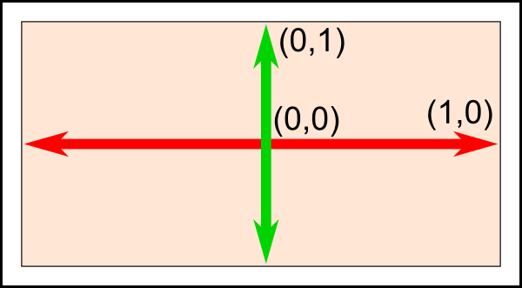

Это то, что встроено в вашу видео карту и то, что вы не можете изменить, поэтому точка с координатами (-1, -1) будет находиться в левом-нижнем углу экрана, точка (1, -1) в правом нижнем, а точка (0, 1) будет находиться посередине по горизонтали и вверху по вертикали. Таким образом наш треугольник заполнит экран. *// уладкаванне відэакарты //*

Рисуем наш треугольник

Следующим шагом будет передача данных о нашем треугольнике в OpenGL. Для этого мы создаем буфер: *// прызначэнне буфера //*

// Это будет идентификатором нашего буфера вершин

GLuint vertexbuffer;

// Создадим 1 буфер и поместим в переменную vertexbuffer его идентификатор

glGenBuffers(1, &vertexbuffer);

// Сделаем только что созданный буфер текущим

glBindBuffer(GL\_ARRAY\_BUFFER, vertexbuffer);

// Передадим информацию о вершинах в OpenGL

glBufferData(GL\_ARRAY\_BUFFER, sizeof(g\_vertex\_buffer\_data), g\_vertex\_buffer\_data, GL\_STATIC\_DRAW);

Сейчас нам необходимо сделать это только 1 раз.

Теперь, в главном цикле, где до этого мы ничего не выводили, наконец можно вывести треугольник : *// openGL program organization //*

// Указываем, что первым буфером атрибутов будут вершины

glEnableVertexAttribArray(0);

glBindBuffer(GL\_ARRAY\_BUFFER, vertexbuffer); *// чаму гэта трэба рабіць другі раз? //*

glVertexAttribPointer(

0, // Атрибут 0. Подробнее об этом будет рассказано в части, посвященной шейдерам.

3, // Размер

GL\_FLOAT, // Тип

GL\_FALSE, // Указывает, что значения не нормализованы

0, // Шаг

(void\*)0 // Смещение массива в буфере

);

// Вывести треугольник!

glDrawArrays(GL\_TRIANGLES, 0, 3); // Начиная с вершины 0, всего 3 вершины -> один треугольник

glDisableVertexAttribArray(0);

Если у вас карта NVidia, то уже сейчас вы можете видеть результат (для других карт продолжайте читать): *// розніца між рознымі відэа-карткамі //*

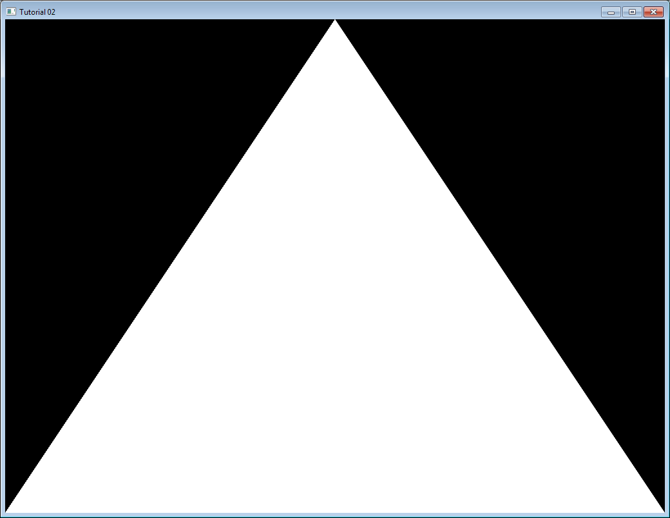

Наконец мы вывели наш скучный белый треугольник. Чтобы пойти дальше и раскрасить его в красный нам понадобится нечто, что называется “шейдеры”.

## Шейдеры

### Компиляция шейдеров

В простейшей возможной конфигурации нам понадобится два шейдера. *// што такое канфігурацыя? //* Один из них называется Вершинным и выполняется для каждой вершины, а другой называется Фрагментным и выполняется для каждого фрагмента. А так как мы включили 4х сглаживание (см. первый урок), то для каждого пикселя мы имеем 4 фрагмента. *// лепей зразумець, што такое фрагмент і зглажванне? //*

В OpenGL шейдеры программируются на языке GLSL (GL Shader Language). В отличие от C или Java, GLSL компилируется во время выполнения программы, поэтому каждый новый запуск приложения будет сопровождаться перекомпиляцией шейдеров. *// структура openGL. Да тлумачэння таго, што такое шэйдэры //*

Эти два шейдера как правило находятся в разных файлах. В этом примере мы имеем SimpleFragmentShader.fragmentshader и SimpleVertexShader.vertexshader. Расширение файлов не имеет значения и может быть любым, к примеру .txt или .glsl.

Итак, вот код. Сейчас вам не обязательно углубляться в понимание шейдеров и так как этот код выполняется всего 1 раз за время исполнения программы, то комментариев в коде будет достаточно. Эта функция будет использована во всех уроках и находится в отдельном файле common/loadShader.cpp . Обратите внимание на то, что также как и с буферами мы не имеем прямого доступа к шейдерам. *// структура OpenGL //* Мы лишь имеем Идентификатор, который указывает на шейдер, а все остальное скрыто внутри драйвера. *// якога драйвера? Відэа-карты??? Структура праграмы OpenGL //*

GLuint LoadShaders(const char \* vertex\_file\_path,const char \* fragment\_file\_path){

// Создаем шейдеры

GLuint VertexShaderID = glCreateShader(GL\_VERTEX\_SHADER);

GLuint FragmentShaderID = glCreateShader(GL\_FRAGMENT\_SHADER);

// Загружаем код Вершинного Шейдера из файла

std::string VertexShaderCode;

std::ifstream VertexShaderStream(vertex\_file\_path, std::ios::in);

if(VertexShaderStream.is\_open())

{

std::string Line = "";

while(getline(VertexShaderStream, Line))

VertexShaderCode += "n" + Line;

VertexShaderStream.close();

}

// Загружаем код Фрагментного шейдера из файла

std::string FragmentShaderCode;

std::ifstream FragmentShaderStream(fragment\_file\_path, std::ios::in);

if(FragmentShaderStream.is\_open()){

std::string Line = "";

while(getline(FragmentShaderStream, Line))

FragmentShaderCode += "n" + Line;

FragmentShaderStream.close();

}

GLint Result = GL\_FALSE;

int InfoLogLength;

// Компилируем Вершинный шейдер

printf("Компиляция шейдера: %sn", vertex\_file\_path);

char const \* VertexSourcePointer = VertexShaderCode.c\_str(); *// пераўтвараем стрым у масіў //*

glShaderSource(VertexShaderID, 1, &VertexSourcePointer , NULL);

glCompileShader(VertexShaderID);

// Выполняем проверку Вершинного шейдера

glGetShaderiv(VertexShaderID, GL\_COMPILE\_STATUS, &Result);

glGetShaderiv(VertexShaderID, GL\_INFO\_LOG\_LENGTH, &InfoLogLength);

if ( InfoLogLength > 0 ){

std::vector<char> VertexShaderErrorMessage(InfoLogLength+1);

glGetShaderInfoLog(VertexShaderID, InfoLogLength, NULL, &VertexShaderErrorMessage[0]);

fprintf(stdout, "%sn", &VertexShaderErrorMessage[0]);

}

// Компилируем Фрагментный шейдер

printf("Компиляция шейдера: %sn", fragment\_file\_path);

char const \* FragmentSourcePointer = FragmentShaderCode.c\_str();

glShaderSource(FragmentShaderID, 1, &FragmentSourcePointer , NULL);

glCompileShader(FragmentShaderID);

// Проверяем Фрагментный шейдер

glGetShaderiv(FragmentShaderID, GL\_COMPILE\_STATUS, &Result);

glGetShaderiv(FragmentShaderID, GL\_INFO\_LOG\_LENGTH, &InfoLogLength);

if ( InfoLogLength > 0 ){

std::vector<char> FragmentShaderErrorMessage(InfoLogLength+1);

glGetShaderInfoLog(FragmentShaderID, InfoLogLength, NULL, &FragmentShaderErrorMessage[0]);

fprintf(stdout, "%s\n", &FragmentShaderErrorMessage[0]);

}

// Создаем шейдерную программу и привязываем шейдеры к ней

fprintf(stdout, "Создаем шейдерную программу и привязываем шейдеры к нейn");

GLuint ProgramID = glCreateProgram();

glAttachShader(ProgramID, VertexShaderID);

glAttachShader(ProgramID, FragmentShaderID);

glLinkProgram(ProgramID);

// Проверяем шейдерную программу

glGetProgramiv(ProgramID, GL\_LINK\_STATUS, &Result);

glGetProgramiv(ProgramID, GL\_INFO\_LOG\_LENGTH, &InfoLogLength);

if ( InfoLogLength > 0 ){

std::vector<char> ProgramErrorMessage(InfoLogLength+1);

glGetProgramInfoLog(ProgramID, InfoLogLength, NULL, &ProgramErrorMessage[0]);

fprintf(stdout, "%s\n", &ProgramErrorMessage[0]);

}

glDeleteShader(VertexShaderID);

glDeleteShader(FragmentShaderID);

return ProgramID;

}

*// тут змешчаны, відаць, стандартныя крокі работы з шэйдэрамі //*

### Наш Вершинный шейдер

Итак, давайте напишем наш первый вершинный шейдер.

Первая строка в нем говорит компилятору, что мы будем использовать синтаксис OpenGL 3.

#version 330 core

Вторая строка объявляет входные данные:

layout(location = 0) in vec3 vertexPosition\_modelspace;

Остановимся подробнее на этом моменте:

* “vec3″ - это вектор с тремя компонентами в GLSL. Это похоже на glm::vec3, который мы использовали для описания треугольника. Главное помнить, что если мы используем 3х компонентные векторы в C++, то мы должны использовать 3х компонентные векторы в GLSL. *// структура OpenGL. Важны момант //*
* “layout(location = 0)” указывает на буфер из которого мы будем получать атрибут *vertexPosition\_modelspace*. Каждая вершина может иметь несколько атрибутов, такие как: позиция, один или несколько цветов, текстурные координаты и другие. *// структура OpenGL //* OpenGL на данном этапе ничего не знает о цвете и все, что он “видит” - это vec3, т. е. вектор с тремя компонентами. Мы же в свою очередь указываем, каким входным данным соответствует какой буфер. *// трэба ўказаць, які буфер змяшчае колеры, які каардынаты і г.д. Лепей зразумець. //* Для этого мы устанавливаем параметр location в такое же значение, которое мы использовали в качестве первого параметра в glVertexAttribPointer. *// гэта быў нуль – ідэнтыфікатар шэйдэра. Вось кропка сінхранізацыі таго, што малюецца, з тым, што мы вызначаем у атрыбутах //* Вообще, здесь не обязательно будет 0, здесь может быть и 12 и любое другое, но не большее чем glGetIntegerv(GL\_MAX\_VERTEX\_ATTRIBS, &v), а также важно чтобы число в location было таким же, как и в glVertexAttribPointer. *// сінхранізацыя шэйдэра і буфернага аб’екта. Важны момант OpenGL //*
* “vertexPosition\_modelspace” будет содержать позицию вершины для каждого прохода вертексного шейдера. Название может быть любым.
* Ключевое слово “in” означает, что этот атрибут является входными данными. Также существует слово “out”, которое указывает соответственно на выходные данные. *// glsl сінтаксіс. Для чаго выкарыстоўваюць выходныя дадзены? //*

Функция, которая будет вызываться для каждого шейдера называется “main”, также как и в C: *// структура glsl //*

void main(){

Наша главная функция будет просто устанавливать позицию вершины в ту, которая получена из буфера. Соответственно, если мы передадим значение (1, 1), то вершина будет отображена в правом верхнем углу экрана, а в следующем уроке мы рассмотрим более интересные вычисления.

gl\_Position.xyz = vertexPosition\_modelspace;

gl\_Position.w = 1.0;

}

gl\_Position - одна из нескольких встроенных в GLSL переменных. В данном случае мы просто присваиваем ей полученное из буфера значение. Все остальное не является обязательным и будет рассмотрено в Уроке 4. *// структура glsl //*

### Наш Фрагментный шейдер

Для нашего первого фрагментного шейдера мы сделаем очень простую вещь - установим цвет каждого фрагмента в красный. (Не забудьте, у нас будет 4 фрагмента на каждый пиксель, так как мы используем 4х сглаживание):

#version 330 core

out vec3 color;

void main(){

color = vec3(1,0,0);

}

И да, вы правы, vec3(1, 0, 0) соответствует красному цвету. Это потому, что на экране компьютера каждый цвет представляется триплетом из Красного, Зеленого и Синего. Таким образом (1, 0, 0) показывает, что цвет является полностью красным, без зеленого и синего. *// структура жалеза //*

### Последние штрихи

Перед главным циклом вызываем нашу функцию LoadShaders:

// Создать и откомпилировать нашу шейдерную программу

GLuint programID = LoadShaders( "SimpleVertexShader.vertexshader", "SimpleFragmentShader.fragmentshader" ); *// нагадваю, што гэта вызначаная карыстальнікам функцыя //*

Теперь внутри главного цикла первым делом мы будем очищать экран. Строка приведенная ниже будет заполнять экран темно-синим цветом, так как перед главным циклом мы указываем именно его glClearColor(0.0f, 0.0f, 0.4f, 0.0f):

glClear(GL\_COLOR\_BUFFER\_BIT | GL\_DEPTH\_BUFFER\_BIT);

И теперь мы сообщаем OpenGL, что хотим использовать именно наш шейдер:

// Устанавливаем наш шейдер текущим

glUseProgram(programID);

// Рисуем треугольник...

… и наконец получаем наш красный треугольник:

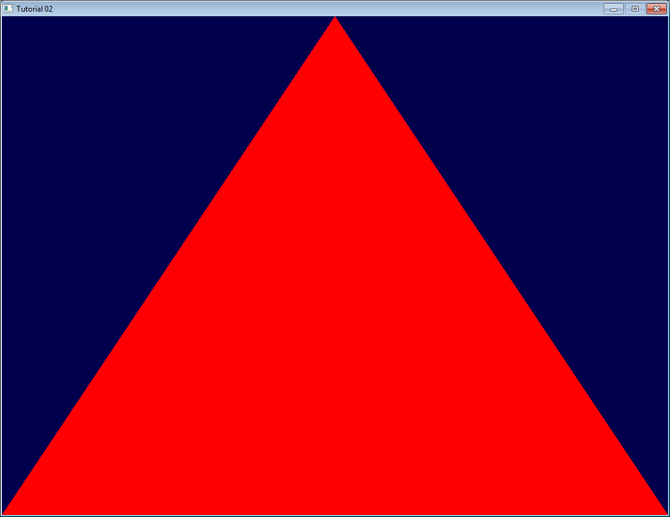

В следующем уроке вы узнаете о трансформациях, т. е. узнаете как установить камеру, как перемещать объекты и т. д. Увидимся :)

*// структура OpenGL праграмы мне зразумела. Ствараецца .cpp файл з функцыяй main, у якой ствараецца акно і іншыя аб’екты опэн-жл. Акрамя гэтага пампуюцца са знешніх файлаў шэйдэрныя праграмы, якія адказваюць непасрэдна за маляванне. Яны праз ідэнтыфікатары сінхранізуюцца з буфернымі аб’ектамі OpenGL. Клас. //*

<http://www.opengl-tutorial.org/ru/beginners-tutorials/tutorial-3-matrices/>

# Урок 3: Матрицы

Движок не перемещает корабль. Корабль остается на месте, а движок перемещает вселенную относительно его. Futurama

Это очень важная часть уроков, убедитесь что прочитали ее несколько раз и хорошо поняли. *// арыентацыя чытача //*

## Однородные координаты

До текущего момента мы оперировали 3х-мерными вершинами как (x, y, z) триплетами. Введем еще один параметр w и будем оперировать векторами вида (x, y, z, w).

Запомните навсегда, что:

* Если w == 1, то вектор (x, y, z, 1) - это позиция в пространстве.
* Если же w == 0, то вектор (x, y, z, 0) - это направление.

Что это дает нам? Ок, для поворота это ничего не меняет, так как и в случае поворота точки и в случае поворота вектора направления вы получаете один и тот же результат. Однако в случае переноса есть разница. Перенос вектора направления даст тот же самый вектор. Подробнее об этом остановимся позднее. *// лепей зразумець, што ёсць перанос, што ёсць паварот. Што такое вектар накірунка ў OpenGL? //*

Однородные координаты позволяют нам с помощью одной математической формулы оперировать векторами в обоих случаях.

## Матрицы трансформаций

### Введение в матрицы

Проще всего представить матрицу, как массив чисел, со строго определенным количеством строк и столбцов. К примеру, матрица 2x3 выглядит так:

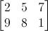

Однако в трехмерной графике мы будем использовать только матрицы 4x4, которые позволят нам трансформировать наши вершины (x, y, z, w). Трансформированная вершина является результатом умножения матрицы на саму вершину:

\*\*Матрица x Вершина (именно в этом порядке!!) = Трансформир. вершина \*\*

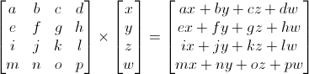

Довольно просто. Мы будем использовать это довольно часто, так что имеет смысл поручить это компьютеру:

#### **В C++, используя GLM:**

glm::mat4 myMatrix;

glm::vec4 myVector;

// Не забудьте тут заполнить матрицу и вектор необходимыми значениями

glm::vec4 transformedVector = myMatrix \* myVector; // Обратите внимание на порядок! Он важен!

#### **В GLSL :**

mat4 myMatrix;

vec4 myVector;

// Не забудьте тут заполнить матрицу и вектор необходимыми значениями

vec4 transformedVector = myMatrix \* myVector; // Да, это очень похоже на GLM :)

Попробуйте поэкспериментировать с этими фрагментами.

### Матрица переноса

Матрица переноса выглядит так:

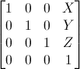

где X, Y, Z - это значения, которые мы хотим добавить к нашему вектору.

Значит, если мы захотим перенести вектор (10, 10, 10, 1) на 10 юнитов в направлении X, то мы получим:

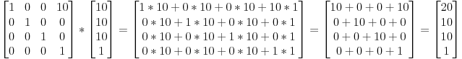

… получим (20, 10, 10, 1) однородный вектор! Не забывайте, что 1 в параметре w, означает позицию, а не направление и наша трансформация не изменила того, что мы работаем с позицией.

Теперь посмотрим, что случится, если вектор (0, 0, -1, 0) представляет собой направление: *// у OpenGL вектар можа яўляць сабой накірунак або пазіцыю. Струкутра OpenGL //*

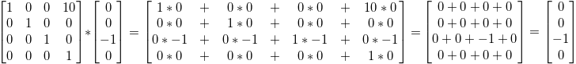

… и получаем наш оригинальный вектор (0, 0, -1, 0). Как было сказано раньше, вектор с параметром w = 0 нельзя перенести. *// зразумеў, што мелася на ўвазе. Перанос не працуе з вектарамі накірункаў //*

И самое время перенести это в код.

#### **В C++, с GLM:**

#include <glm/gtc/transform.hpp> // после <glm/glm.hpp> *// у кодзе matrix\_transform.hpp //*

glm::mat4 myMatrix = glm::translate(10.0f, 0.0f, 0.0f);

glm::vec4 myVector(10.0f, 10.0f, 10.0f, 0.0f);

glm::vec4 transformedVector = myMatrix \* myVector;

\*\*В GLSL : \*\*По факту, вы никогда не будете делать это в шейдере, чаще всего вы будете выполнять glm::translate() в C++, чтобы вычислить матрицу, передать ее в GLSL, а уже в шейдере выполнить умножение: *// тэхніка выкарыстання OpenGL //*

vec4 transformedVector = myMatrix \* myVector;

### Единичная матрица

Это специальная матрица, которая не делает ничего, но мы затрагиваем ее, так как важно помнить, что A умноженное на 1.0 дает A:

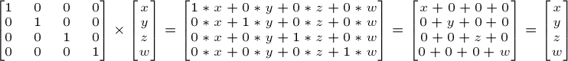

#### **В C++ :**

glm::mat4 myIdentityMatrix = glm::mat4(1.0f);

### Матрица масштабирования

Выглядит также просто:

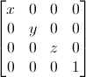

Значит, если вы хотите применить масштабирование вектора (позицию или направление - это не важно) на 2.0 во всех направлениях, то вам необходимо:

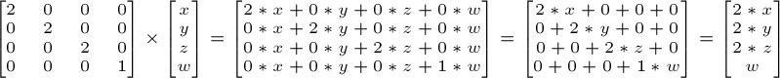

Обратите внимание, что w не меняется, а также обратите внимание на то, что единичная матрица - это частный случай матрицы масштабирования с коэффициентом масштаба равным 1 по всем осям. Также единичная матрица - это частный случай матрицы переноса, где (X, Y, Z) = (0, 0, 0) соответственно.

#### **В C++ :**

// добавьте #include <glm/gtc/matrix\_transform.hpp> и #include <glm/gtx/transform.hpp>

glm::mat4 myScalingMatrix = glm::scale(2.0f, 2.0f ,2.0f);

### Матрица поворота

Сложнее чем рассмотренные ранее. Мы опустим здесь детали, так как вам не обязательно знать это точно для ежедневного использования. Для получения более подробной информации можете перейти по ссылке [Matrices and Quaternions FAQ](http://www.cs.princeton.edu/~gewang/projects/darth/stuff/quat_faq.html) (довольно популярный ресурс и возможно там доступен ваш язык)

#### **В C++ :**

// добавьте #include <glm/gtc/matrix\_transform.hpp> и #include <glm/gtx/transform.hpp>

glm::vec3 myRotationAxis( ??, ??, ??);

glm::rotate( angle\_in\_degrees, myRotationAxis );

### Собираем трансформации вместе

Итак, теперь мы умеем поворачивать, переносить и масштабировать наши векторы. Следующий шагом было бы неплохо объединить трансформации, что реализуется по следующей формуле:

TransformedVector = TranslationMatrix \* RotationMatrix \* ScaleMatrix \* OriginalVector;

ВНИМАНИЕ! Эта формула на самом деле показывает, что сначала выполняется масштабирование, потом поворот и только в самую последнюю очередь выполняется перенос. Именно так работает перемножение матриц. *// вельмі важны нюанс OpenGL і матрычнай алгебры пераўтварэнняў //*

Обязательно запомните в каком порядке все это выполняется, потому что порядок действительно важен, в конце концов вы можете сами это проверить:

* Сделайте шаг вперед и повернитесь влево
* Повернитесь влево и сделайте шаг вперед

Разницу действительно важно понимать, так как вы постоянно будете с этим сталкиваться. К примеру, когда вы будете работать с игровыми персонажами или какими-то объектами, то всегда сначала выполняйте масштабирование, потом поворот и только потом перенос. *// рэкамендацыя кнігі //*

Перемножение двух матриц очень похоже на перемножение матрицы и вектора, поэтому мы опустим описание, а если вы хотите узнать больше, то можете опять перейти по ссылке [Matrices and Quaternions FAQ](http://www.cs.princeton.edu/~gewang/projects/darth/stuff/quat_faq.html).

#### **В C++, с GLM :**

glm::mat4 myModelMatrix = myTranslationMatrix \* myRotationMatrix \* myScaleMatrix;

glm::vec4 myTransformedVector = myModelMatrix \* myOriginalVector;

#### **В GLSL :**

mat4 transform = mat2 \* mat1;

vec4 out\_vec = transform \* in\_vec;

*// тут вызначаны аператар памнажэння для гэтых тыпаў дадзен //*

### Мировая, видовая и проекционная матрицы

*До конца этого урока мы будем полагать, что знаем как отображать любимую 3D модель из Blender - обезьянку Suzanne. // сувязь тэхналогій //*

Мировая, видовая и проекционная матрицы - это удобный инструмент для разделения трансформаций.

#### Мировая матрица

Эта модель, также, как и наш красный треугольник задается множеством вершин, координаты которых заданы относительно центра объекта, т. е. вершина с координатами (0, 0, 0) будет находиться в центре объекта.

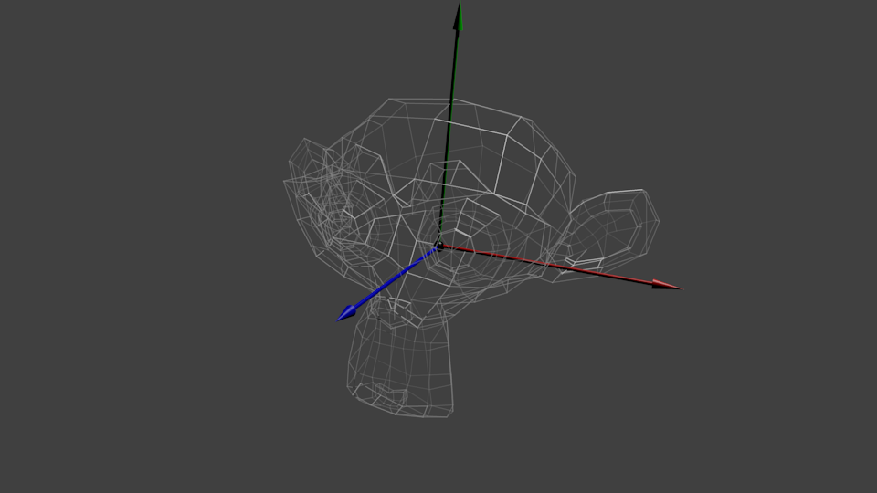

Далее мы бы хотели перемещать нашу модель, так как игрок управляет ей с помощью клавиатуры и мышки. Все, что мы делаем - это применяем масштабирование, потом поворот и перенос. Эти действия выполняются для каждой вершины, в каждом кадре (выполняются в GLSL, а не в C++!) и тем самым наша модель перемещается на экране. *// рэалізацыя графікі і тэхніка выкарыстання OpenGL. Нешта змяшчаецца ў шэйдэрах, а нешта ў кодзе С++ //*

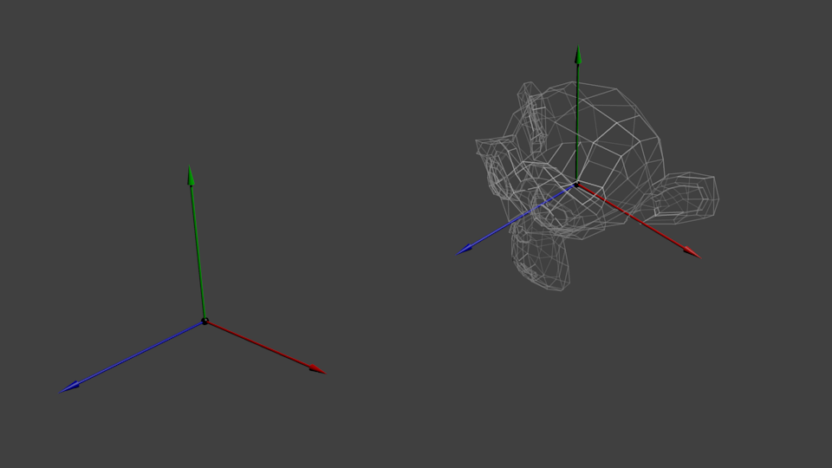

Теперь наши вершины в мировом пространстве. Это показывает черная стрелка на рисунке. Мы перешли из пространства объекта (все вершины заданы относительно центра объекта) к мировому пространству (все вершины заданы относительно центра мира) *// паняцці OpenGL //*

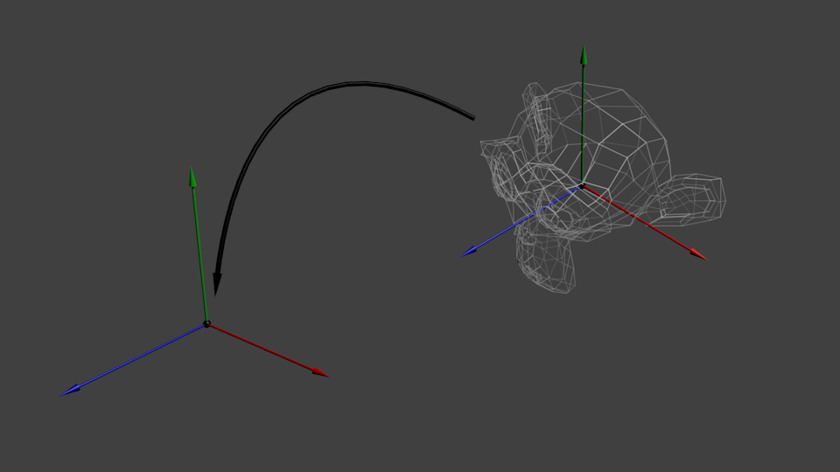

Схематично это показывается так:

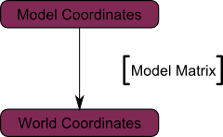

#### Видовая матрица

Еще раз процитируем Футураму:

Движок не перемещает корабль. Корабль остается на том же месте, а движок перемещает вселенную вокруг него.

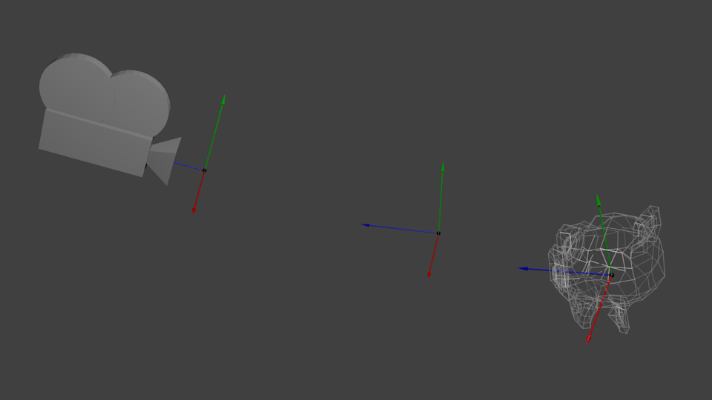

Попробуйте представить это применительно к камере. Например, если вы хотите сфотографировать гору, то вы не перемещаете камеру, а перемещаете гору. Это не возможно в реальной жизни, но это невероятно просто в компьютерной графике.

Итак, изначально ваша камера находится в центре мировой системы координат. Чтобы переместить мир вам необходимо ввести еще одну матрицу. Допустим, что вы хотите переместить камеру на 3 юнита вправо (+X), что будет эквивалентом перемещения всего мира на 3 юнита влево (-X). В коде это выглядит так:

// Добавьте #include <glm/gtc/matrix\_transform.hpp> и #include <glm/gtx/transform.hpp>

glm::mat4 ViewMatrix = glm::translate(-3.0f, 0.0f ,0.0f);

Опять же, изображение ниже полностью показывает это. Мы перешли из мировой системы координат (все вершины заданы относительно центра мировой системы) к системе координат камеры (все вершины заданы относительно камеры):

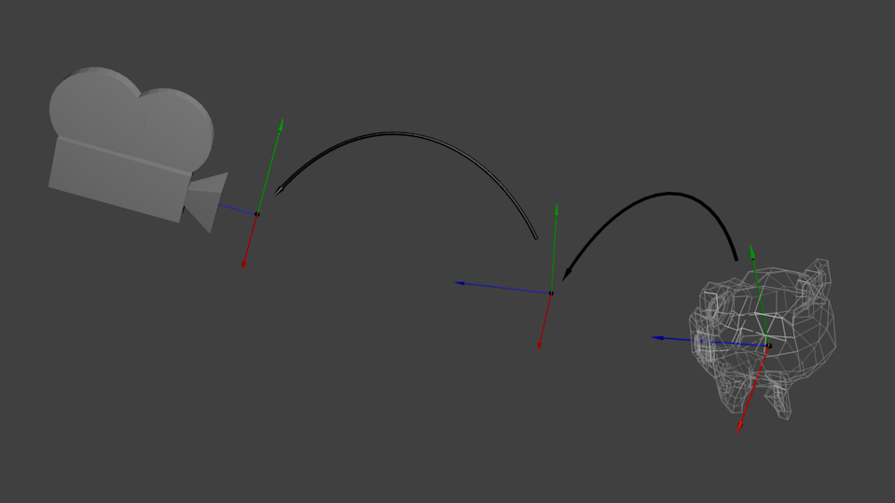

Ну и пока ваш мозг переваривает это, мы посмотрим на функцию, которую предоставляет нам GLM, а точнее на glm::LookAt:

glm::mat4 CameraMatrix = glm::LookAt(

cameraPosition, // Позиция камеры в мировом пространстве

cameraTarget, // Указывает куда вы смотрите в мировом пространстве

upVector // Вектор, указывающий направление вверх. Обычно (0, 1, 0)

);

А вот диаграмма, которая показывает то, что мы делаем:

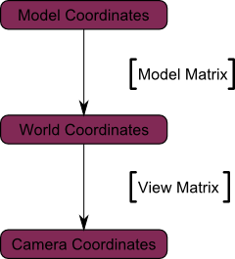

#### Проекционная матрица

Итак, теперь мы находимся в пространстве камеры. Это означает, что вершина, которая получит координаты x == 0 и y == 0 будет отображаться по центру экрана. Однако, при отображении объекта огромную роль играет также дистанция до камеры (z). Для двух вершин, с одинаковыми x и y, вершина имеющая большее значение по z будет отображаться ближе, чем другая.

Это называется перспективной проекцией:

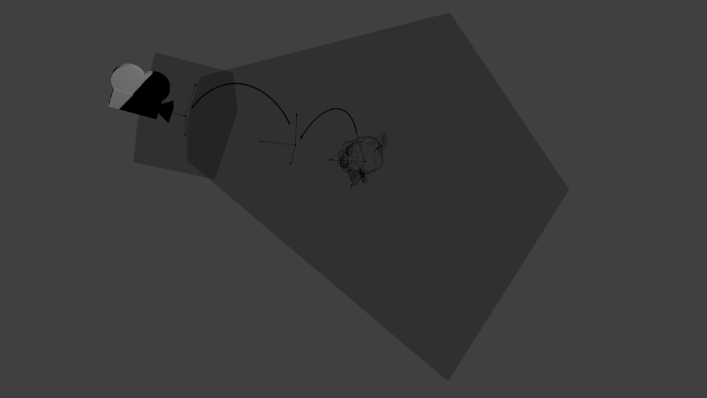

И к счастью для нас, матрица 4х4 может выполнить эту проекцию¹ :

glm::mat4 projectionMatrix = glm::perspective(

FoV, // Горизонтальное поле обзора в градусах. Обычно между 90&deg; (очень широкое) и 30&deg; (узкое)

4.0f / 3.0f, // Отношение сторон. Зависит от размеров вашего окна. Заметьте, что 4/3 == 800/600 == 1280/960

0.1f, // Ближняя плоскость отсечения. Должна быть больше 0.

100.0f // Дальняя плоскость отсечения.

);

*// лепей зразумець параметры гэтай функцыі //*

Еще раз:

Мы перешли из Пространства Камеры (все вершины заданы относительно камеры) в Однородное пространство (все вершины находятся в небольшом кубе. Все, что находится внутри куба - выводится на экран).

Схема:

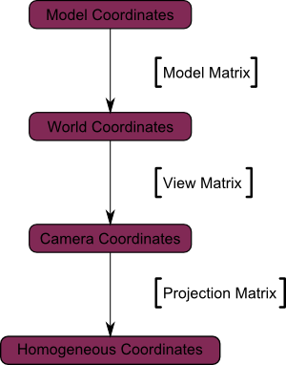

Теперь посмотрим на следующие изображения, чтобы вы могли лучше понять что же происходит с проекцией. До проецирования мы имеем синие объекты в пространстве камеры, в то время как красная фигура показывает обзор камеры, т. е. все то, что камера видит.

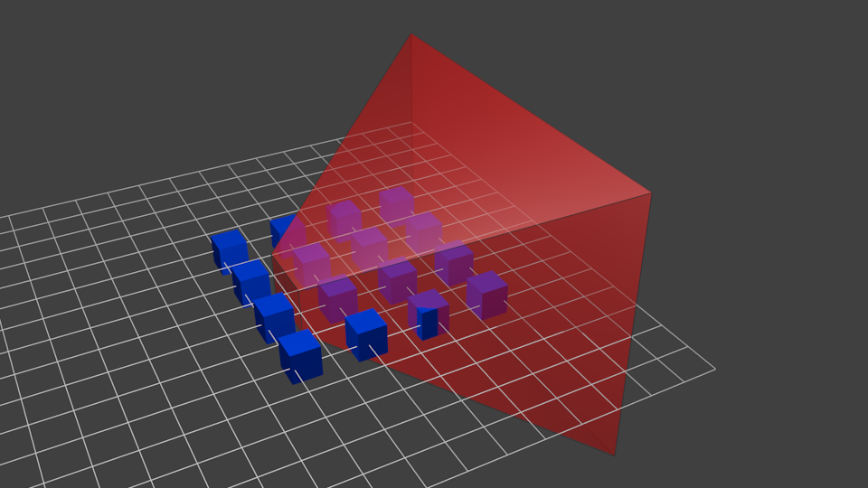

Применение Проекционной матрицы дает следующий эффект:

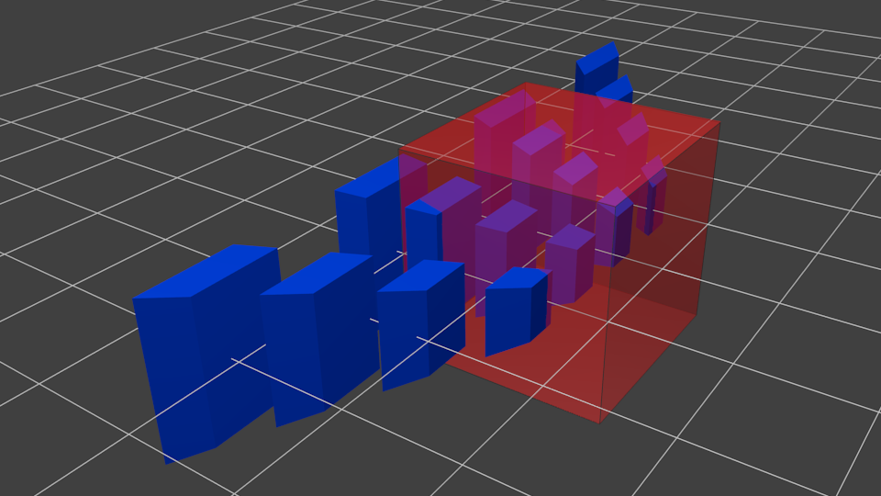

На этом изображении обзор камеры представляет собой куб и все объекты деформируются. Объекты, которые находятся ближе к камере отображаются большими, а те, которые дальше - маленькими. Прямо как в реальности!

Вот так это будет выглядеть:

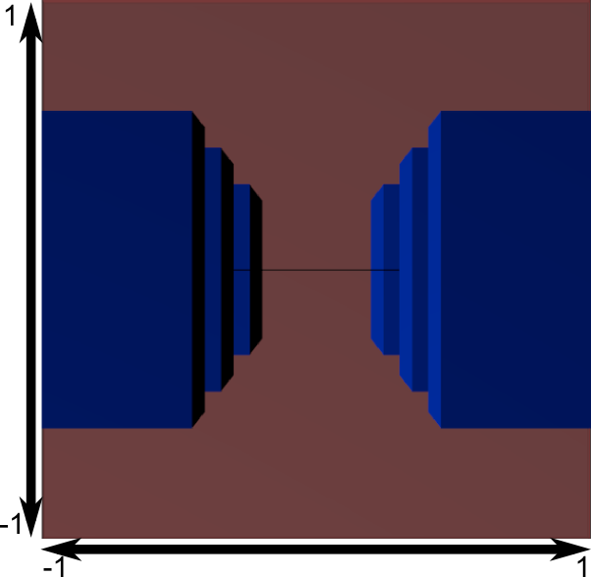

Изображение является квадратным, поэтому следующие математические трансформации применяются, чтобы растянуть изображение согласно актуальным размерам окна:

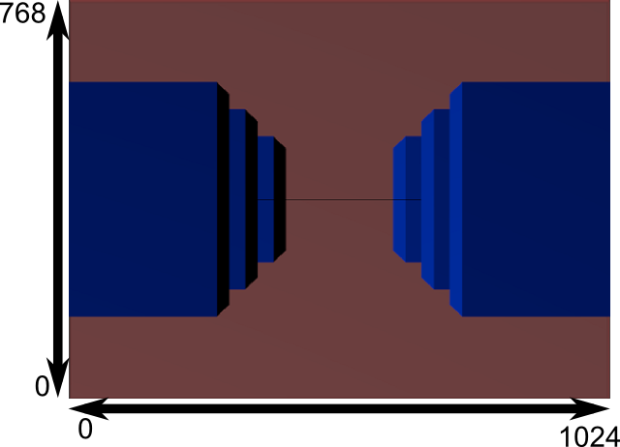

И это изображение является тем, что на самом деле будет выведено.

*// структура OpenGL //*

### Объединяем трансформации : матрица ModelViewProjection

… Просто стандартные матричные преобразования, которые вы уже полюбили!

#### // C++ : вычисление матрицы

glm::mat4 MVPmatrix = projection \* view \* model; // Запомните! В обратном порядке!

#### // GLSL : применение матрицы

transformed\_vertex = MVP \* in\_vertex;

### Совмещаем все вместе

* Первый шаг - создание нашей MVP матрицы. Это должно быть сделано для каждой модели, которую вы отображаете.

// Проекционная матрица : 45&deg; поле обзора, 4:3 соотношение сторон, диапазон : 0.1 юнит <-> 100 юнитов

glm::mat4 Projection = glm::perspective(glm::radians(45.0f), 4.0f / 3.0f, 0.1f, 100.0f);

// Матрица камеры

glm::mat4 View = glm::lookAt(

glm::vec3(4,3,3), // Камера находится в мировых координатах (4,3,3)

glm::vec3(0,0,0), // И направлена в начало координат

glm::vec3(0,1,0) // "Голова" находится сверху

);

// Матрица модели : единичная матрица (Модель находится в начале координат)

glm::mat4 Model = glm::mat4(1.0f); // Индивидуально для каждой модели

// Итоговая матрица ModelViewProjection, которая является результатом перемножения наших трех матриц

glm::mat4 MVP = Projection \* View \* Model;

* Второй шаг - передать это в GLSL:

// Получить хэндл переменной в шейдере

// Только один раз во время инициализации. *// тэхніка выкарыстання OpenGL і шэйдэраў //*

GLuint MatrixID = glGetUniformLocation(programID, "MVP");

// Передать наши трансформации в текущий шейдер

// Для каждой модели, которую вы выводите MVP будет различным (как минимум часть M) *// лепей зразумець гэта. Чаму? //*

glUniformMatrix4fv(MatrixID, 1, GL\_FALSE, &MVP[0][0]);

* Третий шаг - используем полученные данные в GLSL, чтобы трансформировать наши вершины.

in vec3 vertexPosition\_modelspace;

uniform mat4 MVP;

void main(){

// Выходная позиция нашей вершины: MVP \* position

vec4 v = vec4(vertexPosition\_modelspace,1); // Переводим в однородный 4D вектор, помните?

gl\_Position = MVP \* v;

}

*// фактычна гэта дазваляе нам разглядаць трохмерны свет і праецыраваць яго пэўным чынам на экран. Прычым праекцыя імітуе месцазнаходжанне камеры. Гэта крута. Гэта цудоўна. Гэта здорава. Гэта выдатна. //*

* Готово! Теперь у нас есть такой же треугольник как и в Уроке 2, все так же находящийся в начале координат (0, 0, 0), но теперь мы его видим в перспективе из точки (4, 3, 3). *// да тлумачэння магчымасцяў OpenGL //*

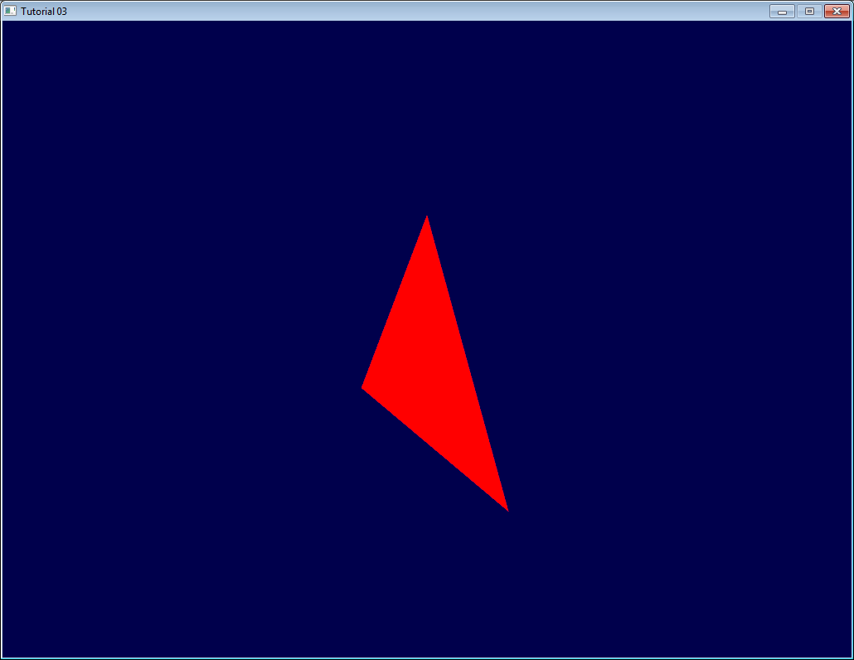

В Уроке 6 вы научитесь изменять эти значения динамически, используя клавиатуру и мышь, чтобы создать камеру, которую вы привыкли видеть в играх. Но для начала мы узнаем как придать нашем моделям цвета (Урок 4) и текстуры (Урок 5).

Задания

* Попробуйте поменять значения glm::perspective
* Вместо использования перспективной проекции попробуйте использовать ортогональную (glm:ortho)
* Измените ModelMatrix для перемещения, поворота и масштабирования треугольника
* Используйте предыдущее задание, но с разным порядком операций. Обратите внимание на результат.

<http://www.opengl-tutorial.org/ru/beginners-tutorials/tutorial-4-a-colored-cube/>

# Tutorial 4 : A Colored Cube

* [Draw a cube](http://www.opengl-tutorial.org/beginners-tutorials/tutorial-4-a-colored-cube/#draw-a-cube)
* [Adding colors](http://www.opengl-tutorial.org/beginners-tutorials/tutorial-4-a-colored-cube/#adding-colors)
* [The Z-Buffer](http://www.opengl-tutorial.org/beginners-tutorials/tutorial-4-a-colored-cube/#the-z-buffer)
* [Exercises](http://www.opengl-tutorial.org/beginners-tutorials/tutorial-4-a-colored-cube/#exercises)

Welcome for the 4rth tutorial ! You will do the following :

* Draw a cube instead of the boring triangle
* Add some fancy colors
* Learn what the Z-Buffer is

## Draw a cube

A cube has six square faces. Since OpenGL only knows about triangles, *// OpenGL structure //* we’ll have to draw 12 triangles : two for each face. We just define our vertices in the same way as we did for the triangle.

*// Our vertices. Three consecutive floats give a 3D vertex; Three consecutive vertices give a triangle.*

*// A cube has 6 faces with 2 triangles each, so this makes 6\*2=12 triangles, and 12\*3 vertices*

**static** **const** GLfloat g\_vertex\_buffer\_data[] **=** {

**-**1.0f,**-**1.0f,**-**1.0f, *// triangle 1 : begin*

**-**1.0f,**-**1.0f, 1.0f,

**-**1.0f, 1.0f, 1.0f, *// triangle 1 : end*

1.0f, 1.0f,**-**1.0f, *// triangle 2 : begin*

**-**1.0f,**-**1.0f,**-**1.0f,

**-**1.0f, 1.0f,**-**1.0f, *// triangle 2 : end*

1.0f,**-**1.0f, 1.0f,

**-**1.0f,**-**1.0f,**-**1.0f,

1.0f,**-**1.0f,**-**1.0f,

1.0f, 1.0f,**-**1.0f,

1.0f,**-**1.0f,**-**1.0f,

**-**1.0f,**-**1.0f,**-**1.0f,

**-**1.0f,**-**1.0f,**-**1.0f,

**-**1.0f, 1.0f, 1.0f,

**-**1.0f, 1.0f,**-**1.0f,

1.0f,**-**1.0f, 1.0f,

**-**1.0f,**-**1.0f, 1.0f,

**-**1.0f,**-**1.0f,**-**1.0f,

**-**1.0f, 1.0f, 1.0f,

**-**1.0f,**-**1.0f, 1.0f,

1.0f,**-**1.0f, 1.0f,

1.0f, 1.0f, 1.0f,

1.0f,**-**1.0f,**-**1.0f,

1.0f, 1.0f,**-**1.0f,

1.0f,**-**1.0f,**-**1.0f,

1.0f, 1.0f, 1.0f,

1.0f,**-**1.0f, 1.0f,

1.0f, 1.0f, 1.0f,

1.0f, 1.0f,**-**1.0f,

**-**1.0f, 1.0f,**-**1.0f,

1.0f, 1.0f, 1.0f,

**-**1.0f, 1.0f,**-**1.0f,

**-**1.0f, 1.0f, 1.0f,

1.0f, 1.0f, 1.0f,

**-**1.0f, 1.0f, 1.0f,

1.0f,**-**1.0f, 1.0f

};

*// мда… не так-та і проста задаваць вертэксы… Ці ёсць больш просты спосаб? Блендэр? Вельмі зручна было бы… //*

The OpenGL buffer is created, bound, filled and configured with the standard functions (glGenBuffers, glBindBuffer, glBufferData, glVertexAttribPointer); *// OpenGL structure. Buffer operations. Intbu them better. Intbu their details //* see Tutorial 2 for a quick reminder. The draw call does not change either, you just have to set the right number of vertices that must be drawn :

*// Draw the triangle !*

glDrawArrays(GL\_TRIANGLES, 0, 12**\***3); *// 12\*3 indices starting at 0 -> 12 triangles -> 6 squares*

A few remarks on this code :

* For now, our 3D model is fixed : in order to change it, you have to modify the source code, recompile the application, and hope for the best. We’ll learn how to load dynamic models in tutorial 7.
* Each vertex is actually written at least 3 times (search “-1.0f,-1.0f,-1.0f” in the code above). This is an awful waste of memory. We’ll learn how to deal with this in tutorial 9.

*// графавая структура крыніцы. Дзве важныя крыніцы, якія варта паляпшаць, карыстаючыся OpenGL //*

You now have all the needed pieces to draw the cube in white. Make the shaders work ! go on, at least try :)

### Adding colors

20.06.2017

A color is, conceptually, exactly the same as a position : it’s just data. In OpenGL terms, they are “attributes”. *// definition of attributes term //* As a matter of fact, we already used this with glEnableVertexAttribArray() and glVertexAttribPointer(). Let’s add another attribute. The code is going to be very similar.

First, declare your colors : one RGB triplet per vertex. Here I generated some randomly, so the result won’t look that good, but you can do something better, for instance by copying the vertex’s position into its own color.

*// One color for each vertex. They were generated randomly.*

**static** **const** GLfloat g\_color\_buffer\_data[] **=** {

0.583f, 0.771f, 0.014f,

0.609f, 0.115f, 0.436f,

0.327f, 0.483f, 0.844f,

0.822f, 0.569f, 0.201f,

0.435f, 0.602f, 0.223f,

0.310f, 0.747f, 0.185f,

0.597f, 0.770f, 0.761f,

0.559f, 0.436f, 0.730f,

0.359f, 0.583f, 0.152f,

0.483f, 0.596f, 0.789f,

0.559f, 0.861f, 0.639f,

0.195f, 0.548f, 0.859f,

0.014f, 0.184f, 0.576f,

0.771f, 0.328f, 0.970f,

0.406f, 0.615f, 0.116f,

0.676f, 0.977f, 0.133f,

0.971f, 0.572f, 0.833f,

0.140f, 0.616f, 0.489f,

0.997f, 0.513f, 0.064f,

0.945f, 0.719f, 0.592f,

0.543f, 0.021f, 0.978f,

0.279f, 0.317f, 0.505f,

0.167f, 0.620f, 0.077f,

0.347f, 0.857f, 0.137f,

0.055f, 0.953f, 0.042f,

0.714f, 0.505f, 0.345f,

0.783f, 0.290f, 0.734f,

0.722f, 0.645f, 0.174f,

0.302f, 0.455f, 0.848f,

0.225f, 0.587f, 0.040f,

0.517f, 0.713f, 0.338f,

0.053f, 0.959f, 0.120f,

0.393f, 0.621f, 0.362f,

0.673f, 0.211f, 0.457f,

0.820f, 0.883f, 0.371f,

0.982f, 0.099f, 0.879f

};

The buffer is created, bound and filled in the exact same way as the previous one :

GLuint colorbuffer;

glGenBuffers(1, **&**colorbuffer);

glBindBuffer(GL\_ARRAY\_BUFFER, colorbuffer);

glBufferData(GL\_ARRAY\_BUFFER, **sizeof**(g\_color\_buffer\_data), g\_color\_buffer\_data, GL\_STATIC\_DRAW);

The configuration is also identical :

*// 2nd attribute buffer : colors*

glEnableVertexAttribArray(1);

glBindBuffer(GL\_ARRAY\_BUFFER, colorbuffer);

glVertexAttribPointer(

1, *// attribute. No particular reason for 1, but must match the layout in the shader.*

3, *// size*

GL\_FLOAT, *// type*

GL\_FALSE, *// normalized?*

0, *// stride*

(**void\***)0 *// array buffer offset*

);

*// варта адзначыць, што bind выклікаецца для дзвюх буфераў перад выкананнем праграмы. Выгляадае ўсё так, што для канкрэтнага набору дадзен існуе свой буфер і такіх буфераў мы можам звязаць з кантэкстам колькі заўгодна //*

Now, in the vertex shader, we have access to this additional buffer :

*// Notice that the "1" here equals the "1" in glVertexAttribPointer // сінхранізацыя шэйдэра з аб’ектамі атрыбутаў – важная рыса OpenGL //*

**layout**(location **=** 1) **in** **vec3** vertexColor;

In our case, we won’t do anything fancy with it in the vertex shader. We will simply forward it to the fragment shader :

*// Output data ; will be interpolated for each fragment.*

**out** **vec3** fragmentColor;

**void** main(){

[...]

*// The color of each vertex will be interpolated*

*// to produce the color of each fragment*

fragmentColor **=** vertexColor;

}

In the fragment shader, you declare fragmentColor again :

*// Interpolated values from the vertex shaders*

**in** **vec3** fragmentColor;

… and copy it in the final output color :

*// Ouput data*

**out** **vec3** color;

*// сінхранізуюцца і шэйдэры самі між сабой //*

**void** main(){

*// Output color = color specified in the vertex shader,*

*// interpolated between all 3 surrounding vertices*

color **=** fragmentColor;

}

And that’s what we get :

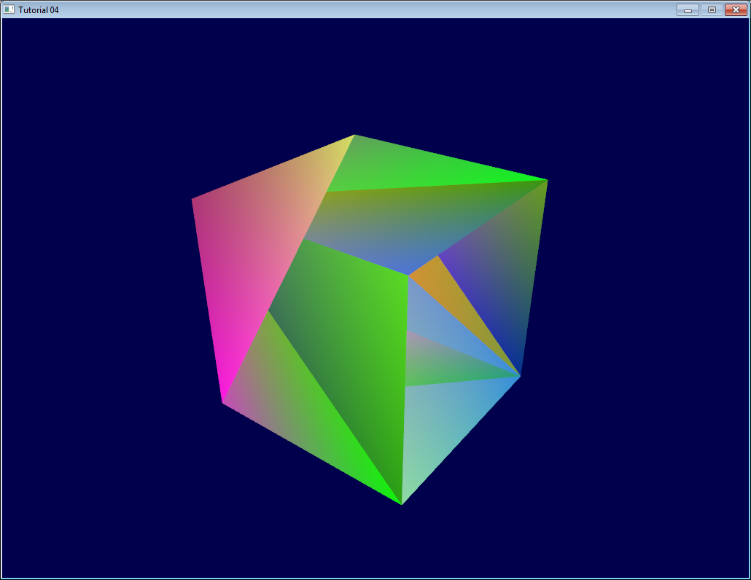

*// паглядзеў яшчэ раз на праграму. Мы ствараем праграму, куды накіроўваем усе нашыя файлы шэйдэраў, а потым мы наладжваем буферы і пасля гэтага выклікаем каманды малявання //*

Urgh. Ugly. To understand what happens, here’s what happens when you draw a “far” triangle and a “near” triangle :

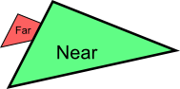

Seems OK. Now draw the “far” triangle last :

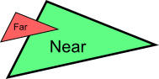

It overdraws the “near” one, even though it’s supposed to be behind it ! This is what happens with our cube : some faces are supposed to be hidden, but since they are drawn last, they are visible. Let’s call the Z-Buffer to the rescue ! *// concept purpose //*

*Quick Note 1* : If you don’t see the problem, change your camera position to (4,3,-3)

*Quick Note 2* : if “color is like position, it’s an attribute”, why do we need to declare out vec3 fragmentColor; and in vec3 fragmentColor; for the color, and not for the position ? Because the position is actually a bit special : It’s the only thing that is compulsory (or OpenGL wouldn’t know where to draw the triangle !). So in the vertex shader, gl\_Position is a “built-in” variable. *// OpenGL structure. GLSL structure //*

## The Z-Buffer

The solution to this problem is to store the depth (i.e. “Z”) component of each fragment in a buffer, and each and every time you want to write a fragment, you first check if you should (i.e the new fragment is closer than the previous one).

You can do this yourself, but it’s so much simpler to just ask the hardware to do it itself : *// OpenGL realization //*

*// Enable depth test*

glEnable(GL\_DEPTH\_TEST);

*// Accept fragment if it closer to the camera than the former one*

glDepthFunc(GL\_LESS);

You also need to clear the depth each frame, instead of only the color :

*// Clear the screen*

glClear(GL\_COLOR\_BUFFER\_BIT **|** GL\_DEPTH\_BUFFER\_BIT);

And this is enough to solve all your problems.

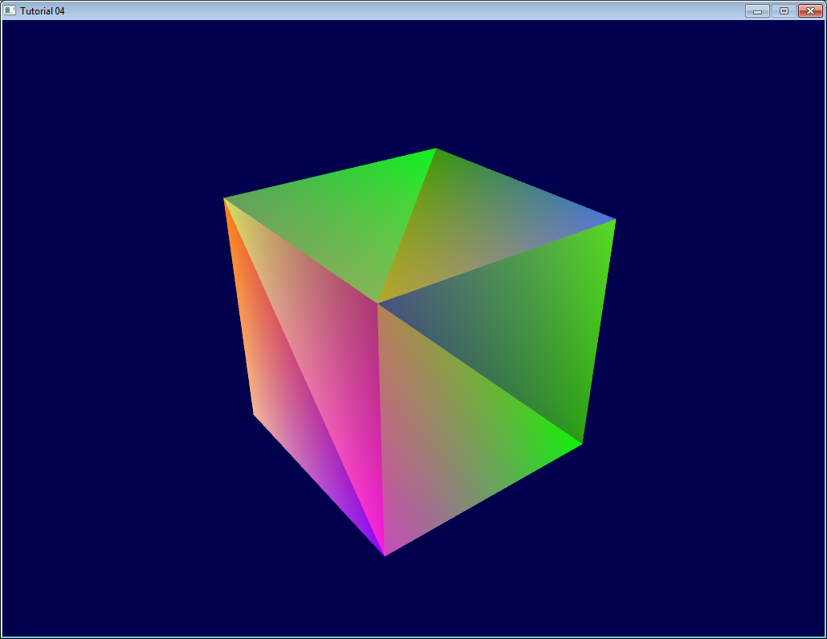

Exercises

* Draw the cube AND the triangle, at different locations. You will need to generate 2 MVP matrices, to make 2 draw calls in the main loop, but only 1 shader is required.
* Generate the color values yourself. Some ideas : At random, so that colors change at each run; Depending on the position of the vertex; a mix of the two; Some other creative idea :) In case you don’t know C, here’s the syntax :

**static** GLfloat g\_color\_buffer\_data[12**\***3**\***3];

**for** (**int** v **=** 0; v **<** 12**\***3 ; v**++**){

g\_color\_buffer\_data[3**\***v**+**0] **=** your red color here;

g\_color\_buffer\_data[3**\***v**+**1] **=** your green color here;

g\_color\_buffer\_data[3**\***v**+**2] **=** your blue color here;

}

* Once you’ve done that, make the colors change each frame. You’ll have to call glBufferData each frame. Make sure the appropriate buffer is bound (glBindBuffer) before !

<http://www.opengl-tutorial.org/beginners-tutorials/tutorial-5-a-textured-cube/>

24/06/2017

# Tutorial 5 : A Textured Cube

In this tutorial, you will learn :

* What are UV coordinates
* How to load textures yourself
* How to use them in OpenGL
* What is filtering and mipmapping, and how to use them
* How to load texture more robustly with GLFW
* What the alpha channel is

## About UV coordinates

When texturing a mesh, you need a way to tell to OpenGL which part of the image has to be used for each triangle. This is done with UV coordinates.

Each vertex can have, on top of its position, a couple of floats, U and V. These coordinates are used to access the texture, in the following way :

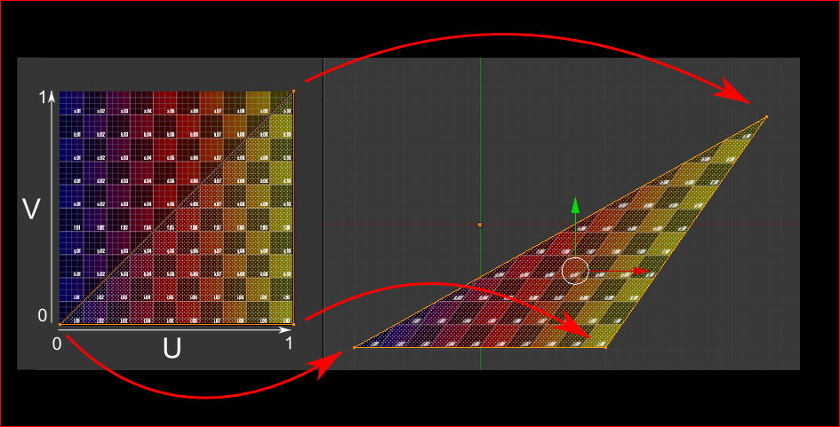

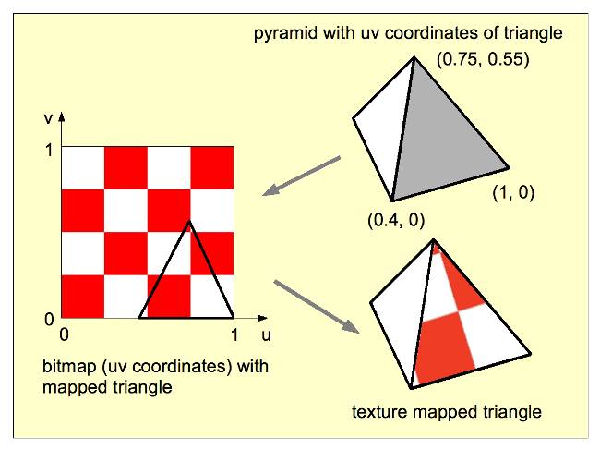

*// гэта ілюстрацыя вельмі добра тлумачыць, што такое каардынаты тэкстуры //*

Notice how the texture is distorted on the triangle.

### Loading .BMP images yourself

Knowing the BMP file format is not crucial : plenty of libraries can load BMP files for you. But it’s very simple and can help you understand how things work under the hood. So we’ll write a BMP file loader from scratch, so that you know how it works, and never use it again. *// цікавая разнавіднасць навучання //*

Here is the declaration of the loading function :

GLuint loadBMP\_custom(**const** **char** **\*** imagepath);

so it’s used like this :

GLuint image **=** loadBMP\_custom("./my\_texture.bmp");

Let’s see how to read a BMP file, then.

First, we’ll need some data. These variable will be set when reading the file.

*// Data read from the header of the BMP file*

**unsigned** **char** header[54]; *// Each BMP file begins by a 54-bytes header*

**unsigned** **int** dataPos; *// Position in the file where the actual data begins*

**unsigned** **int** width, height;

**unsigned** **int** imageSize; *// = width\*height\*3*

*// Actual RGB data*

**unsigned** **char** **\*** data;

We now have to actually open the file

*// Open the file*

**FILE** **\*** file **=** fopen(imagepath,"rb");

**if** (**!**file){printf("Image could not be opened\n"); **return** 0;}

The first thing in the file is a 54-bytes header. It contains information such as “Is this file really a BMP file?”, the size of the image, the number of bits per pixel, etc. So let’s read this header :

**if** ( fread(header, 1, 54, file)**!=**54 ){ *// If not 54 bytes read : problem*

printf("Not a correct BMP file\n");

**return** false;

}

The header always begins by BM. As a matter of fact, here’s what you get when you open a .BMP file in a hexadecimal editor :

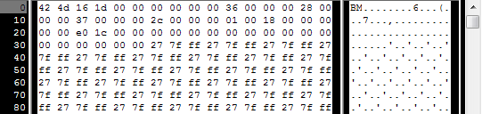

So we have to check that the two first bytes are really ‘B’ and ‘M’ :

**if** ( header[0]**!=**'B' **||** header[1]**!=**'M' ){

printf("Not a correct BMP file\n");

**return** 0;

}

Now we can read the size of the image, the location of the data in the file, etc :

*// Read ints from the byte array*

dataPos **=** **\***(**int\***)**&**(header[0x0A]);

imageSize **=** **\***(**int\***)**&**(header[0x22]);

width **=** **\***(**int\***)**&**(header[0x12]);

height **=** **\***(**int\***)**&**(header[0x16]);

*// для гэтага трэба ведаць дадзены фармат унутрана //*

We have to make up some info if it’s missing :

*// Some BMP files are misformatted, guess missing information*

**if** (imageSize**==**0) imageSize**=**width**\***height**\***3; *// 3 : one byte for each Red, Green and Blue component*

**if** (dataPos**==**0) dataPos**=**54; *// The BMP header is done that way*

Now that we know the size of the image, we can allocate some memory to read the image into, and read :

*// Create a buffer*

data **=** **new** **unsigned** **char** [imageSize];

*// Read the actual data from the file into the buffer*

fread(data,1,imageSize,file); *// мы тут знаходзімся ў файле адразу пасля хедэра, калі паглядзець на мінулы код //*

*//Everything is in memory now, the file can be closed*

fclose(file);

We arrive now at the real OpenGL part. Creating textures is very similar to creating vertex buffers: Create a texture, bind it, fill it, and configure it.

In glTexImage2D, the GL\_RGB indicates that we are talking about a 3-component color, and GL\_BGR says how exactly it is represented in RAM. As a matter of fact, BMP does not store Red->Green->Blue but Blue->Green->Red, so we have to tell it to OpenGL. *// вось з-за чаго важна мець на ўвазе, што парадак захавання колераў можа быць розным //*

*// Create one OpenGL texture*

GLuint textureID;

glGenTextures(1, **&**textureID);

*// "Bind" the newly created texture : all future texture functions will modify this texture*

glBindTexture(GL\_TEXTURE\_2D, textureID);

*// Give the image to OpenGL*

glTexImage2D(GL\_TEXTURE\_2D, 0,GL\_RGB, width, height, 0, GL\_BGR, GL\_UNSIGNED\_BYTE, data);

glTexParameteri(GL\_TEXTURE\_2D, GL\_TEXTURE\_MAG\_FILTER, GL\_NEAREST);

glTexParameteri(GL\_TEXTURE\_2D, GL\_TEXTURE\_MIN\_FILTER, GL\_NEAREST);

We’ll explain those last two lines later. Meanwhile, on the C++-side, you can use your new function to load a texture :

GLuint Texture **=** loadBMP\_custom("uvtemplate.bmp");

Another very important point :\*\* use power-of-two textures !\*\*

* good : 128\*128, 256\*256, 1024\*1024, 2\*2…
* bad : 127\*128, 3\*5, …
* okay but weird : 128\*256

*// гаворка ідзе, відаць, пра пажаданыя памеры рысунка //*

### Using the texture in OpenGL

We’ll have a look at the fragment shader first. Most of it is straightforward :

**#version 330 core**

*// Interpolated values from the vertex shaders*

**in** **vec2** UV;

*// Ouput data*

**out** **vec3** color;

*// Values that stay constant for the whole mesh.*

**uniform** **sampler2D** myTextureSampler;

**void** main(){

*// Output color = color of the texture at the specified UV*

color **=** texture( myTextureSampler, UV ).rgb;

}

Three things :

* The fragment shader needs UV coordinates. Seems fair.
* It also needs a “sampler2D” in order to know which texture to access (you can access several texture in the same shader) *// important GLSL concept //*
* Finally, accessing a texture is done with texture(), which gives back a (R,G,B,A) vec4. We’ll see about the A shortly.

The vertex shader is simple too, you just have to pass the UVs to the fragment shader :

**#version 330 core**

*// Input vertex data, different for all executions of this shader.*

**layout**(location **=** 0) **in** **vec3** vertexPosition\_modelspace;

**layout**(location **=** 1) **in** **vec2** vertexUV;

*// Output data ; will be interpolated for each fragment.*

**out** **vec2** UV;

*// Values that stay constant for the whole mesh.*

**uniform** **mat4** MVP;

**void** main(){

*// Output position of the vertex, in clip space : MVP \* position*

gl\_Position **=** MVP **\*** **vec4**(vertexPosition\_modelspace,1);

*// UV of the vertex. No special space for this one.*

UV **=** vertexUV;

}

Remember “layout(location = 1) in vec2 vertexUV” from Tutorial 4 ? Well, we’ll have to do the exact same thing here, but instead of giving a buffer (R,G,B) triplets, we’ll give a buffer of (U,V) pairs.

*// Two UV coordinatesfor each vertex. They were created with Blender. You'll learn shortly how to do this yourself.*

**static** **const** GLfloat g\_uv\_buffer\_data[] **=** {

0.000059f, 1.0f**-**0.000004f,

0.000103f, 1.0f**-**0.336048f,

0.335973f, 1.0f**-**0.335903f,

1.000023f, 1.0f**-**0.000013f,

0.667979f, 1.0f**-**0.335851f,

0.999958f, 1.0f**-**0.336064f,

0.667979f, 1.0f**-**0.335851f,

0.336024f, 1.0f**-**0.671877f,

0.667969f, 1.0f**-**0.671889f,

1.000023f, 1.0f**-**0.000013f,

0.668104f, 1.0f**-**0.000013f,

0.667979f, 1.0f**-**0.335851f,

0.000059f, 1.0f**-**0.000004f,

0.335973f, 1.0f**-**0.335903f,

0.336098f, 1.0f**-**0.000071f,

0.667979f, 1.0f**-**0.335851f,

0.335973f, 1.0f**-**0.335903f,

0.336024f, 1.0f**-**0.671877f,

1.000004f, 1.0f**-**0.671847f,

0.999958f, 1.0f**-**0.336064f,

0.667979f, 1.0f**-**0.335851f,

0.668104f, 1.0f**-**0.000013f,

0.335973f, 1.0f**-**0.335903f,

0.667979f, 1.0f**-**0.335851f,

0.335973f, 1.0f**-**0.335903f,

0.668104f, 1.0f**-**0.000013f,

0.336098f, 1.0f**-**0.000071f,

0.000103f, 1.0f**-**0.336048f,

0.000004f, 1.0f**-**0.671870f,

0.336024f, 1.0f**-**0.671877f,

0.000103f, 1.0f**-**0.336048f,

0.336024f, 1.0f**-**0.671877f,

0.335973f, 1.0f**-**0.335903f,

0.667969f, 1.0f**-**0.671889f,

1.000004f, 1.0f**-**0.671847f,

0.667979f, 1.0f**-**0.335851f

};

The UV coordinates above correspond to the following model :

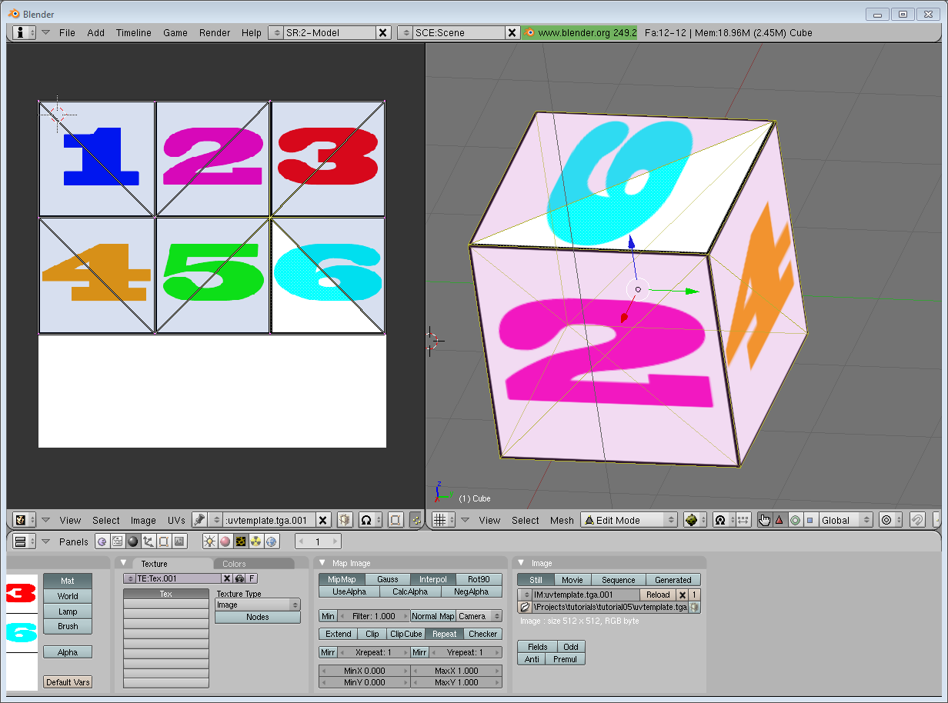

The rest is obvious. Generate the buffer, bind it, fill it, configure it, and draw the Vertex Buffer as usual. Just be careful to use 2 as the second parameter (size) of glVertexAttribPointer instead of 3.

This is the result :

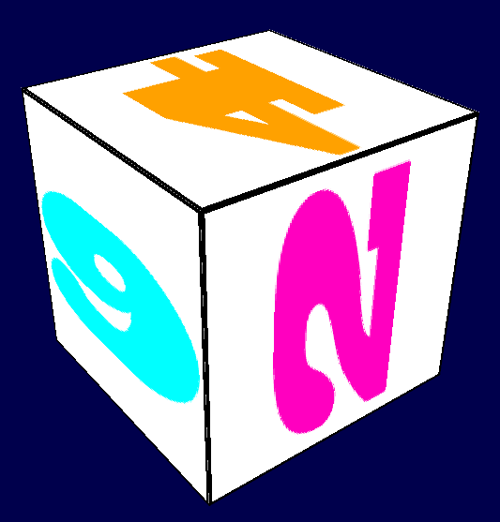

and a zoomed-in version :



*// тут больш падрабязна напісана пра uv-каадрынаты. Гэта, па факце, праекцыя трохмернай фігуры на плоскасць. Uv – гэта каардынаты на плоскасці, якім адпавядаюць xyz каардынаты на трохмерным аб’екце //*

<https://ru.wikipedia.org/wiki/UV-%D0%BF%D1%80%D0%B5%D0%BE%D0%B1%D1%80%D0%B0%D0%B7%D0%BE%D0%B2%D0%B0%D0%BD%D0%B8%D0%B5>

### What is filtering and mipmapping, and how to use them

As you can see in the screenshot above, the texture quality is not that great. This is because in loadBMP\_custom, we wrote :

glTexParameteri(GL\_TEXTURE\_2D, GL\_TEXTURE\_MAG\_FILTER, GL\_NEAREST);

glTexParameteri(GL\_TEXTURE\_2D, GL\_TEXTURE\_MIN\_FILTER, GL\_NEAREST);

This means that in our fragment shader, texture() takes the texel that is at the (U,V) coordinates, and continues happily.

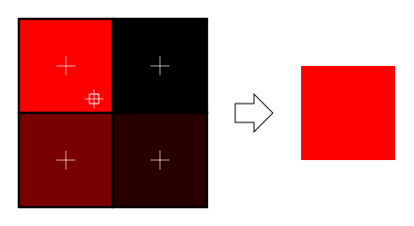

There are several things we can do to improve this.

#### Linear filtering

With linear filtering, texture() also looks at the other texels around, and mixes the colours according to the distance to each center. This avoids the hard edges seen above. *// essential graphical problem //*

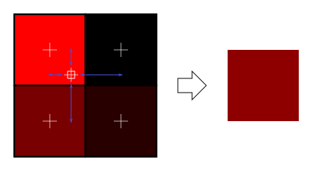

This is much better, and this is used a lot, but if you want very high quality you can also use anisotropic filtering, which is a bit slower.

#### Anisotropic filtering

This one approximates the part of the image that is really seen through the fragment. For instance, if the following texture is seen from the side, and a little bit rotated, anisotropic filtering will compute the colour contained in the blue rectangle by taking a fixed number of samples (the “anisotropic level”) along its main direction.

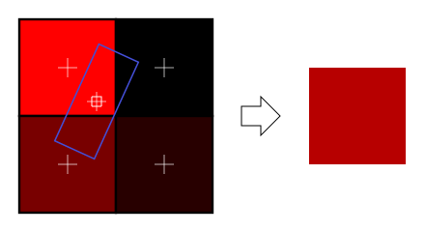

### Mipmaps

Both linear and anisotropic filtering have a problem. If the texture is seen from far away, mixing only 4 texels won’t be enough. Actually, if your 3D model is so far away than it takes only 1 fragment on screen, ALL the texels of the image should be averaged to produce the final color. This is obviously not done for performance reasons. Instead, we introduce MipMaps : *// intbu better this problem and this solution //*

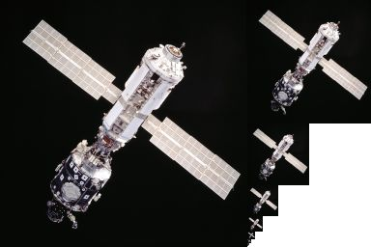

* At initialisation time, you scale down your image by 2, successively, until you only have a 1x1 image (which effectively is the average of all the texels in the image)
* When you draw a mesh, you select which mipmap is the more appropriate to use given how big the texel should be.
* You sample this mipmap with either nearest, linear or anisotropic filtering
* For additional quality, you can also sample two mipmaps and blend the results.

*// intbu better this solution on examples //*

Luckily, all this is very simple to do, OpenGL does everything for us provided that you ask him nicely :

*// When MAGnifying the image (no bigger mipmap available), use LINEAR filtering*

glTexParameteri(GL\_TEXTURE\_2D, GL\_TEXTURE\_MAG\_FILTER, GL\_LINEAR);

*// When MINifying the image, use a LINEAR blend of two mipmaps, each filtered LINEARLY too*

glTexParameteri(GL\_TEXTURE\_2D, GL\_TEXTURE\_MIN\_FILTER, GL\_LINEAR\_MIPMAP\_LINEAR);

*// Generate mipmaps, by the way.*

glGenerateMipmap(GL\_TEXTURE\_2D);

### How to load texture with GLFW

Our loadBMP\_custom function is great because we made it ourselves, but using a dedicated library is better. GLFW2 can do that too (but only for TGA files, and this feature has been removed in GLFW3, that we now use) :

GLuint loadTGA\_glfw(**const** **char** **\*** imagepath){

*// Create one OpenGL texture*

GLuint textureID;

glGenTextures(1, **&**textureID);

*// "Bind" the newly created texture : all future texture functions will modify this texture*

glBindTexture(GL\_TEXTURE\_2D, textureID);

*// Read the file, call glTexImage2D with the right parameters*

glfwLoadTexture2D(imagepath, 0);

*// Nice trilinear filtering.*

glTexParameteri(GL\_TEXTURE\_2D, GL\_TEXTURE\_WRAP\_S, GL\_REPEAT);

glTexParameteri(GL\_TEXTURE\_2D, GL\_TEXTURE\_WRAP\_T, GL\_REPEAT);

glTexParameteri(GL\_TEXTURE\_2D, GL\_TEXTURE\_MAG\_FILTER, GL\_LINEAR);

glTexParameteri(GL\_TEXTURE\_2D, GL\_TEXTURE\_MIN\_FILTER, GL\_LINEAR\_MIPMAP\_LINEAR);

glGenerateMipmap(GL\_TEXTURE\_2D);

*// Return the ID of the texture we just created*

**return** textureID;

}

### Compressed Textures

At this point, you’re probably wondering how to load JPEG files instead of TGA.

Short answer : don’t. GPUs can’t understand JPEG. So you’ll compress your original image in JPEG, and decompress it so that the GPU can understand it. You’re back to raw images, but you lost image quality while compressing to JPEG.

There’s a better option.

#### Creating compressed textures

* Download [The Compressonator](http://developer.amd.com/Resources/archive/ArchivedTools/gpu/compressonator/Pages/default.aspx), an AMD tool
* Load a Power-Of-Two texture in it
* Generate mipmaps so that you won’t have to do it on runtime
* Compress it in DXT1, DXT3 or in DXT5 (more about the differences between the various formats on [Wikipedia](http://en.wikipedia.org/wiki/S3_Texture_Compression)) :

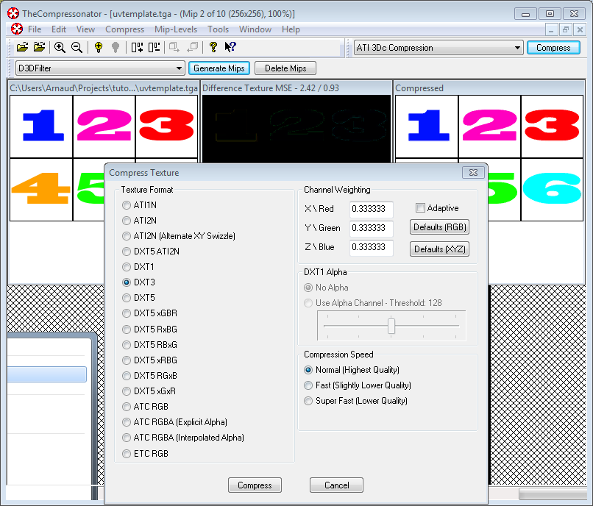

* Export it as a .DDS file.

At this point, your image is compressed in a format that is directly compatible with the GPU. Whenever calling texture() in a shader, it will uncompress it on-the-fly. This can seem slow, but since it takes a LOT less memory, less data needs to be transferred. But memory transfers are expensive; and texture decompression is free (there is dedicated hardware for that). Typically, using texture compression yields a 20% increase in performance. So you save on performance and memory, at the expense of reduced quality.

#### Using the compressed texture

Let’s see how to load the image. It’s very similar to the BMP code, except that the header is organized differently :

GLuint loadDDS(**const** **char** **\*** imagepath){

**unsigned** **char** header[124];

**FILE** **\***fp;

*/\* try to open the file \*/*

fp **=** fopen(imagepath, "rb");

**if** (fp **==** NULL)

**return** 0;

*/\* verify the type of file \*/*

**char** filecode[4];

fread(filecode, 1, 4, fp);

**if** (strncmp(filecode, "DDS ", 4) **!=** 0) {

fclose(fp);

**return** 0;

}

*/\* get the surface desc \*/*

fread(**&**header, 124, 1, fp);

**unsigned** **int** height **=** **\***(**unsigned** **int\***)**&**(header[8 ]);

**unsigned** **int** width **=** **\***(**unsigned** **int\***)**&**(header[12]);

**unsigned** **int** linearSize **=** **\***(**unsigned** **int\***)**&**(header[16]);

**unsigned** **int** mipMapCount **=** **\***(**unsigned** **int\***)**&**(header[24]);

**unsigned** **int** fourCC **=** **\***(**unsigned** **int\***)**&**(header[80]);

After the header is the actual data : all the mipmap levels, successively. We can read them all in one batch :

**unsigned** **char** **\*** buffer;

**unsigned** **int** bufsize;

*/\* how big is it going to be including all mipmaps? \*/*

bufsize **=** mipMapCount **>** 1 **?** linearSize **\*** 2 **:** linearSize;

buffer **=** (**unsigned** **char\***)malloc(bufsize **\*** **sizeof**(**unsigned** **char**));

fread(buffer, 1, bufsize, fp);

*/\* close the file pointer \*/*

fclose(fp);

Here we’ll deal with 3 different formats : DXT1, DXT3 and DXT5. We need to convert the “fourCC” flag into a value that OpenGL understands.

**unsigned** **int** components **=** (fourCC **==** FOURCC\_DXT1) **?** 3 **:** 4;

**unsigned** **int** format;

**switch**(fourCC)

{

**case** FOURCC\_DXT1:

format **=** GL\_COMPRESSED\_RGBA\_S3TC\_DXT1\_EXT;

**break**;

**case** FOURCC\_DXT3:

format **=** GL\_COMPRESSED\_RGBA\_S3TC\_DXT3\_EXT;

**break**;

**case** FOURCC\_DXT5:

format **=** GL\_COMPRESSED\_RGBA\_S3TC\_DXT5\_EXT;

**break**;

**default:**

free(buffer);

**return** 0;

}

*// код вышэй я пакуль што не даследваў //*

Creating the texture is done as usual :

*// Create one OpenGL texture*

GLuint textureID;

glGenTextures(1, **&**textureID);

*// "Bind" the newly created texture : all future texture functions will modify this texture*

glBindTexture(GL\_TEXTURE\_2D, textureID);

And now, we just have to fill each mipmap one after another :

**unsigned** **int** blockSize **=** (format **==** GL\_COMPRESSED\_RGBA\_S3TC\_DXT1\_EXT) **?** 8 **:** 16;

**unsigned** **int** offset **=** 0;

*/\* load the mipmaps \*/*

**for** (**unsigned** **int** level **=** 0; level **<** mipMapCount **&&** (width **||** height); **++**level)

{

**unsigned** **int** size **=** ((width**+**3)**/**4)**\***((height**+**3)**/**4)**\***blockSize;

glCompressedTexImage2D(GL\_TEXTURE\_2D, level, format, width, height,

0, size, buffer **+** offset);

offset **+=** size;

width **/=** 2;

height **/=** 2;

}

free(buffer);

**return** textureID;

### Inversing the UVs

DXT compression comes from the DirectX world, where the V texture coordinate is inversed compared to OpenGL. So if you use compressed textures, you’ll have to use ( coord.u, 1.0-coord.v) to fetch the correct texel. You can do this whenever you want : in your export script, in your loader, in your shader…

## Conclusion

You just learnt to create, load and use textures in OpenGL.

In general, you should only use compressed textures, since they are smaller to store, almost instantaneous to load, and faster to use; the main drawback it that you have to convert your images through The Compressonator (or any similar tool) *// recommendation. It is not so necessary for my application which is not the game //*

Exercices

* The DDS loader is implemented in the source code, but not the texture coordinate modification. Change the code at the appropriate place to display the cube correctly.
* Experiment with the various DDS formats. Do they give different result ? Different compression ratios ?
* Try not to generate mipmaps in The Compressonator. What is the result ? Give 3 different ways to fix this.

References

* [Using texture compression in OpenGL](http://www.oldunreal.com/editing/s3tc/ARB_texture_compression.pdf) , Sébastien Domine, NVIDIA

*// я падаследваў код – і разабраўся з ім. дарэчы, пры вывучэнні праграмавання – сама эфектыўна работаць з кодам. Ведаць гэты аспект тнав і паразважаць, чаму гэта так. //*

25.06.2017

<https://ru.wikipedia.org/wiki/%D0%A2%D0%B5%D0%BA%D1%81%D0%B5%D0%BB_(%D0%B3%D1%80%D0%B0%D1%84%D0%B8%D0%BA%D0%B0)> - *// пра тэкселі і палезнасць МІП-тэкстурыравання. МІП-тэкстурыраванне патрэбна для таго, каб не захоўваць вялікія тэкстуры тады, калі на экране аб’ект, які яны запаўняюць, вельмі малы. Выкарыстоўваецца МІП-мапінг. //*

<http://www.opengl-tutorial.org/beginners-tutorials/tutorial-6-keyboard-and-mouse/>

# Tutorial 6 : Keyboard and Mouse

Welcome for our 6th tutorial ! *// цудоўны прыклад фарміравання пазітыўнага настрою ў навучэнца //*

We will now learn how to use the mouse and the keyboard to move the camera just like in a FPS.

## The interface

Since this code will be re-used throughout the tutorials, we will put the code in a separate file : common/controls.cpp, and declare the functions in common/controls.hpp so that tutorial06.cpp knows about them.

The code of tutorial06.cpp doesn’t change much from the previous tutorial. The major modification is that instead of computing the MVP matrix once, we now have to do it every frame. So let’s move this code inside the main loop : *// structure of OpenGL program //*

**do**{

*// ...*

*// Compute the MVP matrix from keyboard and mouse input*

computeMatricesFromInputs();

glm**::**mat4 ProjectionMatrix **=** getProjectionMatrix();

glm**::**mat4 ViewMatrix **=** getViewMatrix();

glm**::**mat4 ModelMatrix **=** glm**::**mat4(1.0);

glm**::**mat4 MVP **=** ProjectionMatrix **\*** ViewMatrix **\*** ModelMatrix;

*// ...*

}

This code needs 3 new functions :

* computeMatricesFromInputs() reads the keyboard and mouse and computes the Projection and View matrices. This is where all the magic happens.
* getProjectionMatrix() just returns the computed Projection matrix.
* getViewMatrix() just returns the computed View matrix.

This is just one way to do it, of course. If you don’t like these functions, go ahead and change them.

Let’s see what’s inside controls.cpp.

The actual code

We’ll need a few variables.

*// position*

glm**::**vec3 position **=** glm**::**vec3( 0, 0, 5 );

*// horizontal angle : toward -Z*

**float** horizontalAngle **=** 3.14f;

*// vertical angle : 0, look at the horizon*

**float** verticalAngle **=** 0.0f;

*// Initial Field of View*

**float** initialFoV **=** 45.0f;

**float** speed **=** 3.0f; *// 3 units / second*

**float** mouseSpeed **=** 0.005f;

FoV is the level of zoom. 80° = very wide angle, huge deformations. 60° - 45° : standard. 20° : big zoom.

We will first recompute position, horizontalAngle, verticalAngle and FoV according to the inputs, and then compute the View and Projection matrices from position, horizontalAngle, verticalAngle and FoV.

Orientation

Reading the mouse position is easy :

*// Get mouse position*

**int** xpos, ypos;

glfwGetMousePos(**&**xpos, **&**ypos);

but we have to take care to put the cursor back to the center of the screen, or it will soon go outside the window and you won’t be able to move anymore.

*// Reset mouse position for next frame*

glfwSetMousePos(1024**/**2, 768**/**2);

Notice that this code assumes that the window is 1024\*768, which of course is not necessarily the case. You can use glfwGetWindowSize if you want, too.

We can now compute our viewing angles :

*// Compute new orientation*

horizontalAngle **+=** mouseSpeed **\*** deltaTime **\*** **float**(1024**/**2 **-** xpos );

verticalAngle **+=** mouseSpeed **\*** deltaTime **\*** **float**( 768**/**2 **-** ypos );

Let’s read this from right to left :

* 1024/2 - xpos means : how far is the mouse from the center of the window ? The bigger this value, the more we want to turn.
* float(…) converts it to a floating-point number so that the multiplication goes well.
* mouseSpeed is just there to speed up or slow down the rotations. Fine-tune this at will, or let the user choose it.
* += : If you didn’t move the mouse, 1024/2-xpos will be 0, and horizontalAngle+=0 doesn’t change horizontalAngle. If you had a “=” instead, you would be forced back to your original orientation each frame, which isn’t good.

We can now compute a vector that represents, in World Space, the direction in which we’re looking

*// Direction : Spherical coordinates to Cartesian coordinates conversion*

glm**::**vec3 direction(

cos(verticalAngle) **\*** sin(horizontalAngle),

sin(verticalAngle),

cos(verticalAngle) **\*** cos(horizontalAngle)

);

This is a standard computation, but if you don’t know about cosine and sinus, here’s a short explanation :

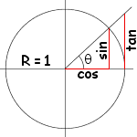

The formula above is just the generalisation to 3D.

Now we want to compute the “up” vector reliably. Notice that “up” isn’t always towards +Y : if you look down, for instance, the “up” vector will be in fact horizontal. Here is an example of to cameras with the same position, the same target, but a different up:

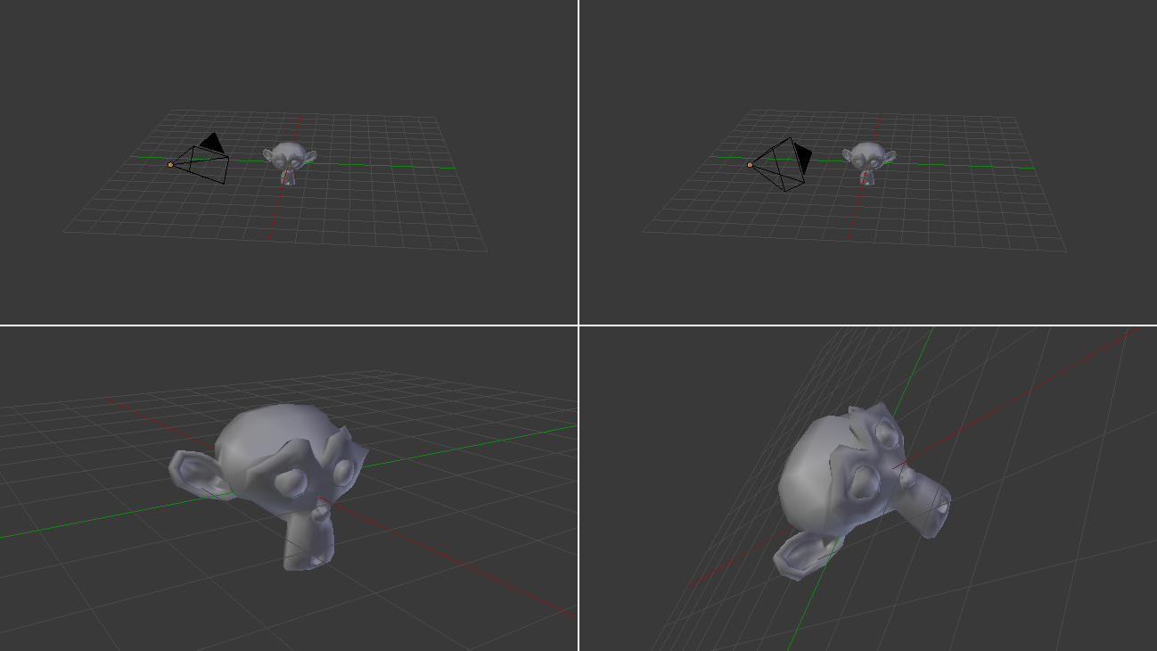

In our case, the only constant is that the vector goes to the right of the camera is always horizontal. You can check this by putting your arm horizontal, and looking up, down, in any direction. So let’s define the “right” vector : its Y coordinate is 0 since it’s horizontal, and its X and Z coordinates are just like in the figure above, but with the angles rotated by 90°, or Pi/2 radians.

*// Right vector*

glm**::**vec3 right **=** glm**::**vec3(

sin(horizontalAngle **-** 3.14f**/**2.0f),

0,

cos(horizontalAngle **-** 3.14f**/**2.0f)

);

We have a “right” vector and a “direction”, or “front” vector. The “up” vector is a vector that is perpendicular to these two. A useful mathematical tool makes this very easy : the cross product.

*// Up vector : perpendicular to both direction and right*

glm**::**vec3 up **=** glm**::**cross( right, direction );

To remember what the cross product does, it’s very simple. Just recall the Right Hand Rule from Tutorial 3. The first vector is the thumb; the second is the index; and the result is the middle finger. It’s very handy.

Position

The code is pretty straightforward. By the way, I used the up/down/right/left keys instead of the awsd because on my azerty keyboard, awsd is actually zqsd. And it’s also different with qwerZ keyboards, let alone korean keyboards. I don’t even know what layout korean people have, but I guess it’s also different.

*// Move forward*

**if** (glfwGetKey( GLFW\_KEY\_UP ) **==** GLFW\_PRESS){

position **+=** direction **\*** deltaTime **\*** speed;

}

*// Move backward*

**if** (glfwGetKey( GLFW\_KEY\_DOWN ) **==** GLFW\_PRESS){

position **-=** direction **\*** deltaTime **\*** speed;

}

*// Strafe right*

**if** (glfwGetKey( GLFW\_KEY\_RIGHT ) **==** GLFW\_PRESS){

position **+=** right **\*** deltaTime **\*** speed;

}

*// Strafe left*

**if** (glfwGetKey( GLFW\_KEY\_LEFT ) **==** GLFW\_PRESS){

position **-=** right **\*** deltaTime **\*** speed;

}

The only special thing here is the deltaTime. You don’t want to move from 1 unit each frame for a simple reason:

* If you have a fast computer, and you run at 60 fps, you’d move of 60\*speed units in 1 second
* If you have a slow computer, and you run at 20 fps, you’d move of 20\*speed units in 1 second

Since having a better computer is not an excuse for going faster, you have to scale the distance by the “time since the last frame”, or “deltaTime”.

* If you have a fast computer, and you run at 60 fps, you’d move of 1/60 \* speed units in 1 frame, so 1\*speed in 1 second.
* If you have a slow computer, and you run at 20 fps, you’d move of 1/20 \* speed units in 1 second, so 1\*speed in 1 second.

*// логіку я тут улаўліваю: каб не адбывалася падглючывання ў выпадку павольных кампутараў. Але што такое юніты, і што значыць “юніты на фрэйм”, я не адчуваю… //*

which is much better. deltaTime is very simple to compute :

**double** currentTime **=** glfwGetTime();

**float** deltaTime **=** **float**(currentTime **-** lastTime);

Field Of View

For fun, we can also bind the wheel of the mouse to the Field Of View, so that we can have a cheap zoom :

**float** FoV **=** initialFoV **-** 5 **\*** glfwGetMouseWheel();

Computing the matrices

Computing the matrices is now straightforward. We use the exact same functions than before, but with our new parameters.

*// Projection matrix : 45&deg; Field of View, 4:3 ratio, display range : 0.1 unit <-> 100 units*

ProjectionMatrix **=** glm**::**perspective(FoV, 4.0f **/** 3.0f, 0.1f, 100.0f);

*// Camera matrix*

ViewMatrix **=** glm**::**lookAt(

position, *// Camera is here*

position**+**direction, *// and looks here : at the same position, plus "direction"*

up *// Head is up (set to 0,-1,0 to look upside-down)*

);

Results



## Backface Culling

Now that you can freely move around, you’ll notice that if you go inside the cube, polygons are still displayed. This can seem obvious, but this remark actually opens an opportunity for optimisation. As a matter of fact, in a usual application, you are never *inside* a cube.

The idea is to let the GPU check if the camera is behind, or in front of, the triangle. If it’s in front, display the triangle; if it’s behind, *and* the mesh is closed, *and* we’re not inside the mesh, *then* there will be another triangle in front of it, and nobody will notice anything, except that everything will be faster : 2 times less triangles on average ! *// маецца на ўвазе, што калі мы апыняемся ўнутры аднаго трохвугольніка, то другі ўжо можна і не маляваць //*

The best thing is that it’s very easy to check this. The GPU computes the normal of the triangle (using the cross product, remember ?) and checks whether this normal is oriented towards the camera or not.

This comes at a cost, unfortunately : the orientation of the triangle is implicit. This means that is you invert two vertices in your buffer, you’ll probably end up with a hole. But it’s generally worth the little additional work. Often, you just have to click “invert normals” in your 3D modeler (which will, in fact, invert vertices, and thus normals) and everything is just fine. *// не вельмі адчуў праблему, пра якую ідзе гаворка… // //*

Enabling backface culling is a breeze :

*// Cull triangles which normal is not towards the camera*

glEnable(GL\_CULL\_FACE); *// цікавая магчымасць OpenGL //*

Exercices

* Restrict verticalAngle so that you can’t go upside-down
* Create a camera that rotates around the object ( position = ObjectCenter + ( radius \* cos(time), height, radius \* sin(time) ) ); bind the radius/height/time to the keyboard/mouse, or whatever
* Have fun !

26.06.2017

<http://www.opengl-tutorial.org/beginners-tutorials/tutorial-7-model-loading/>

# Tutorial 7 : Model loading

* [Loading the OBJ](http://www.opengl-tutorial.org/beginners-tutorials/tutorial-7-model-loading/#loading-the-obj)
  + [Example OBJ file](http://www.opengl-tutorial.org/beginners-tutorials/tutorial-7-model-loading/#example-obj-file)
  + [Creating an OBJ file in Blender](http://www.opengl-tutorial.org/beginners-tutorials/tutorial-7-model-loading/#creating-an-obj-file-in-blender)
  + [Reading the file](http://www.opengl-tutorial.org/beginners-tutorials/tutorial-7-model-loading/#reading-the-file)
  + [Processing the data](http://www.opengl-tutorial.org/beginners-tutorials/tutorial-7-model-loading/#processing-the-data)
* [Using the loaded data](http://www.opengl-tutorial.org/beginners-tutorials/tutorial-7-model-loading/#using-the-loaded-data)
* [Results](http://www.opengl-tutorial.org/beginners-tutorials/tutorial-7-model-loading/#results)
* [Other formats/loaders](http://www.opengl-tutorial.org/beginners-tutorials/tutorial-7-model-loading/#other-formatsloaders)

Until now, we hardcoded our cube directly in the source code. I’m sure you will agree that this was cumbersome and not very handy.

In this tutorial we will learn how to load 3D meshes from files. We will do this just like we did for the textures : we will write a tiny, very limited loader, and I’ll give you some pointers to actual libraries that can do this better that us.

To keep this tutorial as simple as possible, we’ll use the OBJ file format, which is both very simple and very common. And once again, to keep things simple, we will only deal with OBJ files with 1 UV coordinate and 1 normal per vertex (you don’t have to know what a normal is right now).

## Loading the OBJ

Our function, located in common/objloader.cpp and declared in common/objloader.hpp, will have the following signature :

**bool** loadOBJ(

**const** **char** **\*** path,

std**::**vector **<** glm**::**vec3 **>** **&** out\_vertices,

std**::**vector **<** glm**::**vec2 **>** **&** out\_uvs,

std**::**vector **<** glm**::**vec3 **>** **&** out\_normals

)

We want loadOBJ to read the file “path”, write the data in out\_vertices/out\_uvs/out\_normals, and return false if something went wrong. std::vector is the C++ way to declare an array of glm::vec3 which size can be modified at will: it has nothing to do with a mathematical vector. Just an array, really. And finally, the & means that function will be able to modify the std::vectors.

## Example OBJ file

An OBJ file looks more or less like this :

# Blender3D v249 OBJ File: untitled.blend

# www.blender3d.org

mtllib cube.mtl

v 1.000000 -1.000000 -1.000000

v 1.000000 -1.000000 1.000000

v -1.000000 -1.000000 1.000000

v -1.000000 -1.000000 -1.000000

v 1.000000 1.000000 -1.000000

v 0.999999 1.000000 1.000001

v -1.000000 1.000000 1.000000

v -1.000000 1.000000 -1.000000

vt 0.748573 0.750412

vt 0.749279 0.501284

vt 0.999110 0.501077

vt 0.999455 0.750380

vt 0.250471 0.500702

vt 0.249682 0.749677

vt 0.001085 0.750380

vt 0.001517 0.499994

vt 0.499422 0.500239

vt 0.500149 0.750166

vt 0.748355 0.998230

vt 0.500193 0.998728

vt 0.498993 0.250415

vt 0.748953 0.250920

vn 0.000000 0.000000 -1.000000

vn -1.000000 -0.000000 -0.000000

vn -0.000000 -0.000000 1.000000

vn -0.000001 0.000000 1.000000

vn 1.000000 -0.000000 0.000000

vn 1.000000 0.000000 0.000001

vn 0.000000 1.000000 -0.000000

vn -0.000000 -1.000000 0.000000

usemtl Material\_ray.png

s off

f 5/1/1 1/2/1 4/3/1

f 5/1/1 4/3/1 8/4/1

f 3/5/2 7/6/2 8/7/2

f 3/5/2 8/7/2 4/8/2

f 2/9/3 6/10/3 3/5/3

f 6/10/4 7/6/4 3/5/4

f 1/2/5 5/1/5 2/9/5

f 5/1/6 6/10/6 2/9/6

f 5/1/7 8/11/7 6/10/7

f 8/11/7 7/12/7 6/10/7

f 1/2/8 2/9/8 3/13/8

f 1/2/8 3/13/8 4/14/8

So :

* # is a comment, just like // in C++
* usemtl and mtllib describe the look of the model. We won’t use this in this tutorial.
* v is a vertex
* vt is the texture coordinate of one vertex
* vn is the normal of one vertex
* f is a face

v, vt and vn are simple to understand. f is more tricky. So, for f 8/11/7 7/12/7 6/10/7 :

* 8/11/7 describes the first vertex of the triangle
* 7/12/7 describes the second vertex of the triangle
* 6/10/7 describes the third vertex of the triangle (duh)
* For the first vertex, 8 says which vertex to use. So in this case, -1.000000 1.000000 -1.000000 (index start to 1, not to 0 like in C++)
* 11 says which texture coordinate to use. So in this case, 0.748355 0.998230
* 7 says which normal to use. So in this case, 0.000000 1.000000 -0.000000

These numbers are called indices. It’s handy because if several vertices share the same position, you just have to write one “v” in the file, and use it several times. This saves memory.

The bad news is that OpenGL can’t be told to use one index for the position, another for the texture, and another for the normal. So the approach I took for this tutorial is to make a standard, non-indexed mesh, and deal with indexing later, in Tutorial 9, which will explain how to work around this.

Creating an OBJ file in Blender

Since our toy loader will be severely limited, we have to be extra careful to set the right options when exporting the file. Here’s how it should look in Blender :

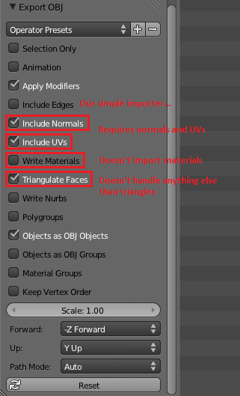

## Reading the file

Ok, down with the actual code. We need some temporary variables in which we will store the contents of the .obj :

std**::**vector**<** **unsigned** **int** **>** vertexIndices, uvIndices, normalIndices;

std**::**vector**<** glm**::**vec3 **>** temp\_vertices;

std**::**vector**<** glm**::**vec2 **>** temp\_uvs;

std**::**vector**<** glm**::**vec3 **>** temp\_normals;

Since Tutorial 5 : A Textured Cube, you know how to open a file :

**FILE** **\*** file **=** fopen(path, "r");

**if**( file **==** NULL ){

printf("Impossible to open the file !\n");

**return** false;

}

Let’s read this file until the end :

**while**( 1 ){

**char** lineHeader[128];

*// read the first word of the line*

**int** res **=** fscanf(file, "%s", lineHeader);

**if** (res **==** EOF)

**break**; *// EOF = End Of File. Quit the loop.*

*// else : parse lineHeader*

(notice that we assume that the first word of a line won’t be longer than 128, which is a very silly assumption. But for a toy parser, it’s all right)

Let’s deal with the vertices first :

**if** ( strcmp( lineHeader, "v" ) **==** 0 ){

glm**::**vec3 vertex;

fscanf(file, "%f %f %f\n", **&**vertex.x, **&**vertex.y, **&**vertex.z );

temp\_vertices.push\_back(vertex);

i.e : If the first word of the line is “v”, then the rest has to be 3 floats, so create a glm::vec3 out of them, and add it to the vector.

}**else** **if** ( strcmp( lineHeader, "vt" ) **==** 0 ){

glm**::**vec2 uv;

fscanf(file, "%f %f\n", **&**uv.x, **&**uv.y );

temp\_uvs.push\_back(uv);

i.e if it’s not a “v” but a “vt”, then the rest has to be 2 floats, so create a glm::vec2 and add it to the vector.

same thing for the normals :

}**else** **if** ( strcmp( lineHeader, "vn" ) **==** 0 ){

glm**::**vec3 normal;

fscanf(file, "%f %f %f\n", **&**normal.x, **&**normal.y, **&**normal.z );

temp\_normals.push\_back(normal);

And now the “f”, which is more difficult :

}**else** **if** ( strcmp( lineHeader, "f" ) **==** 0 ){

std**::**string vertex1, vertex2, vertex3;

**unsigned** **int** vertexIndex[3], uvIndex[3], normalIndex[3];

**int** matches **=** fscanf(file, "%d/%d/%d %d/%d/%d %d/%d/%d\n", **&**vertexIndex[0], **&**uvIndex[0], **&**normalIndex[0], **&**vertexIndex[1], **&**uvIndex[1], **&**normalIndex[1], **&**vertexIndex[2], **&**uvIndex[2], **&**normalIndex[2] );

**if** (matches **!=** 9){

printf("File can't be read by our simple parser : ( Try exporting with other options\n");

**return** false;

}

vertexIndices.push\_back(vertexIndex[0]);

vertexIndices.push\_back(vertexIndex[1]);

vertexIndices.push\_back(vertexIndex[2]);

uvIndices .push\_back(uvIndex[0]);

uvIndices .push\_back(uvIndex[1]);

uvIndices .push\_back(uvIndex[2]);

normalIndices.push\_back(normalIndex[0]);

normalIndices.push\_back(normalIndex[1]);

normalIndices.push\_back(normalIndex[2]);

This code is in fact very similar to the previous one, except that there is more data to read.

*// вышэй распавядалася пра працэсінг і фармат .obj файлаў, а таксама прыводзіўся метад, які дазваляе парсінг гэтага файла. Я магу і сам такі метад напісаць. //*

## Processing the data

So what we did there was simply to change the “shape” of the data. We had a string, we now have a set of std::vectors. But it’s not enough, we have to put this into a form that OpenGL likes. Namely, removing the indexes and have plain glm::vec3 instead. This operation is called indexing. *// concept definition //*

We go through each vertex ( each v/vt/vn ) of each triangle ( each line with a “f” ) :

*// For each vertex of each triangle*

**for**( **unsigned** **int** i**=**0; i**<**vertexIndices.size(); i**++** ){

the index to the vertex position is vertexIndices[i] :

**unsigned** **int** vertexIndex **=** vertexIndices[i];

so the position is temp\_vertices[ vertexIndex-1 ] (there is a -1 because C++ indexing starts at 0 and OBJ indexing starts at 1, remember ?) :

glm**::**vec3 vertex **=** temp\_vertices[ vertexIndex**-**1 ];

And this makes the position of our new vertex

out\_vertices.push\_back(vertex);

The same is applied for UVs and normals, and we’re done !

## Using the loaded data

Once we’ve got this, almost nothing changes. Instead of declaring our usual static const GLfloat g\_vertex\_buffer\_data[] = {…}, you declare a std::vector vertices instead (same thing for UVS and normals). You call loadOBJ with the right parameters :

*// Read our .obj file*

std**::**vector**<** glm**::**vec3 **>** vertices;

std**::**vector**<** glm**::**vec2 **>** uvs;

std**::**vector**<** glm**::**vec3 **>** normals; *// Won't be used at the moment.*

**bool** res **=** loadOBJ("cube.obj", vertices, uvs, normals);

and give your vectors to OpenGL instead of your arrays :

glBufferData(GL\_ARRAY\_BUFFER, vertices.size() **\*** **sizeof**(glm**::**vec3), **&**vertices[0], GL\_STATIC\_DRAW);

And that’s it !

Results

Sorry for the lame texture, I’m NOT a good artist :( Any contribution welcome !

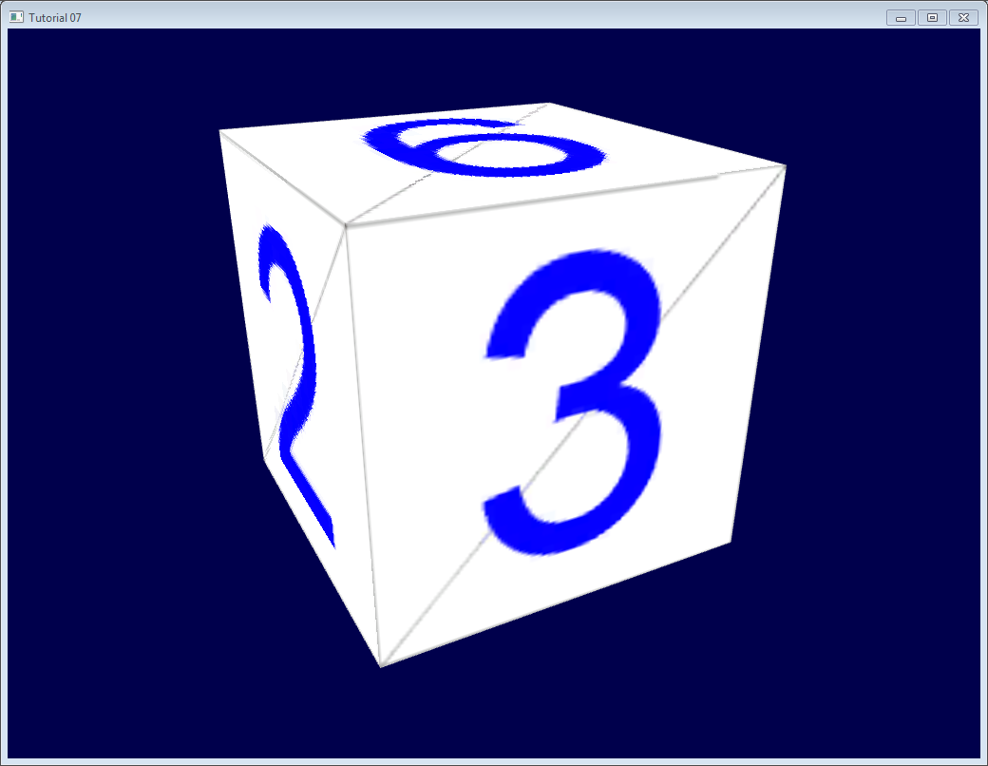

## Other formats/loaders

This tiny loader should give you enough to get started, but won’t want to use this in real life. Have a look at our [Useful Links & Tools](http://www.opengl-tutorial.org/miscellaneous/useful-tools-links/) page for some tools you can use. Note, however, that you’d better wait for tutorial 9 before \*actually \*trying to use them. *// графавая структура кнігі //*

<http://www.opengl-tutorial.org/beginners-tutorials/tutorial-8-basic-shading/>

# Tutorial 8 : Basic shading

In this 8th tutorial, we will learn how to do some basic shading. This includes :

* Beeing more bright when closer to a light source
* Having highlights when looking in the reflection of a light (specular lighting)
* Beeing darker when light is not directly towards the model (diffuse lighting)
* Cheating a lot (ambient lighting)

This does NOT include:

* Shadows. This is a broad topic that deserves its own tutorial(s)
* Mirror-like reflections (this includes water)
* Any sophisticated light-matter interaction like subsurface scattering (like wax)
* Anisotrophic materials (like brushed metal)
* Physically based shading, which tries to mimic the reality closely
* Ambient Occlusion (it’s darker in a cave)
* Color Bleeding (a red carpet will make a white ceiling a litte bit red)
* Transparency
* Any kind of Global Illumination whatsoever (it’s the name that regroups all previous ones)

*// intbu better these optical effects //*

In a word: Basic.

## Normals

During the last few tutorials you’ve been dealing with normal without really knowing what they were. *// reader orientation //*

### Triangle normals

The normal of a plane is a vector of length 1 that is perpendicular to this plane.

The normal of a triangle is a vector of length 1 that is perpendicular to this triangle. It is easily computed by taking the cross product of two of its edges (the cross product of a and b produces a vector that is perpendicular to both a and b, remember ?), and normalized : its length is brought back to 1. In pseudo-code :

triangle ( v1, v2, v3 )

edge1 = v2-v1

edge2 = v3-v1

triangle.normal = cross(edge1, edge2).normalize()

Don’t mix up normal and normalize(). Normalize() divides a vector (any vector, not necessarily a normal) by its length so that its new length is 1. normal is just the name for some vectors that happen to represent, well, a normal. *// note //*

### Vertex normals

By extension, we call the normal of a vertex the combination of the normals of the surroundings triangles. This is handy because in vertex shaders, we deal with vertices, not triangles, so it’s better to have information on the vertex. And any way, we can’t have information on triangles in OpenGL. *// OpenGL structure //* In pseudo-code:

vertex v1, v2, v3, ....

triangle tr1, tr2, tr3 // all share vertex v1

v1.normal = normalize( tr1.normal + tr2.normal + tr3.normal )

#### Using vertex normals in OpenGL

To use normals in OpenGL, it’s very easy. A normal is an attribute of a vertex, just like its position, its color, its UV coordinates… so just do the usual stuff. *// kinds of vertex attributes //* Our loadOBJ function from Tutorial 7 already reads them from the OBJ file. *// representation graph structure //*

GLuint normalbuffer;

glGenBuffers(1, **&**normalbuffer);

glBindBuffer(GL\_ARRAY\_BUFFER, normalbuffer);

glBufferData(GL\_ARRAY\_BUFFER, normals.size() **\*** **sizeof**(glm**::**vec3), **&**normals[0], GL\_STATIC\_DRAW);

and

*// 3rd attribute buffer : normals*

glEnableVertexAttribArray(2);

glBindBuffer(GL\_ARRAY\_BUFFER, normalbuffer);

glVertexAttribPointer(

2, *// attribute*

3, *// size*

GL\_FLOAT, *// type*

GL\_FALSE, *// normalized?*

0, *// stride*

(**void\***)0 *// array buffer offset*

);

and this is enough to get us started.

## The Diffuse part

### The importance of the surface normal

When light hits an object, an important fraction of it is reflected in all directions. This is the “diffuse component”. (We’ll see what happens with the other fraction soon) *// physics of light interaction with material //*

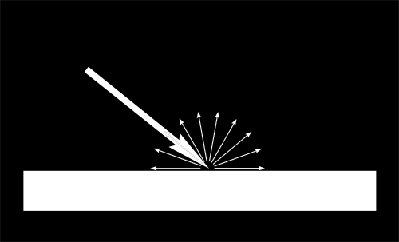

When a certain flux of light arrives at the surface, this surface is illuminated differently according to the angle at which the light arrives. *// optics //*

If the light is perpendicular to the surface, it is concentrated on a small surface. If it arrives at a gazing angle, the same quantity of light spreads on a greater surface: *// elementary optics //*

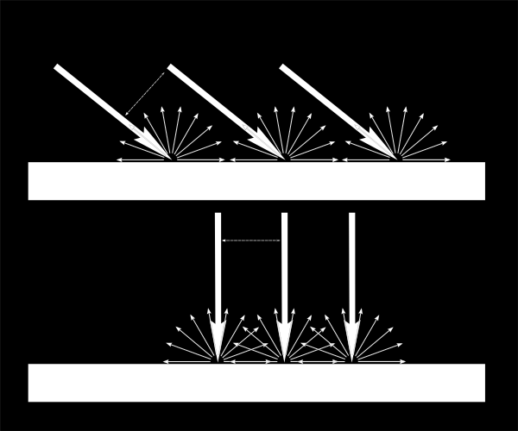

This means that each point of the surface will look darker with gazing light (but remember, more points will be illuminated, so the total quantity of light will remain the same )

This means that when we compute the colour of a pixel, the angle between the incoming light and the surface normal matters. We thus have :

*// Cosine of the angle between the normal and the light direction,*

*// clamped above 0*

*// - light is at the vertical of the triangle -> 1*

*// - light is perpendicular to the triangle -> 0*

**float** cosTheta **=** dot( n,l );

color **=** LightColor **\*** cosTheta;

*// intbu better this mathematics //*

In this code, n is the surface normal and l is the unit vector that goes from the surface to the light (and not the contrary, even if it’s non inuitive. It makes the math easier). *// I understood that color is much brighter when light is perpendicular (cos = 1) and it is absolutely dark (0,0,0) when light is absolutely touching the surface (cos = 0). But why cos is right function? //*

#### Beware of the sign

Something is missing in the formula of our cosTheta. If the light is behind the triangle, n and l will be opposed, so n.l will be negative. This would mean that colour = someNegativeNumber, which doesn’t mean much. So we have to clamp cosTheta to 0 : *// possibility of logically stupid result. This is difference between reflection of physics on mathematics //*

*// Cosine of the angle between the normal and the light direction,*

*// clamped above 0*

*// - light is at the vertical of the triangle -> 1*

*// - light is perpendicular to the triangle -> 0*

*// - light is behind the triangle -> 0*

**float** cosTheta **=** clamp( dot( n,l ), 0,1 );

color **=** LightColor **\*** cosTheta;

## Material Color

Of course, the output colour also depends on the colour of the material. In this image, the white light is made out of green, red and blue light. When colliding with the red material, green and blue light is absorbed, and only the red remains. *// peculiarities of optics. Physical aspects of color //*

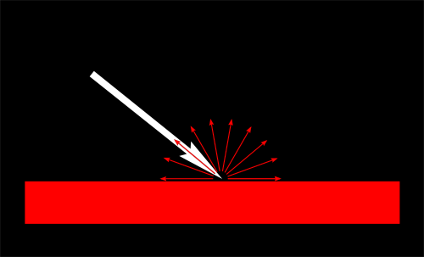

We can model this by a simple multiplication : *// intbu better why? Examples are interesting. //*

color **=** MaterialDiffuseColor **\*** LightColor **\*** cosTheta;

## Modeling the light

We will first assume that we have a punctual light that emits in all directions in space, like a candle.

With such a light, the luminous flux that our surface will receive will depend on its distance to the light source: the further away, the less light. In fact, the amount of light will diminish with the square of the distance : *// aspects of optics //*

color **=** MaterialDiffuseColor **\*** LightColor **\*** cosTheta **/** (distance**\***distance); *// intbu better adequacy of chosen syntax //*

Lastly, we need another parameter to control the power of the light. This could be encoded into LightColor (and we will in a later tutorial), but for now let’s just have a color (e.g. white) and a power (e.g. 60 Watts).

color **=** MaterialDiffuseColor **\*** LightColor **\*** LightPower **\*** cosTheta **/** (distance**\***distance);

## Putting it all together

For this code to work, we need a handful of parameters (the various colours and powers) and some more code.

MaterialDiffuseColor is simply fetched from the texture.

LightColor and LightPower are set in the shader through GLSL uniforms.

cosTheta depends on n and l. We can express them in any space provided it’s the same for both. We choose the camera space because it’s easy to compute the light’s position in this space : *// intbu better advantage of this. Remind conception of camera space //*

*// Normal of the computed fragment, in camera space*

**vec3** n **=** normalize( Normal\_cameraspace ); *// we calculate n-vector in camera space. Where camera position is (0,0,0)??? //*

*// Direction of the light (from the fragment to the light)*

**vec3** l **=** normalize( LightDirection\_cameraspace);

with Normal\_cameraspace and LightDirection\_cameraspace computed in the Vertex shader and passed to the fragment shader :

*// Output position of the vertex, in clip space : MVP \* position*

gl\_Position **=** MVP **\*** **vec4**(vertexPosition\_modelspace,1);

*// Position of the vertex, in worldspace : M \* position*

Position\_worldspace **=** (M **\*** **vec4**(vertexPosition\_modelspace,1)).xyz;

*// Vector that goes from the vertex to the camera, in camera space.*

*// In camera space, the camera is at the origin (0,0,0). // camera space definition //*

**vec3** vertexPosition\_cameraspace **=** ( V **\*** M **\*** **vec4**(vertexPosition\_modelspace,1)).xyz;

EyeDirection\_cameraspace **=** **vec3**(0,0,0) **-** vertexPosition\_cameraspace;

*// Vector that goes from the vertex to the light, in camera space. M is ommited because it's identity // why? //.*

**vec3** LightPosition\_cameraspace **=** ( V **\*** **vec4**(LightPosition\_worldspace,1)).xyz;

LightDirection\_cameraspace **=** LightPosition\_cameraspace **+** EyeDirection\_cameraspace;

*// Normal of the the vertex, in camera space*

Normal\_cameraspace **=** ( V **\*** M **\*** **vec4**(vertexNormal\_modelspace,0)).xyz; *// Only correct if ModelMatrix does not scale the model ! Use its inverse transpose if not.*

This code can seem impressive but it’s nothing we didn’t learn in Tutorial 3 : Matrices. I paid attention to write the name of the space in each vector’s name, so that keeping track of what is happening is much easier. **You should do that, too.** *// code style recommendation //*

M and V are the Model and View matrices, which are passed to the shader in the exact same way as MVP. *// matrices kinds. Remind and to better understand //*

## Time for work

You’ve got everything you need to code a diffuse lighting. Go ahead, and learn the hard way :) *// learner orientation //*

## Result

With only the Diffuse component, we have the following result (sorry for the lame texture again) :

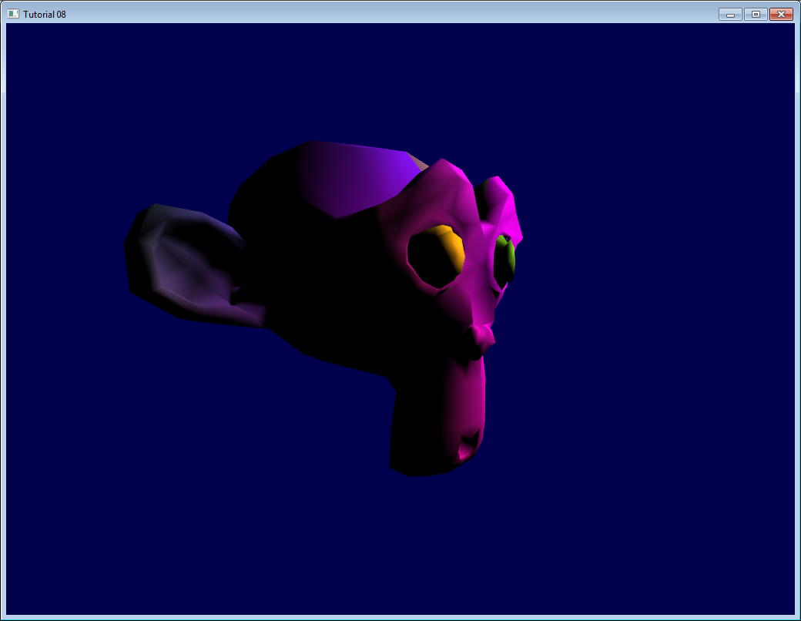

It’s better than before, but there is still much missing. In particular, the back of Suzanne is completely black since we used clamp().

## The Ambient component

The Ambient component is the biggest cheat ever.

We expect the back of Suzanne to be receive more light because in real life, the lamp would light the wall behind it, which would in turn (slightly less) light the back of the object. *// сцяна за малпачкай падсвечваецца, як кажуць у дадзеным цьютарале. І, як я разумею, гэта і збіраюцца сімуліраваць у дадзеным кодзе //*

This is awfully expensive to compute. *// agree. To compute these optical effects directly is very expensive operation. //*

So the usual hack is to simply fake some light. In fact, is simply makes the 3D model \*emit \*light so that it doesn’t appear completely black.

This can be done this way:

**vec3** MaterialAmbientColor **=** **vec3**(0.1,0.1,0.1) **\*** MaterialDiffuseColor;

color **=**

*// Ambient : simulates indirect lighting // purpose of ambient //*

MaterialAmbientColor **+**

*// Diffuse : "color" of the object*

MaterialDiffuseColor **\*** LightColor **\*** LightPower **\*** cosTheta **/** (distance**\***distance) ; *// we add some some member which models ambient light from wall //*

Let’s see what it gives

## Results

Ok so that’s a little bit better. You can adjust the (0.1, 0.1, 0.1) if you want better results. *// падгонка ў мадэліраванні графіцы //*

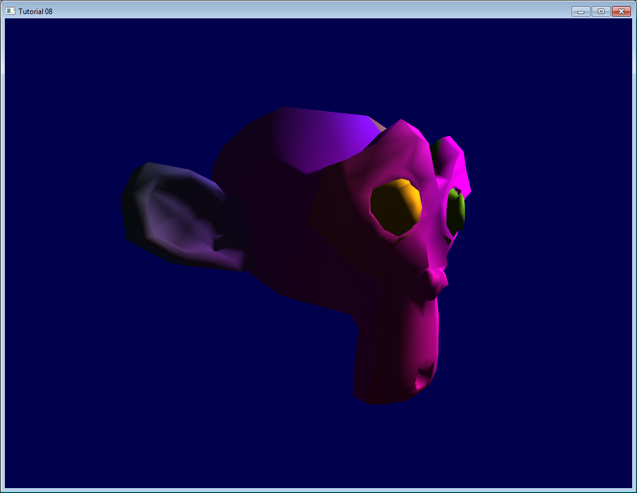

## The Specular component

The other part of light that is reflected is reflected mostly in the direction that is the reflection of the light on the surface. This is the specular component. *// аспекты оптыцы //*

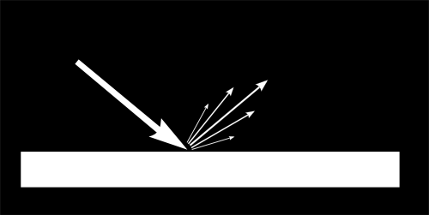

As you can see in the image, it forms a kind of lobe. In extreme cases, the diffuse component can be null, the lobe can be very very very narrow (all the light is reflected in a single direction) and you get a mirror. *// люстэрка з пункту гледжання оптыцы //*

(*we can indeed tweak the parameters to get a mirror, but in our case, the only thing we take into account in this mirror is the lamp. So this would make for a weird mirror)*

*// Eye vector (towards the camera)*

**vec3** E **=** normalize(EyeDirection\_cameraspace);

*// Direction in which the triangle reflects the light*

**vec3** R **=** reflect(**-**l,n);

*// Cosine of the angle between the Eye vector and the Reflect vector,*

*// clamped to 0*

*// - Looking into the reflection -> 1*

*// - Looking elsewhere -> < 1*

**float** cosAlpha **=** clamp( dot( E,R ), 0,1 );

color **=**

*// Ambient : simulates indirect lighting*

MaterialAmbientColor **+**

*// Diffuse : "color" of the object*

MaterialDiffuseColor **\*** LightColor **\*** LightPower **\*** cosTheta **/** (distance**\***distance) ;

*// Specular : reflective highlight, like a mirror*

MaterialSpecularColor **\*** LightColor **\*** LightPower **\*** pow(cosAlpha,5) **/** (distance**\***distance);

*// intbu better. Асабліва адкуль косінус узяўся ў пятай ступені //*

R is the direction in which the light reflects. E is the inverse direction of the eye (just like we did for “l”); If the angle between these two is little, it means we are looking straight into the reflection. *// вось чаму пятая ступеня. Пры аддаленні ад гэтага вугла ўплыў спекьюлярнага складніка святла радыкальна змяншаецца //*

pow(cosAlpha,5) is used to control the width of the specular lobe. Increase 5 to get a thinner lobe. *// гэта падгоначны параметр //*

## Final result

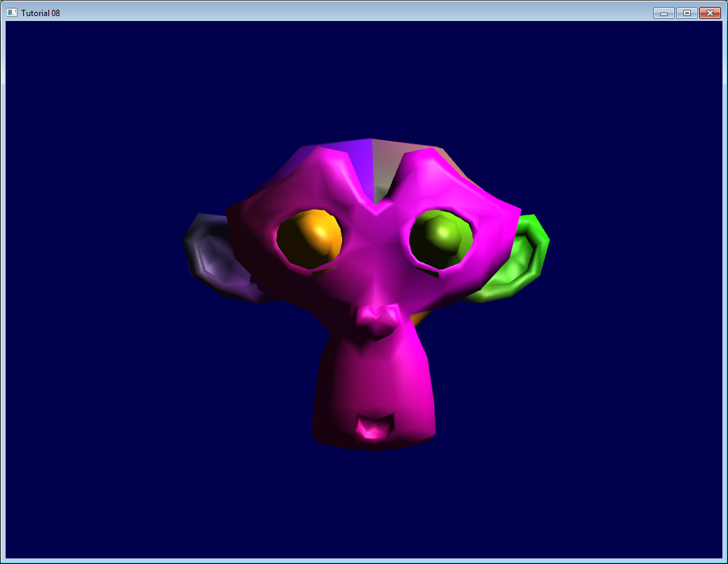

Notice the specular highlights on the nose and on the eyebrows.

This shading model has been used for years due to its simplicity. It has a number of problems, so it is replaced by physically-based models like the microfacet BRDF, but we will see this later. *// гісторыя і стан тэмы //*

In the next tutorial, we’ll learn how to improve the performance of your VBO. This will be the first Intermediate tutorial !

03.07.2017

<http://www.opengl-tutorial.org/intermediate-tutorials/tutorial-9-vbo-indexing/>

# *Tutorial 9 : VBO Indexing*

## *The principle of indexing*

*Until now, when building your VBO // тыповая задача пры рабоце з OpenGL //, we always duplicated our vertices whenever two triangles shared an edge.*

*In this tutorial, we introduce indexing, which enables to reuse the same vertex over and over again. This is done with an index buffer. // purpose of this important concept in OpenGL //*

*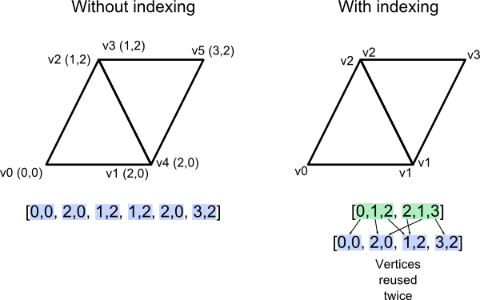*

*// graphical explanation what is indexing //*

*The index buffer contains integers, three for each triangle in the mesh, which reference the various attribute buffers (position, colour, UV coordinates, other UV coordinates, normal, …). It’s a little bit like in the OBJ file format, with one huge difference : there is only ONE index buffer. This means that for a vertex to be shared between two triangles, all attributes must be the same. // OpenGL requirenment //*

## *Shared vs Separate*

*Let’s take the example of the normals. In this figure, the artist who created these two triangle probably wanted them to represent a smooth surface. We can thus blend the normals of the two triangle into a single vertex normal. For visualization purposes, I added a red line which represents the aspect of the smooth surface.*

*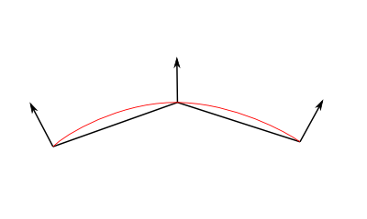*

*In this second figure however, the artist visibly wanted a “seam”, a rough edge. But if we merge the normals, this means that the shader will smoothly interpolate as usual and create a smooth aspect just like before : // example of smoothing concept //*

*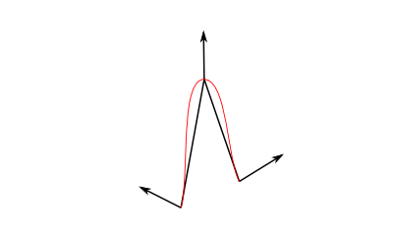*

*So in this case it’s actually better to have two different normals, one for each vertex. The only way to do this in OpenGL is to duplicate the whole vertex, with its whole set of attributes. // for rough surface it is necessary to duplicate attributes? Intbu. //*

*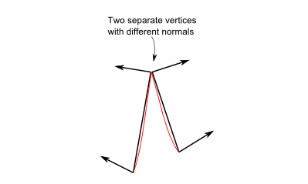*

## *Indexed VBO in OpenGL*

*Using indexing is very simple. First, you need to create an additional buffer, which you fill with the right indices. The code is the same as before, but now it’s an ELEMENT\_ARRAY\_BUFFER, not an ARRAY\_BUFFER.*

*std****::****vector****<unsigned******int>*** *indices;*

*// fill "indices" as needed*

*// Generate a buffer for the indices*

*GLuint elementbuffer;*

*glGenBuffers(1,* ***&****elementbuffer);*

*glBindBuffer(GL\_ELEMENT\_ARRAY\_BUFFER, elementbuffer);*

*glBufferData(GL\_ELEMENT\_ARRAY\_BUFFER, indices.size()* ***\*******sizeof****(****unsigned******int****),* ***&****indices[0], GL\_STATIC\_DRAW);*

*and to draw the mesh, simply replace glDrawArrays by this :*

*// Index buffer*

*glBindBuffer(GL\_ELEMENT\_ARRAY\_BUFFER, elementbuffer);*

*// Draw the triangles !*

*glDrawElements(*

*GL\_TRIANGLES, // mode*

*indices.size(), // count*

*GL\_UNSIGNED\_INT, // type*

*(****void\*****)0 // element array buffer offset*

*);*

*(quick note : it’s better to use “unsigned short” than “unsigned int”, because it takes less memory, which also makes it faster) // recommendation //*

### *Filling the index buffer*

*Now we actually have a problem. As I said before, OpenGL can only use one index buffer, whereas OBJ (and some other popular 3D formats like Collada) use one index buffer by attribute. Which means that we somehow have to convert from N index buffers to 1 index buffer.*

*The algorithm to do this is as follows :*

*For each input vertex*

*Try to find a similar ( = same for all attributes ) vertex between all those we already output*

*If found :*

*A similar vertex is already in the VBO, use it instead !*

*If not found :*

*No similar vertex found, add it to the VBO*

*// псеўдакод алгарытма //*

*The actual C++ code can be found in common/vboindexer.cpp. It’s heavily commented so if you understand the algorithm above, it should be all right. // патэрн навучання. Даследваць. //*

*The criterion for similarity is that vertices’ position, UVs and normals should be \*\* equal. You’ll have to adapt this if you add more attributes.*

*Searching a similar vertex is done with a lame linear search for simplicity. A std::map would be more appropriate for real use.*

## *Extra : the FPS counter*

*It’s not directly related to indexing, but it’s a good moment to have a look at*[*the FPS counter*](http://www.opengl-tutorial.org/miscellaneous/an-fps-counter/)*because we can eventually see the speed improvement of indexing. Other performance tools are available in*[*Tools - Debuggers*](http://www.opengl-tutorial.org/miscellaneous/useful-tools-links/#debugging-tools)*.*

[*http://www.opengl-tutorial.org/miscellaneous/an-fps-counter/*](http://www.opengl-tutorial.org/miscellaneous/an-fps-counter/)

### *An FPS counter*

*In real-time graphics, it is important to keep an eye on performance. A good practice is to choose a target FPS ( usually 60 or 30 ) and make everything possible to stick to it. // асаблівасці графічнага праграміравання //*

*A FPS counter looks like this :*

***double*** *lastTime* ***=*** *glfwGetTime();*

***int*** *nbFrames* ***=*** *0;*

***do****{*

*// Measure speed*

***double*** *currentTime* ***=*** *glfwGetTime();*

*nbFrames****++****;*

***if*** *( currentTime* ***-*** *lastTime* ***>=*** *1.0 ){ // If last prinf() was more than 1 sec ago*

*// printf and reset timer*

*printf("%f ms/frame\n", 1000.0****/double****(nbFrames));*

*nbFrames* ***=*** *0;*

*lastTime* ***+=*** *1.0;*

*}*

*// цудоўны спосаб вымяраць колькасць фрэймаў у секунду //*

*... rest of the main loop*

*There is an odd thing in this code. It displays the time, in milliseconds, needed to draw a frame (averaged on 1 second) instead of how many frame were drawn in the last second.*

*This is actually****much better****. Don’t rely on FPS. Never. FramesPerSecond = 1/SecondsPerFrame, so this is an inverse relationship, and we humans suck at understanding this kind of relationship. Let’s take an example.*

*You write a great rendering function that runs at 1000 FPS ( 1ms/frame ). But you forgot a little computation in a shader, which adds an extra cost of 0.1ms. And bam, 1/0.0011 = 900. You just lost 100FPS. Morality :****never use FPS for performance analysis.*** *// зразумела, бо гэта велічыня можа ўводзіць у засмучэнне, бо яна дужа скочыць пры невялікіх зменах //*

*If you intend to make a 60fps game, your target will be 16.6666ms ; If you intend to make a 30fps game, your target will be 33.3333ms. That’s all you need to know. // мера эфектыўнасці графічнай работы. А ў qml гэта можна вымяраць? //*

*This code is available in all tutorials starting from*[*Tutorial 9 : VBO indexing*](http://www.opengl-tutorial.org/intermediate-tutorials/tutorial-9-vbo-indexing/)*; see*[*tutorial09\_vbo\_indexing/tutorial09.cpp*](https://github.com/opengl-tutorials/ogl/blob/master/tutorial09_vbo_indexing/tutorial09.cpp#L142)*. Other performance tools are available in*[*Tools - Debuggers*](http://www.opengl-tutorial.org/miscellaneous/useful-tools-links/#debugging-tools)*.*

[*http://www.opengl-tutorial.org/intermediate-tutorials/tutorial-10-transparency/*](http://www.opengl-tutorial.org/intermediate-tutorials/tutorial-10-transparency/)

# *Tutorial 10 : Transparency*

## *The alpha channel*

*The concept of the alpha channel is pretty simple. Instead of a writing an RGB result, you write an RGBA :*

*// Ouput data : it's now a vec4*

***out******vec4*** *color;*

*the first 3 components are still accessed with the .xyz swizzle operator, while the last one is accessed with .a :*

*color.a* ***=*** *0.3;*

*Unintuitively, alpha = opaqueness, so alpha = 1 means fully opaque while alpha = 0 means fully transparent.*

*Here, we simply hardcode the alpha channel at 0.3, but you probably want to use a uniform, or read it from a RGBA texture ( TGA supports the alpha channel, and GLFW supports TGA )*

*Here’s the result. Make sure to turn backface culling off (glDisable(GL\_CULL\_FACE) ) because since we can look through the mesh, we could see that it has no “back” face.*

*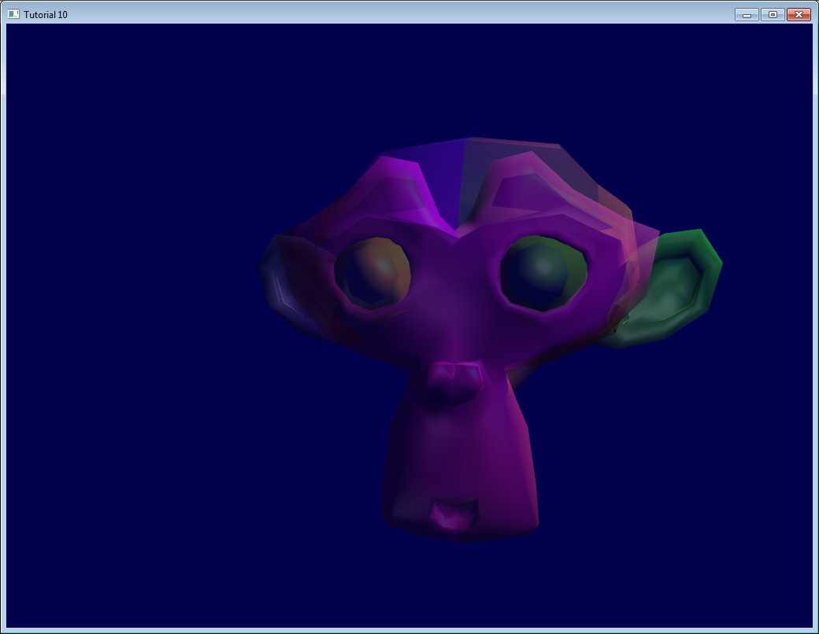*

*Order matters !*

*The previous screenshot looks okay-ish, but that’s just because we’re lucky.*

## *The problem*

*Here, I drew two squares with 50% alpha, one green and one red. You can see that order is important, the final colour gives an important clue to the eyes for proper depth perception.*

*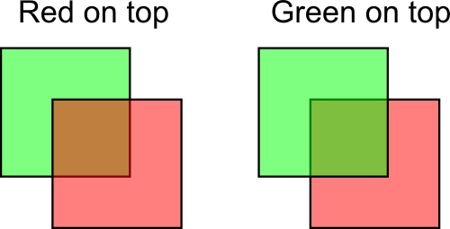*

*This phenomena also happens in our scene. Let’s change the viewpoint a bit :*

*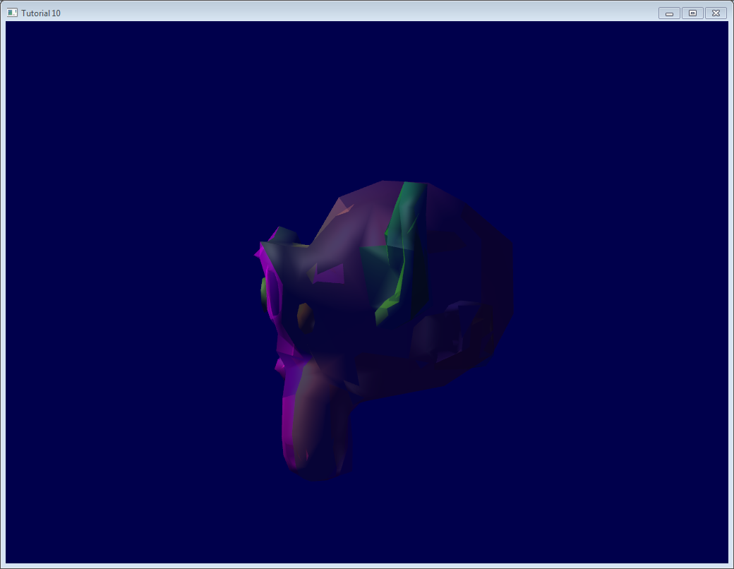*

*It turns out that this is a very hard problem. You never see lots of transparency in games, do you ?*

## *Usual solution*

*The usual solution is to sort all transparent triangles. Yes, ALL transparent triangles.*

* *Draw the opaque part of the world so that the depth buffer already can reject hidden transparent triangles*
* *Sort transparent triangles, from the furthest to the closest*
* *Draw the transparent triangles.*

*You can sort whatever you want with qsort (in C) or std::sort (in C++). I won’t dig in the details, because…*

### *Caveat*

*Doing so will work ( more on this in the next section ), but : // графавая структура кнігі //*

* *You will be fillrate limited. That is, each fragment will be written 10, 20 times, maybe more. This is way too much for the poor memory bus. Usually the depth buffer allows to reject enough “far” fragments, but here, you explicitly sorted them, so the depth buffer is actually useless.*
* *You will be doing this 4 times per pixel ( we use 4xMSAA ), except if you use some clever optimization // чаму па чатыры разы??? Лепей зразумець… //*
* *Sorting all the transparent triangles takes time*
* *If you have to switch your texture, or worse, your shader, from triangle to triangle, you’re going into deep performance trouble. Don’t do this. // intbu what does this mean??? //*

*A good enough solution is often to :*

* *Limit to a maximum the number of transparent polygons*
* *Use the same shader and the same texture for all of them*
* *If they are supposed to look very different, use your texture !*
* *If you can avoid sorting, and it still doesn’t look \*too \*bad, consider yourself lucky. // intbu better //*

## *Order-Independent Transparency*

*A number of other techniques are worth investigating if your engine really, really needs state-of-the-art transparency : // кантэкст выкарысання іншых тэхнік забеспячэння празрыстасці //*

* [*The original 2001 Depth Peeling paper*](http://citeseerx.ist.psu.edu/viewdoc/download?doi=10.1.1.18.9286&rep=rep1&type=pdf)*: pixel-perfect results, not very fast.*
* [*Dual Depth Peeling*](http://developer.download.nvidia.com/SDK/10/opengl/src/dual_depth_peeling/doc/DualDepthPeeling.pdf)*: a slight improvement*
* *Several papers on bucket sort. Uses an array of fragments; sort them by depth in a shader.*
* [*ATI’s Mecha Demo*](http://fr.slideshare.net/hgruen/oit-and-indirect-illumination-using-dx11-linked-lists)*: good and fast, but tricky to implement, needs recent hardware. Uses a linked list of fragments.*
* [*Cyril Crassin’s variation on the ATI’s technique*](http://blog.icare3d.org/2010/07/opengl-40-abuffer-v20-linked-lists-of.html)*: even harder implementation*

*Note that even a recent game like Little Big Planet, which ran on a powerful console, used only 1 layer of transparency. // intbu what is one layer of transparency? //*

## *The blend function*

*In order for the previous code to work, you need to setup your blend function.*

*// Enable blending*

*glEnable(GL\_BLEND);*

*glBlendFunc(GL\_SRC\_ALPHA, GL\_ONE\_MINUS\_SRC\_ALPHA);*

*Which means :*

*New color in framebuffer =*

*current alpha in framebuffer \* current color in framebuffer +*

*(1 - current alpha in framebuffer) \* shader's output color*

*// лепей зразумець тэарэтычнае абгрунтаванне гэтага алгарытма //*

*Example from the image above, with red on top :*

***new*** *color* ***=*** *0.5****\*****(0,1,0)* ***+*** *(1****-****0.5)****\*****(1,0.5,0.5); // (the red was already blended with the white background)*

***new*** *color* ***=*** *(1, 0.75, 0.25)* ***=*** *the same orange*

[*http://www.opengl-tutorial.org/intermediate-tutorials/tutorial-11-2d-text/*](http://www.opengl-tutorial.org/intermediate-tutorials/tutorial-11-2d-text/)

# *Tutorial 11 : 2D text*

*In this tutorial, we’ll learn to draw 2D text on top of our 3D content. In our case, this will be a simple timer :*

*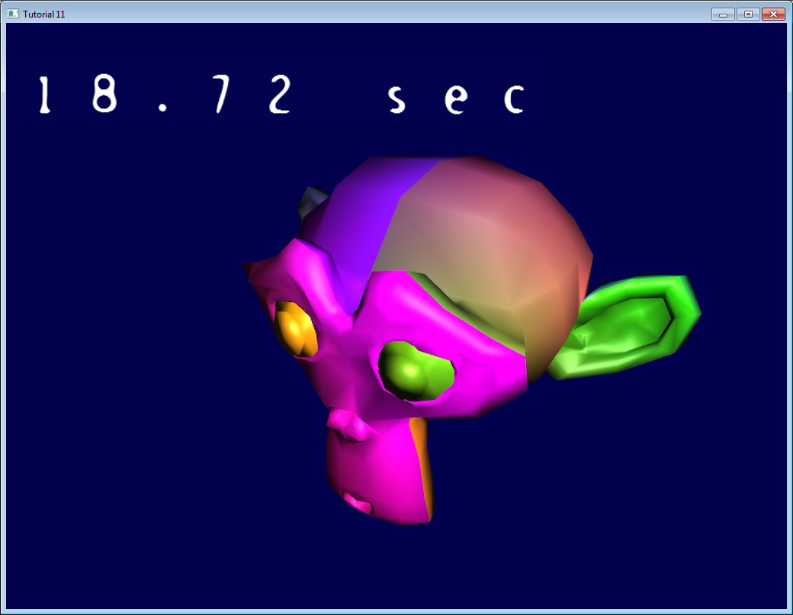*

## *The API*

*We’re going to implement this simple interface (in common/text2D.h):*

***void*** *initText2D(****const******char******\**** *texturePath);*

***void*** *printText2D(****const******char******\**** *text,* ***int*** *x,* ***int*** *y,* ***int*** *size);*

***void*** *cleanupText2D();*

*In order for the code to work at both 640\*480 and 1080p, x and y will be coordinates in [0-800][0-600]. The vertex shader will adapt this to the actual size of the screen.*

*See common/text2D.cpp for the complete implementation.*

## *The texture*

*initText2D simply reads a texture and a couple of shaders. There’s nothing fancy about it, but let’s look at the texture :*

*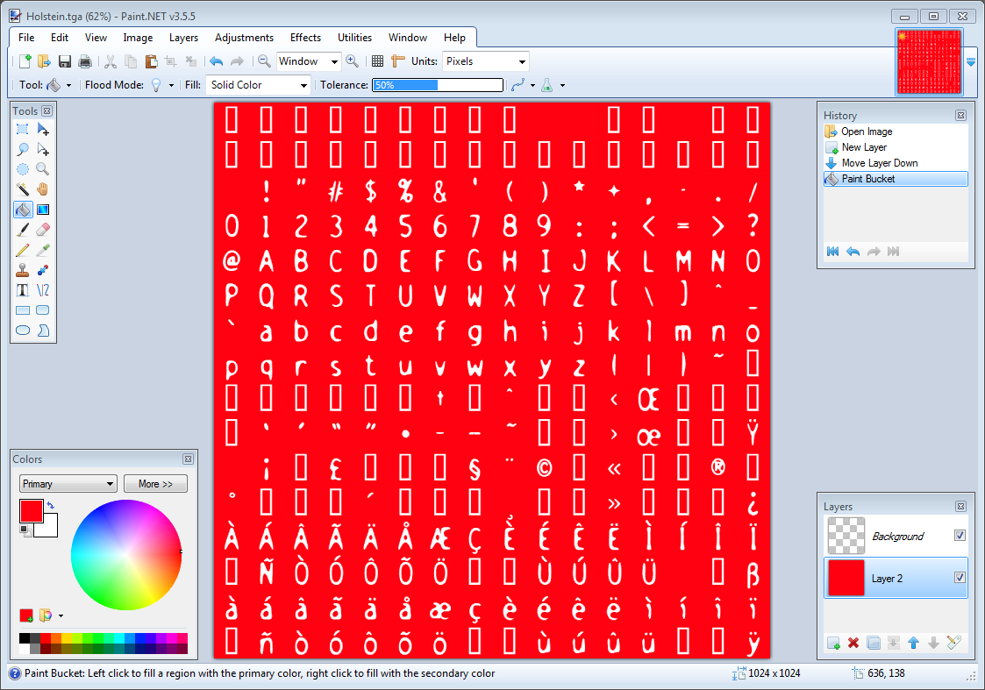*

*This texture was generated using*[*CBFG*](http://www.codehead.co.uk/cbfg/)*, one of the many tools that generate textures from fonts. If was then imported in Paint.NET where I added a red background (for visualisation purposes only : everywhere you see red, it’s supposed to be transparent ).*

*The goal of printText2D will thus be to generate quads with the appropriate screen position and texture coordinates.*

## *Drawing*

*We have to fill these buffers :*

*std****::****vector****<****glm****::****vec2****>*** *vertices;*

*std****::****vector****<****glm****::****vec2****>*** *UVs;*

*For each character, we compute the coordinates of the four vertices that will define the quad, and add the two triangles :*

***for*** *(* ***unsigned******int*** *i****=****0 ; i****<****length ; i****++*** *){*

*glm****::****vec2 vertex\_up\_left* ***=*** *glm****::****vec2( x****+****i****\*****size , y****+****size );*

*glm****::****vec2 vertex\_up\_right* ***=*** *glm****::****vec2( x****+****i****\*****size****+****size, y****+****size );*

*glm****::****vec2 vertex\_down\_right* ***=*** *glm****::****vec2( x****+****i****\*****size****+****size, y );*

*glm****::****vec2 vertex\_down\_left* ***=*** *glm****::****vec2( x****+****i****\*****size , y );*

*vertices.push\_back(vertex\_up\_left );*

*vertices.push\_back(vertex\_down\_left );*

*vertices.push\_back(vertex\_up\_right );*

*vertices.push\_back(vertex\_down\_right);*

*vertices.push\_back(vertex\_up\_right);*

*vertices.push\_back(vertex\_down\_left);*

*Now for the UVs. The upper-left coordinate is computed as follows :*

***char*** *character* ***=*** *text[i];*

***float*** *uv\_x* ***=*** *(character****%****16)****/****16.0f;*

***float*** *uv\_y* ***=*** *(character****/****16)****/****16.0f;*

*This works ( sort of - see below ) because the*[*ASCII code for A*](http://www.asciitable.com/)*is 65.*

*65%16 = 1, so A is on column #1 (starts at 0 !).*

*65/16 = 4, so A is on line #4 ( it’s integer division, so it’s not 4.0625 as it should be)*

*Both are divided by 16.0 to fit in the [0.0 - 1.0] range needed by OpenGL textures.*

*And now we just have to do the very same thing than we did, but for the vertices :*

*glm****::****vec2 uv\_up\_left* ***=*** *glm****::****vec2( uv\_x , 1.0f* ***-*** *uv\_y );*

*glm****::****vec2 uv\_up\_right* ***=*** *glm****::****vec2( uv\_x****+****1.0f****/****16.0f, 1.0f* ***-*** *uv\_y );*

*glm****::****vec2 uv\_down\_right* ***=*** *glm****::****vec2( uv\_x****+****1.0f****/****16.0f, 1.0f* ***-*** *(uv\_y* ***+*** *1.0f****/****16.0f) );*

*glm****::****vec2 uv\_down\_left* ***=*** *glm****::****vec2( uv\_x , 1.0f* ***-*** *(uv\_y* ***+*** *1.0f****/****16.0f) );*

*UVs.push\_back(uv\_up\_left );*

*UVs.push\_back(uv\_down\_left );*

*UVs.push\_back(uv\_up\_right );*

*UVs.push\_back(uv\_down\_right);*

*UVs.push\_back(uv\_up\_right);*

*UVs.push\_back(uv\_down\_left);*

*}*

*The rest is just as usual : bind the buffers, fill them, select the shader program, bind the texture, enable/bind/configure the vertex attributes, enable the blending, and call glDrawArrays. Hooray ! You’re done.*

*Note a very important thing : the coordinates are generated in the [0,800][0,600] range. In other words, there is NO NEED for a matrix here. The vertex shader simply has to put it in the [-1,1][-1,1] range with very simple math (this could be done in C++ too) :*

***void*** *main(){*

*// Output position of the vertex, in clip space*

*// map [0..800][0..600] to [-1..1][-1..1]*

***vec2*** *vertexPosition\_homoneneousspace* ***=*** *vertexPosition\_screenspace* ***-******vec2****(400,300); // [0..800][0..600] -> [-400..400][-300..300]*

*vertexPosition\_homoneneousspace* ***/=******vec2****(400,300);*

*gl\_Position* ***=******vec4****(vertexPosition\_homoneneousspace,0,1);*

*// UV of the vertex. No special space for this one.*

*UV* ***=*** *vertexUV;*

*}*

*The fragment shader does very little too :*

***void*** *main(){*

*color* ***=*** *texture( myTextureSampler, UV );*

*}*

*By the way, don’t use this code for production, since it only handles the Latin alphabet. Or don’t sell anything to India, China, Japan ( or even Germany, since there is no ß on this image ). This texture will mostly work in France (notice the é, à, ç, etc) because it’s been generated with my locale. And beware while adapting code from other tutorials of when using libraries, most of them use OpenGL 2, which isn’t compatible. Unfortunately I don’t know any good-enough library which handles UTF-8. // state of field. Book recommendation //*

*By the way, you should read*[*The Absolute Minimum Every Software Developer Absolutely, Positively Must Know About Unicode and Character Sets (No Excuses!)*](http://www.joelonsoftware.com/articles/Unicode.html)*by Joel Spolsky.*

*See also*[*this Valve article*](http://www.valvesoftware.com/publications/2007/SIGGRAPH2007_AlphaTestedMagnification.pdf)*if you need large text.*

[*https://www.joelonsoftware.com/2003/10/08/the-absolute-minimum-every-software-developer-absolutely-positively-must-know-about-unicode-and-character-sets-no-excuses/*](https://www.joelonsoftware.com/2003/10/08/the-absolute-minimum-every-software-developer-absolutely-positively-must-know-about-unicode-and-character-sets-no-excuses/)

[*http://www.valvesoftware.com/publications/2007/SIGGRAPH2007\_AlphaTestedMagnification.pdf*](http://www.valvesoftware.com/publications/2007/SIGGRAPH2007_AlphaTestedMagnification.pdf)

[*http://www.opengl-tutorial.org/intermediate-tutorials/tutorial-12-opengl-extensions/*](http://www.opengl-tutorial.org/intermediate-tutorials/tutorial-12-opengl-extensions/)

# *Tutorial 12 : OpenGL Extensions*

## *Extensions*

*With each new generation, the performance of GPU increases, allowing to render more triangles and more pixels. However, raw performance isn’t the only concern. NVIDIA, AMD and Intel also improve their graphic cards by providing more functionality. Let’s have a look at some examples.*

### *ARB\_fragment\_program*

*Back in 2002, GPUs had no vertex shaders or fragment shaders : everything was hardcoded inside the chip. This was called the Fixed-Function Pipeline (FFP). As such, the most recent version of the API, which was OpenGL 1.3, proposed no way to create, manipulate and use so-called “shaders”, since it didn’t even exist. But then NVIDIA decided that it could be handy to describe the rendering process with actual code, instead of hundreds of flags and state variables. This is how ARB\_fragment\_program was created : there was no GLSL, but instead you could write stuff like this :*

*!!ARBfp1.0 MOV result.color, fragment.color; END*

*But obviously to tell OpenGL to use such code, you needed special functions, which were not yet in OpenGL. Before moving on to the explanations, one more example.*

### *ARB\_debug\_output*

*Ok, you say, but this ARB\_fragment\_program is too old, surely I don’t need this extension stuff anymore? Well there are newer extensions which are very handy. One of them is ARB\_debug\_output, which expose a functionality that doesn’t exist in OpenGL 3.3 but that you can/should use anyway. It defines tokens like GL\_DEBUG\_OUTPUT\_SYNCHRONOUS\_ARB or GL\_DEBUG\_SEVERITY\_MEDIUM\_ARB, and functions like DebugMessageCallbackARB. The great thing about this extension is that whenever you write some incorrect code, for instance :*

*glEnable(GL\_TEXTURE); // Incorrect ! You probably meant GL\_TEXTURE\_2D !*

*you can have an error message and the exact location of the problem. Lessons learned :*

* *Extensions are still very useful, even in modern, 3.3 OpenGL*
* *Use ARB\_debug\_output ! See below for links.*

*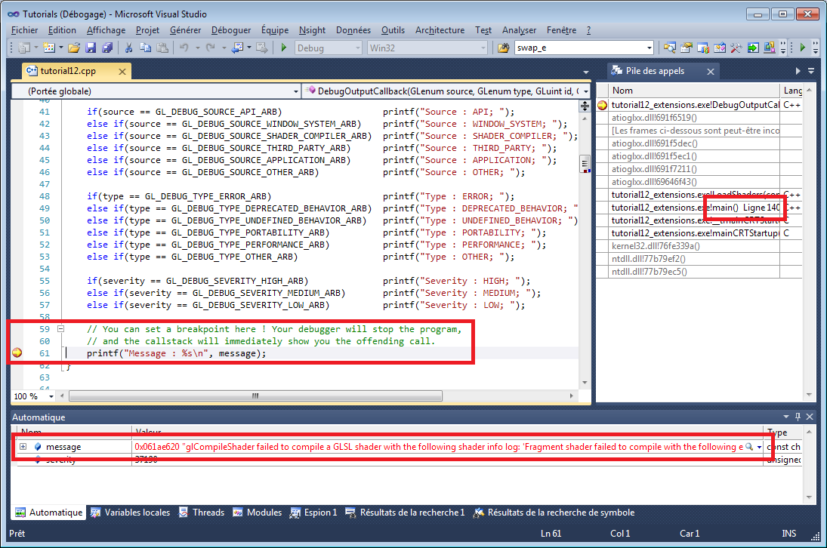*

### *Getting an extension - the hard way*

*The “manual” way for checking is an extension is present is to use this code snippet (from the*[*OpenGL.org wiki*](http://www.opengl.org/wiki/GlGetString)*) :*

***int*** *NumberOfExtensions;*

*glGetIntegerv(GL\_NUM\_EXTENSIONS,* ***&****NumberOfExtensions);*

***for****(i****=****0; i****<****NumberOfExtensions; i****++****) {*

***const*** *GLubyte* ***\*****ccc****=****glGetStringi(GL\_EXTENSIONS, i);*

***if*** *( strcmp(ccc, (****const*** *GLubyte* ***\*****)"GL\_ARB\_debug\_output")* ***==*** *0 ){*

*// The extension is supported by our hardware and driver*

*// Try to get the "glDebugMessageCallbackARB" function :*

*glDebugMessageCallbackARB* ***=*** *(PFNGLDEBUGMESSAGECALLBACKARBPROC) wglGetProcAddress("glDebugMessageCallbackARB");*

*}*

*}*

### *Getting all extensions - the easy way*

*All in all this is very complicated. Libraries like GLEW, GLee, gl3w, etc, make it much easier. For instance, with GLEW, you just have to call glewInit() after you created your window, and handy variables are created :*

***if*** *(GLEW\_ARB\_debug\_output){ // Ta-Dah ! }*

*( a word of caution : debug\_output is special because you have to enable it at context creation. In GLFW, this is done with glfwOpenWindowHint(GLFW\_OPENGL\_DEBUG\_CONTEXT, 1); )*

## *ARB vs EXT vs …*

*The name of each extention contains information on its availability :*

*GL\_ : all platforms; GLX\_ : Linux & Mac only (X11); WGL\_ : Windows only*

*EXT : A generic extention. ARB : the extention has been accepted by all the members of the OpenGL Architecture Review Board (EXT extentions are often promoted to ARB after a while). NV/AMD/INTEL : Quite self-explanatory =)*

## *Designing with Extentions*

### *The problem*

*Let’s say that your OpenGL 3.3 application needs to render some large lines. You could write a complicated vertex shader to do that, or simply rely on*[*GL\_NV\_path\_rendering*](http://www.opengl.org/registry/specs/NV/path_rendering.txt)*, which will handle all the complicated stuff for you.*

*You will thus have code that look like this :*

***if*** *( GLEW\_NV\_path\_rendering ){*

*glPathStringNV( ... ); // Draw the shape. Easy !*

*}****else****{*

*// Else what ? You still have to draw the lines*

*// on older NVIDIA hardware, on AMD and on INTEL !*

*// So you have to implement it yourself anyway !*

*}*

### *Choosing the limit*

*One usually choose to use an extention when the gain in rendering quality or performance outweights the pain of maintaining two different paths. // нюансы пашырэняў… даволі цікава… //*

*For instance, Braid (the 2D game where you travel in time) has all kinds of image-warping effects when you mess with the time, which simply aren’t rendered on older hardware.*

*With OpenGL 3.3 and above, you already have 99% of the tools you’re likely to need. Some extensions can be very useful, like GL\_AMD\_pinned\_memory, but this is often not like a few years ago when having GL\_ARB\_framebuffer\_object ( used for Render To Texture ) could make your game look 10 times better.*

*If you have to handle older hardware, though, OpenGL 3+ won’t be available, and you’ll have to use OpenGL 2+ instead. You won’t be able to assume that you have all the fancy extensions anymore, and you’ll need to cope with that.*

*For further details, see for instance the*[*OpenGL 2.1 version of Tutorial 14 - Render To Texture, line 167*](https://github.com/opengl-tutorials/ogl/blob/2.1_branch/tutorial14_render_to_texture/tutorial14.cpp#L167)*, where I have to check the presence of GL\_ARB\_framebuffer\_object by hand. See also the*[*FAQ*](http://www.opengl-tutorial.org/miscellaneous/faq/)*.*

## *Conclusion*

*OpenGL Extentions provide a nice way to extend OpenGL’s capabilities, depending on your user’s GPU.*

*While extentions are nowaday mostly for advanced use since most functionality is already in the core, it’s still important to know how they work and how you can use them to improve your software - at the expense of higher maintainance.*

## *Further reading*

* [*debug\_output tutorial by Aks*](http://sites.google.com/site/opengltutorialsbyaks/introduction-to-opengl-4-1---tutorial-05)*you can skip Step 1 thanks to GLEW.*
* [*The OpenGL extension registry*](http://www.opengl.org/registry/)*All extensions specifications. The bible.*
* [*GLEW*](http://glew.sourceforge.net/)*The OpenGL Extension Wrangler Library*
* [*gl3w*](https://github.com/skaslev/gl3w)*Simple OpenGL 3/4 core profile loading*

[*http://www.opengl-tutorial.org/intermediate-tutorials/tutorial-13-normal-mapping/*](http://www.opengl-tutorial.org/intermediate-tutorials/tutorial-13-normal-mapping/)

# *Tutorial 13 : Normal Mapping*

*Welcome for our 13th tutorial ! Today we will talk about normal mapping.*

*Since*[*Tutorial 8 : Basic shading*](http://www.opengl-tutorial.org/beginners-tutorials/tutorial-8-basic-shading/)*, you know how to get decent shading using triangle normals. One caveat is that until now, we only had one normal per vertex : inside each triangle, they vary smoothly, on the opposite to the colour, which samples a texture. The basic idea of normal mapping is to give normals similar variations. // каб можна было паказваць вельмі шарахаватыя паверхні? //*

### *Normal textures*

*A “normal texture” looks like this :*

*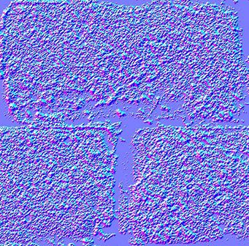*

*In each RGB texel is encoded a XYZ vector : each colour component is between 0 and 1, and each vector component is between -1 and 1, so this simple mapping goes from the texel to the normal :*

*normal* ***=*** *(2****\*****color)****-****1 // on each component*

*The texture has a general blue tone because overall, the normal is towards the “outside of the surface”. As usual, X is right in the plane of the texture, Y is up (again in the plane of the texture), thus given the right hand rule Z point to the “outside” of the plane of the texture.*

*This texture is mapped just like the diffuse one; The big problem is how to convert our normal, which is expressed in the space each individual triangle ( tangent space, also called image space), in model space (since this is what is used in our shading equation).*

## *Tangent and Bitangent*

*You are now so familiar with matrices that you know that in order to define a space (in our case, the tangent space), we need 3 vectors. We already have our UP vector : it’s the normal, given by Blender or computed from the triangle by a simple cross product. It’s represented in blue, just like the overall color of the normal map :*

*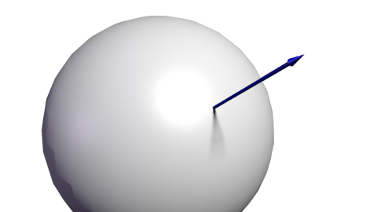*

*Next we need a tangent, T : a vector perpendicular (???) to the surface. But there are many such vectors :*

*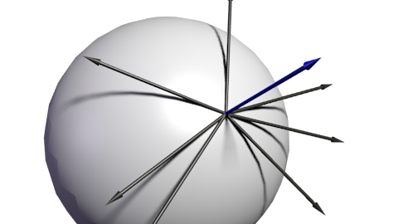*

*Which one should we choose ? In theory, any, but we have to be consistent with the neighbors to avoid introducing ugly edges. The standard method is to orient the tangent in the same direction that our texture coordinates :*

*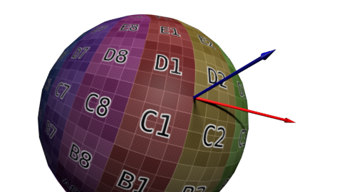*

*Since we need 3 vectors to define a basis, we must also compute the bitangent B (which is any other tangent vector, but if everything is perpendicular, math is simpler) :*

*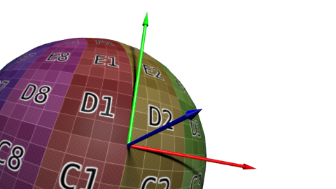*

*Here is the algorithm : if we note deltaPos1 and deltaPos2 two edges of our triangle, and deltaUV1 and deltaUV2 the corresponding differences in UVs, we can express our problem with the following equation :*

*deltaPos1* ***=*** *deltaUV1.x* ***\**** *T* ***+*** *deltaUV1.y* ***\**** *B*

*deltaPos2* ***=*** *deltaUV2.x* ***\**** *T* ***+*** *deltaUV2.y* ***\**** *B*

*Just solve this system for T and B, and you have your vectors ! (See code below)*

*Once we have our T, B, N vectors, we also have this nice matrix which enables us to go from Tangent Space to Model Space :*

*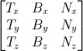*

*With this TBN matrix, we can transform normals (extracted from the texture) into model space. However, it’s usually done the other way around : transform everything from Model Space to Tangent Space, and keep the extracted normal as-is. All computations are done in Tangent Space, which doesn’t changes anything.*

*Do have this inverse transformation, we simply have to take the matrix inverse, which in this case (an orthogonal matrix, i.e each vector is perpendicular to the others. See “going further” below) is also its transpose, much cheaper to compute :*

*invTBN* ***=*** *transpose(TBN)*

*, i.e. : 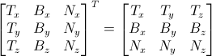*

## *Preparing our VBO*

### *Computing the tangents and bitangents*

*Since we need our tangents and bitangents on top of our normals, we have to compute them for the whole mesh. We’ll do this in a separate function :*

***void*** *computeTangentBasis(*

*// inputs*

*std****::****vector****<****glm****::****vec3****>******&*** *vertices,*

*std****::****vector****<****glm****::****vec2****>******&*** *uvs,*

*std****::****vector****<****glm****::****vec3****>******&*** *normals,*

*// outputs*

*std****::****vector****<****glm****::****vec3****>******&*** *tangents,*

*std****::****vector****<****glm****::****vec3****>******&*** *bitangents*

*){*

*For each triangle, we compute the edge (deltaPos) and the deltaUV*

***for*** *(* ***int*** *i****=****0; i****<****vertices.size(); i****+=****3){*

*// Shortcuts for vertices*

*glm****::****vec3* ***&*** *v0* ***=*** *vertices[i****+****0];*

*glm****::****vec3* ***&*** *v1* ***=*** *vertices[i****+****1];*

*glm****::****vec3* ***&*** *v2* ***=*** *vertices[i****+****2];*

*// Shortcuts for UVs*

*glm****::****vec2* ***&*** *uv0* ***=*** *uvs[i****+****0];*

*glm****::****vec2* ***&*** *uv1* ***=*** *uvs[i****+****1];*

*glm****::****vec2* ***&*** *uv2* ***=*** *uvs[i****+****2];*

*// Edges of the triangle : postion delta*

*glm****::****vec3 deltaPos1* ***=*** *v1****-****v0;*

*glm****::****vec3 deltaPos2* ***=*** *v2****-****v0;*

*// UV delta*

*glm****::****vec2 deltaUV1* ***=*** *uv1****-****uv0;*

*glm****::****vec2 deltaUV2* ***=*** *uv2****-****uv0;*

*We can now use our formula to compute the tangent and the bitangent :*

***float*** *r* ***=*** *1.0f* ***/*** *(deltaUV1.x* ***\**** *deltaUV2.y* ***-*** *deltaUV1.y* ***\**** *deltaUV2.x);*

*glm****::****vec3 tangent* ***=*** *(deltaPos1* ***\**** *deltaUV2.y* ***-*** *deltaPos2* ***\**** *deltaUV1.y)****\*****r;*

*glm****::****vec3 bitangent* ***=*** *(deltaPos2* ***\**** *deltaUV1.x* ***-*** *deltaPos1* ***\**** *deltaUV2.x)****\*****r;*

*Finally, we fill the \*tangents \*and \*bitangents \*buffers. Remember, these buffers are not indexed yet, so each vertex has its own copy.*

*// Set the same tangent for all three vertices of the triangle.*

*// They will be merged later, in vboindexer.cpp*

*tangents.push\_back(tangent);*

*tangents.push\_back(tangent);*

*tangents.push\_back(tangent);*

*// Same thing for binormals*

*bitangents.push\_back(bitangent);*

*bitangents.push\_back(bitangent);*

*bitangents.push\_back(bitangent);*

*}*

### *Indexing*

*Indexing our VBO is very similar to what we used to do, but there is a subtle difference.*

*If we find a similar vertex (same position, same normal, same texture coordinates), we don’t want to use its tangent and binormal too ; on the contrary, we want to average them. So let’s modify our old code a bit :*

*// Try to find a similar vertex in out\_XXXX*

***unsigned******int*** *index;*

***bool*** *found* ***=*** *getSimilarVertexIndex(in\_vertices[i], in\_uvs[i], in\_normals[i], out\_vertices, out\_uvs, out\_normals, index);*

***if*** *( found ){ // A similar vertex is already in the VBO, use it instead !*

*out\_indices.push\_back( index );*

*// Average the tangents and the bitangents*

*out\_tangents[index]* ***+=*** *in\_tangents[i];*

*out\_bitangents[index]* ***+=*** *in\_bitangents[i];*

*}****else****{ // If not, it needs to be added in the output data.*

*// Do as usual*

*[...]*

*}*

*Note that we don’t normalize anything here. This is actually handy, because this way, small triangles, which have smaller tangent and bitangent vectors, will have a weaker effect on the final vectors than big triangles (which contribute more to the final shape).*

## *The shader*

### *Additional buffers & uniforms*

*We need two new buffers : one for the tangents, and one for the bitangents :*

*GLuint tangentbuffer;*

*glGenBuffers(1,* ***&****tangentbuffer);*

*glBindBuffer(GL\_ARRAY\_BUFFER, tangentbuffer);*

*glBufferData(GL\_ARRAY\_BUFFER, indexed\_tangents.size()* ***\*******sizeof****(glm****::****vec3),* ***&****indexed\_tangents[0], GL\_STATIC\_DRAW);*

*GLuint bitangentbuffer;*

*glGenBuffers(1,* ***&****bitangentbuffer);*

*glBindBuffer(GL\_ARRAY\_BUFFER, bitangentbuffer);*

*glBufferData(GL\_ARRAY\_BUFFER, indexed\_bitangents.size()* ***\*******sizeof****(glm****::****vec3),* ***&****indexed\_bitangents[0], GL\_STATIC\_DRAW);*

*We also need a new uniform for our new normal texture :*

*[...]*

*GLuint NormalTexture* ***=*** *loadTGA\_glfw("normal.tga");*

*[...]*

*GLuint NormalTextureID* ***=*** *glGetUniformLocation(programID, "NormalTextureSampler");*

*And one for the 3x3 ModelView matrix. This is strictly speaking not necessary, but it’s easier ; more about this later. We just need the 3x3 upper-left part because we will multiply directions, so we can drop the translation part.*

*GLuint ModelView3x3MatrixID* ***=*** *glGetUniformLocation(programID, "MV3x3");*

*So the full drawing code becomes :*

*// Clear the screen*

*glClear(GL\_COLOR\_BUFFER\_BIT* ***|*** *GL\_DEPTH\_BUFFER\_BIT);*

*// Use our shader*

*glUseProgram(programID);*

*// Compute the MVP matrix from keyboard and mouse input*

*computeMatricesFromInputs();*

*glm****::****mat4 ProjectionMatrix* ***=*** *getProjectionMatrix();*

*glm****::****mat4 ViewMatrix* ***=*** *getViewMatrix();*

*glm****::****mat4 ModelMatrix* ***=*** *glm****::****mat4(1.0);*

*glm****::****mat4 ModelViewMatrix* ***=*** *ViewMatrix* ***\**** *ModelMatrix;*

*glm****::****mat3 ModelView3x3Matrix* ***=*** *glm****::****mat3(ModelViewMatrix); // Take the upper-left part of ModelViewMatrix*

*glm****::****mat4 MVP* ***=*** *ProjectionMatrix* ***\**** *ViewMatrix* ***\**** *ModelMatrix;*

*// Send our transformation to the currently bound shader,*

*// in the "MVP" uniform*

*glUniformMatrix4fv(MatrixID, 1, GL\_FALSE,* ***&****MVP[0][0]);*

*glUniformMatrix4fv(ModelMatrixID, 1, GL\_FALSE,* ***&****ModelMatrix[0][0]);*

*glUniformMatrix4fv(ViewMatrixID, 1, GL\_FALSE,* ***&****ViewMatrix[0][0]);*

*glUniformMatrix4fv(ViewMatrixID, 1, GL\_FALSE,* ***&****ViewMatrix[0][0]);*

*glUniformMatrix3fv(ModelView3x3MatrixID, 1, GL\_FALSE,* ***&****ModelView3x3Matrix[0][0]);*

*glm****::****vec3 lightPos* ***=*** *glm****::****vec3(0,0,4);*

*glUniform3f(LightID, lightPos.x, lightPos.y, lightPos.z);*

*// Bind our diffuse texture in Texture Unit 0*

*glActiveTexture(GL\_TEXTURE0);*

*glBindTexture(GL\_TEXTURE\_2D, DiffuseTexture);*

*// Set our "DiffuseTextureSampler" sampler to user Texture Unit 0*

*glUniform1i(DiffuseTextureID, 0);*

*// Bind our normal texture in Texture Unit 1*

*glActiveTexture(GL\_TEXTURE1);*

*glBindTexture(GL\_TEXTURE\_2D, NormalTexture);*

*// Set our "Normal TextureSampler" sampler to user Texture Unit 0*

*glUniform1i(NormalTextureID, 1);*

*// 1rst attribute buffer : vertices*

*glEnableVertexAttribArray(0);*

*glBindBuffer(GL\_ARRAY\_BUFFER, vertexbuffer);*

*glVertexAttribPointer(*

*0, // attribute*

*3, // size*

*GL\_FLOAT, // type*

*GL\_FALSE, // normalized?*

*0, // stride*

*(****void\*****)0 // array buffer offset*

*);*

*// 2nd attribute buffer : UVs*

*glEnableVertexAttribArray(1);*

*glBindBuffer(GL\_ARRAY\_BUFFER, uvbuffer);*

*glVertexAttribPointer(*

*1, // attribute*

*2, // size*

*GL\_FLOAT, // type*

*GL\_FALSE, // normalized?*

*0, // stride*

*(****void\*****)0 // array buffer offset*

*);*

*// 3rd attribute buffer : normals*

*glEnableVertexAttribArray(2);*

*glBindBuffer(GL\_ARRAY\_BUFFER, normalbuffer);*

*glVertexAttribPointer(*

*2, // attribute*

*3, // size*

*GL\_FLOAT, // type*

*GL\_FALSE, // normalized?*

*0, // stride*

*(****void\*****)0 // array buffer offset*

*);*

*// 4th attribute buffer : tangents*

*glEnableVertexAttribArray(3);*

*glBindBuffer(GL\_ARRAY\_BUFFER, tangentbuffer);*

*glVertexAttribPointer(*

*3, // attribute*

*3, // size*

*GL\_FLOAT, // type*

*GL\_FALSE, // normalized?*

*0, // stride*

*(****void\*****)0 // array buffer offset*

*);*

*// 5th attribute buffer : bitangents*

*glEnableVertexAttribArray(4);*

*glBindBuffer(GL\_ARRAY\_BUFFER, bitangentbuffer);*

*glVertexAttribPointer(*

*4, // attribute*

*3, // size*

*GL\_FLOAT, // type*

*GL\_FALSE, // normalized?*

*0, // stride*

*(****void\*****)0 // array buffer offset*

*);*

*// Index buffer*

*glBindBuffer(GL\_ELEMENT\_ARRAY\_BUFFER, elementbuffer);*

*// Draw the triangles !*

*glDrawElements(*

*GL\_TRIANGLES, // mode*

*indices.size(), // count*

*GL\_UNSIGNED\_INT, // type*

*(****void\*****)0 // element array buffer offset*

*);*

*glDisableVertexAttribArray(0);*

*glDisableVertexAttribArray(1);*

*glDisableVertexAttribArray(2);*

*glDisableVertexAttribArray(3);*

*glDisableVertexAttribArray(4);*

*// Swap buffers*

*glfwSwapBuffers();*

### *Vertex shader*

*As said before, we’ll do everything in camera space, because it’s simpler to get the fragment’s position in this space. This is why we multiply our T,B,N vectors with the ModelView matrix.*

*vertexNormal\_cameraspace* ***=*** *MV3x3* ***\**** *normalize(vertexNormal\_modelspace);*

*vertexTangent\_cameraspace* ***=*** *MV3x3* ***\**** *normalize(vertexTangent\_modelspace);*

*vertexBitangent\_cameraspace* ***=*** *MV3x3* ***\**** *normalize(vertexBitangent\_modelspace);*

*These three vector define a the TBN matrix, which is constructed this way :*

*mat3 TBN = transpose(mat3(*

*vertexTangent\_cameraspace,*

*vertexBitangent\_cameraspace,*

*vertexNormal\_cameraspace*

*)); // You can use dot products instead of building this matrix and transposing it. See References for details.*

*This matrix goes from camera space to tangent space (The same matrix, but with XXX\_modelspace instead, would go from model space to tangent space). We can use it to compute the light direction and the eye direction, in tangent space :*

*LightDirection\_tangentspace = TBN \* LightDirection\_cameraspace;*

*EyeDirection\_tangentspace = TBN \* EyeDirection\_cameraspace;*

*Fragment shader*

*Our normal, in tangent space, is really straightforward to get : it’s our texture :*

*// Local normal, in tangent space*

***vec3*** *TextureNormal\_tangentspace* ***=*** *normalize(texture( NormalTextureSampler, UV ).rgb****\*****2.0* ***-*** *1.0);*

*So we’ve got everything we need now. Diffuse lighting uses clamp( dot( n,l ), 0,1 ), with n and l expressed in tangent space (it doesn’t matter in which space you make your dot and cross products; the important thing is that n and l are both expressed in the same space). Specular lighting uses clamp( dot( E,R ), 0,1 ), again with E and R expressed in tangent space. Yay !*

*Results*

*Here is our result so far. You can notice that :*

* *The bricks look bumpy because we have lots of variations in the normals*
* *Cement looks flat because the normal texture is uniformly blue*

*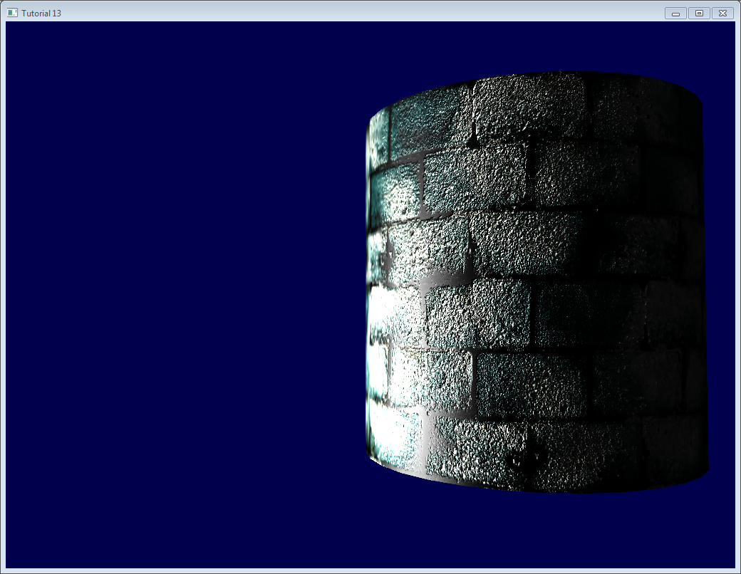*

*Going further*

*Orthogonalization*

*In our vertex shader we took the transpose instead of the inverse because it’s faster. But it only works if the space that the matrix represents is orthogonal, which is not yet the case. Luckily, this is very easy to fix : we just have to make the tangent perpendicular to the normal at he end of computeTangentBasis() :*

*t* ***=*** *glm****::****normalize(t* ***-*** *n* ***\**** *glm****::****dot(n, t));*

*This formula may be hard to grasp, so a little schema might help :*

*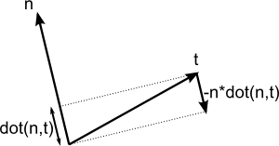*

*n and t are almost perpendicular, so we “push” t in the direction of -n by a factor of dot(n,t)*

[*Here*](http://www.cse.illinois.edu/iem/least_squares/gram_schmidt/)*’s a little applet that explains it too (Use only 2 vectors).*

*Handedness*

*You usually don’t have to worry about that, but in some cases, when you use symmetric models, UVs are oriented in the wrong way, and your T has the wrong orientation.*

*To check whether it must be inverted or not, the check is simple : TBN must form a right-handed coordinate system, i.e. cross(n,t) must have the same orientation than b.*

*In mathematics, “Vector A has the same orientation as Vector B” translates as dot(A,B)>0, so we need to check if dot( cross(n,t) , b ) > 0.*

*If it’s false, just invert t :*

***if*** *(glm****::****dot(glm****::****cross(n, t), b)* ***<*** *0.0f){*

*t* ***=*** *t* ***\*******-****1.0f;*

*}*

*This is also done for each vertex at the end of computeTangentBasis().*

*Specular texture*

*Just for fun, I added a specular texture to the code. It looks like this :*

*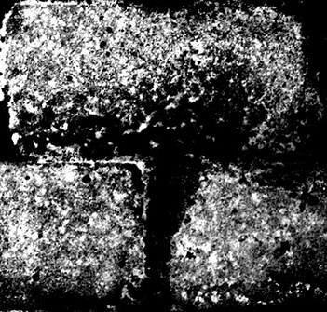*

*and is used instead of the simple “vec3(0.3,0.3,0.3)” grey that we used as specular color.*

*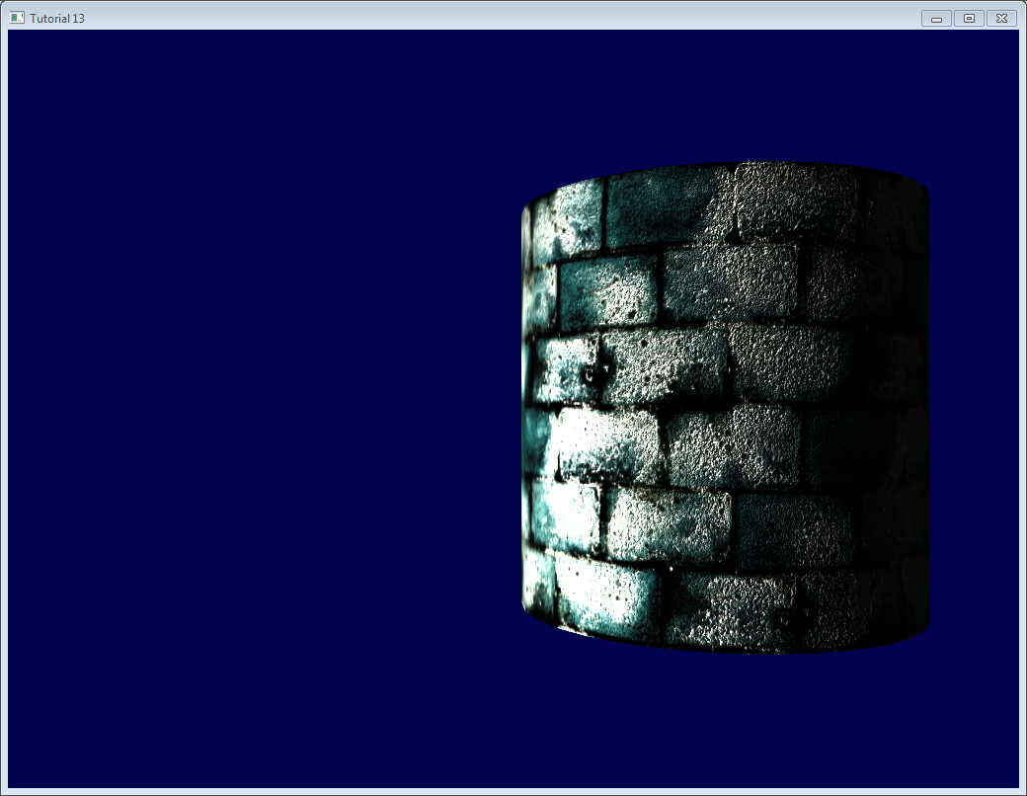*

*Notice that now, cement is always black : the texture says that it has no specular component.*

*Debugging with the immediate mode*

*The real aim of this website is that you DON’T use immediate mode, which is deprecated, slow, and problematic in many aspects.*

*However, it also happens to be really handy for debugging :*

*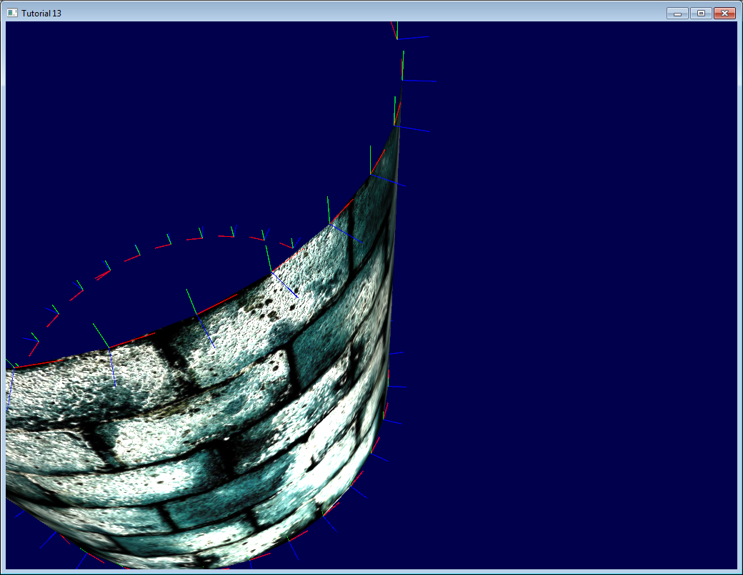*

*Here we visualize our tangent space with lines drawn in immediate mode.*

*For this, you need to abandon the 3.3 core profile :*

*glfwOpenWindowHint(GLFW\_OPENGL\_PROFILE, GLFW\_OPENGL\_COMPAT\_PROFILE);*

*then give our matrices to OpenGL’s old-school pipeline (you can write another shader too, but it’s simpler this way, and you’re hacking anyway) :*

*glMatrixMode(GL\_PROJECTION);*

*glLoadMatrixf((****const*** *GLfloat****\*****)****&****ProjectionMatrix[0]);*

*glMatrixMode(GL\_MODELVIEW);*

*glm****::****mat4 MV* ***=*** *ViewMatrix* ***\**** *ModelMatrix;*

*glLoadMatrixf((****const*** *GLfloat****\*****)****&****MV[0]);*

*Disable shaders :*

*glUseProgram(0);*

*And draw your lines (in this case, normals, normalized and multiplied by 0.1, and applied at the correct vertex) :*

*glColor3f(0,0,1);*

*glBegin(GL\_LINES);*

***for*** *(****int*** *i****=****0; i****<****indices.size(); i****++****){*

*glm****::****vec3 p* ***=*** *indexed\_vertices[indices[i]];*

*glVertex3fv(****&****p.x);*

*glm****::****vec3 o* ***=*** *glm****::****normalize(indexed\_normals[indices[i]]);*

*p****+=****o****\*****0.1f;*

*glVertex3fv(****&****p.x);*

*}*

*glEnd();*

*Remember : don’t use immediate mode in real world ! Only for debugging ! And don’t forget to re-enable the core profile afterwards, it will make sure that you don’t do such things.*

*Debugging with colors*

*When debugging, it can be useful to visualize the value of a vector. The easiest way to do this is to write it on the framebuffer instead of the actual colour. For instance, let’s visualize LightDirection\_tangentspace :*

*color.xyz* ***=*** *LightDirection\_tangentspace;*

*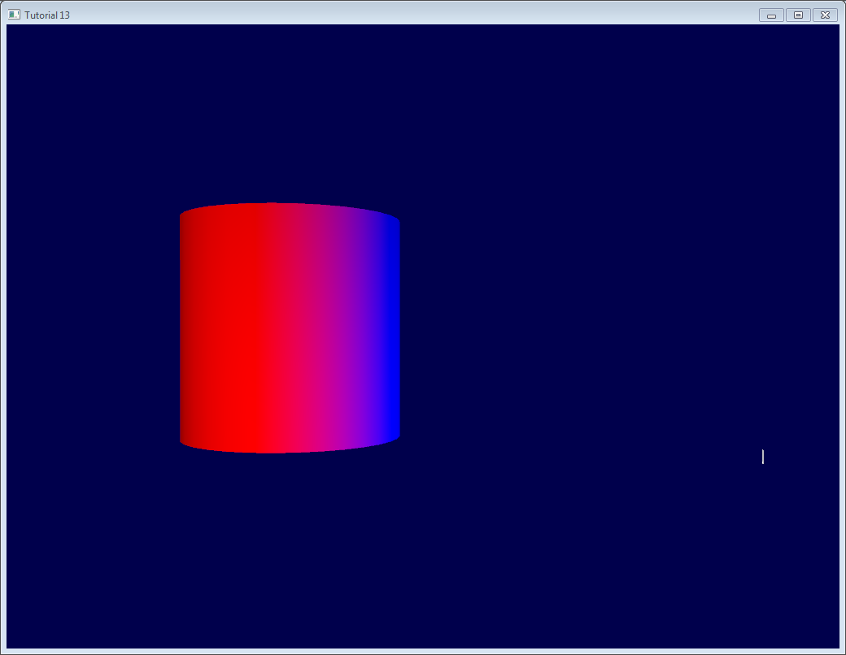*

*This means :*

* *On the right part of the cylinder, the light (represented by the small white line) is UP (in tangent space). In other words, the light is in the direction of the normal of the triangles.*
* *On the middle part of the cylinder, the light is in the direction of the tangent (towards +X)*

*A few tips :*

* *Depending on what you’re trying to visualize, you may want to normalize it.*
* *If you can’t make sense of what you’re seeing, visualize all components separately by forcing for instance green and blue to 0.*
* *Avoid messing with alpha, it’s too complicated :)*
* *If you want to visualize negative value, you can use the same trick that our normal textures use : visualize (v+1.0)/2.0 instead, so that black means -1 and full color means +1. It’s hard to understand what you see, though.*

*Debugging with variable names*

*As already stated before, it’s crucial to exactly know in which space your vectors are. Don’t take the dot product of a vector in camera space and a vector in model space.*

*Appending the space of each vector in their names (“…\_modelspace”) helps fixing math bugs tremendously.*

*How to create a normal map*

*Created by James O’Hare. Click to enlarge.*

*// я не стаў далей чытаць, бо мне тут анічога не зразумела. Паршывенька напісаны цьютарал //*

*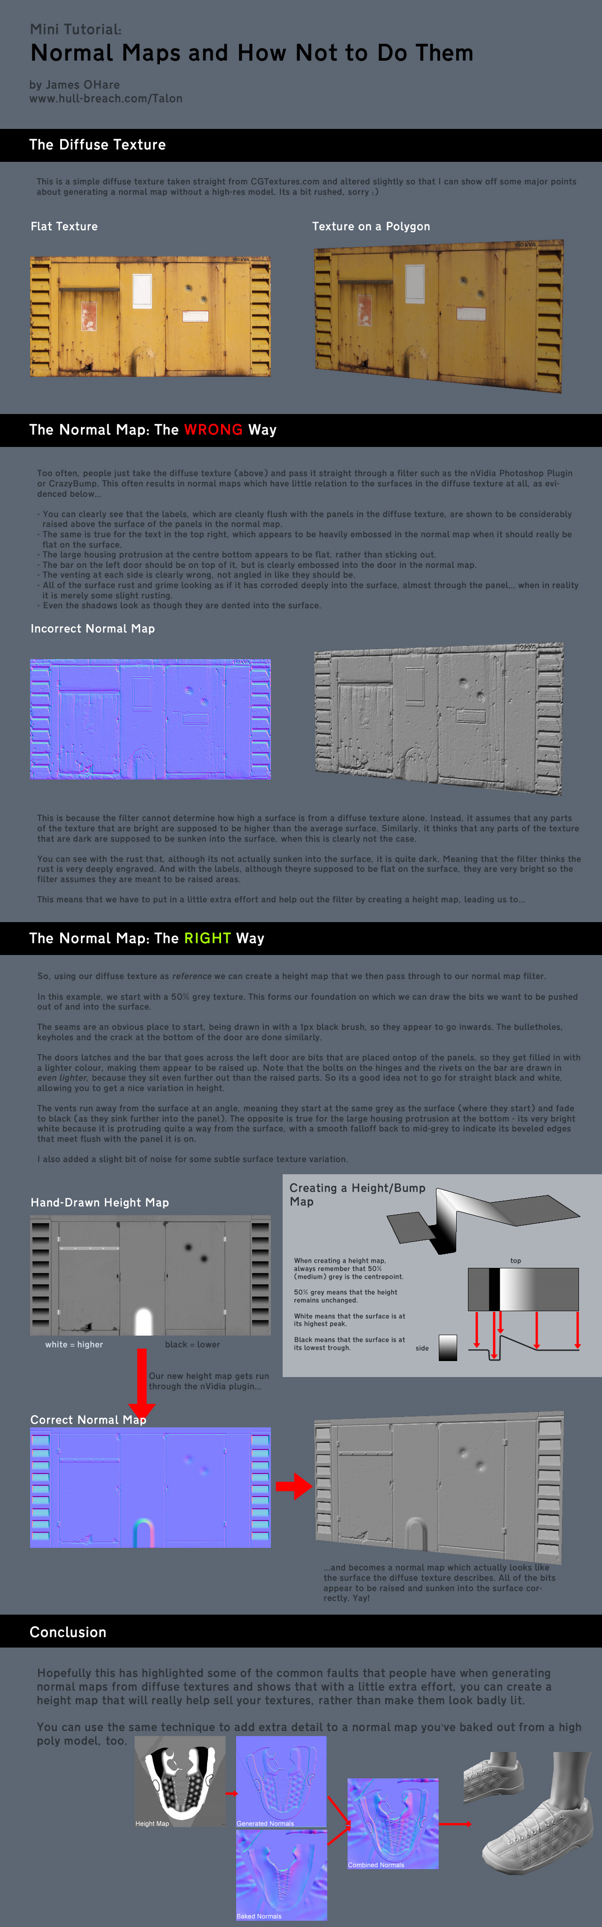*

*// у дадзенай брашуры цудоўна паказана, што выкарыстоўваць фільтры для стварэння нармальных тэкстур – кепска. Але што такое нармальная тэкстура – і для чаго прызначаецца, мне не вельмі ясна //*

*…*

*References*

* [*Lengyel, Eric. “Computing Tangent Space Basis Vectors for an Arbitrary Mesh”. Terathon Software 3D Graphics Library, 2001.*](http://www.terathon.com/code/tangent.html)
* [*Real Time Rendering, third edition*](http://www.amazon.com/dp/1568814240)
* [*ShaderX4*](http://www.amazon.com/dp/1584504250)

*// спадзяюся, наступны цьютарал, будзе для мяне яснейшым // //*

[*http://www.opengl-tutorial.org/intermediate-tutorials/tutorial-14-render-to-texture/*](http://www.opengl-tutorial.org/intermediate-tutorials/tutorial-14-render-to-texture/)

# *Tutorial 14: Render To Texture*

*Render-To-Texture is a handful method to create a variety of effects. The basic idea is that you render a scene just like you usually do, but this time in a texture that you can reuse later. // intbu better this main idea //*

*Applications include in-game cameras, post-processing, and as many GFX as you can imagine.*

## *Render To Texture*

*We have three tasks: creating the texture in which we’re going to render ; actually rendering something in it ; and using the generated texture.*

### *Creating the Render Target*

*What we’re going to render to is called a Framebuffer. It’s a container for textures and an optional depth buffer. It’s created just like any other object in OpenGL :*

*// The framebuffer, which regroups 0, 1, or more textures, and 0 or 1 depth buffer.*

*GLuint FramebufferName* ***=*** *0;*

*glGenFramebuffers(1,* ***&****FramebufferName);*

*glBindFramebuffer(GL\_FRAMEBUFFER, FramebufferName);*

*Now we need to create the texture which will contain the RGB output of our shader. This code is very classic :*

*// The texture we're going to render to*

*GLuint renderedTexture;*

*glGenTextures(1,* ***&****renderedTexture);*

*// "Bind" the newly created texture : all future texture functions will modify this texture*

*glBindTexture(GL\_TEXTURE\_2D, renderedTexture);*

*// Give an empty image to OpenGL ( the last "0" )*

*glTexImage2D(GL\_TEXTURE\_2D, 0,GL\_RGB, 1024, 768, 0,GL\_RGB, GL\_UNSIGNED\_BYTE, 0);*

*// Poor filtering. Needed !*

*glTexParameteri(GL\_TEXTURE\_2D, GL\_TEXTURE\_MAG\_FILTER, GL\_NEAREST);*

*glTexParameteri(GL\_TEXTURE\_2D, GL\_TEXTURE\_MIN\_FILTER, GL\_NEAREST);*

*We also need a depth buffer. This is optional, depending on what you actually need to draw in your texture; but since we’re going to render Suzanne, we need depth-testing.*

*// The depth buffer*

*GLuint depthrenderbuffer;*

*glGenRenderbuffers(1,* ***&****depthrenderbuffer);*

*glBindRenderbuffer(GL\_RENDERBUFFER, depthrenderbuffer);*

*glRenderbufferStorage(GL\_RENDERBUFFER, GL\_DEPTH\_COMPONENT, 1024, 768);*

*glFramebufferRenderbuffer(GL\_FRAMEBUFFER, GL\_DEPTH\_ATTACHMENT, GL\_RENDERBUFFER, depthrenderbuffer);*

*Finally, we configure our framebuffer*

*// Set "renderedTexture" as our colour attachement #0*

*glFramebufferTexture(GL\_FRAMEBUFFER, GL\_COLOR\_ATTACHMENT0, renderedTexture, 0);*

*// Set the list of draw buffers.*

*GLenum DrawBuffers[1]* ***=*** *{GL\_COLOR\_ATTACHMENT0};*

*glDrawBuffers(1, DrawBuffers); // "1" is the size of DrawBuffers*

*Something may have gone wrong during the process, depending on the capabilities of the GPU. This is how you check it :*

*// Always check that our framebuffer is ok // recommendation //*

***if****(glCheckFramebufferStatus(GL\_FRAMEBUFFER)* ***!=*** *GL\_FRAMEBUFFER\_COMPLETE)*

***return*** *false;*

### *Rendering to the texture*

*Rendering to the texture is straightforward. Simply bind your framebuffer, and draw your scene as usual. Easy !*

*// Render to our framebuffer*

*glBindFramebuffer(GL\_FRAMEBUFFER, FramebufferName);*

*glViewport(0,0,1024,768); // Render on the whole framebuffer, complete from the lower left corner to the upper right*

*The fragment shader just needs a minor adaptation :*

*layout(location* ***=*** *0) out vec3 color;*

*This means that when writing in the variable “color”, we will actually write in the Render Target 0, which happens to be our texure because DrawBuffers[0] is GL\_COLOR\_ATTACHMENTi, which is, in our case, renderedTexture.*

*To recap :*

* *color will be written to the first buffer because of layout(location=0).*
* *The first buffer is GL\_COLOR\_ATTACHMENT0 because of DrawBuffers[1] = {GL\_COLOR\_ATTACHMENT0}*
* *GL\_COLOR\_ATTACHMENT0 has renderedTexture attached, so this is where your color is written.*
* *In other words, you can replace GL\_COLOR\_ATTACHMENT0 by GL\_COLOR\_ATTACHMENT2 and it will still work.*

*Note : there is no layout(location=i) in OpenGL < 3.3, but you use glFragData[i] = mvvalue anyway.*

### *Using the rendered texture*

*We’re going to draw a simple quad that fills the screen. We need the usual buffers, shaders, IDs, …*

*// The fullscreen quad's FBO*

*GLuint quad\_VertexArrayID;*

*glGenVertexArrays(1,* ***&****quad\_VertexArrayID);*

*glBindVertexArray(quad\_VertexArrayID);*

***static******const*** *GLfloat g\_quad\_vertex\_buffer\_data[]* ***=*** *{*

***-****1.0f,* ***-****1.0f, 0.0f,*

*1.0f,* ***-****1.0f, 0.0f,*

***-****1.0f, 1.0f, 0.0f,*

***-****1.0f, 1.0f, 0.0f,*

*1.0f,* ***-****1.0f, 0.0f,*

*1.0f, 1.0f, 0.0f,*

*};*

*GLuint quad\_vertexbuffer;*

*glGenBuffers(1,* ***&****quad\_vertexbuffer);*

*glBindBuffer(GL\_ARRAY\_BUFFER, quad\_vertexbuffer);*

*glBufferData(GL\_ARRAY\_BUFFER,* ***sizeof****(g\_quad\_vertex\_buffer\_data), g\_quad\_vertex\_buffer\_data, GL\_STATIC\_DRAW);*

*// тут я ўжо страціў ніць разваг. Я слаба разумею, што мы робім… //*

*// Create and compile our GLSL program from the shaders // прызначэнне дадзенай часткі OpenGL кода //*

*GLuint quad\_programID* ***=*** *LoadShaders( "Passthrough.vertexshader", "SimpleTexture.fragmentshader" );*

*GLuint texID* ***=*** *glGetUniformLocation(quad\_programID, "renderedTexture");*

*GLuint timeID* ***=*** *glGetUniformLocation(quad\_programID, "time");*

*Now you want to render to the screen. This is done by using 0 as the second parameter of glBindFramebuffer.*

*// Render to the screen*

*glBindFramebuffer(GL\_FRAMEBUFFER, 0);*

*glViewport(0,0,1024,768); // Render on the whole framebuffer, complete from the lower left corner to the upper right*

*We can draw our full-screen quad with such a shader:*

***#version 330 core***

***in******vec2*** *UV;*

***out******vec3*** *color;*

***uniform******sampler2D*** *renderedTexture;*

***uniform******float*** *time;*

***void*** *main(){*

*color* ***=*** *texture( renderedTexture, UV* ***+*** *0.005****\*vec2****( sin(time****+****1024.0****\*****UV.x),cos(time****+****768.0****\*****UV.y)) ).xyz;*

*}*

*This code simply sample the texture, but adds a tiny offset which depends on time.*

*Results*

*// я не зразумеў ні асноўную канцэпцыю, ні асноўную ідэю… //*

*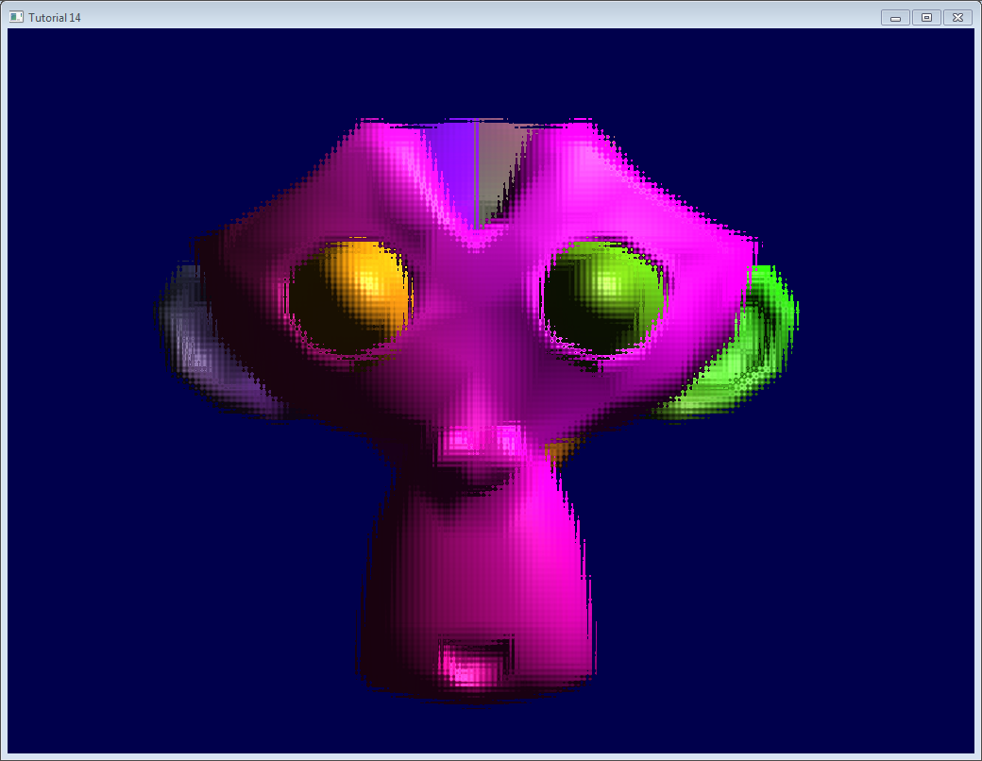*

## *Going further*

### *Using the depth*

*In some cases you might need the depth when using the rendered texture. In this case, simply render to a texture created as follows :*

*glTexImage2D(GL\_TEXTURE\_2D, 0,GL\_DEPTH\_COMPONENT24, 1024, 768, 0,GL\_DEPTH\_COMPONENT, GL\_FLOAT, 0);*

*(“24” is the precision, in bits. You can choose between 16, 24 and 32, depending on your needs. Usually 24 is fine)*

*This should be enough to get you started, but the provided source code implements this too.*

*Note that this should be somewhat slower, because the driver won’t be able to use some optimisations such as*[*Hi-Z*](http://fr.slideshare.net/pjcozzi/z-buffer-optimizations)*.*

*In this screenshot, the depth levels are artificially “prettified”. Usually, its much more difficult to see anything on a depth texture. Near = Z near 0 = black, far = Z near 1 = white.*

*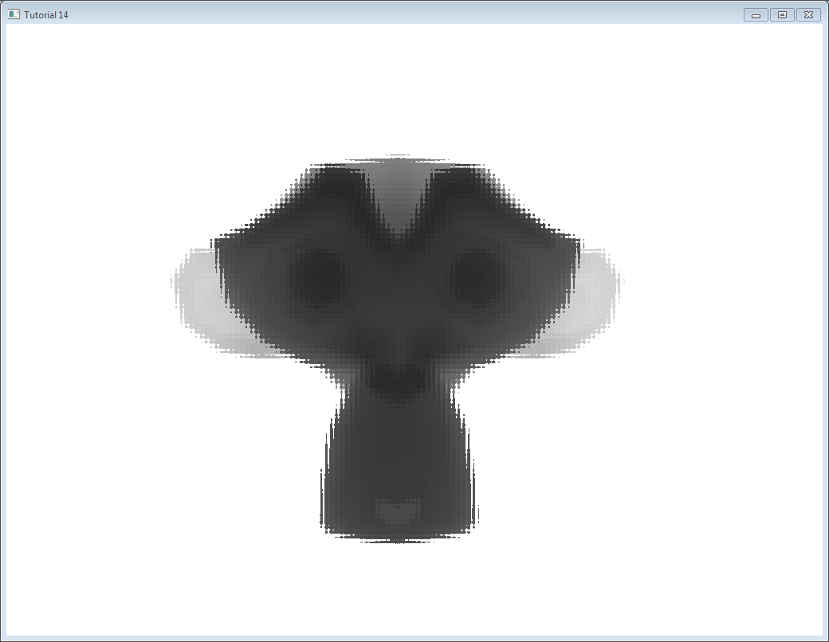*

### *Multisampling*

*You can write to multisampled textures instead of “basic” textures : you just have to replace glTexImage2D by*[*glTexImage2DMultisample*](http://www.opengl.org/sdk/docs/man3/xhtml/glTexImage2DMultisample.xml)*in the C++ code, and sampler2D/texture by sampler2DMS/texelFetch in the fragment shader.*

*There is a big caveat, though : texelFetch needs another argument, which is the number of the sample to fetch. In other words, there is no automatic “filtering” (the correct term, when talking about multisampling, is “resolution”).*

*So you may have to resolve the MS texture yourself, in another, non-MS texture, thanks to yet another shader.*

*Nothing difficult, but it’s just bulky.*

### *Multiple Render Targets*

*You may write to several textures at the same time.*

*Simply create several textures (all with the correct and same size !), call glFramebufferTexture with a different color attachement for each, call glDrawBuffers with updated parameters ( something like (2,{GL\_COLOR\_ATTACHMENT0,GL\_COLOR\_ATTACHMENT1}})), and add another output variable in your fragment shader :*

***layout****(location* ***=*** *1)* ***out******vec3*** *normal\_tangentspace; // or whatever*

*Hint : If you effectively need to output a vector in a texture, floating-point textures exist, with 16 or 32 bit precision instead of 8… See*[*glTexImage2D*](http://www.opengl.org/sdk/docs/man/xhtml/glTexImage2D.xml)*’s reference (search for GL\_FLOAT).*

*Hint2 : For previous versions of OpenGL, use glFragData[1] = myvalue instead.*

*Exercices*

* *Try using glViewport(0,0,512,768); instead of glViewport(0,0,1024,768); (try with both the framebuffer and the screen)*
* *Experiment with other UV coordinates in the last fragment shader*
* *Transform the quad with a real transformation matrix. First hardcode it, and then try to use the functions of controls.hpp ; what do you notice ?*

*// скажу шчыра: асноўную ідэю і гэтага цьюторыяла я не ўцяміў… Код мне не ясны. Для чаго патрэбны фрэйм-буфер, я не разумею… // //*

[*http://www.opengl-tutorial.org/intermediate-tutorials/tutorial-15-lightmaps/*](http://www.opengl-tutorial.org/intermediate-tutorials/tutorial-15-lightmaps/)

# *Tutorial 15 : Lightmaps*

## *Introduction*

*This a video-only tutorial. It doesn’t introduce any new OpenGL-specific technique/syntax, but shows you how to use the techniques you already know to build high-quality shadows.*

*This tutorials explains how to build a simple world in Blender, and bake the lightmaps so that you can use them in your application.*

*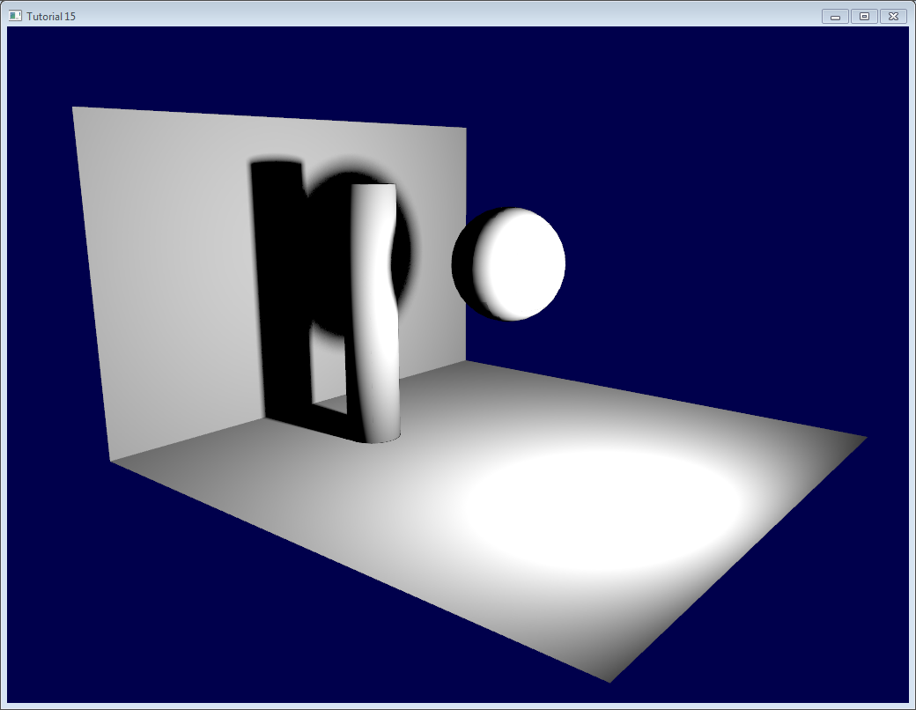*

*No prior knowledge of Blender is required. I will explain all keyboard shortcuts and everything.*

## *A note on lightmaps*

*Lightmaps are baked. Once and for all. This means that they are completely static, you can’t decide to move the light at runtime. Or even remove it. // intbu better this // //*

*This can still be useful for the sunlight, though, or indoor scenes where you may not break the light bulbs. Mirror Edge, released in 2009, uses them extensively, both indoors and outdoors.*

*What’s more, it’s very easy to setup, and you can’t beat the speed.*

## *The video*

*This is a 1024x768p video, use HD mode…*

### *Addendum*

*When rendering it in OpenGL, you might notice some glitches (exaggerated here) :*

*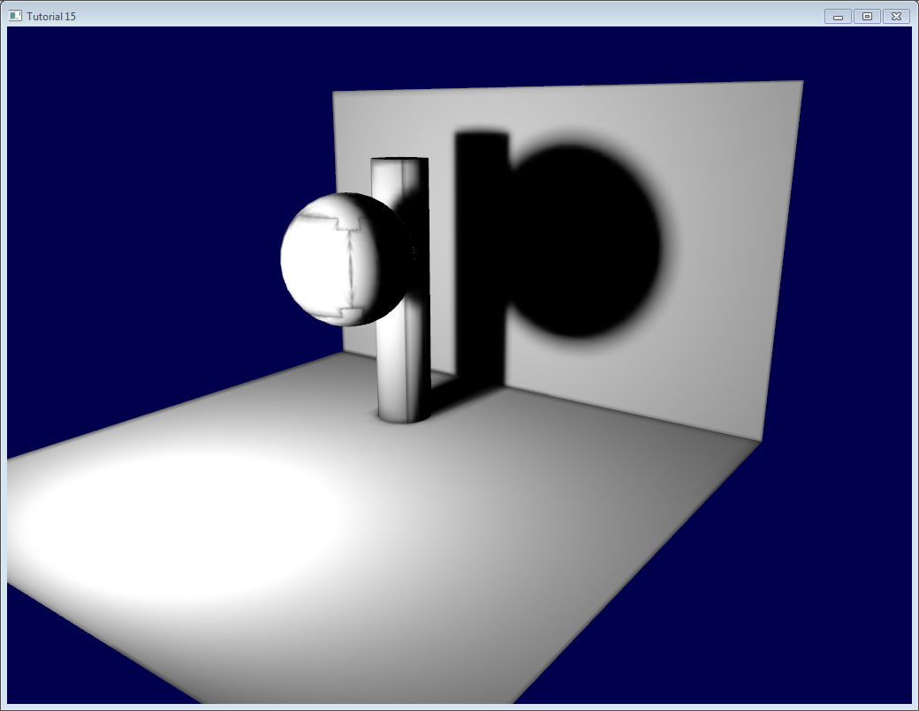*

*This is because of mipmapping, which blends texels together when seen at a distance. Black pixels from the texture’s background get mixed with good parts of the lightmap. To avoid this, there are a few things you can do : // я гэтага кепскага эфекту і не заўважыў… // //*

* *You can ask Blender to generate a margin around the limits of the UV map. This is the “margin” parameter in the “bake” panel. For good results, you may have to go up to a margin of 20 texels.*
* *You can use a bias in your texture fetch :*

*color* ***=*** *texture( myTextureSampler, UV,* ***-****2.0 ).rgb;*

*-2 is the bias. You’ll have to experiment with this value. The screenshot above was taken with a bias of +2, which means that OpenGL will select two mipmaps above the one it should have taken (so it’s 16 times smaller, hence the glitches)*

* *You can fill the black background in a post-processing step. I’ll post more about this later.*

[*http://www.opengl-tutorial.org/intermediate-tutorials/tutorial-16-shadow-mapping/*](http://www.opengl-tutorial.org/intermediate-tutorials/tutorial-16-shadow-mapping/)

# *Tutorial 16 : Shadow mapping*

*In Tutorial 15 we learnt how to create lightmaps, which encompasses static lighting. While it produces very nice shadows, it doesn’t deal with animated models.*

*Shadow maps are the current (as of 2016) way to make dynamic shadows. The great thing about them is that it’s fairly easy to get to work. The bad thing is that it’s terribly difficult to get to work right. // разнавіднасць складанасці. Аспекты тстр //*

*In this tutorial, we’ll first introduce the basic algorithm, see its shortcomings, and then implement some techniques to get better results. Since at time of writing (2012) shadow maps are still a heavily researched topic, we’ll give you some directions to further improve your own shadowmap, depending on your needs. // стан галіны //*

## *Basic shadowmap*

*The basic shadowmap algorithm consists in two passes. First, the scene is rendered from the point of view of the light. Only the depth of each fragment is computed. Next, the scene is rendered as usual, but with an extra test to see it the current fragment is in the shadow.*

*The “being in the shadow” test is actually quite simple. If the current sample is further from the light than the shadowmap at the same point, this means that the scene contains an object that is closer to the light. In other words, the current fragment is in the shadow.*

*The following image might help you understand the principle :*

*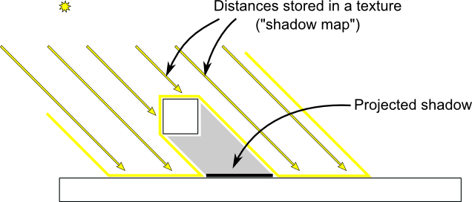*

## *Rendering the shadow map*

*In this tutorial, we’ll only consider directional lights - lights that are so far away that all the light rays can be considered parallel. As such, rendering the shadow map is done with an orthographic projection matrix. An orthographic matrix is just like a usual perspective projection matrix, except that no perspective is taken into account - an object will look the same whether it’s far or near the camera.*

#### Setting up the rendertarget and the MVP matrix

*Since Tutorial 14, you know how to render the scene into a texture in order to access it later from a shader. // я вось гэту тэму не вельмі добра ўлавіў //*

*Here we use a 1024x1024 16-bit depth texture to contain the shadow map. 16 bits are usually enough for a shadow map. Feel free to experiment with these values. Note that we use a depth texture, not a depth renderbuffer, since we’ll need to sample it later. // чым адрозніваецца дэпс-структура ад дэпс-фрэймбуфера? //*

*// The framebuffer, which regroups 0, 1, or more textures, and 0 or 1 depth buffer.*

*GLuint FramebufferName* ***=*** *0;*

*glGenFramebuffers(1,* ***&****FramebufferName);*

*glBindFramebuffer(GL\_FRAMEBUFFER, FramebufferName);*

*// мы ствараем, генеруем і звязваем фрэймбуфер //*

*// Depth texture. Slower than a depth buffer, but you can sample it later in your shader // што такое дэпс-структура і ў чым яе перавага? //*

*GLuint depthTexture;*

*glGenTextures(1,* ***&****depthTexture);*

*glBindTexture(GL\_TEXTURE\_2D, depthTexture);*

*glTexImage2D(GL\_TEXTURE\_2D, 0,GL\_DEPTH\_COMPONENT16, 1024, 1024, 0,GL\_DEPTH\_COMPONENT, GL\_FLOAT, 0);*

*glTexParameteri(GL\_TEXTURE\_2D, GL\_TEXTURE\_MAG\_FILTER, GL\_NEAREST);*

*glTexParameteri(GL\_TEXTURE\_2D, GL\_TEXTURE\_MIN\_FILTER, GL\_NEAREST);*

*glTexParameteri(GL\_TEXTURE\_2D, GL\_TEXTURE\_WRAP\_S, GL\_CLAMP\_TO\_EDGE);*

*glTexParameteri(GL\_TEXTURE\_2D, GL\_TEXTURE\_WRAP\_T, GL\_CLAMP\_TO\_EDGE);*

*glFramebufferTexture(GL\_FRAMEBUFFER, GL\_DEPTH\_ATTACHMENT, depthTexture, 0);*

*glDrawBuffer(GL\_NONE); // No color buffer is drawn to.*

*// Always check that our framebuffer is ok*

***if****(glCheckFramebufferStatus(GL\_FRAMEBUFFER)* ***!=*** *GL\_FRAMEBUFFER\_COMPLETE)*

***return*** *false;*

*The MVP matrix used to render the scene from the light’s point of view is computed as follows :*

* *The Projection matrix is an orthographic matrix which will encompass everything in the axis-aligned box (-10,10),(-10,10),(-10,20) on the X,Y and Z axes respectively. These values are made so that our entire \*visible \*scene is always visible ; more on this in the Going Further section.*
* *The View matrix rotates the world so that in camera space, the light direction is -Z (would you like to re-read*[*Tutorial 3*](http://www.opengl-tutorial.org/beginners-tutorials/tutorial-3-matrices/)*?)*
* *The Model matrix is whatever you want.*

*glm****::****vec3 lightInvDir* ***=*** *glm****::****vec3(0.5f,2,2);*

*// Compute the MVP matrix from the light's point of view*

*glm****::****mat4 depthProjectionMatrix* ***=*** *glm****::****ortho****<float>****(****-****10,10,****-****10,10,****-****10,20);*

*glm****::****mat4 depthViewMatrix* ***=*** *glm****::****lookAt(lightInvDir, glm****::****vec3(0,0,0), glm****::****vec3(0,1,0));*

*glm****::****mat4 depthModelMatrix* ***=*** *glm****::****mat4(1.0);*

*glm****::****mat4 depthMVP* ***=*** *depthProjectionMatrix* ***\**** *depthViewMatrix* ***\**** *depthModelMatrix;*

*// Send our transformation to the currently bound shader,*

*// in the "MVP" uniform*

*glUniformMatrix4fv(depthMatrixID, 1, GL\_FALSE,* ***&****depthMVP[0][0])*

### *The shaders*

*The shaders used during this pass are very simple. The vertex shader is a pass-through shader which simply compute the vertex’ position in homogeneous coordinates :*

***#version 330 core***

*// Input vertex data, different for all executions of this shader.*

***layout****(location* ***=*** *0)* ***in******vec3*** *vertexPosition\_modelspace;*

*// Values that stay constant for the whole mesh.*

***uniform******mat4*** *depthMVP;*

***void*** *main(){*

*gl\_Position* ***=*** *depthMVP* ***\*******vec4****(vertexPosition\_modelspace,1);*

*}*

*The fragment shader is just as simple: it simply writes the depth of the fragment at location 0 (i.e. in our depth texture).*

***#version 330 core***

*// Ouput data*

***layout****(location* ***=*** *0)* ***out******float*** *fragmentdepth;*

***void*** *main(){*

*// Not really needed, OpenGL does it anyway*

*fragmentdepth* ***=*** *gl\_FragCoord.z;*

*}*

*// дэпс – гэта z-каардыната //*

*Rendering a shadow map is usually more than twice as fast as the normal render, because only low precision depth is written, instead of both the depth and the color; Memory bandwidth is often the biggest performance issue on GPUs. // лепей зразумець гэту перавагу графічных працэсараў //*

*Result*

*The resulting texture looks like this :*

**

*A dark colour means a small z ; hence, the upper-right corner of the wall is near the camera. At the opposite, white means z=1 (in homogeneous coordinates), so this is very far.*

### *Using the shadow map*

#### Basic shader

*Now we go back to our usual shader. For each fragment that we compute, we must test whether it is “behind” the shadow map or not.*

*To do this, we need to compute the current fragment’s position in the same space that the one we used when creating the shadowmap. So we need to transform it once with the usual MVP matrix, and another time with the depthMVP matrix.*

*There is a little trick, though. Multiplying the vertex’ position by depthMVP will give homogeneous coordinates, which are in [-1,1] ; but texture sampling must be done in [0,1].*

*For instance, a fragment in the middle of the screen will be in (0,0) in homogeneous coordinates ; but since it will have to sample the middle of the texture, the UVs will have to be (0.5, 0.5). // гэта адрозненне тэкстурных каардынатаў ад аднародных я ўразумеў //*

*This can be fixed by tweaking the fetch coordinates directly in the fragment shader but it’s more efficient to multiply the homogeneous coordinates by the following matrix, which simply divides coordinates by 2 ( the diagonal : [-1,1] -> [-0.5, 0.5] ) and translates them ( the lower row : [-0.5, 0.5] -> [0,1] ). // мы фактычна, хочам прывесці дзве выявы – экранную і тэкстурную да адных каардынатаў. Мы прыводзім выяўную да тэкстурнай //*

*glm****::****mat4 biasMatrix(*

*0.5, 0.0, 0.0, 0.0,*

*0.0, 0.5, 0.0, 0.0,*

*0.0, 0.0, 0.5, 0.0,*

*0.5, 0.5, 0.5, 1.0*

*);*

*glm****::****mat4 depthBiasMVP* ***=*** *biasMatrix****\*****depthMVP;*

*We can now write our vertex shader. It’s the same as before, but we output 2 positions instead of 1 :*

* *gl\_Position is the position of the vertex as seen from the current camera*
* *ShadowCoord is the position of the vertex as seen from the last camera (the light)*

*// вертэкс шэйдэра будзе выдаваць на выхадзе дзве пазіцыі, якія будуць потым выкарыстоўвацца для высвятлення колеру ў фрагментным шэйдэры //*

*// Output position of the vertex, in clip space: MVP \* position*

*gl\_Position* ***=*** *MVP* ***\*******vec4****(vertexPosition\_modelspace,1);*

*// Same, but with the light's view matrix*

*ShadowCoord* ***=*** *DepthBiasMVP* ***\*******vec4****(vertexPosition\_modelspace,1);*

*The fragment shader is then very simple :*

* *texture( shadowMap, ShadowCoord.xy ).z is the distance between the light and the nearest occluder*
* *ShadowCoord.z is the distance between the light and the current fragment*

*// а як яны першае вызначаюць? //*

*… so if the current fragment is further than the nearest occluder, this means we are in the shadow (of said nearest occluder) :*

***float*** *visibility* ***=*** *1.0;*

***if*** *( texture( shadowMap, ShadowCoord.xy ).z* ***<*** *ShadowCoord.z){*

*visibility* ***=*** *0.5;*

*}*

*// усё ж такі, не зразумеў, як мы знаходзім адлегласць да першай перашкоды… //*

*We just have to use this knowledge to modify our shading. Of course, the ambient colour isn’t modified, since its purpose in life is to fake some incoming light even when we’re in the shadow (or everything would be pure black) // гэта сімуляцыя пераадлюстраванняў //*

*color* ***=***

*// Ambient : simulates indirect lighting*

*MaterialAmbientColor* ***+***

*// Diffuse : "color" of the object*

*visibility* ***\**** *MaterialDiffuseColor* ***\**** *LightColor* ***\**** *LightPower* ***\**** *cosTheta****+***

*// Specular : reflective highlight, like a mirror*

*visibility* ***\**** *MaterialSpecularColor* ***\**** *LightColor* ***\**** *LightPower* ***\**** *pow(cosAlpha,5);*

#### Result - Shadow acne

*Here’s the result of the current code. Obviously, the global idea it there, but the quality is unacceptable.*

*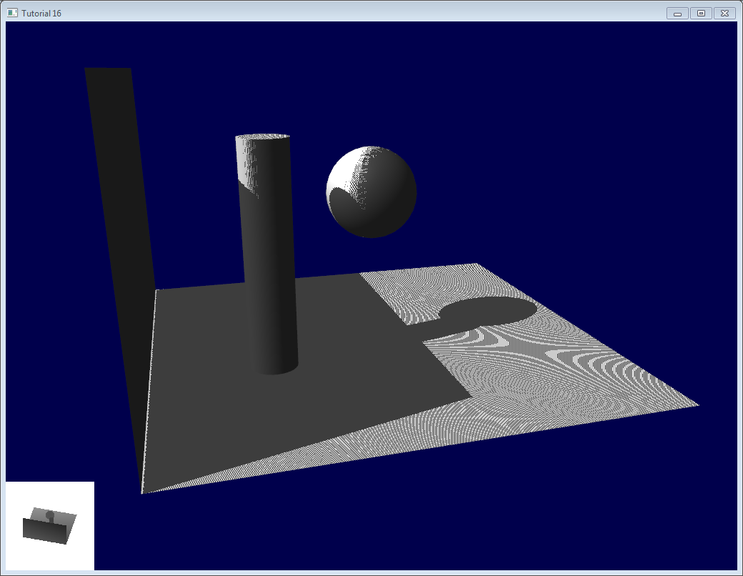*

*Let’s look at each problem in this image. The code has 2 projects : shadowmaps and shadowmaps\_simple; start with whichever you like best. The simple version is just as ugly as the image above, but is simpler to understand.*

#### Problems

##### *Shadow acne*

*The most obvious problem is called shadow acne :*

*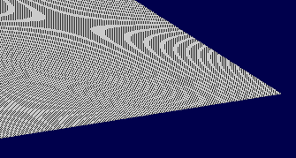*

*This phenomenon is easily explained with a simple image :*

*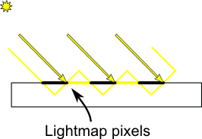*

*// я так разумею, злучана з тым, што ў нас крокпі на паверхні знаходзяцца не ў плоскасці, а як зуб’я, бо ў OpenGL трохвугольнік – гэта асноўнае //*

*The usual “fix” for this is to add an error margin: we only shade if the current fragment’s depth (again, in light space) is really far away from the lightmap value. We do this by adding a bias : // не зусім зразумеў, якім бокам тут далучаецца лайтмэп… //*

***float*** *bias* ***=*** *0.005;*

***float*** *visibility* ***=*** *1.0;*

***if*** *( texture( shadowMap, ShadowCoord.xy ).z* ***<*** *ShadowCoord.z****-****bias){*

*visibility* ***=*** *0.5;*

*}*

*The result is already much nicer :*

*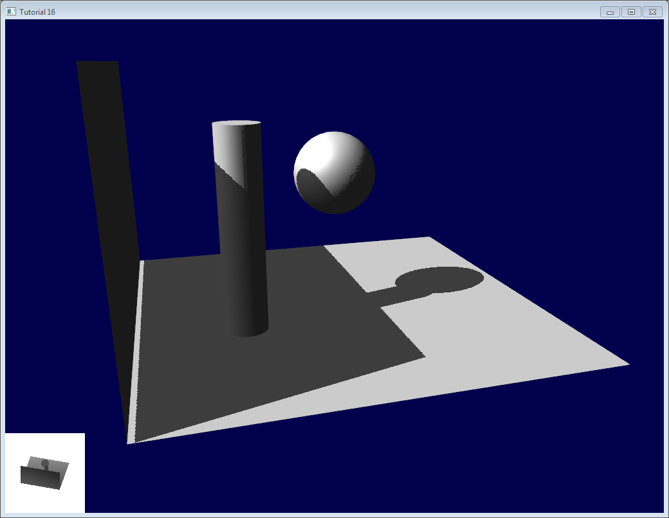*

*However, you can notice that because of our bias, the artefact between the ground and the wall has gone worse. What’s more, a bias of 0.005 seems too much on the ground, but not enough on curved surface : some artefacts remain on the cylinder and on the sphere. // слэнгавы тэрмін “артэфакт” у графіцы абазначае пэўны баг //*

*A common approach is to modify the bias according to the slope :*

***float*** *bias* ***=*** *0.005****\*****tan(acos(cosTheta)); // cosTheta is dot( n,l ), clamped between 0 and 1*

*bias* ***=*** *clamp(bias, 0,0.01);*

*Shadow acne is now gone, even on curved surfaces.*

*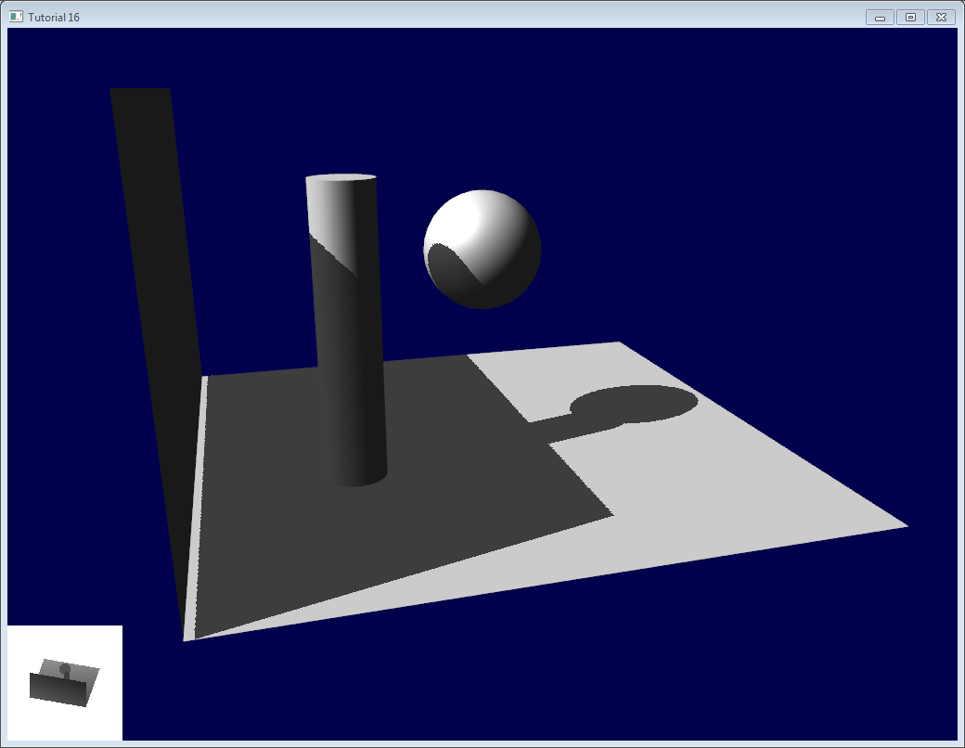*

*Another trick, which may or may not work depending on your geometry, is to render only the back faces in the shadow map. This forces us to have a special geometry ( see next section - Peter Panning ) with thick walls, but at least, the acne will be on surfaces which are in the shadow :*

*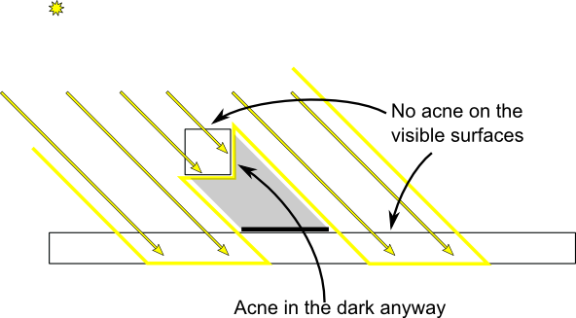*

*// intbu better this trick and this picture // //*

*When rendering the shadow map, cull front-facing triangles :*

*// We don't use bias in the shader, but instead we draw back faces,*

*// which are already separated from the front faces by a small distance*

*// (if your geometry is made this way)*

*glCullFace(GL\_FRONT); // Cull front-facing triangles -> draw only back-facing triangles*

*And when rendering the scene, render normally (backface culling)*

*glCullFace(GL\_BACK); // Cull back-facing triangles -> draw only front-facing triangles*

*This method is used in the code, in addition to the bias. // intbu this method //*

#### Peter Panning

*We have no shadow acne anymore, but we still have this wrong shading of the ground, making the wall to look as if it’s flying (hence the term “Peter Panning”). In fact, adding the bias made it worse.*

*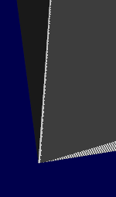*

*This one is very easy to fix : simply avoid thin geometry. This has two advantages :*

* *First, it solves Peter Panning : if the geometry is more deep than your bias, you’re all set.*
* *Second, you can turn on backface culling when rendering the lightmap, because now, there is a polygon of the wall which is facing the light, which will occlude the other side, which wouldn’t be rendered with backface culling.*

*The drawback is that you have more triangles to render ( two times per frame ! )*

*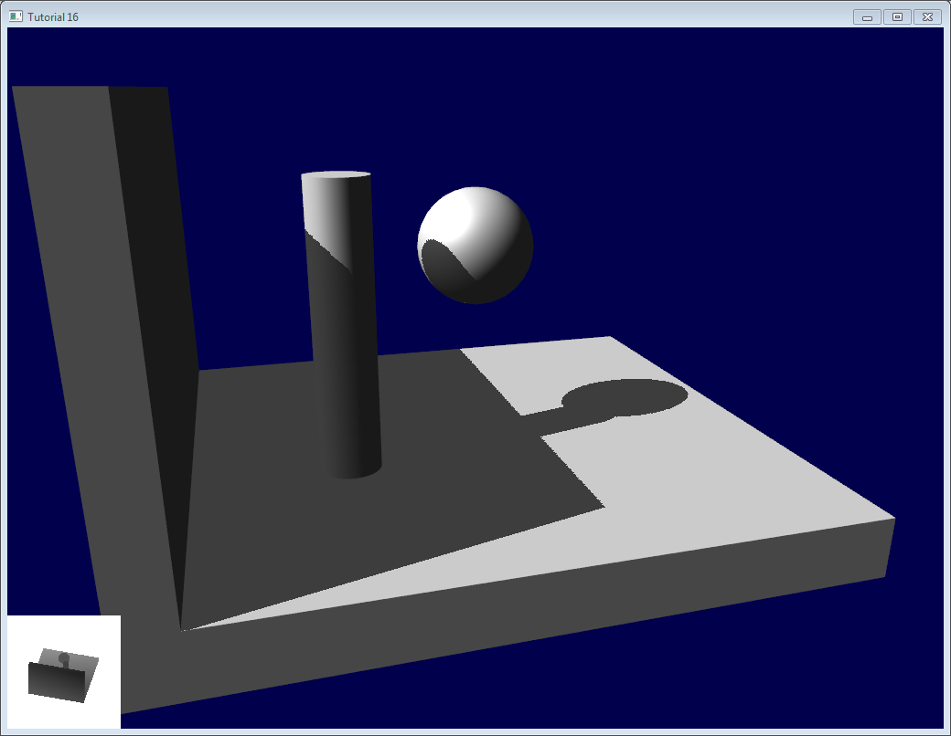*

#### Aliasing

*Even with these two tricks, you’ll notice that there is still aliasing on the border of the shadow. In other words, one pixel is white, and the next is black, without a smooth transition inbetween.*

**

##### *PCF*

*The easiest way to improve this is to change the shadowmap’s sampler type to sampler2DShadow. The consequence is that when you sample the shadowmap once, the hardware will in fact also sample the neighboring texels, do the comparison for all of them, and return a float in [0,1] with a bilinear filtering of the comparison results.*

*For instance, 0.5 means that 2 samples are in the shadow, and 2 samples are in the light.*

*Note that it’s not the same than a single sampling of a filtered depth map ! A comparison always returns true or false; PCF gives a interpolation of 4 “true or false”.*

**

*As you can see, shadow borders are smooth, but shadowmap’s texels are still visible.*

##### *Poisson Sampling*

*An easy way to deal with this is to sample the shadowmap N times instead of once. Used in combination with PCF, this can give very good results, even with a small N. Here’s the code for 4 samples :*

***for*** *(****int*** *i****=****0;i****<****4;i****++****){*

***if*** *( texture( shadowMap, ShadowCoord.xy* ***+*** *poissonDisk[i]****/****700.0 ).z* ***<*** *ShadowCoord.z****-****bias ){*

*visibility****-=****0.2;*

*}*

*}*

*poissonDisk is a constant array defines for instance as follows :*

***vec2*** *poissonDisk[4]* ***=******vec2****[](*

***vec2****(* ***-****0.94201624,* ***-****0.39906216 ),*

***vec2****( 0.94558609,* ***-****0.76890725 ),*

***vec2****(* ***-****0.094184101,* ***-****0.92938870 ),*

***vec2****( 0.34495938, 0.29387760 )*

*);*

*This way, depending on how many shadowmap samples will pass, the generated fragment will be more or less dark :*

*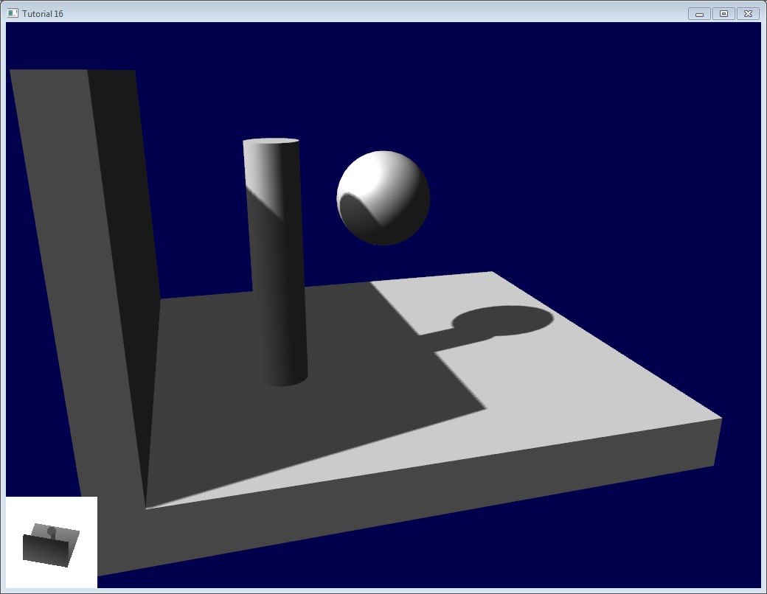*

*The 700.0 constant defines how much the samples are “spread”. Spread them too little, and you’ll get aliasing again; too much, and you’ll get this :\* banding (this screenshot doesn’t use PCF for a more dramatic effect, but uses 16 samples instead) \**

*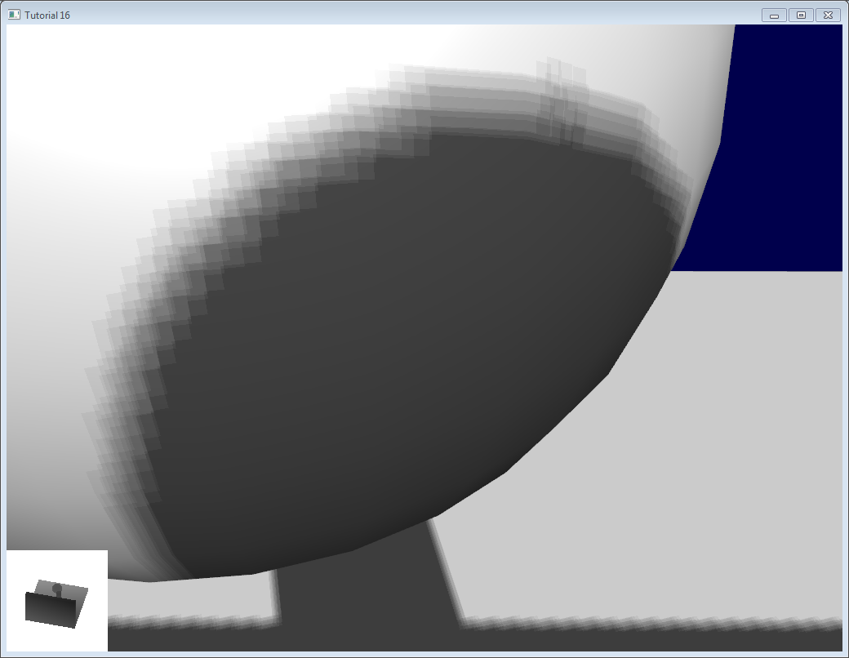*

*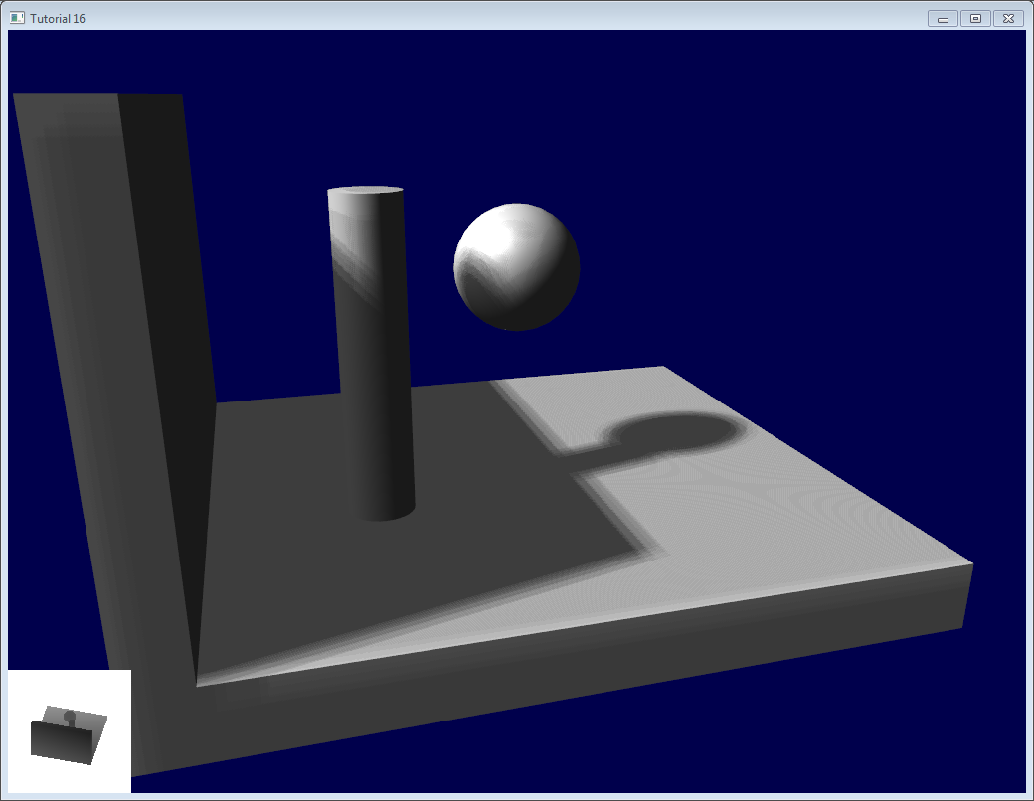*

#### Stratified Poisson Sampling

*We can remove this banding by choosing different samples for each pixel. There are two main methods : Stratified Poisson or Rotated Poisson. Stratified chooses different samples; Rotated always use the same, but with a random rotation so that they look different. In this tutorial I will only explain the stratified version.*

*// усё.. я зноў трошку страціў ніць разваг… //*

*The only difference with the previous version is that we index poissonDisk with a random index :*

***for*** *(****int*** *i****=****0;i****<****4;i****++****){*

***int*** *index* ***=*** *// A random number between 0 and 15, different for each pixel (and each i !)*

*visibility* ***-=*** *0.2****\*****(1.0****-****texture( shadowMap,* ***vec3****(ShadowCoord.xy* ***+*** *poissonDisk[index]****/****700.0, (ShadowCoord.z****-****bias)****/****ShadowCoord.w) ));*

*}*

*We can generate a random number with a code like this, which returns a random number in [0,1[ :*

***float*** *dot\_product* ***=*** *dot(seed4,* ***vec4****(12.9898,78.233,45.164,94.673));*

***return*** *fract(sin(dot\_product)* ***\**** *43758.5453);*

*In our case, seed4 will be the combination of i (so that we sample at 4 different locations) and … something else. We can use gl\_FragCoord ( the pixel’s location on the screen ), or Position\_worldspace :*

*// - A random sample, based on the pixel's screen location.*

*// No banding, but the shadow moves with the camera, which looks weird.*

***int*** *index* ***=******int****(16.0****\*****random(gl\_FragCoord.xyy, i))****%****16;*

*// - A random sample, based on the pixel's position in world space.*

*// The position is rounded to the millimeter to avoid too much aliasing*

*//int index = int(16.0\*random(floor(Position\_worldspace.xyz\*1000.0), i))%16;*

*This will make patterns such as in the picture above disappear, at the expense of visual noise. Still, a well-done noise is often less objectionable than these patterns.*

**

*See*[*tutorial16/ShadowMapping.fragmentshader*](https://github.com/opengl-tutorials/ogl/blob/master/tutorial16_shadowmaps/ShadowMapping.fragmentshader)*for three example implementions.*

## *Going further*

*Even with all these tricks, there are many, many ways in which our shadows could be improved. Here are the most common :*

### *Early bailing*

*Instead of taking 16 samples for each fragment (again, it’s a lot), take 4 distant samples. If all of them are in the light or in the shadow, you can probably consider that all 16 samples would have given the same result : bail early. If some are different, you’re probably on a shadow boundary, so the 16 samples are needed.*

*// што такое сэмплы? //*

### *Spot lights*

*Dealing with spot lights requires very few changes. The most obvious one is to change the orthographic projection matrix into a perspective projection matrix : // intbu better the main idea //*

*glm****::****vec3 lightPos(5, 20, 20);*

*glm****::****mat4 depthProjectionMatrix* ***=*** *glm****::****perspective****<float>****(45.0f, 1.0f, 2.0f, 50.0f);*

*glm****::****mat4 depthViewMatrix* ***=*** *glm****::****lookAt(lightPos, lightPos****-****lightInvDir, glm****::****vec3(0,1,0));*

*same thing, but with a perspective frustum instead of an orthographic frustum. Use texture2Dproj to account for perspective-divide (see footnotes in tutorial 4 - Matrices)*

*The second step is to take into account the perspective in the shader. (see footnotes in tutorial 4 - Matrices. In a nutshell, a perspective projection matrix actually doesn’t do any perspective at all. This is done by the hardware, by dividing the projected coordinates by w. Here, we emulate the transformation in the shader, so we have to do the perspective-divide ourselves. By the way, an orthographic matrix always generates homogeneous vectors with w=1, which is why they don’t produce any perspective)*

*Here are two way to do this in GLSL. The second uses the built-in textureProj function, but both methods produce exactly the same result.*

***if*** *( texture( shadowMap, (ShadowCoord.xy****/****ShadowCoord.w) ).z* ***<*** *(ShadowCoord.z****-****bias)****/****ShadowCoord.w )*

***if*** *( textureProj( shadowMap, ShadowCoord.xyw ).z* ***<*** *(ShadowCoord.z****-****bias)****/****ShadowCoord.w )*

*Point lights*

*Same thing, but with depth cubemaps. A cubemap is a set of 6 textures, one on each side of a cube; what’s more, it is not accessed with standard UV coordinates, but with a 3D vector representing a direction.*

*The depth is stored for all directions in space, which make possible for shadows to be cast all around the point light.*

### *Combination of several lights*

*The algorithm handles several lights, but keep in mind that each light requires an additional rendering of the scene in order to produce the shadowmap. This will require an enormous amount of memory when applying the shadows, and you might become bandwidth-limited very quickly.*

### *Automatic light frustum*

*In this tutorial, the light frustum hand-crafted to contain the whole scene. While this works in this restricted example, it should be avoided. If your map is 1Km x 1Km, each texel of your 1024x1024 shadowmap will take 1 square meter; this is lame. The projection matrix of the light should be as tight as possible.*

*For spot lights, this can be easily changed by tweaking its range.*

*Directional lights, like the sun, are more tricky : they really do illuminate the whole scene. Here’s a way to compute a the light frustum :*

1. *Potential Shadow Receivers, or PSRs for short, are objects which belong at the same time to the light frustum, to the view frustum, and to the scene bounding box. As their name suggest, these objects are susceptible to be shadowed : they are visible by the camera and by the light.*
2. *Potential Shadow Casters, or PCFs, are all the Potential Shadow Receivers, plus all objects which lie between them and the light (an object may not be visible but still cast a visible shadow).*

*So, to compute the light projection matrix, take all visible objects, remove those which are too far away, and compute their bounding box; Add the objects which lie between this bounding box and the light, and compute the new bounding box (but this time, aligned along the light direction).*

*Precise computation of these sets involve computing convex hulls intersections, but this method is much easier to implement.*

*This method will result in popping when objects disappear from the frustum, because the shadowmap resolution will suddenly increase. Cascaded Shadow Maps don’t have this problem, but are harder to implement, and you can still compensate by smoothing the values over time.*

### *Exponential shadow maps*

*Exponential shadow maps try to limit aliasing by assuming that a fragment which is in the shadow, but near the light surface, is in fact “somewhere in the middle”. This is related to the bias, except that the test isn’t binary anymore : the fragment gets darker and darker when its distance to the lit surface increases.*

*This is cheating, obviously, and artefacts can appear when two objects overlap.*

### *Light-space perspective Shadow Maps*

*LiSPSM tweaks the light projection matrix in order to get more precision near the camera. This is especially important in case of “duelling frustra” : you look in a direction, but a spot light “looks” in the opposite direction. You have a lot of shadowmap precision near the light, i.e. far from you, and a low resolution near the camera, where you need it the most.*

*However LiSPM is tricky to implement. See the references for details on the implementation.*

### *Cascaded shadow maps*

*CSM deals with the exact same problem than LiSPSM, but in a different way. It simply uses several (2-4) standard shadow maps for different parts of the view frustum. The first one deals with the first meters, so you’ll get great resolution for a quite little zone. The next shadowmap deals with more distant objects. The last shadowmap deals with a big part of the scene, but due tu the perspective, it won’t be more visually important than the nearest zone.*

*Cascarded shadow maps have, at time of writing (2012), the best complexity/quality ratio. This is the solution of choice in many cases.*

## *Conclusion*

*As you can see, shadowmaps are a complex subject. Every year, new variations and improvement are published, and to day, no solution is perfect.*

*Fortunately, most of the presented methods can be mixed together : It’s perfectly possible to have Cascaded Shadow Maps in Light-space Perspective, smoothed with PCF… Try experimenting with all these techniques. // метад работы з тэмай //*

*As a conclusion, I’d suggest you to stick to pre-computed lightmaps whenever possible, and to use shadowmaps only for dynamic objects. And make sure that the visual quality of both are equivalent : it’s not good to have a perfect static environment and ugly dynamic shadows, either. // як я разумею, лайтмэпы выкарыстоўваюць для статычных ценяў, а шэдоў мэпы для дынамічных ценяў – варта гэта ўсё лепей зразумець потым //*

[*http://www.opengl-tutorial.org/intermediate-tutorials/tutorial-17-quaternions/*](http://www.opengl-tutorial.org/intermediate-tutorials/tutorial-17-quaternions/)

# *Tutorial 17 : Rotations*

*09.07.2017*

*This tutorial goes a bit outside the scope of OpenGL, but nevertheless tackles a very common problem: how to represent rotations ?*

*In Tutorial 3 - Matrices, we learnt that matrices are able to rotate a point around a specific axis. While matrices are a neat way to transform vertices, handling matrices is difficult: for instance, getting the rotation axis from the final matrix is quite tricky.*

*We will present the two most common ways to represent rotation: Euler angles and Quaternions. Most importantly, we will explain why you should probably use Quaternions.*

*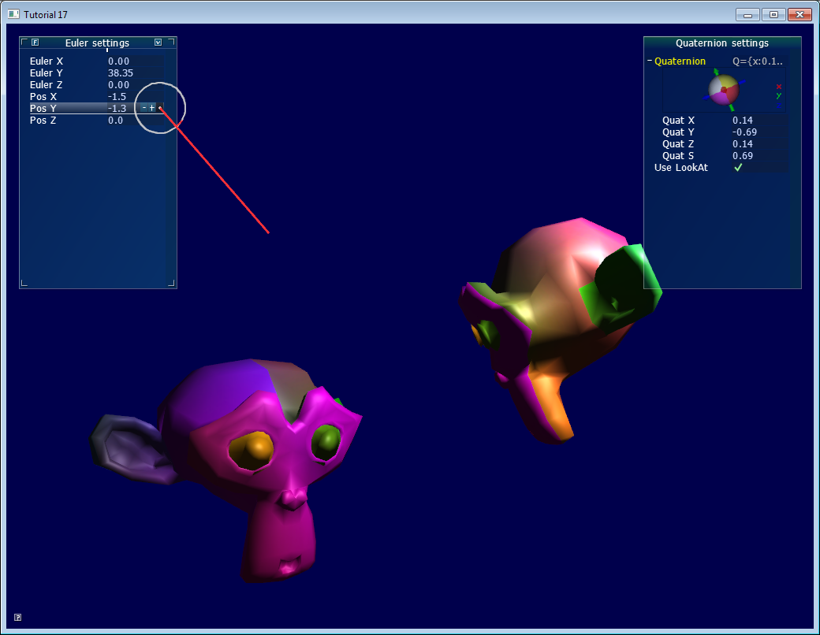*

## *Foreword: rotation VS orientation*

*While reading articles on rotations, you might get confused because of the vocabulary. In this tutorial:*

* *An orientation is a state: “the object’s orientation is…”*
* *A rotation is an operation: “Apply this rotation to the object”*

*That is, when you apply a rotation, you change the orientation. Both can be represented with the same tools, which leads to the confusion. Now, let’s get started…*

## *Euler Angles*

*Euler angles are the easiest way to think of an orientation. You basically store three rotations around the X, Y and Z axes. It’s a very simple concept to grasp. You can use a vec3 to store it:*

*vec3 EulerAngles( RotationAroundXInRadians, RotationAroundYInRadians, RotationAroundZInRadians);*

*These 3 rotations are then applied successively, usually in this order: first Y, then Z, then X (but not necessarily). Using a different order yields different results.*

*One simple use of Euler angles is setting a character’s orientation. Usually game characters do not rotate on X and Z, only on the vertical axis. Therefore, it’s easier to write, understand and maintain “float direction;” than 3 different orientations.*

*Another good use of Euler angles is an FPS camera: you have one angle for the heading (Y), and one for up/down (X). See*[*common/controls.cpp*](https://github.com/opengl-tutorials/ogl/blob/master/common/controls.cpp)*for an example.*

*However, when things get more complex, Euler angle will be hard to work with. For instance:*

* *Interpolating smoothly between 2 orientations is hard. Naively interpolating the X,Y and Z angles will be ugly.*
* *Applying several rotations is complicated and unprecise: you have to compute the final rotation matrix, and guess the Euler angles from this matrix*
* *A well-known problem, the “Gimbal Lock”, will sometimes block your rotations, and other singularities which will flip your model upside-down.*
* *Different angles make the same rotation ( -180° and 180°, for instance )*
* *It’s a mess - as said above, usually the right order is YZX, but if you also use a library with a different order, you’ll be in trouble.*
* *Some operations are complicated: for instance, rotation of N degrees around a specific axis.*

*Quaternions are a tool to represent rotations, which solves these problems.*

## *Quaternions*

*A quaternion is a set of 4 numbers, [x y z w], which represents rotations the following way:*

*// RotationAngle is in radians*

*x* ***=*** *RotationAxis.x* ***\**** *sin(RotationAngle* ***/*** *2)*

*y* ***=*** *RotationAxis.y* ***\**** *sin(RotationAngle* ***/*** *2)*

*z* ***=*** *RotationAxis.z* ***\**** *sin(RotationAngle* ***/*** *2)*

*w* ***=*** *cos(RotationAngle* ***/*** *2)*

*RotationAxis is, as its name implies, the axis around which you want to make your rotation.*

*RotationAngle is the angle of rotation around this axis.*

*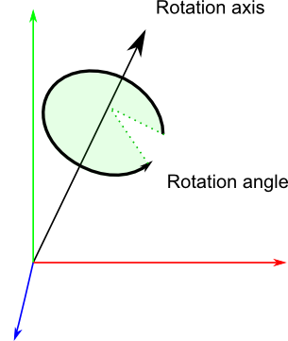*

*So essentially quaternions store a rotation axis and a rotation angle, in a way that makes combining rotations easy.*

### *Reading quaternions*

*This format is definitely less intuitive than Euler angles, but it’s still readable: the xyz components match roughly the rotation axis, and w is the acos of the rotation angle (divided by 2). For instance, imagine that you see the following values in the debugger: [ 0.7 0 0 0.7 ]. x=0.7, it’s bigger than y and z, so you know it’s mostly a rotation around the X axis; and 2\*acos(0.7) = 1.59 radians, so it’s a rotation of 90°.*

*Similarly, [0 0 0 1] (w=1) means that angle = 2\*acos(1) = 0, so this is a unit quaternion, which makes no rotation at all.*

### *Basic operations*

*Knowing the math behind the quaternions is rarely useful: the representation is so unintuitive that you usually only rely on utility functions which do the math for you. If you’re interested, see the math books in the*[*Useful Tools & Links*](http://www.opengl-tutorial.org/miscellaneous/useful-tools-links/)*page.*

### *How do I create a quaternion in C++ ?*

*// Don't forget to #include <glm/gtc/quaternion.hpp> and <glm/gtx/quaternion.hpp>*

*// Creates an identity quaternion (no rotation)*

*quat MyQuaternion;*

*// Direct specification of the 4 components*

*// You almost never use this directly*

*MyQuaternion* ***=*** *quat(w,x,y,z);*

*// Conversion from Euler angles (in radians) to Quaternion*

*vec3 EulerAngles(90, 45, 0);*

*MyQuaternion* ***=*** *quat(EulerAngles);*

*// Conversion from axis-angle*

*// In GLM the angle must be in degrees here, so convert it.*

*MyQuaternion* ***=*** *gtx****::****quaternion****::****angleAxis(degrees(RotationAngle), RotationAxis);*

### *How do I create a quaternion in GLSL ?*

*You don’t. Convert your quaternion to a rotation matrix, and use it in the Model Matrix. Your vertices will be rotated as usual, with the MVP matrix.*

*In some cases, you might actually want to use quaternions in GLSL, for instance if you do skeletal animation on the GPU. There is no quaternion type in GLSL, but you can pack one in a vec4, and do the math yourself in the shader.*

### *How do I convert a quaternion to a matrix ?*

*mat4 RotationMatrix* ***=*** *quaternion****::****toMat4(quaternion);*

*You can now use it to build your Model matrix as usual:*

*mat4 RotationMatrix* ***=*** *quaternion****::****toMat4(quaternion);*

*...*

*mat4 ModelMatrix* ***=*** *TranslationMatrix* ***\**** *RotationMatrix* ***\**** *ScaleMatrix;*

*// You can now use ModelMatrix to build the MVP matrix*

## *So, which one should I choose ?*

*Choosing between Euler angles and quaternions is tricky. Euler angles are intuitive for artists, so if you write some 3D editor, use them. But quaternions are handy for programmers, and faster too, so you should use them in a 3D engine core. // кантэкст выкарыстання паняцця //*

*The general consensus is exactly that: use quaternions internally, and expose Euler angles whenever you have some kind of user interface. // рэкамендацыя //*

*You will be able to handle all you will need (or at least, it will be easier), and you can still use Euler angles for entities that require it ( as said above: the camera, humanoids, and that’s pretty much it) with a simple conversion.*

## *Other resources*

* *The books on*[*Useful Tools & Links*](http://www.opengl-tutorial.org/miscellaneous/useful-tools-links/)*!*
* *As old as it can be, Game Programming Gems 1 has several awesome articles on quaternions. You can probably find them online too.*
* *A*[*GDC presentation*](http://www.essentialmath.com/GDC2012/GDC2012_JMV_Rotations.pdf)*on rotations*
* *The Game Programing Wiki’s*[*Quaternion tutorial*](http://content.gpwiki.org/index.php/OpenGL:Tutorials:Using_Quaternions_to_represent_rotation)
* *Ogre3D’s*[*FAQ on quaternions*](http://www.ogre3d.org/tikiwiki/Quaternion+and+Rotation+Primer)*. Most of the 2nd part is ogre-specific, though.*
* *Ogre3D’s*[*Vector3D.h*](https://bitbucket.org/sinbad/ogre/src/3cbd67467fab3fef44d1b32bc42ccf4fb1ccfdd0/OgreMain/include/OgreVector3.h?at=default)*and*[*Quaternion.cpp*](https://bitbucket.org/sinbad/ogre/src/3cbd67467fab3fef44d1b32bc42ccf4fb1ccfdd0/OgreMain/src/OgreQuaternion.cpp?at=default)

## *Cheat-sheet*

### *How do I know if two quaternions are similar ?*

*When using vector, the dot product gives the cosine of the angle between these vectors. If this value is 1, then the vectors are in the same direction.*

*With quaternions, it’s exactly the same:*

***float*** *matching* ***=*** *quaternion****::****dot(q1, q2);*

***if*** *( abs(matching****-****1.0)* ***<*** *0.001 ){*

*// q1 and q2 are similar*

*}*

*You can also get the angle between q1 and q2 by taking the acos() of this dot product.*

## *How do I apply a rotation to a point ?*

*You can do the following:*

*rotated\_point* ***=*** *orientation\_quaternion* ***\**** *point;*

*… but if you want to compute your Model Matrix, you should probably convert it to a matrix instead.*

*Note that the center of rotation is always the origin. If you want to rotate around another point:*

*rotated\_point* ***=*** *origin* ***+*** *(orientation\_quaternion* ***\**** *(point****-****origin));*

### *How do I interpolate between 2 quaternions ?*

*This is called a SLERP: Spherical Linear intERPolation. With GLM, you can do this with mix:*

*glm****::****quat interpolatedquat* ***=*** *quaternion****::****mix(quat1, quat2, 0.5f); // or whatever factor*

### *How do I cumulate 2 rotations ?*

*Simple ! Just multiply the two quaternions together. The order is the same as for matrices, i.e. reverse: // intbu better //*

*quat combined\_rotation* ***=*** *second\_rotation* ***\**** *first\_rotation;*

### *How do I find the rotation between 2 vectors ?*

*(in other words: the quaternion needed to rotate v1 so that it matches v2)*

*The basic idea is straightforward:*

* *The angle between the vectors is simple to find: the dot product gives its cosine.*
* *The needed axis is also simple to find: it’s the cross product of the two vectors.*

*The following algorithm does exactly this, but also handles a number of special cases: // не глядзеў //*

*quat RotationBetweenVectors(vec3 start, vec3 dest){*

*start* ***=*** *normalize(start);*

*dest* ***=*** *normalize(dest);*

***float*** *cosTheta* ***=*** *dot(start, dest);*

*vec3 rotationAxis;*

***if*** *(cosTheta* ***<******-****1* ***+*** *0.001f){*

*// special case when vectors in opposite directions:*

*// there is no "ideal" rotation axis*

*// So guess one; any will do as long as it's perpendicular to start*

*rotationAxis* ***=*** *cross(vec3(0.0f, 0.0f, 1.0f), start);*

***if*** *(gtx****::****norm****::****length2(rotationAxis)* ***<*** *0.01 ) // bad luck, they were parallel, try again!*

*rotationAxis* ***=*** *cross(vec3(1.0f, 0.0f, 0.0f), start);*

*rotationAxis* ***=*** *normalize(rotationAxis);*

***return*** *gtx****::****quaternion****::****angleAxis(180.0f, rotationAxis);*

*}*

*rotationAxis* ***=*** *cross(start, dest);*

***float*** *s* ***=*** *sqrt( (1****+****cosTheta)****\*****2 );*

***float*** *invs* ***=*** *1* ***/*** *s;*

***return*** *quat(*

*s* ***\**** *0.5f,*

*rotationAxis.x* ***\**** *invs,*

*rotationAxis.y* ***\**** *invs,*

*rotationAxis.z* ***\**** *invs*

*);*

*}*

*(You can find this function in*[*common/quaternion\_utils.cpp*](https://github.com/opengl-tutorials/ogl/blob/master/common/quaternion_utils.cpp)*)*

### *I need an equivalent of gluLookAt. How do I orient an object towards a point ?*

*Use RotationBetweenVectors ! // пакуль што не глядзеў… //*

*// Find the rotation between the front of the object (that we assume towards +Z,*

*// but this depends on your model) and the desired direction*

*quat rot1* ***=*** *RotationBetweenVectors(vec3(0.0f, 0.0f, 1.0f), direction);*

*Now, you might also want to force your object to be upright:*

*// Recompute desiredUp so that it's perpendicular to the direction*

*// You can skip that part if you really want to force desiredUp*

*vec3 right* ***=*** *cross(direction, desiredUp);*

*desiredUp* ***=*** *cross(right, direction);*

*// Because of the 1rst rotation, the up is probably completely screwed up.*

*// Find the rotation between the "up" of the rotated object, and the desired up*

*vec3 newUp* ***=*** *rot1* ***\**** *vec3(0.0f, 1.0f, 0.0f);*

*quat rot2* ***=*** *RotationBetweenVectors(newUp, desiredUp);*

*Now, combine them:*

*quat targetOrientation* ***=*** *rot2* ***\**** *rot1; // remember, in reverse order.*

*Beware, “direction” is, well, a direction, not the target position ! But you can compute the position simply: targetPos - currentPos.*

*Once you have this target orientation, you will probably want to interpolate between startOrientation and targetOrientation.*

*(You can find this function in common/quaternion\_utils.cpp)*

### *How do I use LookAt, but limit the rotation at a certain speed ?*

*The basic idea is to do a SLERP ( = use glm::mix ), but play with the interpolation value so that the angle is not bigger than the desired value: // Intbu better //*

***float*** *mixFactor* ***=*** *maxAllowedAngle* ***/*** *angleBetweenQuaternions;*

*quat result* ***=*** *glm****::****gtc****::****quaternion****::****mix(q1, q2, mixFactor);*

*Here is a more complete implementation, which deals with many special cases. Note that it doesn’t use mix() directly as an optimization. // не глядзеў, бо мала часу і сумняваюся ў якасці аўтарскіх радкоў… //*

*quat RotateTowards(quat q1, quat q2,* ***float*** *maxAngle){*

***if****( maxAngle* ***<*** *0.001f ){*

*// No rotation allowed. Prevent dividing by 0 later.*

***return*** *q1;*

*}*

***float*** *cosTheta* ***=*** *dot(q1, q2);*

*// q1 and q2 are already equal.*

*// Force q2 just to be sure*

***if****(cosTheta* ***>*** *0.9999f){*

***return*** *q2;*

*}*

*// Avoid taking the long path around the sphere*

***if*** *(cosTheta* ***<*** *0){*

*q1* ***=*** *q1****\*-****1.0f;*

*cosTheta* ***\*=******-****1.0f;*

*}*

***float*** *angle* ***=*** *acos(cosTheta);*

*// If there is only a 2&deg; difference, and we are allowed 5&deg;,*

*// then we arrived.*

***if*** *(angle* ***<*** *maxAngle){*

***return*** *q2;*

*}*

***float*** *fT* ***=*** *maxAngle* ***/*** *angle;*

*angle* ***=*** *maxAngle;*

*quat res* ***=*** *(sin((1.0f* ***-*** *fT)* ***\**** *angle)* ***\**** *q1* ***+*** *sin(fT* ***\**** *angle)* ***\**** *q2)* ***/*** *sin(angle);*

*res* ***=*** *normalize(res);*

***return*** *res;*

*}*

*You can use it like that:*

*CurrentOrientation* ***=*** *RotateTowards(CurrentOrientation, TargetOrientation, 3.14f* ***\**** *deltaTime );*

*(You can find this function in common/quaternion\_utils.cpp)*

### *How do I…*

*If you can’t figure it out, drop us an email, and we’ll add it to the list !*

[*http://www.opengl-tutorial.org/intermediate-tutorials/billboards-particles/billboards/*](http://www.opengl-tutorial.org/intermediate-tutorials/billboards-particles/billboards/)

# *Billboards*

*Billboards are 2D elements incrusted in a 3D world. Not a 2D menu on top of everything else; not a 3D plane around which you can turn; but something in-between, like health bars in many games.*

*What’s different with billboards is that they are positionned at a specific location, but their orientation is automatically computed so that it always faces the camera.*

## *Solution #1 : The 2D way*

*This one is supra-easy.*

*Just compute where your point is on screen, and display a 2D text (see Tutorial 11) at this position.*

*// Everything here is explained in Tutorial 3 ! There's nothing new.*

*glm****::****vec4 BillboardPos\_worldspace(x,y,z, 1.0f);*

*glm****::****vec4 BillboardPos\_screenspace* ***=*** *ProjectionMatrix* ***\**** *ViewMatrix* ***\**** *BillboardPos\_worldspace;*

*BillboardPos\_screenspace* ***/=*** *BillboardPos\_screenspace.w;*

***if*** *(BillboardPos\_screenspace.z* ***<*** *0.0f){*

*// Object is behind the camera, don't display it.*

*}*

*Ta-dah !*

*On the plus side, this method is really easy, and the billboard will have the same size regardless of its distance to the camera. But 2D text is always displayed on top of everything else, and this can/will mess up the rendering and show above other objects.*

## *Solution #2 : The 3D way*

*This one is usually better and not much more complicated.*

*The goal is to keep the mesh aligned with the camera, even when the camera moves :*

**

*You can view this problem as generating an appropriate Model matrix, even though it’s is much simpler than that.*

*The idea is that each corner of the billboard is at the center position, displaced by the camera’s up and right vectors :*

*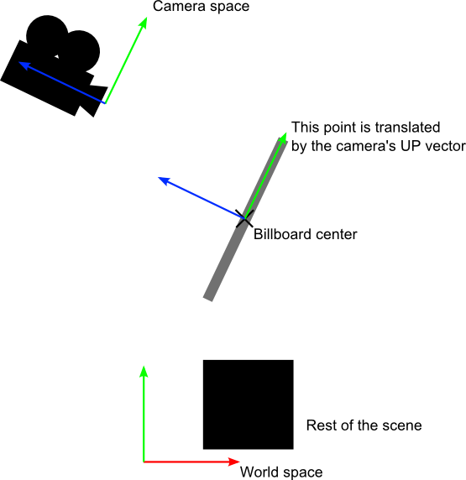*

*// малюнак зразумеў не вельмі //*

*Of course, we only know the billboard’s center position in world space, so we also need the camera’s up/right vectors in world space.*

*In camera space, the camera’s up vector is (0,1,0). To get it in world space, just multiply this by the matrix that goes from Camera Space to World Space, which is, of course, the inverse of the View matrix.*

*An easier way to express the same math is :*

*CameraRight\_worldspace = {ViewMatrix[0][0], ViewMatrix[1][0], ViewMatrix[2][0]}*

*CameraUp\_worldspace = {ViewMatrix[0][1], ViewMatrix[1][1], ViewMatrix[2][1]}*

*Once we have this, it’s very easy to compute the final vertex’ position :*

***vec3*** *vertexPosition\_worldspace* ***=***

*particleCenter\_wordspace*

***+*** *CameraRight\_worldspace* ***\**** *squareVertices.x* ***\**** *BillboardSize.x*

***+*** *CameraUp\_worldspace* ***\**** *squareVertices.y* ***\**** *BillboardSize.y;*

* *particleCenter\_worldspace is, as its name suggests, the billboard’s center position. It is specified with an uniform vec3.*
* *squareVertices is the original mesh. squareVertices.x is -0.5 for the left vertices, which are thus moved towars the left of the camera (because of the \*CameraRight\_worldspace)*
* *BillboardSize is the size, in world units, of the billboard, sent as another uniform.*

*And presto, here's the result. Wasn't this easy ?*

**

*For the record, here’s how squareVertices is made :*

*// The VBO containing the 4 vertices of the particles.*

***static******const*** *GLfloat g\_vertex\_buffer\_data[]* ***=*** *{*

***-****0.5f,* ***-****0.5f, 0.0f,*

*0.5f,* ***-****0.5f, 0.0f,*

***-****0.5f, 0.5f, 0.0f,*

*0.5f, 0.5f, 0.0f,*

*};*

## *Solution #3 : The fixed-size 3D way*

*As you can see above, the size of the billboard changes with respect to the camera’s distance. This is the expected result in some cases, but in others, such as health bars, you probably want a fixed-size instead.*

*Since the displacement between the center and a corner must be fixed in screen-space, that’s exactly what we’re going to do : compute the center’s position in screen space, and offset it.*

*vertexPosition\_worldspace* ***=*** *particleCenter\_wordspace;*

*// Get the screen-space position of the particle's center*

*gl\_Position* ***=*** *VP* ***\**** *vec4(vertexPosition\_worldspace, 1.0f);*

*// Here we have to do the perspective division ourselves.*

*gl\_Position* ***/=*** *gl\_Position.w;*

*// Move the vertex in directly screen space. No need for CameraUp/Right\_worlspace here.*

*gl\_Position.xy* ***+=*** *squareVertices.xy* ***\**** *vec2(0.2, 0.05);*

*Remember that at this stage of the rendering pipeline, you’re in Normalized Device Coordinates, so between -1 and 1 on both axes : it’s not in pixels.*

*If you want a size in pixels, easy : just use (ScreenSizeInPixels / BillboardSizeInPixels) instead of BillboardSizeInScreenPercentage.*

**

## *Solution #4 : Vertical rotation only*

*Some systems model faraway trees and lamps as billboards. But you really, really don’t want your tree to be bent : it MUST be vertical. So you need an hybrid system that rotates only around one axis.*

*Well, this one is left as an exercise to the reader !*

*// аўтар не вельмі ясна выказваецца наконт таго, што ён хоча сказаць. Не самы якасны цьютарал. Але што такое білборды, я ўцяміў //*

[*http://www.opengl-tutorial.org/intermediate-tutorials/billboards-particles/particles-instancing/*](http://www.opengl-tutorial.org/intermediate-tutorials/billboards-particles/particles-instancing/)

# *Particles / Instancing*

*Particles are very similar to 3D billboards. There are two major differences, though :*

* *there is usually a LOT of them*
* *they move*
* *the appear and die.*
* *they are semi-transparent*

*Both of these difference come with problems. This tutorial will present ONE way to solve them; there are many other possibilities.*

## *Particles, lots of them !*

*The first idea to draw many particles would be to use the previous tutorial’s code, and call glDrawArrays once for each particle. This is a very bad idea, because this means that all your shiny GTX’ 512+ multiprocessors will all be dedicated to draw ONE quad (obviously, only one will be used, so that’s 99% efficiency loss). Then you will draw the second billboard, and it will be the same.*

*Clearly, we need a way to draw all particles at the same time.*

*There are many ways to do this; here are three of them :*

* *Generate a single VBO with all the particles in them. Easy, effective, works on all platforms.*
* *Use geometry shaders. Not in the scope of this tutorial, mostly because 50% of the computers don’t support this.*
* *Use instancing. Not available on ALL computers, but a vast majority of them.*

*In this tutorial, we’ll use the 3rd option, because it is a nice balance between performance and availability, and on top of that, it’s easy to add support for the first method once this one works.*

## *Instancing*

*“Instancing” means that we have a base mesh (in our case, a simple quad of 2 triangles), but many instances of this quad.*

*Technically, it’s done via several buffers:*

* *Some of them describe the base mesh*
* *Some of them describe the particularities of each instance of the base mesh.*

*You have many, many options on what to put in each buffer. In our simple case, we have:*

* *One buffer for the vertices of the mesh. No index buffer, so it’s 6 vec3, which make 2 triangles, which make 1 quad.*
* *One buffer for the particles’ centers.*
* *One buffer for the particles’ colors.*

*These are very standard buffers. They are created this way:*

*// The VBO containing the 4 vertices of the particles.*

*// Thanks to instancing, they will be shared by all particles.*

***static******const*** *GLfloat g\_vertex\_buffer\_data[]* ***=*** *{*

***-****0.5f,* ***-****0.5f, 0.0f,*

*0.5f,* ***-****0.5f, 0.0f,*

***-****0.5f, 0.5f, 0.0f,*

*0.5f, 0.5f, 0.0f,*

*};*

*GLuint billboard\_vertex\_buffer;*

*glGenBuffers(1,* ***&****billboard\_vertex\_buffer);*

*glBindBuffer(GL\_ARRAY\_BUFFER, billboard\_vertex\_buffer);*

*glBufferData(GL\_ARRAY\_BUFFER,* ***sizeof****(g\_vertex\_buffer\_data), g\_vertex\_buffer\_data, GL\_STATIC\_DRAW);*

*// The VBO containing the positions and sizes of the particles*

*GLuint particles\_position\_buffer;*

*glGenBuffers(1,* ***&****particles\_position\_buffer);*

*glBindBuffer(GL\_ARRAY\_BUFFER, particles\_position\_buffer);*

*// Initialize with empty (NULL) buffer : it will be updated later, each frame.*

*glBufferData(GL\_ARRAY\_BUFFER, MaxParticles* ***\**** *4* ***\*******sizeof****(GLfloat), NULL, GL\_STREAM\_DRAW);*

*// The VBO containing the colors of the particles*

*GLuint particles\_color\_buffer;*

*glGenBuffers(1,* ***&****particles\_color\_buffer);*

*glBindBuffer(GL\_ARRAY\_BUFFER, particles\_color\_buffer);*

*// Initialize with empty (NULL) buffer : it will be updated later, each frame.*

*glBufferData(GL\_ARRAY\_BUFFER, MaxParticles* ***\**** *4* ***\*******sizeof****(GLubyte), NULL, GL\_STREAM\_DRAW);*

*, which is as usual. They are updated this way :*

*// Update the buffers that OpenGL uses for rendering.*

*// There are much more sophisticated means to stream data from the CPU to the GPU,*

*// but this is outside the scope of this tutorial.*

*// http://www.opengl.org/wiki/Buffer\_Object\_Streaming*

*glBindBuffer(GL\_ARRAY\_BUFFER, particles\_position\_buffer);*

*glBufferData(GL\_ARRAY\_BUFFER, MaxParticles* ***\**** *4* ***\*******sizeof****(GLfloat), NULL, GL\_STREAM\_DRAW); // Buffer orphaning, a common way to improve streaming perf. See above link for details.*

*glBufferSubData(GL\_ARRAY\_BUFFER, 0, ParticlesCount* ***\*******sizeof****(GLfloat)* ***\**** *4, g\_particule\_position\_size\_data);*

*glBindBuffer(GL\_ARRAY\_BUFFER, particles\_color\_buffer);*

*glBufferData(GL\_ARRAY\_BUFFER, MaxParticles* ***\**** *4* ***\*******sizeof****(GLubyte), NULL, GL\_STREAM\_DRAW); // Buffer orphaning, a common way to improve streaming perf. See above link for details.*

*glBufferSubData(GL\_ARRAY\_BUFFER, 0, ParticlesCount* ***\*******sizeof****(GLubyte)* ***\**** *4, g\_particule\_color\_data);*

*, which is as usual. Before render, they are bound this way :*

*// 1rst attribute buffer : vertices*

*glEnableVertexAttribArray(0);*

*glBindBuffer(GL\_ARRAY\_BUFFER, billboard\_vertex\_buffer);*

*glVertexAttribPointer(*

*0, // attribute. No particular reason for 0, but must match the layout in the shader.*

*3, // size*

*GL\_FLOAT, // type*

*GL\_FALSE, // normalized?*

*0, // stride*

*(****void\*****)0 // array buffer offset*

*);*

*// 2nd attribute buffer : positions of particles' centers*

*glEnableVertexAttribArray(1);*

*glBindBuffer(GL\_ARRAY\_BUFFER, particles\_position\_buffer);*

*glVertexAttribPointer(*

*1, // attribute. No particular reason for 1, but must match the layout in the shader.*

*4, // size : x + y + z + size => 4*

*GL\_FLOAT, // type*

*GL\_FALSE, // normalized?*

*0, // stride*

*(****void\*****)0 // array buffer offset*

*);*

*// 3rd attribute buffer : particles' colors*

*glEnableVertexAttribArray(2);*

*glBindBuffer(GL\_ARRAY\_BUFFER, particles\_color\_buffer);*

*glVertexAttribPointer(*

*2, // attribute. No particular reason for 1, but must match the layout in the shader.*

*4, // size : r + g + b + a => 4*

*GL\_UNSIGNED\_BYTE, // type*

*GL\_TRUE, // normalized? \*\*\* YES, this means that the unsigned char[4] will be accessible with a vec4 (floats) in the shader \*\*\**

*0, // stride*

*(****void\*****)0 // array buffer offset*

*);*

*, which is as usual. The difference comes when rendering. Instead of using glDrawArrays (or glDrawElements if your base mesh has an index buffer), you use glDrawArrraysInstanced / glDrawElementsInstanced, which is equivalent to calling glDrawArrays N times (N is the last parameter, in our case ParticlesCount) :*

*glDrawArraysInstanced(GL\_TRIANGLE\_STRIP, 0, 4, ParticlesCount);*

*Bue something is missing here. We didn’t tell OpenGL which buffer was for the base mesh, and which were for the different instances. This is done with glVertexAttribDivisor. Here’s the full commented code :*

*// These functions are specific to glDrawArrays\*Instanced\*.*

*// The first parameter is the attribute buffer we're talking about.*

*// The second parameter is the "rate at which generic vertex attributes advance when rendering multiple instances"*

*// http://www.opengl.org/sdk/docs/man/xhtml/glVertexAttribDivisor.xml*

*glVertexAttribDivisor(0, 0); // particles vertices : always reuse the same 4 vertices -> 0*

*glVertexAttribDivisor(1, 1); // positions : one per quad (its center) -> 1*

*glVertexAttribDivisor(2, 1); // color : one per quad -> 1*

*// Draw the particules !*

*// This draws many times a small triangle\_strip (which looks like a quad).*

*// This is equivalent to :*

*// for(i in ParticlesCount) : glDrawArrays(GL\_TRIANGLE\_STRIP, 0, 4),*

*// but faster.*

*glDrawArraysInstanced(GL\_TRIANGLE\_STRIP, 0, 4, ParticlesCount);*

*As you can see, instancing is very versatile, because you can pass any integer as the AttribDivisor. For instance, with glVertexAttribDivisor(2, 10), each 10 subsequent instances will have the same color.*

*// я гэты код не чытаў, бо мне вельмі цяжка яго ўсвядоміць //*

## *What’s the point?*

*The point is that now, we only have to update a small buffer each frame (the center of the particles) and not a huge mesh. This is a x4 bandwidth gain! // перавагу зразумеў, але тэхнічныя дэталі – не. Таксама мне не ясна, што такое меш… //*

## *Life and death*

*On the contrary to most other objects in the scene, particles die and born at a very high rate. We need a decently fast way to get new particles and to discard them, something better than “new Particle()”.*

### *Creating new particles*

*For this, we will have a big particles container:*

*// CPU representation of a particle*

***struct*** *Particle{*

*glm****::****vec3 pos, speed;*

***unsigned******char*** *r,g,b,a; // Color*

***float*** *size, angle, weight;*

***float*** *life; // Remaining life of the particle. if < 0 : dead and unused.*

*};*

***const******int*** *MaxParticles* ***=*** *100000;*

*Particle ParticlesContainer[MaxParticles];*

*Now, we need a way to create new ones. This function searches linearly in ParticlesContainer, which should be an horrible idea, except that it starts at the last known place, so this function usually returns immediately:*

***int*** *LastUsedParticle* ***=*** *0;*

*// Finds a Particle in ParticlesContainer which isn't used yet.*

*// (i.e. life < 0);*

***int*** *FindUnusedParticle(){*

***for****(****int*** *i****=****LastUsedParticle; i****<****MaxParticles; i****++****){*

***if*** *(ParticlesContainer[i].life* ***<*** *0){*

*LastUsedParticle* ***=*** *i;*

***return*** *i;*

*}*

*}*

***for****(****int*** *i****=****0; i****<****LastUsedParticle; i****++****){*

***if*** *(ParticlesContainer[i].life* ***<*** *0){*

*LastUsedParticle* ***=*** *i;*

***return*** *i;*

*}*

*}*

***return*** *0; // All particles are taken, override the first one*

*}*

*We can now fill ParticlesContainer[particleIndex] with interesting “life”, “color”, “speed” and “position” values. See the code for details, but you can do pretty much anything here. The only interesting bit is, how many particles should we generate each frame ? This is mostly application-dependant, so let’s say 10000 new particles per second (yes, it’s quite a lot) :*

***int*** *newparticles* ***=*** *(****int****)(deltaTime****\*****10000.0);*

*except that you should probably clamp this to a fixed number :*

*// Generate 10 new particule each millisecond,*

*// but limit this to 16 ms (60 fps), or if you have 1 long frame (1sec),*

*// newparticles will be huge and the next frame even longer.*

***int*** *newparticles* ***=*** *(****int****)(deltaTime****\*****10000.0);*

***if*** *(newparticles* ***>*** *(****int****)(0.016f****\*****10000.0))*

*newparticles* ***=*** *(****int****)(0.016f****\*****10000.0);*

*// для мяне гэты код таксама даволі складаны. Таму я пакуль яго не чытаў //*

### *Deleting old particles[[1]](#footnote-1)*

*There’s a trick, see below =)*

*The main simulation loop*

*ParticlesContainer contains both active and “dead” particles, but the buffer that we send to the GPU needs to have only living particles.*

*So we will iterate on each particle, check if it is alive, if it must die, and if everything is allright, add some gravity, and finally copy it in a GPU-specific buffer.*

*// Simulate all particles*

***int*** *ParticlesCount* ***=*** *0;*

***for****(****int*** *i****=****0; i****<****MaxParticles; i****++****){*

*Particle****&*** *p* ***=*** *ParticlesContainer[i]; // shortcut*

***if****(p.life* ***>*** *0.0f){*

*// Decrease life*

*p.life* ***-=*** *delta;*

***if*** *(p.life* ***>*** *0.0f){*

*// Simulate simple physics : gravity only, no collisions*

*p.speed* ***+=*** *glm****::****vec3(0.0f,****-****9.81f, 0.0f)* ***\**** *(****float****)delta* ***\**** *0.5f;*

*p.pos* ***+=*** *p.speed* ***\**** *(****float****)delta;*

*p.cameradistance* ***=*** *glm****::****length2( p.pos* ***-*** *CameraPosition );*

*//ParticlesContainer[i].pos += glm::vec3(0.0f,10.0f, 0.0f) \* (float)delta;*

*// Fill the GPU buffer*

*g\_particule\_position\_size\_data[4****\*****ParticlesCount****+****0]* ***=*** *p.pos.x;*

*g\_particule\_position\_size\_data[4****\*****ParticlesCount****+****1]* ***=*** *p.pos.y;*

*g\_particule\_position\_size\_data[4****\*****ParticlesCount****+****2]* ***=*** *p.pos.z;*

*g\_particule\_position\_size\_data[4****\*****ParticlesCount****+****3]* ***=*** *p.size;*

*g\_particule\_color\_data[4****\*****ParticlesCount****+****0]* ***=*** *p.r;*

*g\_particule\_color\_data[4****\*****ParticlesCount****+****1]* ***=*** *p.g;*

*g\_particule\_color\_data[4****\*****ParticlesCount****+****2]* ***=*** *p.b;*

*g\_particule\_color\_data[4****\*****ParticlesCount****+****3]* ***=*** *p.a;*

*}****else****{*

*// Particles that just died will be put at the end of the buffer in SortParticles();*

*p.cameradistance* ***=******-****1.0f;*

*}*

*ParticlesCount****++****;*

*}*

*}*

*This is what you get. Almost there, but there’s a problem…*

*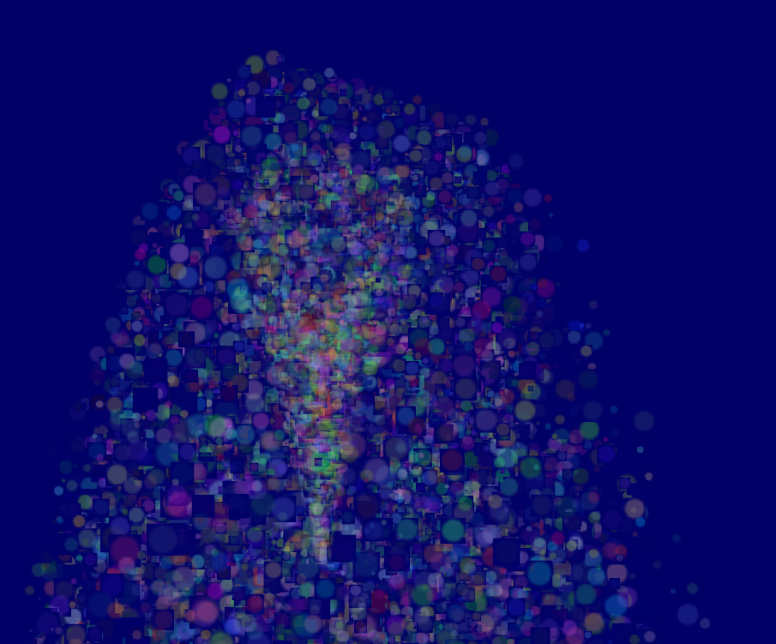*

*Sorting*

*As explained in*[*Tutorial 10*](http://www.opengl-tutorial.org/intermediate-tutorials/tutorial-10-transparency/)*, you need to sort semi-transparent objects from back to front for the blending to be correct.*

***void*** *SortParticles(){*

*std****::****sort(****&****ParticlesContainer[0],* ***&****ParticlesContainer[MaxParticles]);*

*}*

*Now, std::sort needs a function that can tell whether a Particle must be put before or after another Particle in the container. This can be done with Particle::operator< :*

*// CPU representation of a particle*

*struct Particle{*

*...*

*bool operator<(Particle& that){*

*// Sort in reverse order : far particles drawn first.*

*return this->cameradistance > that.cameradistance;*

*}*

*};*

*This will make ParticleContainer be sorted, and the particles now display correctly\*:*

**

*// я не вельмі ўспрымаю гэты складаны код //*

## *Going further*

### *Animated particles*

*You can animate your particles’ texture with a texture atlas. Send the age of each particle along with the position, and in the shaders, compute the UVs like we did for the*[*2D font tutorial*](http://www.opengl-tutorial.org/intermediate-tutorials/tutorial-11-2d-text/)*. A texture atlas looks like this:*

*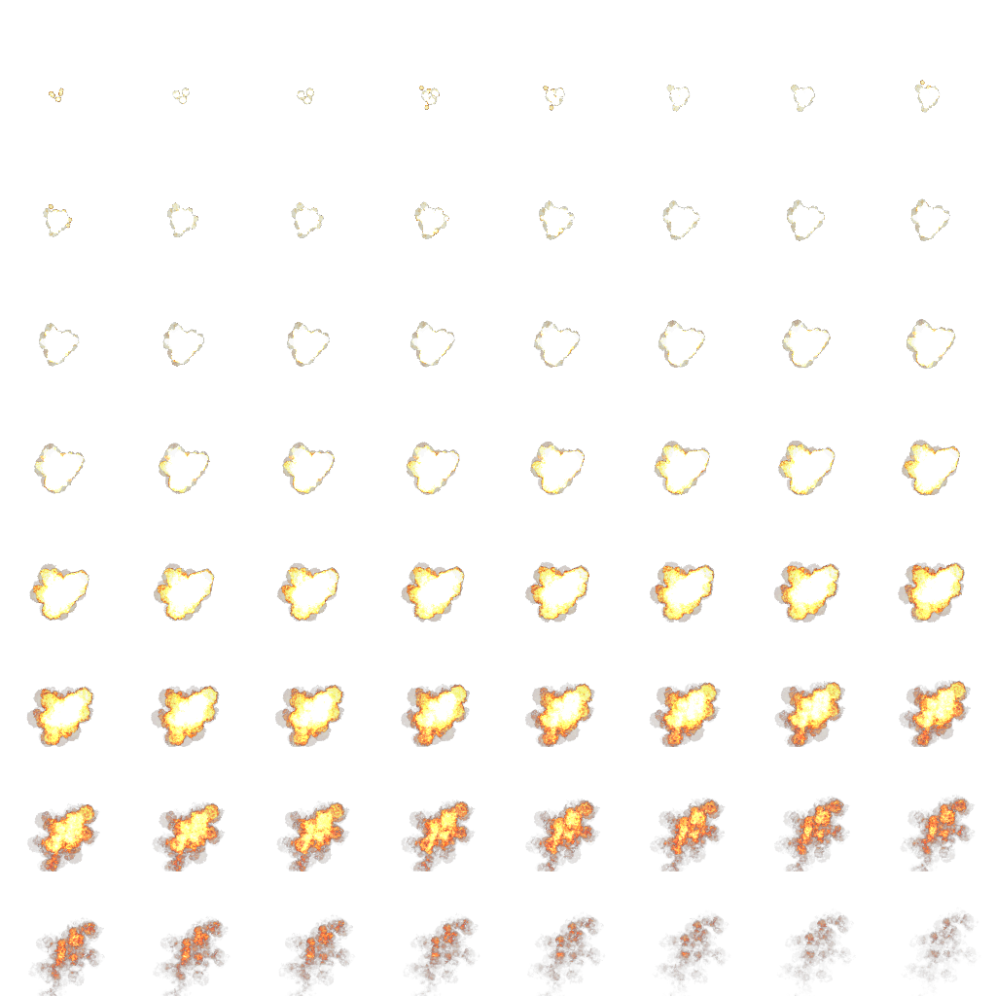*

*// гэта мне зразумела. Мы праз тэкстуру можам апісваць дынаміку візуальных аб’ектаў //*

## *Handling several particle systems*

*If you need more than one particle system, you have two options: either use a single ParticleContainer, or one per system. // арганізацыя мноства сістэмы часцінак //*

*If you have a single container for ALL particles, then you will be able to sort them perfectly. The main drawback is that you’ll have to use the same texture for all particles, which is a big problem. This can be solved by using a texture atlas (one big texture with all your different textures on it, just use different UVs), but it’s not really handy to edit and use. // выкарыстанне атласа тэкстур мне ясно. Але чаму гэта недахоп – не //*

*If you have one container per particle system, on the other hand, particles will only be sorted inside these containers: if two particle sytems overlap, artefacts will start to appear. Depending on your application, this might not be a problem. // intbu this better //*

*Of course, you can also use some kind of hybrid system with several particle systems, each with a (small and manageable) atlas. // intbu this better. I don’t understand //*

## *Smooth particles*

*You’ll notice very soon a common artifact: when your particle intersect some geometry, the limit becomes very visible and ugly : // intbu beter this problem //*

*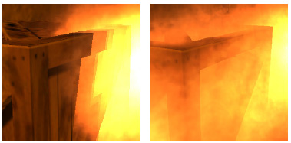*

*(image from http://www.gamerendering.com/2009/09/16/soft-particles/ )*

*A common technique to solve this is to test if the currently-drawn fragment is near the Z-Buffer. If so, the fragment is faded out.*

*However, you’ll have to sample the Z-Buffer, which is not possible with the “normal” Z-Buffer. You need to render your scene in a*[*render target*](http://www.opengl-tutorial.org/intermediate-tutorials/tutorial-14-render-to-texture/)*. Alternatively, you can copy the Z-Buffer from one framebuffer to another with glBlitFramebuffer.*

*http://developer.download.nvidia.com/whitepapers/2007/SDK10/SoftParticles\_hi.pdf*

### *Improving fillrate*

*One of the most limiting factor in modern GPUs is fillrate : the amount of fragments (pixels) it can write in the 16.6ms allowed to get 60 FPS. // найбольш моцнае абмежаванне сучасных графічных сістэм //*

*This is a problem, because particles typically need a LOT of fillrate, since you can re-draw the same fragment 10 times, each time with another particle; and if you don’t do that, you get the same artifacts as above. // intbu better //*

*Amongst all the fragments that are written, many are completely useless // why? //: these on the border. Your particle textures are often completely transparent on the edges, but the particle’s mesh will still draw them - and update the color buffer with exactly the same value than before.*

*This small utility computes a mesh (the one you’re supposed to draw with glDrawArraysInstanced() ) that tightly fits your texture :*

*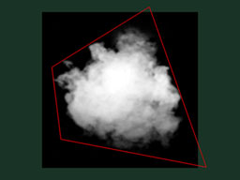*

[*http://www.humus.name/index.php?page=Cool&ID=8*](http://www.humus.name/index.php?page=Cool&ID=8)*. Emil Person’s site has plenty of other fascinating articles, too.*

## *Particle physics*

*At some point, you’ll probably want your particles to interact some more with your world. In particular, particles could rebound on the ground.*

*You could simply launch a raycast for each particle, between the current position and the future one; we learnt to do this in the*[*Picking tutorials*](http://www.opengl-tutorial.org/miscellaneous/clicking-on-objects/picking-with-a-physics-library/)*. But this is extremely expensive, you just can’t to this for each particle, each frame. // не зразумеў //*

*Depending on your application, you can either approximate your geometry with a set of planes and do the raycast on these planes only; Or, you can use real raycast, but cache the results and approximate nearby collisions with the cache (or, you can do both).*

*A completely different technique is to use the existing Z-Buffer as a very rough approximation of the (visible) geometry, and collide particles on this. This is “good enough” and fast, but you’ll have to do all your simulation on the GPU, since you can’t access the Z-Buffer on the CPU (at least not fast), so it’s way more complicated.*

*Here are a few links about these techniques :*

[*http://www.altdevblogaday.com/2012/06/19/hack-day-report/*](http://www.altdevblogaday.com/2012/06/19/hack-day-report/)

[*http://www.gdcvault.com/search.php#&category=free&firstfocus=&keyword=Chris+Tchou’s%2BHalo%2BReach%2BEffects&conference\_id=*](http://www.gdcvault.com/search.php#&category=free&firstfocus=&keyword=Chris+Tchou's%2BHalo%2BReach%2BEffects&conference_id=)

## *GPU Simulation*

*As said above, you can simulate the particles’ movements completely on the GPU. You will still have to manage your particle’s lifecycle on the CPU - at least to spawn them.*

*You have many options to do this, and none in the scope of this tutorial ; I’ll just give a few pointers.*

* *Use Transform Feedback. It allows you to store the outputs of a vertex shader in a GPU-side VBO. Store the new positions in this VBO, and next frame, use this VBO as the starting point, and store the new position in the former VBO.*
* *Same thing but without Transform Feedback: encode your particles’ positions in a texture, and update it with Render-To-Texture.*
* *Use a General-Purpose GPU library : CUDA or OpenCL, which have interoperability functions with OpenGL.*
* *Use a Compute Shader. Cleanest solution, but only available on very recent GPUs.*
* *Note that for simplicity, in this implementation, ParticleContainer is sorted after updating the GPU buffers. This makes the particles not exactly sorted (there is a one-frame delay), but it’s not really noticeable. You can fix it by splitting the main loop in 2 : Simulate, Sort, and update.*

*// не чытаў, бо гэта мне цяжка зразумець //*

[*http://unick-soft.ru/article.php?id=15*](http://unick-soft.ru/article.php?id=15)

# *агульныя звесткі пра OpenGL*

*Магчымасць апаратнага паскарэння.*

*Прарысоўка 3D-графікі.*

*Неабходныя навыкі: валодаць мовай праграмавання.*

*Базавыя паняцці кампутарнай графікі: пиксель, хранение цвета в формате RGBA, принцип хранения изображений, альфа смешивание, графические примитивы и другие.*

*Пазіцыяніраванне аб’ектаў: афінныя пераўтварэнні: перемещение, вращение и увеличение размера. С математической точки зрения эти преобразования записываются соответствующими матрицами.*

*“*Начать изучение я бы посоветовал с хорошей книги, при этом постоянно практикуясь. На русском языке не так много хороших книг, так как большинство из них уже устарели. Я бы посоветовал следующую книгу: "OpenGL. Руководство по программированию". При начальном обучении книга может показаться довольно сложной. Параллельно с ней можно изучать статьи с примерами http://nehe.gamedev.net (перевод статей на русский http://pmg.org.ru/nehe).

Для работы с окном можно использовать glut или взять инициализацию окна из готового примера. Небольшой совет, если вы будете брать код из готовых примеров, то изучите каждую функцию, так как простое копирование не поможет вам выучить OpenGL.*”*

[*https://learnopengl.com/#!Introduction*](https://learnopengl.com/#!Introduction)

*// паспрабую павучыць вось па гэтым цьютарале //*

# Introduction

Since you came here you probably want to learn the inner workings of computer graphics and do all the stuff the cool kids do by yourself. Doing things by yourself is extremely fun and resourceful and gives you a great understanding of graphics programming. However, there are a few items that need to be taken into consideration before starting your journey.

## Prerequisites

*// прадспасылкі //*

Since OpenGL is a graphics API and not a platform of its own, it requires a language to operate in and the language of choice is C++, therefore a decent knowledge of the C++ programming language is required for these tutorials. However, I will try to explain most of the concepts used, including advanced C++ topics where required so it is not required to be an expert in C++, but you should be able to write more than just a 'Hello World' program. If you don't have much experience with C++ I can recommend the following free tutorials at [www.learncpp.com](http://www.learncpp.com/).

Also, we will be using some math (linear algebra, geometry and trigonometry) along the way and I will try to explain all the required concepts of the math required. However, I'm not a mathematician by heart so even though my explanations might be easy to understand, they will most likely be incomplete. So where necessary I will provide pointers to good resources that explain the material in a more complete fashion. Do not be scared about the mathematical knowledge required before starting your journey into OpenGL; almost all the concepts can be understood with a basic mathematical background and I will try to keep the mathematics to a minimum where possible. Most of the functionality does not even require you to understand all the math as long as you know how to use it.

## Structure

LearnOpenGL is broken down into a number of general subjects. Each subject contains several sections that each explain different concepts in large detail. Each of the subjects can be found at the menu to your left. The subjects are taught in a linear fashion (so it is advised to start from the top to the bottom, unless otherwise instructed) where each page explains the background theory and the practical aspects.

To make the tutorials easier to follow and give them some added structure the site contains boxes, code blocks, color hintsand function references. *// рэпрэзентатыўныя аспекты навучання //*

### Boxes

**Green** boxes encompasses some notes or useful features/hints about OpenGL or the subject at hand. **Red** boxes will contain warnings or other features you have to be extra careful with.

### Code

You will find plenty of small pieces of code in the website that are located in dark-gray boxes with syntax-highlighted code as you can see below:

// This box contains code

Since these provide only snippets of code, wherever necessary I will provide a link to the entire source code required for a given subject.

### Color hints

Some words are displayed with a different color to make it extra clear these words portray a special meaning:

* Definition: green words specify a definition i.e. an important aspect/name of something you're likely to hear more often.
* Program logic: red words specify function names or class names.
* Variables: blue words specify variables including all OpenGL constants.

### OpenGL Function references

A particularly well appreciated feature of LearnOpenGL is the ability to review most of OpenGL's functions wherever they show up in the content. Whenever a function is found in the content that is documented at the website, the function will show up with a slightly noticeable underline. You can hover the mouse over the function and after a small interval, a pop-up window will show relevant information about this function including a nice overview of what the function actually does. Hover your mouse over glEnable to see it in action.

Now that you got a bit of a feel of the structure of the site, hop over to the Getting Started section to start your journey in OpenGL! *// арыентацыя чытача //*

[*https://learnopengl.com/#!Getting-started/OpenGL*](https://learnopengl.com/#!Getting-started/OpenGL)

# OpenGL

Before starting our journey we should first define what OpenGL actually is. OpenGL is mainly considered an API (an Application Programming Interface) that provides us with a large set of functions that we can use to manipulate graphics and images. However, OpenGL by itself is not an API, but merely a specification, developed and maintained by the [Khronos Group](http://www.khronos.org/).



The OpenGL specification specifies exactly what the result/output of each function should be and how it should perform. It is then up to the developers implementing this specification to come up with a solution of how this function should operate. Since the OpenGL specification does not give us implementation details, the actual developed versions of OpenGL are allowed to have different implementations, as long as their results comply with the specification (and are thus the same to the user).

The people developing the actual OpenGL libraries are usually the graphics card manufacturers. Each graphics card that you buy supports specific versions of OpenGL which are the versions of OpenGL developed specifically for that card (series). When using an Apple system the OpenGL library is maintained by Apple themselves and under Linux there exists a combination of graphic suppliers' versions and hobbyists' adaptations of these libraries. This also means that whenever OpenGL is showing weird behavior that it shouldn't, this is most likely the fault of the graphics cards manufacturers (or whoever developed/maintained the library).

Since most implementations are built by graphics card manufacturers. Whenever there is a bug in the implementation this is usually solved by updating your video card drivers; those drivers include the newest versions of OpenGL that your card supports. This is one of the reasons why it's always advised to occasionally update your graphic drivers. *// аспекты графічных картак //*

Khronos publicly hosts all specification documents for all the OpenGL versions. The interested reader can find the OpenGL specification of version 3.3 (which is what we'll be using) [here](https://www.opengl.org/registry/doc/glspec33.core.20100311.withchanges.pdf) which is a details good read if you want to delve into the of OpenGL (note how they mostly just describe results and not implementations). The specifications also provide a great reference for finding the **exact** workings of its functions. *// крыніца па OpenGL //*

## Core-profile vs Immediate mode

In the old days, using OpenGL meant developing in immediate mode (often referred to as the fixed function pipeline) which was an easy-to-use method for drawing graphics. Most of the functionality of OpenGL was hidden in the library and developers did not have much freedom at how OpenGL does its calculations. Developers eventually got hungry for more flexibility and over time the specifications became more flexible; developers gained more control over their graphics. The immediate mode is really easy to use and understand, but it is also extremely inefficient. For that reason the specification started to deprecate immediate mode functionality from version 3.2 and started motivating developers to develop in OpenGL's core-profile mode which is a division of OpenGL's specification that removed all old deprecated functionality.

When using OpenGL's core-profile, OpenGL forces us to use modern practices. Whenever we try to use one of OpenGL's deprecated functions, OpenGL raises an error and stops drawing. The advantage of learning the modern approach is that it is very flexible and efficient, but unfortunately is also more difficult to learn. The immediate mode abstracted quite a lot from the **actual** operations OpenGL performed and while it was easy to learn, it was hard to grasp how OpenGL actually operates. The modern approach requires the developer to truly understand OpenGL and graphics programming and while it is a bit difficult, it allows for much more flexibility, more efficiency and most importantly a much better understanding of graphics programming.

This is also the reason why our tutorials are geared at Core-Profile OpenGL version 3.3. Although it is more difficult, it is greatly worth the effort.

As of today, much higher versions of OpenGL are published (at the time of writing 4.5) at which you might ask: why do I want to learn OpenGL 3.3 when OpenGL 4.5 is out? The answer to that question is relatively simple. All future versions of OpenGL starting from 3.3 basically add extra useful features to OpenGL without changing OpenGL's core mechanics; the newer versions just introduce slightly more efficient or more useful ways to accomplish the same tasks. The result is that all concepts and techniques remain the same over the modern OpenGL versions so it is perfectly valid to learn OpenGL 3.3. Whenever you're ready and/or more experienced you can easily use specific functionality from more recent OpenGL versions.

When using functionality from the most recent version of OpenGL, only the most modern graphics cards will be able to run your application. This is often why most developers generally target lower versions of OpenGL and optionally enable higher version functionality.

In some tutorials you'll sometimes find more modern features which are noted down as such.

*16.07.2017*

## Extensions

A great feature of OpenGL is its support of extensions. Whenever a graphics company comes up with a new technique or a new large optimization for rendering this is often found in an extension implemented in the drivers. *// тыповая сітуацыя ў галіне //* If the hardware an application runs on supports such an extension the developer can use the functionality provided by the extension for more advanced or efficient graphics. This way, a graphics developer can still use these new rendering techniques without having to wait for OpenGL to include the functionality in its future versions, simply by checking if the extension is supported by the graphics card. *// тэхніка выкарыстання OpenGL //* Often, when an extension is popular or very useful it eventually becomes part of future OpenGL versions. *// прырода эвалюцыі бібліятэкі. Лепей зразумець, што рабіць, калі пашырэнне яшчэ не выкарыстоўваецца ў OpenGL? //*

The developer then has to query whether any of these extensions are available (or use an OpenGL extension library). This allows the developer to do things better or more efficient, based on whether an extension is available: *// тэхніка выканання напісання графікі //*

**if**(GL\_ARB\_extension\_name)

{

// Do cool new and modern stuff supported by hardware

}

**else**

{

// Extension not supported: do it the old way

}

With OpenGL version 3.3 we rarely need an extension for most techniques, but wherever it is necessary proper instructions are provided.

## State machine

OpenGL is by itself a large state machine: a collection of variables that define how OpenGL should currently operate. The state of OpenGL is commonly referred to as the OpenGL context. When using OpenGL, we often change its state by setting some options, manipulating some buffers and then render using the current context. *// базавая структура OpenGL //*

Whenever we tell OpenGL that we now want to draw lines instead of triangles for example, we change the state of OpenGL by changing some context variable that sets how OpenGL should draw. As soon as we changed the state by telling OpenGL it should draw lines, the next drawing commands will now draw lines instead of triangles. *// прыклад //*

When working in OpenGL we will come across several state-changing functions that change the context and several state-using functions that perform some operations based on the current state of OpenGL. As long as you keep in mind that OpenGL is basically one large state machine, most of its functionality will make more sense. *// базавая структура OpenGL і кагнетыўная ўстаноўка яго ўспрыняцця //*

## Objects

The OpenGL libraries are written in C and allows for many derivations in other languages, but in its core it remains a C-library. Since many of C's language-constructs do not translate that well to other higher-level languages, OpenGL was developed with several abstractions in mind. One of those abstractions are objects in OpenGL. *// рэалізацыя і кросплатформеннасць OpenGL //*

An object in OpenGL is a collection of options that represents a subset of OpenGL's state. For example, we could have an object that represents the settings of the drawing window; we could then set its size, how many colors it supports and so on. One could visualize an object as a C-like struct:

**struct** object\_name {

**float** option1;

**int** option2;

**char**[] name;

};

Whenever we want to use objects it generally looks something like this (with OpenGL's context visualized as a large struct):

// The State of OpenGL

**struct** OpenGL\_Context {

...

object\* object\_Window\_Target;

...

};

// create object

**unsigned** **int** objectId = 0;

glGenObject(1, &objectId);

// bind object to context

glBindObject(GL\_WINDOW\_TARGET, objectId);

// set options of object currently bound to GL\_WINDOW\_TARGET

glSetObjectOption(GL\_WINDOW\_TARGET, GL\_OPTION\_WINDOW\_WIDTH, 800);

glSetObjectOption(GL\_WINDOW\_TARGET, GL\_OPTION\_WINDOW\_HEIGHT, 600);

// set context target back to default

glBindObject(GL\_WINDOW\_TARGET, 0);

This little piece of code is a workflow you'll frequently see when working in OpenGL. We first create an object and store a reference to it as an id (the real object data is stored behind the scenes). *// рэалізацыя і выкарыстанне тэхналогіі //* Then we bind the object to the target location of the context (the location of the example window object target is defined as GL\_WINDOW\_TARGET). Next we set the window options and finally we un-bind the object by setting the current object id of the window target to 0. The options we set are stored in the object referenced by objectId and restored as soon as we bind the object back to GL\_WINDOW\_TARGET.

The code samples provided so far are only approximations of how OpenGL operates; throughout the tutorial you will come across enough actual examples. *// цудоўная арыентацыя чытача наконт таго, як успрымаць прывадзімы матэрыял //*

The great thing about using these objects is that we can define more than one object in our application, set their options and whenever we start an operation that uses OpenGL's state, we bind the object with our preferred settings. *// лепей зразумець дадзеную перавагу і адметнасць тэхналогіі //* There are objects for example that act as container objects for 3D model data (a house or a character) and whenever we want to draw one of them, we bind the object containing the model data that we want to draw (we first created and set options for these objects). Having several objects allows us to specify many models and whenever we want to draw a specific model, we simply bind the corresponding object before drawing without setting all their options again. *// перавага раздзялення мадэлі аб’екта ад наладак яго малявання. Гэта маецца на ўвазе? //*

## Let's get started

You now learned a bit about OpenGL as a specification and a library, how OpenGL approximately operates under the hood and a few custom tricks that OpenGL uses. Don't worry if you didn't get all of it; throughout the tutorial we'll walk through each step and you'll see enough examples to really get a grasp of OpenGL. If you're ready for the next step we can start creating an OpenGL context and our first window [here](https://learnopengl.com/#!Getting-started/Creating-a-window).

## Additional resources

* [opengl.org](https://www.opengl.org/): official website of OpenGL.
* [OpenGL registry](https://www.opengl.org/registry/): hosts the OpenGL specifications and extensions for all OpenGL versions.

[*https://learnopengl.com/#!Getting-started/Creating-a-window*](https://learnopengl.com/#!Getting-started/Creating-a-window)

# Creating a window

The first thing we need to do to create stunning graphics is to create an OpenGL context and an application window to draw in. However, those operations are specific per operating system and OpenGL purposefully tries to abstract from these operations. This means we have to create a window, define a context and handle user input all by ourselves. *// лепей зразумець гэту адметнасць тэхналогіі. Кросплатформеннасць. //*

Luckily, there are quite a few libraries out there that already provide the functionality we seek, some specifically aimed at OpenGL. Those libraries save us all the operation-system specific work and give us a window and an OpenGL context to render in. Some of the more popular libraries are GLUT, SDL, SFML and GLFW. For our tutorials we will be using **GLFW**. *// структура распрацоўкі ў OpenGL. Трэба стварыць спачатку акно і кантэкст. Успрымай тэхналогію як машыну станаў. Памятай пра гэта //*

*29.07.2017*

*// я толькі зараз змог падключыць і настроіць сабе OpenGL. Гэта было даволі цяжка.*

*Для падключэння я прапісаў у пераменныя асяроддзя бібліятэкі і бінарнікі кампілятара, які знаходзіцца ў дырэкторыі: C:\Qt\Tools\*

*Потым я падключыў да свайго праекта статычную бібліятэку: C:\Qt\Tools\mingw530\_32\i686-w64-mingw32\lib\libopengl32.a (дзе знайсці дынамічную, я не знайшоў).*

*З той жа дырэкторыі, толькі ў інклюдах знаходзіцца файл gl.h*

*//*

*Зараз будзем трошку вывучаць GLFW*

*GLFW*

[*http://www.glfw.org/docs/latest/*](http://www.glfw.org/docs/latest/)

***Introduction***

*GLFW is a free, Open Source, multi-platform library for OpenGL, OpenGL ES and Vulkan application development. It provides a simple, platform-independent API for creating windows, contexts and surfaces, reading input, handling events, etc.*

*See*[***New features in 3.2***](http://www.glfw.org/docs/latest/news.html#news_32)*for release highlights or the*[*version history*](http://www.glfw.org/changelog.html)*for details.*

[***Getting started***](http://www.glfw.org/docs/latest/quick_guide.html)*is a guide for users new to GLFW. It takes you through how to write a small but complete program.*

*There are guides for each section of the API:*

* [***Introduction to the API***](http://www.glfw.org/docs/latest/intro_guide.html)*– initialization, error handling and high-level design*
* [***Window guide***](http://www.glfw.org/docs/latest/window_guide.html)*– creating and working with windows and framebuffers*
* [***Context guide***](http://www.glfw.org/docs/latest/context_guide.html)*– working with OpenGL and OpenGL ES contexts*
* [***Vulkan guide***](http://www.glfw.org/docs/latest/vulkan_guide.html)*- working with Vulkan objects and extensions*
* [***Monitor guide***](http://www.glfw.org/docs/latest/monitor_guide.html)*– enumerating and working with monitors and video modes*
* [***Input guide***](http://www.glfw.org/docs/latest/input_guide.html)*– receiving events, polling and processing input*

*Once you have written a program, see*[***Compiling GLFW***](http://www.glfw.org/docs/latest/compile_guide.html)*and*[***Building applications***](http://www.glfw.org/docs/latest/build_guide.html)*.*

*The*[*reference documentation*](http://www.glfw.org/docs/latest/modules.html)*provides more detailed information about specific functions.*

[***Moving from GLFW 2 to 3***](http://www.glfw.org/docs/latest/moving_guide.html)*explains what has changed and how to update existing code to use the new API.*

*There is a section on*[***Guarantees and limitations***](http://www.glfw.org/docs/latest/intro_guide.html#guarantees_limitations)*for pointer lifetimes, reentrancy, thread safety, event order and backward and forward compatibility.*

*The*[*FAQ*](http://www.glfw.org/faq.html)*answers many common questions about the design, implementation and use of GLFW.*

*Finally,*[***Standards conformance***](http://www.glfw.org/docs/latest/compat_guide.html)*explains what APIs, standards and protocols GLFW uses and what happens when they are not present on a given machine.*

*This documentation was generated with Doxygen. The sources for it are available in both the*[*source distribution*](http://www.glfw.org/download.html)*and*[*GitHub repository*](https://github.com/glfw/glfw)*.*

[*http://www.glfw.org/docs/latest/quick\_guide.html*](http://www.glfw.org/docs/latest/quick_guide.html)

## **Getting started**

This guide takes you through writing a simple application using GLFW 3. The application will create a window and OpenGL context, render a rotating triangle and exit when the user closes the window or presses Escape. This guide will introduce a few of the most commonly used functions, but there are many more.

This guide assumes no experience with earlier versions of GLFW. If you have used GLFW 2 in the past, read [**Moving from GLFW 2 to 3**](http://www.glfw.org/docs/latest/moving_guide.html), as some functions behave differently in GLFW 3.

### Step by step

#### Including the GLFW header

In the source files of your application where you use OpenGL or GLFW, you need to include the GLFW 3 header file.

#include <[GLFW/glfw3.h](http://www.glfw.org/docs/latest/glfw3_8h.html)>

This defines all the constants, types and function prototypes of the GLFW API. It also includes the OpenGL header from your development environment and defines all the constants and types necessary for it to work on your platform without including any platform-specific headers.

In other words:

* Do not include the OpenGL header yourself, as GLFW does this for you in a platform-independent way
* Do not include windows.h or other platform-specific headers unless you plan on using those APIs yourself
* If you do need to include such headers, include them before the GLFW header and it will detect this

On some platforms supported by GLFW the OpenGL header and link library only expose older versions of OpenGL. The most extreme case is Windows, which only exposes OpenGL 1.2. The easiest way to work around this is to use an [**extension loader library**](http://www.glfw.org/docs/latest/context_guide.html#context_glext_auto).

If you are using such a library then you should include its header before the GLFW header. This lets it replace the OpenGL header included by GLFW without conflicts. This example uses [glad](https://github.com/Dav1dde/glad), but the same rule applies to all such libraries.

#include <glad/glad.h>

#include <[GLFW/glfw3.h](http://www.glfw.org/docs/latest/glfw3_8h.html)>

#### Initializing and terminating GLFW

Before you can use most GLFW functions, the library must be initialized. On successful initialization, GLFW\_TRUE is returned. If an error occurred, GLFW\_FALSE is returned.

**if** (![glfwInit](http://www.glfw.org/docs/latest/group__init.html#ga317aac130a235ab08c6db0834907d85e)())

{

// Initialization failed

}

Note that GLFW\_TRUE and GLFW\_FALSE are and will always be just one and zero.

When you are done using GLFW, typically just before the application exits, you need to terminate GLFW.

[glfwTerminate](http://www.glfw.org/docs/latest/group__init.html#gaaae48c0a18607ea4a4ba951d939f0901)();

This destroys any remaining windows and releases any other resources allocated by GLFW. After this call, you must initialize GLFW again before using any GLFW functions that require it.

#### Setting an error callback

Most events are reported through callbacks, whether it's a key being pressed, a GLFW window being moved, or an error occurring. Callbacks are simply C functions (or C++ static methods) that are called by GLFW with arguments describing the event.

In case a GLFW function fails, an error is reported to the GLFW error callback. You can receive these reports with an error callback. This function must have the signature below. This simple error callback just prints the error description to stderr.

**void** error\_callback(**int** error, **const** **char**\* description)

{

fprintf(stderr, "Error: %s\n", description);

}

Callback functions must be set, so GLFW knows to call them. The function to set the error callback is one of the few GLFW functions that may be called before initialization, which lets you be notified of errors both during and after initialization.

[glfwSetErrorCallback](http://www.glfw.org/docs/latest/group__init.html#gaa5d796c3cf7c1a7f02f845486333fb5f)(error\_callback);

### Creating a window and context

The window and its OpenGL context are created with a single call to [**glfwCreateWindow**](http://www.glfw.org/docs/latest/group__window.html#ga5c336fddf2cbb5b92f65f10fb6043344), which returns a handle to the created combined window and context object

[GLFWwindow](http://www.glfw.org/docs/latest/group__window.html#ga3c96d80d363e67d13a41b5d1821f3242)\* window = [glfwCreateWindow](http://www.glfw.org/docs/latest/group__window.html#ga5c336fddf2cbb5b92f65f10fb6043344)(640, 480, "My Title", NULL, NULL);

**if** (!window)

{

// Window or OpenGL context creation failed

}

This creates a 640 by 480 windowed mode window with an OpenGL context. If window or OpenGL context creation fails, NULL will be returned. You should always check the return value. // *рэкамендацыя* // While window creation rarely fails, context creation depends on properly installed drivers and may fail even on machines with the necessary hardware. *// заўвага: частая крыніца памылак //*

By default, the OpenGL context GLFW creates may have any version. You can require a minimum OpenGL version by setting the GLFW\_CONTEXT\_VERSION\_MAJOR and GLFW\_CONTEXT\_VERSION\_MINOR hints before creation. If the required minimum version is not supported on the machine, context (and window) creation fails.

[glfwWindowHint](http://www.glfw.org/docs/latest/group__window.html#ga7d9c8c62384b1e2821c4dc48952d2033)([GLFW\_CONTEXT\_VERSION\_MAJOR](http://www.glfw.org/docs/latest/glfw3_8h.html#afe5e4922de1f9932d7e9849bb053b0c0), 2);

[glfwWindowHint](http://www.glfw.org/docs/latest/group__window.html#ga7d9c8c62384b1e2821c4dc48952d2033)([GLFW\_CONTEXT\_VERSION\_MINOR](http://www.glfw.org/docs/latest/glfw3_8h.html#a31aca791e4b538c4e4a771eb95cc2d07), 0);

[GLFWwindow](http://www.glfw.org/docs/latest/group__window.html#ga3c96d80d363e67d13a41b5d1821f3242)\* window = [glfwCreateWindow](http://www.glfw.org/docs/latest/group__window.html#ga5c336fddf2cbb5b92f65f10fb6043344)(640, 480, "My Title", NULL, NULL);

**if** (!window)

{

// Window or context creation failed

}

The window handle is passed to all window related functions and is provided to along to all window related callbacks, so they can tell which window received the event.

When a window and context is no longer needed, destroy it. *// рэкамендацыя //*

#### [glfwDestroyWindow](http://www.glfw.org/docs/latest/group__window.html#gacdf43e51376051d2c091662e9fe3d7b2)(window);

Once this function is called, no more events will be delivered for that window and its handle becomes invalid.

## Making the OpenGL context current

Before you can use the OpenGL API, you must have a current OpenGL context.

[glfwMakeContextCurrent](http://www.glfw.org/docs/latest/group__context.html#ga1c04dc242268f827290fe40aa1c91157)(window);

The context will remain current until you make another context current or until the window owning the current context is destroyed.

If you are using an [**extension loader library**](http://www.glfw.org/docs/latest/context_guide.html#context_glext_auto) to access modern OpenGL then this is when to initialize it, as the loader needs a current context to load from. This example uses [glad](https://github.com/Dav1dde/glad), but the same rule applies to all such libraries.

gladLoadGLLoader((GLADloadproc) [glfwGetProcAddress](http://www.glfw.org/docs/latest/group__context.html#ga35f1837e6f666781842483937612f163));

#### Checking the window close flag

Each window has a flag indicating whether the window should be closed.

When the user attempts to close the window, either by pressing the close widget in the title bar or using a key combination like Alt+F4, this flag is set to 1. Note that **the window isn't actually closed**, so you are expected to monitor this flag and either destroy the window or give some kind of feedback to the user. *// рэкамендацыя //*

**while** (![glfwWindowShouldClose](http://www.glfw.org/docs/latest/group__window.html#ga24e02fbfefbb81fc45320989f8140ab5)(window))

{

// Keep running

}

You can be notified when the user is attempting to close the window by setting a close callback with [**glfwSetWindowCloseCallback**](http://www.glfw.org/docs/latest/group__window.html#gaade9264e79fae52bdb78e2df11ee8d6a). The callback will be called immediately after the close flag has been set.

You can also set it yourself with [**glfwSetWindowShouldClose**](http://www.glfw.org/docs/latest/group__window.html#ga49c449dde2a6f87d996f4daaa09d6708). This can be useful if you want to interpret other kinds of input as closing the window, like for example pressing the Escape key.

#### Receiving input events

Each window has a large number of callbacks that can be set to receive all the various kinds of events. To receive key press and release events, create a key callback function.

**static** **void** key\_callback([GLFWwindow](http://www.glfw.org/docs/latest/group__window.html#ga3c96d80d363e67d13a41b5d1821f3242)\* window, **int** key, **int** scancode, **int** action, **int** mods)

{

**if** (key == [GLFW\_KEY\_ESCAPE](http://www.glfw.org/docs/latest/group__keys.html#gaac6596c350b635c245113b81c2123b93) && action == [GLFW\_PRESS](http://www.glfw.org/docs/latest/group__input.html#ga2485743d0b59df3791c45951c4195265))

[glfwSetWindowShouldClose](http://www.glfw.org/docs/latest/group__window.html#ga49c449dde2a6f87d996f4daaa09d6708)(window, [GLFW\_TRUE](http://www.glfw.org/docs/latest/glfw3_8h.html#a2744fbb29b5631bb28802dbe0cf36eba));

}

*// стварэнне колбэк-функцый – гэта аснова праграміравання glfw //*

The key callback, like other window related callbacks, are set per-window.

[glfwSetKeyCallback](http://www.glfw.org/docs/latest/group__input.html#ga7e496507126f35ea72f01b2e6ef6d155)(window, key\_callback);

In order for event callbacks to be called when events occur, you need to process events as described below. *// патрабаванне //*

#### Rendering with OpenGL

Once you have a current OpenGL context, you can use OpenGL normally. In this tutorial, a multi-colored rotating triangle will be rendered. The framebuffer size needs to be retrieved for glViewport.

**int** width, height;

[glfwGetFramebufferSize](http://www.glfw.org/docs/latest/group__window.html#ga0e2637a4161afb283f5300c7f94785c9)(window, &width, &height);

glViewport(0, 0, width, height);

You can also set a framebuffer size callback using [**glfwSetFramebufferSizeCallback**](http://www.glfw.org/docs/latest/group__window.html#ga3203461a5303bf289f2e05f854b2f7cf) and be notified when the size changes.

Actual rendering with OpenGL is outside the scope of this tutorial, but there are [many](https://open.gl/) [excellent](http://learnopengl.com/) [tutorial](http://openglbook.com/) [sites](http://ogldev.atspace.co.uk/) that teach modern OpenGL. Some of them use GLFW to create the context and window while others use GLUT or SDL, but remember that OpenGL itself always works the same.

#### Reading the timer

To create smooth animation, a time source is needed. GLFW provides a timer that returns the number of seconds since initialization. The time source used is the most accurate on each platform and generally has micro- or nanosecond resolution. *// аспекты таймера //*

**double** time = [glfwGetTime](http://www.glfw.org/docs/latest/group__input.html#gaa6cf4e7a77158a3b8fd00328b1720a4a)();

#### Swapping buffers

GLFW windows by default use double buffering. That means that each window has two rendering buffers; a front buffer and a back buffer. The front buffer is the one being displayed and the back buffer the one you render to.

When the entire frame has been rendered, the buffers need to be swapped with one another, so the back buffer becomes the front buffer and vice versa. *// рэалізацыя тэхналогіі //*

[glfwSwapBuffers](http://www.glfw.org/docs/latest/group__window.html#ga15a5a1ee5b3c2ca6b15ca209a12efd14)(window);

The swap interval indicates how many frames to wait until swapping the buffers, commonly known as vsync. By default, the swap interval is zero, meaning buffer swapping will occur immediately. On fast machines, many of those frames will never be seen, as the screen is still only updated typically 60-75 times per second, so this wastes a lot of CPU and GPU cycles.

Also, because the buffers will be swapped in the middle the screen update, leading to [screen tearing](https://en.wikipedia.org/wiki/Screen_tearing).

For these reasons, applications will typically want to set the swap interval to one. It can be set to higher values, but this is usually not recommended, because of the input latency it leads to. *// рэкамендацыя //*

[glfwSwapInterval](http://www.glfw.org/docs/latest/group__context.html#ga6d4e0cdf151b5e579bd67f13202994ed)(1);

This function acts on the current context and will fail unless a context is current.

#### Processing events

GLFW needs to communicate regularly with the window system both in order to receive events and to show that the application hasn't locked up. Event processing must be done regularly while you have visible windows and is normally done each frame after buffer swapping. *// тыповая рэалізацыя графічных прылажэнняў //*

There are two methods for processing pending events; polling and waiting. This example will use event polling, which processes only those events that have already been received and then returns immediately.

[glfwPollEvents](http://www.glfw.org/docs/latest/group__window.html#ga37bd57223967b4211d60ca1a0bf3c832)();

This is the best choice when rendering continually, like most games do. If instead you only need to update your rendering once you have received new input, [**glfwWaitEvents**](http://www.glfw.org/docs/latest/group__window.html#ga554e37d781f0a997656c26b2c56c835e) is a better choice. *// кантэкст выкарыстання паняццяў //* It waits until at least one event has been received, putting the thread to sleep in the meantime, and then processes all received events. This saves a great deal of CPU cycles and is useful for, for example, many kinds of editing tools.

#### Putting it together

Now that you know how to initialize GLFW, create a window and poll for keyboard input, it's possible to create a simple program.

This program creates a 640 by 480 windowed mode window and starts a loop that clears the screen, renders a triangle and processes events until the user either presses Escape or closes the window.

#include <glad/glad.h>

#include <[GLFW/glfw3.h](http://www.glfw.org/docs/latest/glfw3_8h.html)>

#include "linmath.h"

#include <stdlib.h>

#include <stdio.h>

**static** **const** **struct**

{

**float** x, y;

**float** r, g, b;

} vertices[3] =

{

{ -0.6f, -0.4f, 1.f, 0.f, 0.f },

{ 0.6f, -0.4f, 0.f, 1.f, 0.f },

{ 0.f, 0.6f, 0.f, 0.f, 1.f }

};

**static** **const** **char**\* vertex\_shader\_text =

"uniform mat4 MVP;\n"

"attribute vec3 vCol;\n"

"attribute vec2 vPos;\n"

"varying vec3 color;\n"

"void main()\n"

"{\n"

" gl\_Position = MVP \* vec4(vPos, 0.0, 1.0);\n"

" color = vCol;\n"

"}\n";

**static** **const** **char**\* fragment\_shader\_text =

"varying vec3 color;\n"

"void main()\n"

"{\n"

" gl\_FragColor = vec4(color, 1.0);\n"

"}\n";

**static** **void** error\_callback(**int** error, **const** **char**\* description)

{

fprintf(stderr, "Error: %s\n", description);

}

**static** **void** key\_callback([GLFWwindow](http://www.glfw.org/docs/latest/group__window.html#ga3c96d80d363e67d13a41b5d1821f3242)\* window, **int** key, **int** scancode, **int** action, **int** mods)

{

**if** (key == [GLFW\_KEY\_ESCAPE](http://www.glfw.org/docs/latest/group__keys.html#gaac6596c350b635c245113b81c2123b93) && action == [GLFW\_PRESS](http://www.glfw.org/docs/latest/group__input.html#ga2485743d0b59df3791c45951c4195265))

[glfwSetWindowShouldClose](http://www.glfw.org/docs/latest/group__window.html#ga49c449dde2a6f87d996f4daaa09d6708)(window, [GLFW\_TRUE](http://www.glfw.org/docs/latest/glfw3_8h.html#a2744fbb29b5631bb28802dbe0cf36eba));

}

**int** main(**void**)

{

[GLFWwindow](http://www.glfw.org/docs/latest/group__window.html#ga3c96d80d363e67d13a41b5d1821f3242)\* window;

GLuint vertex\_buffer, vertex\_shader, fragment\_shader, program;

GLint mvp\_location, vpos\_location, vcol\_location;

[glfwSetErrorCallback](http://www.glfw.org/docs/latest/group__init.html#gaa5d796c3cf7c1a7f02f845486333fb5f)(error\_callback);

**if** (![glfwInit](http://www.glfw.org/docs/latest/group__init.html#ga317aac130a235ab08c6db0834907d85e)())

exit(EXIT\_FAILURE);

[glfwWindowHint](http://www.glfw.org/docs/latest/group__window.html#ga7d9c8c62384b1e2821c4dc48952d2033)([GLFW\_CONTEXT\_VERSION\_MAJOR](http://www.glfw.org/docs/latest/glfw3_8h.html#afe5e4922de1f9932d7e9849bb053b0c0), 2);

[glfwWindowHint](http://www.glfw.org/docs/latest/group__window.html#ga7d9c8c62384b1e2821c4dc48952d2033)([GLFW\_CONTEXT\_VERSION\_MINOR](http://www.glfw.org/docs/latest/glfw3_8h.html#a31aca791e4b538c4e4a771eb95cc2d07), 0);

window = [glfwCreateWindow](http://www.glfw.org/docs/latest/group__window.html#ga5c336fddf2cbb5b92f65f10fb6043344)(640, 480, "Simple example", NULL, NULL);

**if** (!window)

{

[glfwTerminate](http://www.glfw.org/docs/latest/group__init.html#gaaae48c0a18607ea4a4ba951d939f0901)();

exit(EXIT\_FAILURE);

}

[glfwSetKeyCallback](http://www.glfw.org/docs/latest/group__input.html#ga7e496507126f35ea72f01b2e6ef6d155)(window, key\_callback);

[glfwMakeContextCurrent](http://www.glfw.org/docs/latest/group__context.html#ga1c04dc242268f827290fe40aa1c91157)(window);

gladLoadGLLoader((GLADloadproc) [glfwGetProcAddress](http://www.glfw.org/docs/latest/group__context.html#ga35f1837e6f666781842483937612f163));

[glfwSwapInterval](http://www.glfw.org/docs/latest/group__context.html#ga6d4e0cdf151b5e579bd67f13202994ed)(1);

// NOTE: OpenGL error checks have been omitted for brevity

glGenBuffers(1, &vertex\_buffer);

glBindBuffer(GL\_ARRAY\_BUFFER, vertex\_buffer);

glBufferData(GL\_ARRAY\_BUFFER, **sizeof**(vertices), vertices, GL\_STATIC\_DRAW);

vertex\_shader = glCreateShader(GL\_VERTEX\_SHADER);

glShaderSource(vertex\_shader, 1, &vertex\_shader\_text, NULL);

glCompileShader(vertex\_shader);

fragment\_shader = glCreateShader(GL\_FRAGMENT\_SHADER);

glShaderSource(fragment\_shader, 1, &fragment\_shader\_text, NULL);

glCompileShader(fragment\_shader);

program = glCreateProgram();

glAttachShader(program, vertex\_shader);

glAttachShader(program, fragment\_shader);

glLinkProgram(program);

mvp\_location = glGetUniformLocation(program, "MVP");

vpos\_location = glGetAttribLocation(program, "vPos");

vcol\_location = glGetAttribLocation(program, "vCol");

glEnableVertexAttribArray(vpos\_location);

glVertexAttribPointer(vpos\_location, 2, GL\_FLOAT, GL\_FALSE,

**sizeof**(**float**) \* 5, (**void**\*) 0);

glEnableVertexAttribArray(vcol\_location);

glVertexAttribPointer(vcol\_location, 3, GL\_FLOAT, GL\_FALSE,

**sizeof**(**float**) \* 5, (**void**\*) (**sizeof**(**float**) \* 2));

**while** (![glfwWindowShouldClose](http://www.glfw.org/docs/latest/group__window.html#ga24e02fbfefbb81fc45320989f8140ab5)(window))

{

**float** ratio;

**int** width, height;

mat4x4 m, p, mvp;

[glfwGetFramebufferSize](http://www.glfw.org/docs/latest/group__window.html#ga0e2637a4161afb283f5300c7f94785c9)(window, &width, &height);

ratio = width / (float) height;

glViewport(0, 0, width, height);

glClear(GL\_COLOR\_BUFFER\_BIT);

mat4x4\_identity(m);

mat4x4\_rotate\_Z(m, m, (**float**) [glfwGetTime](http://www.glfw.org/docs/latest/group__input.html#gaa6cf4e7a77158a3b8fd00328b1720a4a)());

mat4x4\_ortho(p, -ratio, ratio, -1.f, 1.f, 1.f, -1.f);

mat4x4\_mul(mvp, p, m);

glUseProgram(program);

glUniformMatrix4fv(mvp\_location, 1, GL\_FALSE, (**const** GLfloat\*) mvp);

glDrawArrays(GL\_TRIANGLES, 0, 3);

[glfwSwapBuffers](http://www.glfw.org/docs/latest/group__window.html#ga15a5a1ee5b3c2ca6b15ca209a12efd14)(window);

[glfwPollEvents](http://www.glfw.org/docs/latest/group__window.html#ga37bd57223967b4211d60ca1a0bf3c832)();

}

[glfwDestroyWindow](http://www.glfw.org/docs/latest/group__window.html#gacdf43e51376051d2c091662e9fe3d7b2)(window);

[glfwTerminate](http://www.glfw.org/docs/latest/group__init.html#gaaae48c0a18607ea4a4ba951d939f0901)();

exit(EXIT\_SUCCESS);

}

…

*// праграму я не правяраў, бо ў мяне няма глада. Вяртаюся да цьютарала OpenGL //*

[*https://learnopengl.com/#!Getting-started/Creating-a-window*](https://learnopengl.com/#!Getting-started/Creating-a-window)

*OpenGL*

## Creating a window

The first thing we need to do to create stunning graphics is to create an OpenGL context and an application window to draw in. However, those operations are specific per operating system and OpenGL purposefully tries to abstract from these operations. *// структура тэхналогіі //* This means we have to create a window, define a context and handle user input all by ourselves.

Luckily, there are quite a few libraries out there that already provide the functionality we seek, some specifically aimed at OpenGL. Those libraries save us all the operation-system specific work and give us a window and an OpenGL context to render in. Some of the more popular libraries are GLUT, SDL, SFML and GLFW. For our tutorials we will be using **GLFW**.

### GLFW

GLFW is a library, written in C, specifically targeted at OpenGL providing the bare necessities required for rendering goodies to the screen. It allows us to create an OpenGL context, define window parameters and handle user input which is all that we need.

The focus of this and the next tutorial is getting GLFW up and running, making sure it properly creates an OpenGL context and that it properly displays a window for us to render in. The tutorial will take a step-by-step approach in retrieving, building and linking the GLFW library. For this tutorial we will use the Microsoft Visual Studio 2015 IDE (note that the process is the same on the more recent visual studio versions). If you're not using Visual Studio (or an older version) don't worry, the process will be similar on most other IDEs.

#### Building GLFW

GLFW can be obtained from their webpage's [download](http://www.glfw.org/download.html) page. GLFW already has pre-compiled binaries and header files for Visual Studio 2013/2015, but for completeness' sake we will compile GLFW ourselves from the source code. So let's download the Source package.

If you're using their pre-compiled binaries, be sure to download the 32 bit versions and not the 64 bit versions (unless you know exactly what you're doing). The 64 bit versions have reportedly been causing weird errors for most readers.

Once you've downloaded the source package, extract it and open its content. We are only interested in a few items:

* The resulting library from compilation.
* The **include** folder.

Compiling the library from the source code guarantees that the resulting library is perfectly tailored for your CPU/OS, a luxury pre-compiled binaries do not always provide (sometimes, pre-compiled binaries are not available for your system). The problem with providing source code to the open world however is that not everyone uses the same IDE for developing their application, which means the project/solution files provided may not be compatible with other people's IDEs. So people then have to build their own project/solution with the given .c/.cpp and .h/.hpp files, which is cumbersome. Exactly for those reasons there is a tool called CMake.

CMake

CMake is a tool that can generate project/solution files of the user's choice (e.g. Visual Studio, Code::Blocks, Eclipse) from a collection of source code files using pre-defined CMake scripts. This allows us to generate a Visual Studio 2012 project file from GLFW's source package which we can use to compile the library. First we need to download and install CMake that can be found on their [download](http://www.cmake.org/cmake/resources/software.html) page. I used the Win32 Installer.

Once CMake is installed you can choose to run CMake from the command line or via their GUI. Since we're not trying to overcomplicate things we're going to use the GUI. CMake requires a source code folder and a destination folder for the binaries. As the source code folder we're going to choose the root folder of the downloaded GLFW source package and for the build folder we're creating a new directory build and then select that directory.

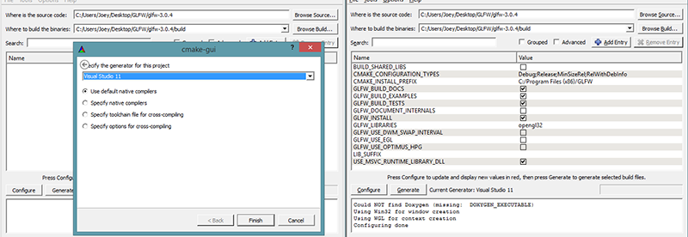

Once the source and destination folders have been set, click the Configure button so CMake can read the required settings and the source code. We then have to choose the generator for the project and since we're using Visual Studio 2015 we will choose the Visual Studio 14 option (Visual Studio 2015 is also known as Visual Studio 14). CMake will then display the possible build options to configure the resulting library. We can leave them to their default values and click Configure again to store the settings. Once the settings have been set, we can click Generate and the resulting project files will be generated in your build folder.

Compilation

In the build folder a file named GLFW.sln can be found and we open it with Visual Studio 2015. Since CMake generated a project file that already contains the proper configuration settings we can hit the Build Solution button and the resulting compiled library can be found in src/Debug named glfw3.lib (note, we're using version 3).

Once the library is generated we need to make sure the IDE knows where to find the library and the include files. There are two approaches in doing this:

1. We find the /lib and /include folders of the IDE/Compiler and add the content of GLFW's include folder to the IDE's /include folder and similarly add glfw3.lib to the IDE's /lib folder. This works, but this is not the recommended approach. It's hard to keep track of your library/include files and a new installation of your IDE/Compiler will result in lost files.
2. The recommended approach is to create a new set of directories at a location of your choice that contains all the header files/libraries from third parties to which you can refer to using your IDE/Compiler. I personally use a single folder that contains a Libs and Include folder where I store all my library and header files respectively for OpenGL projects. Now all my third party libraries are organized within a single location (that could be shared across multiple computers). The requirement is however, that each time we create a new project we have to tell the IDE where to find those directories.

Once the required files are stored at a location of your choice, we can start creating our first OpenGL project with GLFW!

*// я з усім гэтым павазіўся, але паспяхова выканаў //*

## Our first project

First, let's open up Visual Studio and create a new project. Choose Visual C++ if multiple options are given and take the Empty Project (don't forget to give your project a suitable name). We now have a workspace to create our very first OpenGL application!

### Linking

In order for the project to use GLFW we need to link the library with our project. This can be done by specifying we want to use glfw3.lib in the linker settings, but our project does not yet know where to find glfw3.lib since we pasted our third party libraries to different directories. We thus need to add those directories to the project first.

We can add those directories (where VS should search for libraries/include-files) by going to the project properties (right-click the project name in the solution explorer) and then go to VC++ Directories as can be seen in the image below:

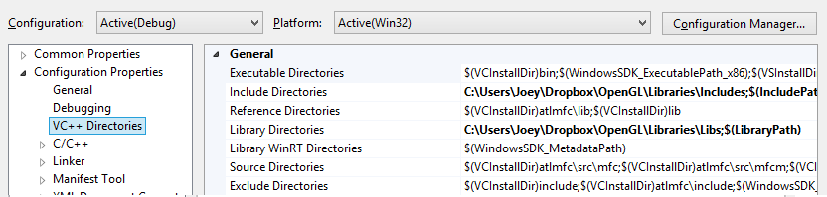

From there on out you can add your own directories to let the project know where to search. This can be done by manually inserting it into the text or clicking the appropriate location string and selecting the <Edit..> option where you'll see the following image for the Include Directories case:

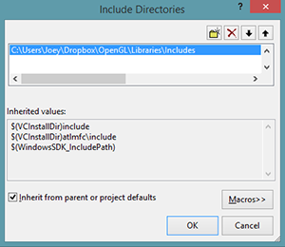

Here you can add as many extra directories as you'd like and from that point on the IDE will also search those directories when searching for header files, so as soon as your Include folder from GLFW is included, you will be able to find all the header files for GLFW by including <GLFW/..>. The same applies for the library directories.

Since VS can now find all the required files we can finally link GLFW to the project by going to the Linker tab and selecting input:

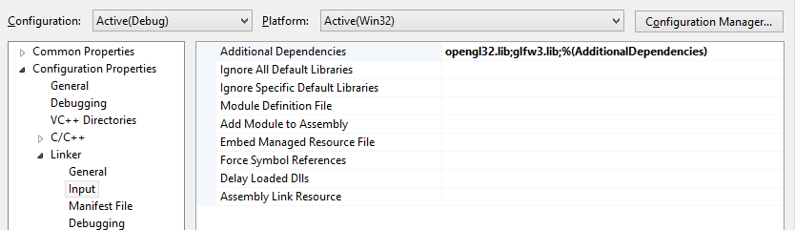

*// я паспяхова далучыў GLFW да сваёй сістэмы //*

To then link to a library you'd have to specify the name of the library to the linker. Since the library name is glfw3.lib, we add that to the Additional Dependencies field (either manually or using the <Edit..> option) and from that point on GLFW will be linked when we compile. Aside from GLFW you should also add a link entry to the OpenGL library, but this might differ per operating system:

### OpenGL library on Windows

If you're on Windows the OpenGL library opengl32.lib comes with the Microsoft SDK which is installed by default when you install Visual Studio. Since this tutorial uses the VS compiler and is on windows we add opengl32.lib to the linker settings. *// а я дабавіў бібліятэку з MinGW //*

#### OpenGL library on Linux

On Linux systems you need to link to the libGL.so library by adding -lGL to your linker settings. If you can't find the library you probably need to install any of the Mesa, NVidia or AMD dev packages, but I won't delve into the details since this is platform-specific (plus I'm not a Linux expert).

Then, once you've added both the GLFW and OpenGL library to the linker settings you can include the headers of GLFW as follows:

#include <GLFW\glfw3.h>

For Linux users compiling with GCC the following command line options might help you compile the project -lglfw3 -lGL -lX11 -lpthread -lXrandr -lXi. Not correctly linking the corresponding libraries will generate many undefined reference errors.

This concludes the setup and configuration of GLFW.

*// скончылі пра настройкі //*

## GLAD

We're still not quite there yet, since there is one other thing we still need to do. Since OpenGL is a standard/specification it is up to the driver manufacturer to implement the specification to a driver that the specific graphics card supports. Since there are many different versions of OpenGL drivers, the location of most of its functions is not known at compile-time and needs to be queried at run-time. It is then the task of the developer to retrieve the location of the functions he/she needs and store them in function pointers for later use. Retrieving those locations is [OS-specific](https://www.khronos.org/opengl/wiki/Load_OpenGL_Functions) and in Windows it looks something like this: *// intbu better this step //*

// define the function's prototype

**typedef** **void** (\*GL\_GENBUFFERS) (**GLsizei**, **GLuint**\*);

// find the function and assign it to a function pointer

GL\_GENBUFFERS glGenBuffers = (GL\_GENBUFFERS)wglGetProcAddress("glGenBuffers");

// function can now be called as normal

**unsigned** **int** buffer;

glGenBuffers(1, &buffer);

As you can see the code looks complex and it's a cumbersome process to do this for each function you might need that is not yet declared. Thankfully, there are libraries for this purpose as well where **GLAD** is a popular and up-to-date library.

### Setting up GLAD

GLAD is an [open source](https://github.com/Dav1dde/glad) library that manages all that cumbersome work we talked about. GLAD has a slightly different configuration setup than most common open source libraries. GLAD uses a [web service](http://glad.dav1d.de/) where we can tell GLAD for which version of OpenGL we'd like to define and load all relevant OpenGL functions according to that version.

Go to the [web service](http://glad.dav1d.de/), make sure the language is set to C++ and in the API section, select an OpenGL version of at least 3.3 (which is what we'll be using for these tutorials; higher versions are fine as well). Also make sure the profile is set to Core and that the Generate a loader option is ticked. Ignore the extensions (for now) and click Generate to produce the resulting library files.

GLAD by now should have provided you a zip file containing two include folders, and a single glad.c file. Copy both include folders (glad and KHR) into your include(s) directoy (or add an extra item pointing to these folders), and add the glad.c file to your project.

*// я так і зрабіў. Усё скампіліравалася. //*

After the previous steps, you should be able to add the following include directive above your file:

#include <glad/glad.h>

Hitting the compile button shouldn't give you any errors, at which point we're set to go for the [next](https://learnopengl.com/#!Getting-started/Hello-Window) tutorial where we'll discuss how we can actually use GLFW and GLAD to configure an OpenGL context and spawn a window. Be sure to check that all your include and library directories are correct and that the library names in the linker settings match with the corresponding libraries. If you're still stuck, check the comments, check any of the additional resources or ask your question below.

## Additional resources

* [GLFW: Window Guide](http://www.glfw.org/docs/latest/window_guide.html): official GLFW guide on setting up and configuring a GLFW window.
* [Building applications](http://www.opengl-tutorial.org/miscellaneous/building-your-own-c-application/): provides great info about the compilation/linking process of your application and a large list of possible errors (plus solutions) that might come up.
* [GLFW with Code::Blocks](http://wiki.codeblocks.org/index.php?title=Using_GLFW_with_Code::Blocks): building GLFW in Code::Blocks IDE.
* [Running CMake](http://www.cmake.org/runningcmake/): short overview of how to run CMake on both Windows and Linux.
* [Writing a build system under Linux](https://learnopengl.com/demo/autotools_tutorial.txt): an autotools tutorial by Wouter Verholst on how to write a build system in Linux, specifically targeted for these tutorials.
* [Polytonic/Glitter](https://github.com/Polytonic/Glitter): a simple boilerplate project that comes pre-configured with all relevant libraries; great for if you want a sample project for the LearnOpenGL tutorials without the hassle of having to compile all the libraries yourself.

### Want to help?

Enjoyed the tutorial? Consider becoming a [patron](https://www.patreon.com/learnopengl) of LearnOpenGL.  
  
Your support helps me create new and better tutorials, improve existing content and enables me to improve the website wherever I can. *// адваротная сувязь //*

[*https://learnopengl.com/#!Getting-started/Hello-Window*](https://learnopengl.com/#!Getting-started/Hello-Window)

## Hello Window

Let's see if we can get GLFW up and running. First, create a .cpp file and add the following includes to the top of your newly created file.

#include <glad/glad.h>

#include <GLFW/glfw3.h>

Be sure to include GLAD before GLFW. *// патрабаванне //* The include file for GLAD contains the correct OpenGL header includes (like GL/gl.h) so including GLAD before other header files that require OpenGL does the trick. *// абгрунтаванне //*

Next, we create the main function where we will instantiate the GLFW window:

**int** main()

{

glfwInit();

glfwWindowHint(GLFW\_CONTEXT\_VERSION\_MAJOR, 3);

glfwWindowHint(GLFW\_CONTEXT\_VERSION\_MINOR, 3);

glfwWindowHint(GLFW\_OPENGL\_PROFILE, GLFW\_OPENGL\_CORE\_PROFILE);

//glfwWindowHint(GLFW\_OPENGL\_FORWARD\_COMPAT, GL\_TRUE);

**return** 0;

}

In the main function we first initialize GLFW with glfwInit, after which we can configure GLFW using glfwWindowHint. The first argument of glfwWindowHint tells us what option we want to configure, where we can select the option from a large enum of possible options prefixed with GLFW\_. The second argument is an integer that sets the value of our option. A list of all the possible options and its corresponding values can be found at [GLFW's window handling](http://www.glfw.org/docs/latest/window.html#window_hints) documentation. If you try to run the application now and it gives a lot of undefined reference errors it means you didn't successfully link the GLFW library. *// у мяне ўсё ў парадку. Але што такое OpenGL профіль, я не вельмі зразумеў… //*

Since the focus of this website is on OpenGL version 3.3 we'd like to tell GLFW that 3.3 is the OpenGL version we want to use. This way GLFW can make the proper arrangements when creating the OpenGL context. This ensures that when a user does not have the proper OpenGL version GLFW fails to run. We set the major and minor version both to 3. We also tell GLFW we want to explicitly use the core-profile. Telling GLFW explicitly that we want to use the core-profile means we'll get access to a smaller subset of OpenGL features (without backwards-compatible features we no longer need). Note that on Mac OS X you need to add glfwWindowHint(GLFW\_OPENGL\_FORWARD\_COMPAT, GL\_TRUE); to your initialization code for it to work. *// лепей зразумець, якія фічы з’яўляюцца новымі і пашыранымі ў параўнанні з кор-профілем? //*

Make sure you have OpenGL versions 3.3 or higher installed on your system/hardware otherwise the application will crash or display undefined behavior. To find the OpenGL version on your machine either call **glxinfo** on Linux machines or use a utility like the [OpenGL Extension Viewer](http://download.cnet.com/OpenGL-Extensions-Viewer/3000-18487_4-34442.html) for Windows. If your supported version is lower try to check if your video card supports OpenGL 3.3+ (otherwise it's really old) and/or update your drivers. *// у мяне 4.0 – я паглядзеў дакументацыю для відэа-адаптэра // //*

Next we're required to create a window object. This window object holds all the windowing data and is used quite frequently by GLFW's other functions.

GLFWwindow\* window = glfwCreateWindow(800, 600, "LearnOpenGL", NULL, NULL);

**if** (window == NULL)

{

std::cout << "Failed to create GLFW window" << std::endl;

glfwTerminate();

**return** -1;

}

glfwMakeContextCurrent(window);

The glfwCreateWindow function requires the window width and height as its first two arguments respectively. The third argument allows us to create a name for the window; for now we call it "LearnOpenGL" but you're allowed to name it however you like. We can ignore the last 2 parameters. The function returns a GLFWwindow object that we'll later need for other GLFW operations. After that we tell GLFW to make the context of our window the main context on the current thread. *// кантэкст патока і кантэкст акна – важныя паняцці OpenGL //*

### GLAD

In the previous tutorial we mentioned that GLAD manages function pointers for OpenGL so we want to initialize GLAD before we call any OpenGL function:

**if** (!gladLoadGLLoader((GLADloadproc)glfwGetProcAddress))

{

std::cout << "Failed to initialize GLAD" << std::endl;

**return** -1;

}

We pass GLAD the function to load the adress of the OpenGL function pointers which is OS-specific. GLFW gives us glfwGetProcAddress that defines the correct function based on which OS we're compiling for.

### Viewport

Before we can start rendering we have to do one last thing. We have to tell OpenGL the size of the rendering window so OpenGL knows how we want to display the data and coordinates with respect to the window. We can set those dimensions via the glViewport function:

glViewport(0, 0, 800, 600);

The first two parameters of glViewport set the location of the lower left corner of the window. The third and fourth parameter set the width and height of the rendering window in pixels, which we retrieve here from GLFW itself.

We could actually set the viewport dimensions at values smaller than GLFW's dimensions; then all the OpenGL rendering would be displayed in a smaller window and we could for example display other elements outside the OpenGL viewport.

Behind the scenes OpenGL uses the data specified via glViewport to transform the 2D coordinates it processed to coordinates on your screen. For example, a processed point of location (-0.5,0.5) would (as its final transformation) be mapped to (200,450) in screen coordinates. Note that processed coordinates in OpenGL are between -1 and 1 so we effectively map from the range (-1 to 1) to (0, 800) and (0, 600). *// рэалізацыя тэхналогіі //*

*// у мяне ўсё працуе без глада, а вось з гладам у мяне праблемы. Так што пакуль без яго. //*

However, the moment a user resizes the window the viewport should be adjusted as well. We can register a callback function on the window that gets called each time the window is resized. This resize callback function has the following prototype:

**void** framebuffer\_size\_callback(GLFWwindow\* window, **int** width, **int** height);

The framebuffer size function takes a GLFWwindow as its first argument and two integers indicating the new window dimensions. Whenever the window changes in size, GLFW calls this function and fills in the proper arguments for you to process.

**void** framebuffer\_size\_callback(GLFWwindow\* window, **int** width, **int** height)

{

glViewport(0, 0, width, height);

}

We do have to tell GLFW we want to call this function on every window resize by registering it:

glfwSetFramebufferSizeCallback(window, framebuffer\_size\_callback);

When the window is first displayed framebuffer\_size\_callback gets called as well with the resulting window dimensions. For retina displays width and height will end up significantly higher than the original input values.

There are many callbacks functions we can set to register our own functions. For example, we can make a callback function to process joystick input changes, process error messages etc. We register the callback functions after we've created the window and before the game loop is initiated. *// структура графічных прылажэнняў OpenGL //*

### Ready your engines

We don't want the application to draw a single image and then immediately quit and close the window. We want the application to keep drawing images and handling user input until the program has been explicitly told to stop. For this reason we have to create a while loop, that we now call the render loop, that keeps on running until we tell GLFW to stop. The following code shows a very simple render loop:

**while**(!glfwWindowShouldClose(window))

{

glfwSwapBuffers(window);

glfwPollEvents();

}

The glfwWindowShouldClose function checks at the start of each loop iteration if GLFW has been instructed to close, if so, the function returns true and the game loop stops running, after which we can close the application.  
The glfwPollEvents function checks if any events are triggered (like keyboard input or mouse movement events), updates the window state, and calls the corresponding functions (which we can set via callback methods). The glfwSwapBuffers will swap the color buffer (a large buffer that contains color values for each pixel in GLFW's window) that has been used to draw in during this iteration and show it as output to the screen.

#### **Double buffer**

When an application draws in a single buffer the resulting image might display flickering issues. This is because the resulting output image is not drawn in an instant, but drawn pixel by pixel and usually from left to right and top to bottom. Because these images are not displayed at an instant to the user, but rather via a step by step generation the result may contain quite a few artifacts. To circumvent these issues, windowing applications apply a double buffer for rendering. The **front** buffer contains the final output image that is shown at the screen, while all the rendering commands draw to the **back** buffer. As soon as all the rendering commands are finished we **swap** the back buffer to the front buffer so the image is instantly displayed to the user, removing all the aforementioned artifacts. *// тэхналогія малявання ў кампутарах і яе рэалізацыя //*

### One last thing

As soon as we exit the render loop we would like to properly clean/delete all resources that were allocated. We can do this via the glfwTerminate function that we call at the end of the main function.

glfwTerminate();

**return** 0;

This will clean up all the resources and properly exit the application. Now try to compile your application and if everything went well you should see the following output:

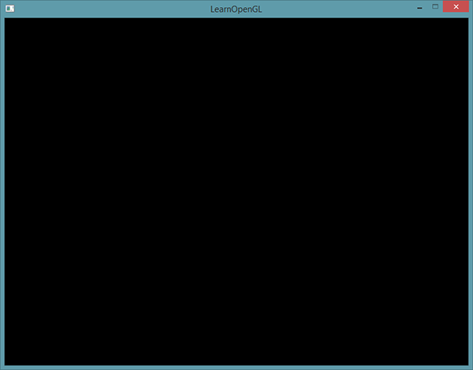

If it's a very dull and boring black image, you did things right! If you didn't get the right image or you're confused as to how everything fits together, check the full source code [here](https://learnopengl.com/code_viewer_gh.php?code=src/1.getting_started/1.1.hello_window/hello_window.cpp).

If you have issues compiling the application, first make sure all your linker options are set correctly and that you properly included the right directories in your IDE (as explained in the previous tutorial). Also make sure your code is correct; you can easily verify it by looking at the source code. If you still have any issues, post a comment below with your issue and me and/or the community will try to help you.

*// у мяне ўсё запусцілася і атрымалася. Толькі з рэндэрынгам пры рэсайзінгу не ўсё так гладка. Застаецца белая паласа, бывае. Потым паглядзець, у чым можа быць праблема //*

### Input

We also want to have some form of input control in GLFW and we can achieve this several of GLFW's input functions. We'll be using GLFW's glfwGetKey function that takes the window as input together with a key. The function returns whether this key is currently being pressed. We're creating a processInput function to keep all input code organized:

**void** processInput(GLFWwindow \*window)

{

**if**(glfwGetKey(window, GLFW\_KEY\_ESCAPE) == GLFW\_PRESS)

glfwSetWindowShouldClose(window, **true**);

}

Here we check whether the user has pressed the escape key (if it's not pressed, glfwGetKey returns GLFW\_RELEASE). If the user did press the escape key, we close GLFW by setting its WindowShouldClose property to true using glfwSetwindowShouldClose. The next condition check of the main while loop will then fail and the application closes.

We then call processInput every iteration of the render loop:

**while** (!glfwWindowShouldClose(window))

{

processInput(window);

glfwSwapBuffers(window);

glfwPollEvents();

}

This gives us an easy way to check for specific key presses and react accordingly every frame.

*// усё цудоўна працуе //*

### Rendering

We want to place all the rendering commands in the render loop, since we want to execute all the rendering commands each iteration of the loop. This would look a bit like this:

// render loop

**while**(!glfwWindowShouldClose(window))

{

// input

processInput(window);

// rendering commands here

...

// check and call events and swap the buffers

glfwPollEvents();

glfwSwapBuffers(window);

}

Just to test if things actually work we want to clear the screen with a color of our choice. At the start of each render iteration we always want to clear the screen otherwise we would still see the results from the previous iteration *// важны аспект рэалізацыі графікі //* (this could be the effect you're looking for, but usually you don't). We can clear the screen's color buffer using the glClear function where we pass in buffer bits to specify which buffer we would like to clear. The possible bits we can set are GL\_COLOR\_BUFFER\_BIT, GL\_DEPTH\_BUFFER\_BIT and GL\_STENCIL\_BUFFER\_BIT. Right now we only care about the color values so we only clear the color buffer.

glClearColor(0.2f, 0.3f, 0.3f, 1.0f);

glClear(GL\_COLOR\_BUFFER\_BIT);

*// усё цудоўна работае, толькі qt не бачыць функцыі OpenGL. Але калі я дабавіў gl.h у інклюды, то і креатар пачаў бачыць усе функцыі OpenGL //*

Note that we also set a color via glClearColor to clear the screen with. Whenever we call glClear and clear the color buffer, the entire colorbuffer will be filled with the color as configured by glClearColor. This will result in a dark green-blueish color. *// рэалізацыя тэхналогіі //*

As you might recall from the OpenGL tutorial, the glClearColor function is a state-setting function and glClear is a state-using function in that it uses the current state to retrieve the clearing color from. *// структура тэхналогіі //*

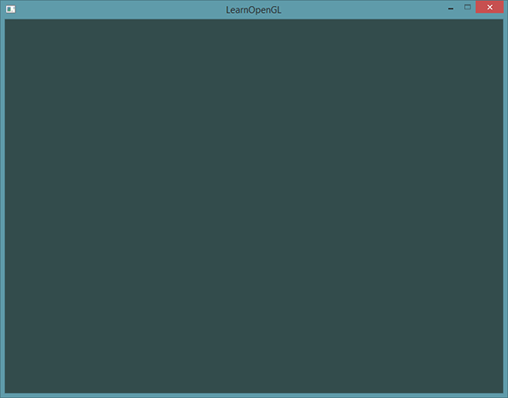

The full source code of the application can be found [here](https://learnopengl.com/code_viewer_gh.php?code=src/1.getting_started/1.2.hello_window_clear/hello_window_clear.cpp).

So right now we got everything ready to fill the game loop with lots of rendering calls, but that's for the [next](https://learnopengl.com/#!Getting-started/Hello-Triangle) tutorial. I think we've been rambling long enough here.

Want to help?

Enjoyed the tutorial? Consider becoming a [patron](https://www.patreon.com/learnopengl) of LearnOpenGL.  
  
Your support helps me create new and better tutorials, improve existing content and enables me to improve the website wherever I can.

[*https://learnopengl.com/#!Getting-started/Hello-Triangle*](https://learnopengl.com/#!Getting-started/Hello-Triangle)

## Hello Triangle

In OpenGL everything is in 3D space, but the screen and window are a 2D array of pixels so a large part of OpenGL's work is about transforming all 3D coordinates to 2D pixels that fit on your screen. *// структура тэхналогіі //* The process of transforming 3D coordinates to 2D coordinates is managed by the graphics pipeline of OpenGL. The graphics pipeline can be divided into two large parts: the first transforms your 3D coordinates into 2D coordinates and the second part transforms the 2D coordinates into actual colored pixels. *// структура тэхналогіі //* In this tutorial we'll briefly discuss the graphics pipeline and how we can use it to our advantage to create some fancy pixels.

There is a difference between a 2D coordinate and a pixel. A 2D coordinate is a very precise representation of where a point is in 2D space, while a 2D pixel is an approximation of that point limited by the resolution of your screen/window. *// розніца між паняццямі //*

The graphics pipeline takes as input a set of 3D coordinates and transforms these to colored 2D pixels on your screen. The graphics pipeline can be divided into several steps where each step requires the output of the previous step as its input. All of these steps are highly specialized (they have one specific function) and can easily be executed in parallel. Because of their parallel nature most graphics cards of today have thousands of small processing cores to quickly process your data within the graphics pipeline by running small programs on the GPU for each step of the pipeline. These small programs are called shaders. *// структура тэхналогіі і графічных картак //*

Some of these shaders are configurable by the developer which allows us to write our own shaders to replace the existing default shaders. This gives us much more fine-grained control over specific parts of the pipeline and because they run on the GPU, they can also save us valuable CPU time. Shaders are written in the OpenGL Shading Language (GLSL) and we'll delve more into that in the next tutorial. *// структура работы //*

Below you'll find an abstract representation of all the stages of the graphics pipeline. Note that the blue sections represent sections where we can inject our own shaders.

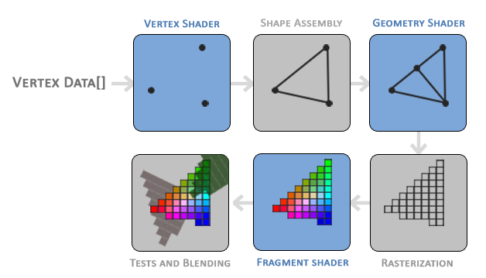

*// цудоўная рэпрэзентацыя структуры тэхналогіі //*

02.08.2017

As you can see the graphics pipeline contains a large number of sections that each handle one specific part of converting your vertex data to a fully rendered pixel. We will briefly explain each part of the pipeline in a simplified way to give you a good overview of how the pipeline operates. *// структура крыніцы //*

As input to the graphics pipeline we pass in a list of three 3D coordinates that should form a triangle in an array here called Vertex Data; this vertex data is a collection of vertices. A vertex is basically a collection of data per 3D coordinate. This vertex's data is represented using vertex attributes that can contain any data we'd like but for simplicity's sake let's assume that each vertex consists of just a 3D position and some color value. *// структура OpenGL //*

In order for OpenGL to know what to make of your collection of coordinates and color values OpenGL requires you to hint what kind of render types you want to form with the data. Do we want the data rendered as a collection of points, a collection of triangles or perhaps just one long line? Those hints are called primitives and are given to OpenGL while calling any of the drawing commands. Some of these hints are GL\_POINTS, GL\_TRIANGLES and GL\_LINE\_STRIP. *// структура тэхналогіі //*

The first part of the pipeline is the vertex shader that takes as input a single vertex. The main purpose of the vertex shader is to transform 3D coordinates into different 3D coordinates (more on that later) and the vertex shader allows us to do some basic processing on the vertex attributes. *// структура тэхналогіі //*

The primitive assembly stage takes as input all the vertices (or vertex if GL\_POINTS is chosen) from the vertex shader that form a primitive and assembles all the point(s) in the primitive shape given; in this case a triangle. *// структура тэхналогіі //*

The output of the primitive assembly stage is passed to the geometry shader. The geometry shader takes as input a collection of vertices that form a primitive and has the ability to generate other shapes by emitting new vertices to form new (or other) primitive(s). In this example case, it generates a second triangle out of the given shape.

The output of the geometry shader is then passed on to the rasterization stage where it maps the resulting primitive(s) to the corresponding pixels on the final screen, resulting in fragments for the fragment shader to use. Before the fragment shaders runs, clipping is performed. Clipping discards all fragments that are outside your view, increasing performance. *// структура тэхналогіі //*

A fragment in OpenGL is all the data required for OpenGL to render a single pixel. *// вызначэнне //*

The main purpose of the fragment shader is to calculate the final color of a pixel and this is usually the stage where all the advanced OpenGL effects occur. Usually the fragment shader contains data about the 3D scene that it can use to calculate the final pixel color (like lights, shadows, color of the light and so on). *// структура тэхналогіі //*

After all the corresponding color values have been determined, the final object will then pass through one more stage that we call the alpha test and blending stage. This stage checks the corresponding depth (and stencil) value (we'll get to those later) of the fragment and uses those to check if the resulting fragment is in front or behind other objects and should be discarded accordingly. The stage also checks for alpha values (alpha values define the opacity of an object) and blends the objects accordingly. So even if a pixel output color is calculated in the fragment shader, the final pixel color could still be something entirely different when rendering multiple triangles. *// структура тэхналогіі //*

As you can see, the graphics pipeline is quite a complex whole and contains many configurable parts. However, for almost all the cases we only have to work with the vertex and fragment shader. The geometry shader is optional and usually left to its default shader. *// звычайная практыка //*

In Modern OpenGL we are **required** to define at least a vertex and fragment shader of our own (there are no default vertex/fragment shaders on the GPU). *// патрабаванне //* For this reason it is often quite difficult to start learning Modern OpenGL since a great deal of knowledge is required before being able to render your first triangle. *// разнавіднасць сістэмы ведаў, дзе асабліва палезны цьютаралы, у якіх вялікая колькасць работы зроблена настаўнікамі, а навучэнец факусіруе сваю ўвагу на пэўных фрагментах тэмы, паступова ахопліваючы яе ўсю. тнав //* Once you do get to finally render your triangle at the end of this chapter you will end up knowing a lot more about graphics programming. *// структура крыніцы ведаў //*

### Vertex input

To start drawing something we have to first give OpenGL some input vertex data. OpenGL is a 3D graphics library so all coordinates that we specify in OpenGL are in 3D (x, y and z coordinate). OpenGL doesn't simply transform **all** your 3D coordinates to 2D pixels on your screen; OpenGL only processes 3D coordinates when they're in a specific range between -1.0 and 1.0 on all 3 axes (x, y and z). All coordinates within this so called normalized device coordinates range will end up visible on your screen (and all coordinates outside this region won't). *// структура тэхналогіі //*

Because we want to render a single triangle we want to specify a total of three vertices with each vertex having a 3D position. We define them in normalized device coordinates (the visible region of OpenGL) in a float array:

**float** vertices[] = {

-0.5f, -0.5f, 0.0f,

0.5f, -0.5f, 0.0f,

0.0f, 0.5f, 0.0f

};

Because OpenGL works in 3D space we render a 2D triangle with each vertex having a z coordinate of 0.0. This way the depth of the triangle remains the same making it look like it's 2D.

### **Normalized Device Coordinates (NDC)**

Once your vertex coordinates have been processed in the vertex shader, they should be in normalized device coordinates which is a small space where the x, y and z values vary from -1.0 to 1.0. Any coordinates that fall outside this range will be discarded/clipped and won't be visible on your screen. Below you can see the triangle we specified within normalized device coordinates (ignoring the z axis):

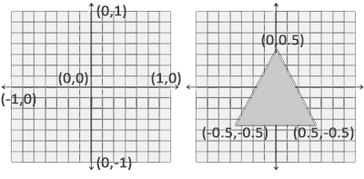

Unlike usual screen coordinates the positive y-axis points in the up-direction and the (0,0) coordinates are at the center of the graph, instead of top-left. Eventually you want all the (transformed) coordinates to end up in this coordinate space, otherwise they won't be visible.

Your NDC coordinates will then be transformed to screen-space coordinates via the viewport transform using the data you provided with glViewport. The resulting screen-space coordinates are then transformed to fragments as inputs to your fragment shader. *// структура тэхналогіі //*

With the vertex data defined we'd like to send it as input to the first process of the graphics pipeline: the vertex shader. This is done by creating memory on the GPU where we store the vertex data, configure how OpenGL should interpret the memory and specify how to send the data to the graphics card. The vertex shader then processes as much vertices as we tell it to from its memory. *// рэализацыя тэхналогіі і яе структура //*

We manage this memory via so called vertex buffer objects (VBO) that can store a large number of vertices in the GPU's memory. The advantage of using those buffer objects is that we can send large batches of data all at once to the graphics card without having to send data a vertex a time. *// перавагі буфераў. Структура тэхналогіі і яе значэнне //* Sending data to the graphics card from the CPU is relatively slow, so wherever we can we try to send as much data as possible at once. *// рэкамендацыя //* Once the data is in the graphics card's memory the vertex shader has almost instant access to the vertices making it extremely fast *// рэалізацыя тэхналогіі. Шэйдэр – гэта праграма для графічнай карткі //*

A vertex buffer object is our first occurrence of an OpenGL object as we've discussed in the [OpenGL](https://learnopengl.com/#!Getting-Started/OpenGL) tutorial. Just like any object in OpenGL this buffer has a unique ID corresponding to that buffer, so we can generate one with a buffer ID using the glGenBuffers function:

**unsigned** **int** VBO;

glGenBuffers(1, &VBO);

*// Вось тут мне прыйшлося раскаментаваць glad, бо інакш праграма не кампіліравалася, бо не было бачна функцыі glGenBuffer. Варта лепей зразумець, чаму? //*

*05.08.2017*

OpenGL has many types of buffer objects and the buffer type of a vertex buffer object is GL\_ARRAY\_BUFFER. *// структура тэхналогіі //* OpenGL allows us to bind to several buffers at once as long as they have a different buffer type. *// структура тэхналогіі //* We can bind the newly created buffer to the GL\_ARRAY\_BUFFER target with the glBindBuffer function:

glBindBuffer(GL\_ARRAY\_BUFFER, VBO);

From that point on any buffer calls we make (on the GL\_ARRAY\_BUFFER target) will be used to configure the currently bound buffer, which is VBO. Then we can make a call to glBufferData function that copies the previously defined vertex data into the buffer's memory: *// гэты метад капіруе дадзены ў відэакартку, наколькі я разумею. Шэйдэр – гэта код, які будзе выкананы з гэтымі дадзенамі на графічным працэсары //*

glBufferData(GL\_ARRAY\_BUFFER, **sizeof**(vertices), vertices, GL\_STATIC\_DRAW);

glBufferData is a function specifically targeted to copy user-defined data into the currently bound buffer. Its first argument is the type of the buffer we want to copy data into: the vertex buffer object currently bound to the GL\_ARRAY\_BUFFER target. The second argument specifies the size of the data (in bytes) we want to pass to the buffer; a simple sizeof of the vertex data suffices. The third parameter is the actual data we want to send.

The fourth parameter specifies how we want the graphics card to manage the given data. This can take 3 forms:

* GL\_STATIC\_DRAW: the data will most likely not change at all or very rarely.
* GL\_DYNAMIC\_DRAW: the data is likely to change a lot.
* GL\_STREAM\_DRAW: the data will change every time it is drawn.

The position data of the triangle does not change and stays the same for every render call so its usage type should best be GL\_STATIC\_DRAW. If, for instance, one would have a buffer with data that is likely to change frequently, a usage type of GL\_DYNAMIC\_DRAW or GL\_STREAM\_DRAW ensures the graphics card will place the data in memory that allows for faster writes. *// рэалізацыя тэхналогіі //*

As of now we stored the vertex data within memory on the graphics card as managed by a vertex buffer object named VBO. Next we want to create a vertex and fragment shader that actually processes this data, so let's start building those. *// структура спецыфікацыі //*

### Vertex shader

The vertex shader is one of the shaders that are programmable by people like us. Modern OpenGL requires that we at least set up a vertex and fragment shader if we want to do some rendering so we will briefly introduce shaders and configure two very simple shaders for drawing our first triangle. *// патрабаванне тэхналогіі і структура кнігі //* In the next tutorial we'll discuss shaders in more detail.

The first thing we need to do is write the vertex shader in the shader language GLSL (OpenGL Shading Language) and then compile this shader so we can use it in our application. Below you'll find the source code of a very basic vertex shader in GLSL:

#version 330 core

**layout** (location = 0) **in** vec3 aPos;

**void** main()

{

gl\_Position = vec4(aPos.x, aPos.y, aPos.z, 1.0);

}

As you can see, GLSL looks similar to C. Each shader begins with a declaration of its version. Since OpenGL 3.3 and higher the version numbers of GLSL match the version of OpenGL (GLSL version 420 corresponds to OpenGL version 4.2 for example). We also explicitly mention we're using core profile functionality. *// glsl sturcture //*

Next we declare all the input vertex attributes in the vertex shader with the in keyword. Right now we only care about position data so we only need a single vertex attribute. GLSL has a vector datatype that contains 1 to 4 floats based on its postfix digit. Since each vertex has a 3D coordinate we create a vec3 input variable with the name aPos. We also specifically set the location of the input variable via layout (location = 0) and you'll later see that why we're going to need that location. *// структура кнігі. Арыентацыя чытача: тое, што не ясна зараз, будзе сказана потым. Аспекты трэпр //*

#### **Vector**

In graphics programming we use the mathematical concept of a vector quite often, since it neatly represents positions/directions in any space and has useful mathematical properties. A vector in GLSL has a maximum size of 4 and each of its values can be retrieved via vec.x,  vec.y, vec.z  and vec.w  respectively where each of them represents a coordinate in space. Note that the vec.w component is not used as a position in space (we're dealing with 3D, not 4D) but is used for something called perspective division. We'll discuss vectors in much greater depth in a later tutorial. *// пра вектары. Структура кнігі і арыентацыя чытача //*

To set the output of the vertex shader we have to assign the position data to the predefined gl\_Position variable which is a vec4 behind the scenes. At the end of the main function, whatever we set gl\_Position to will be used as the output of the vertex shader. Since our input is a vector of size 3 we have to cast this to a vector of size 4. We can do this by inserting the vec3 values inside the constructor of vec4 and set its w component to 1.0f (we will explain why in a later tutorial). *// вельмі цудоўна, што аўтар выяўна абазначае несказанную інфармацыю і арыентуе чытача ў тым, дзе яе можна будзе знайсці. Так нашмат лягчэй вывучаць і не ламаеш галаву, стоячы на месцы //*

The current vertex shader is probably the most simple vertex shader we can imagine because we did no processing whatsoever on the input data and simply forwarded it to the shader's output. In real applications the input data is usually not already in normalized device coordinates so we first have to transform the input data to coordinates that fall within OpenGL's visible region *// этапы работы па стварэнні графічных прылажэнняў //*

### Compiling a shader

We wrote the source code for the vertex shader (stored in a C string), but in order for OpenGL to use the shader it has to dynamically compile it at run-time from its source code.

The first thing we need to do is create a shader object, again referenced by an ID. *// сутнасць тэхналогіі //* So we store the vertex shader as a GLuint and create the shader with glCreateShader:

**unsigned** **int** vertexShader;

vertexShader = glCreateShader(GL\_VERTEX\_SHADER);

We provide the type of shader we want to create as an argument to glCreateShader. Since we're creating a vertex shader we pass in GL\_VERTEX\_SHADER.

Next we attach the shader source code to the shader object and compile the shader:

glShaderSource(vertexShader, 1, &vertexShaderSource, NULL);

glCompileShader(vertexShader);

The glShaderSource function takes the shader object to compile to as its first argument. The second argument specifies how many strings we're passing as source code, which is only one. The third parameter is the actual source code of the vertex shader and we can leave the 4th parameter to NULL.

You probably want to check if compilation was successful after the call to glCompileShader and if not, what errors were found so you can fix those. Checking for compile-time errors is accomplished as follows:

**int** success;

**char** infoLog[512];

glGetShaderiv(vertexShader, GL\_COMPILE\_STATUS, &success);

First we define an integer to indicate success and a storage container for the error messages (if any). Then we check if compilation was successful with glGetShaderiv. If compilation failed, we should retrieve the error message with glGetShaderInfoLog and print the error message.

**if**(!success)

{

glGetShaderInfoLog(vertexShader, 512, NULL, infoLog);

std::cout << "ERROR::SHADER::VERTEX::COMPILATION\_FAILED\n" << infoLog << std::endl;

}

If no errors were detected while compiling the vertex shader it is now compiled.

### Fragment shader

The fragment shader is the second and final shader we're going to create for rendering a triangle. The fragment shader is all about calculating the color output of your pixels. To keep things simple the fragment shader will always output an orange-ish color. *// структура спецыфікацыі //*

Colors in computer graphics are represented as an array of 4 values: the red, green, blue and alpha (opacity) component, commonly abbreviated to RGBA. When defining a color in OpenGL or GLSL we set the strength of each component to a value between 0.0 and 1.0. If, for example, we would set red to 1.0f and green to 1.0f we would get a mixture of both colors and get the color yellow. Given those 3 color components we can generate over 16 million different colors!

#version 330 core

**out** vec4 FragColor;

**void** main()

{

FragColor = vec4(1.0f, 0.5f, 0.2f, 1.0f);

}

The fragment shader only requires one output variable and that is a vector of size 4 that defines the final color output that we should calculate ourselves. We can declare output values with the out keyword, that we here promptly named FragColor. Next we simply assign a vec4 to the color output as an orange color with an alpha value of 1.0 (1.0 being completely opaque).

The process for compiling a fragment shader is similar to the vertex shader, although this time we use the GL\_FRAGMENT\_SHADER constant as the shader type:

**unsigned** **int** fragmentShader;

fragmentShader = glCreateShader(GL\_FRAGMENT\_SHADER);

glShaderSource(fragmentShader, 1, &fragmentShaderSource, NULL);

glCompileShader(fragmentShader);

Both the shaders are now compiled and the only thing left to do is link both shader objects into a shader program that we can use for rendering.

#### Shader program

A shader program object is the final linked version of multiple shaders combined. *// структура тэхналогіі. Важная сутнасць тэхналогіі //* To use the recently compiled shaders we have to link them to a shader program object and then activate this shader program when rendering objects. The activated shader program's shaders will be used when we issue render calls. *// рэалізацыя тэхналогіі //*

When linking the shaders into a program it links the outputs of each shader to the inputs of the next shader. This is also where you'll get linking errors if your outputs and inputs do not match. *// рэалізацыя тэхналогіі. І тэхніка выканання тэхналогіі//*

Creating a program object is easy:

**unsigned** **int** shaderProgram;

shaderProgram = glCreateProgram();

The glCreateProgram function creates a program and returns the ID reference to the newly created program object. Now we need to attach the previously compiled shaders to the program object and then link them with glLinkProgram:

glAttachShader(shaderProgram, vertexShader);

glAttachShader(shaderProgram, fragmentShader);

glLinkProgram(shaderProgram);

The code should be pretty self-explanatory, we attach the shaders to the program and link them via glLinkProgram.

Just like shader compilation we can also check if linking a shader program failed and retrieve the corresponding log. However, instead of using glGetShaderiv and glGetShaderInfoLog we now use:

glGetProgramiv(shaderProgram, GL\_LINK\_STATUS, &success);

**if**(!success) {

glGetProgramInfoLog(shaderProgram, 512, NULL, infoLog);

...

}

The result is a program object that we can activate by calling glUseProgram with the newly created program object as its argument:

glUseProgram(shaderProgram);

Every shader and rendering call after glUseProgram will now use this program object (and thus the shaders). *// рэалізацыя тэхналогіі //*

Oh yeah, and don't forget to delete the shader objects once we've linked them into the program object; we no longer need them anymore:

glDeleteShader(vertexShader);

glDeleteShader(fragmentShader);

Right now we sent the input vertex data to the GPU and instructed the GPU how it should process the vertex data within a vertex and fragment shader. We're almost there, but not quite yet. OpenGL does not yet know how it should interpret the vertex data in memory and how it should connect the vertex data to the vertex shader's attributes. We'll be nice and tell OpenGL how to do that. *// этап распрацоўкі графічных прылажэнняў //*

### Linking Vertex Attributes

The vertex shader allows us to specify any input we want in the form of vertex attributes and while this allows for great flexibility, it does mean we have to manually specify what part of our input data goes to which vertex attribute in the vertex shader. This means we have to specify how OpenGL should interpret the vertex data before rendering. *// этап праектавання графічных прылажэнняў //*

Our vertex buffer data is formatted as follows: *// цудоўнейшая рэпрэзентацыя. Ёсць усе сутнасці і нават байты. //*

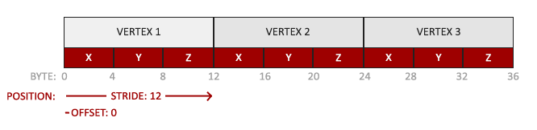

* The position data is stored as 32-bit (4 byte) floating point values.
* Each position is composed of 3 of those values.
* There is no space (or other values) between each set of 3 values. The values are tightly packed in the array.
* The first value in the data is at the beginning of the buffer.

*// гэта, я так разумею, характарыстыка канкрэтна гэтага прыклада //*

With this knowledge we can tell OpenGL how it should interpret the vertex data (per vertex attribute) using glVertexAttribPointer:

glVertexAttribPointer(0, 3, GL\_FLOAT, GL\_FALSE, 3 \* **sizeof**(**float**), (**void**\*)0);

glEnableVertexAttribArray(0);

The function glVertexAttribPointer has quite a few parameters so let's carefully walk through them:

* The first parameter specifies which vertex attribute we want to configure. Remember that we specified the location of the position vertex attribute in the vertex shader with layout (location = 0). This sets the location of the vertex attribute to 0 and since we want to pass data to this vertex attribute, we pass in 0. *// злучэнне шэйдэра з праграмай //*
* The next argument specifies the size of the vertex attribute. The vertex attribute is a vec3 so it is composed of 3 values.
* The third argument specifies the type of the data which is GL\_FLOAT (a vec\* in GLSL consists of floating point values). *// структура glsl //*
* The next argument specifies if we want the data to be normalized. If we set this to GL\_TRUE all the data that has a value not between 0 (or -1 for signed data) and 1 will be mapped to those values. We leave this at GL\_FALSE.
* The fifth argument is known as the stride and tells us the space between consecutive vertex attribute sets. *// паняцце этрыбьют сет змяшчае некалькі атрыбутаў, якія характаразуюць канкрэтны вузел //* Since the next set of position data is located exactly 3 times the size of a float away we specify that value as the stride. Note that since we know that the array is tightly packed (there is no space between the next vertex attribute value) we could've also specified the stride as 0 to let OpenGL determine the stride (this only works when values are tightly packed). *// intbu //* Whenever we have more vertex attributes we have to carefully define the spacing between each vertex attribute but we'll get to see more examples of that later on.
* The last parameter is of type void\* and thus requires that weird cast. This is the offset of where the position data begins in the buffer. Since the position data is at the start of the data array this value is just 0. We will explore this parameter in more detail later on *// арыентацыя чытача //*

*// вось зараз я значна лепей зразумеў гэту функцыю!!! Класны цьютарал! //*

Each vertex attribute takes its data from memory managed by a VBO and which VBO it takes its data from (one could have multiple VBOs) is determined by the VBO currently bound to GL\_ARRAY\_BUFFER when calling glVertexAttribPointer. *// важны аспект тэхналогіі. Для чаго можа спатрэбіцца некалькі ВБО? //* Since the previously defined VBO was bound before calling glVertexAttribPointer vertex attribute 0 is now associated with its vertex data. *// нагадаю, што кожны ВБО змяшчае канкрэтныя вертэксныя дадзены //*

Now that we specified how OpenGL should interpret the vertex data we should also enable the vertex attribute with glEnableVertexAttribArray giving the vertex attribute location as its argument; vertex attributes are disabled by default. *// структура тэхналогіі //* From that point on we have everything set up: we initialized the vertex data in a buffer using a vertex buffer object, set up a vertex and fragment shader and told OpenGL how to link the vertex data to the vertex shader's vertex attributes. *// этапы напісання графічнай праграмы //* Drawing an object in OpenGL would now look something like this:

// 0. copy our vertices array in a buffer for OpenGL to use

glBindBuffer(GL\_ARRAY\_BUFFER, VBO);

glBufferData(GL\_ARRAY\_BUFFER, **sizeof**(vertices), vertices, GL\_STATIC\_DRAW);

// 1. then set the vertex attributes pointers

glVertexAttribPointer(0, 3, GL\_FLOAT, GL\_FALSE, 3 \* **sizeof**(**float**), (**void**\*)0);

glEnableVertexAttribArray(0);

// 2. use our shader program when we want to render an object

glUseProgram(shaderProgram);

// 3. now draw the object

someOpenGLFunctionThatDrawsOurTriangle();

We have to repeat this process every time we want to draw an object. It may not look like that much, but imagine if we have over 5 vertex attributes and perhaps 100s of different objects (which is not uncommon). Binding the appropriate buffer objects and configuring all vertex attributes for each of those objects quickly becomes a cumbersome process. What if there was some way we could store all these state configurations into an object and simply bind this object to restore its state? *// пастанощка задачы //*

#### Vertex Array Object

A vertex array object (also known as VAO) can be bound just like a vertex buffer object and any subsequent vertex attribute calls from that point on will be stored inside the VAO. This has the advantage that when configuring vertex attribute pointers you only have to make those calls once and whenever we want to draw the object, we can just bind the corresponding VAO. This makes switching between different vertex data and attribute configurations as easy as binding a different VAO. All the state we just set is stored inside the VAO.

Core OpenGL **requires** that we use a VAO so it knows what to do with our vertex inputs. If we fail to bind a VAO, OpenGL will most likely refuse to draw anything. *// патрабаванне тэхналогіі //*

A vertex array object stores the following:

* Calls to glEnableVertexAttribArray or glDisableVertexAttribArray.
* Vertex attribute configurations via glVertexAttribPointer.
* Vertex buffer objects associated with vertex attributes by calls to glVertexAttribPointer.

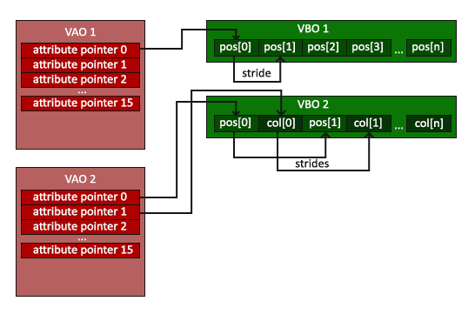

*// не магу пакуль сказаць, што добра ўлаўліваю ідэю ВАО і гэту схему… //*

The process to generate a VAO looks simliar to that of a VBO:

**unsigned** **int** VAO;

glGenVertexArrays(1, &VAO);

To use a VAO all you have to do is bind the VAO using glBindVertexArray. From that point on we should bind/configure the corresponding VBO(s) and attribute pointer(s) and then unbind the VAO for later use. As soon as we want to draw an object, we simply bind the VAO with the prefered settings before drawing the object and that is it. In code this would look a bit like this:

// ..:: Initialization code (done once (unless your object frequently changes)) :: ..

// 1. bind Vertex Array Object

glBindVertexArray(VAO);

// 2. copy our vertices array in a buffer for OpenGL to use

glBindBuffer(GL\_ARRAY\_BUFFER, VBO);

glBufferData(GL\_ARRAY\_BUFFER, **sizeof**(vertices), vertices, GL\_STATIC\_DRAW);

// 3. then set our vertex attributes pointers

glVertexAttribPointer(0, 3, GL\_FLOAT, GL\_FALSE, 3 \* **sizeof**(**float**), (**void**\*)0);

glEnableVertexAttribArray(0);

[...]

// ..:: Drawing code (in render loop) :: ..

// 4. draw the object

glUseProgram(shaderProgram);

glBindVertexArray(VAO);

someOpenGLFunctionThatDrawsOurTriangle();

And that is it! Everything we did the last few million pages led up to this moment, a VAO that stores our vertex attribute configuration and which VBO to use. Usually when you have multiple objects you want to draw, you first generate/configure all the VAOs (and thus the required VBO and attribute pointers) and store those for later use. The moment we want to draw one of our objects, we take the corresponding VAO, bind it, then draw the object and unbind the VAO again. *// вось зараз для мяне стала зразумелай уся сутнасць гэтых ВАО. Гэта абстракцыя, якая робіць разуменне і напісанне кода ясней праз прынцып схавання Парнаса. Важнейшы прынцып траз //*

#### The triangle we've all been waiting for

To draw our objects of choice OpenGL provides us with the glDrawArrays function that draws primitives using the currently active shader, the previously defined vertex attribute configuration and with the VBO's vertex data (indirectly bound via the VAO). *// рэалізацыя тэхналогіі //*

glUseProgram(shaderProgram);

glBindVertexArray(VAO);

glDrawArrays(GL\_TRIANGLES, 0, 3);

The glDrawArrays function takes as its first argument the OpenGL primitive type we would like to draw. Since we said at the start we wanted to draw a triangle and I don't like lying to you, we pass in GL\_TRIANGLES. The second argument specifies the starting index of the vertex array we'd like to draw; we just leave this at 0. *// intbu this parameter //* The last argument specifies how many vertices we want to draw, which is 3 (we only render 1 triangle from our data, which is exactly 3 vertices long).

Now try to compile the code and work your way backwards if any errors popped up. As soon as your application compiles, you should see the following result:

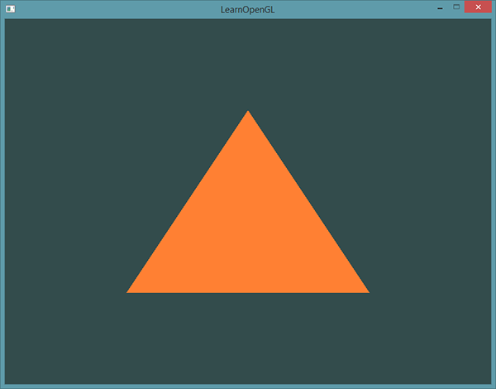

The source code for the complete program can be found [here](https://learnopengl.com/code_viewer_gh.php?code=src/1.getting_started/2.1.hello_triangle/hello_triangle.cpp) .

Modifying other VAOs requires a call to glBindVertexArray anyways so we generally don't unbind VAOs (nor VBOs) when it's not directly necessary.

*// гэта палезная вытрымка з кода //*

If your output does not look the same you probably did something wrong along the way so check the complete source code, see if you missed anything or ask below in the comments section.

*// У МЯНЕ ЎСЁ ПРАЦУЕ!!! //*

*06.08.2017*

### Element Buffer Objects

There is one last thing we'd like to discuss when rendering vertices and that is element buffer objects abbreviated to EBO. *// яшчэ адна сутнасць тэхналогіі //* To explain how element buffer objects work it's best to give an example: suppose we want to draw a rectangle instead of a triangle. We can draw a rectangle using two triangles (OpenGL mainly works with triangles *// структура тэхналогіі //*). This will generate the following set of vertices:

**float** vertices[] = {

// first triangle

0.5f, 0.5f, 0.0f, // top right

0.5f, -0.5f, 0.0f, // bottom right

-0.5f, 0.5f, 0.0f, // top left

// second triangle

0.5f, -0.5f, 0.0f, // bottom right

-0.5f, -0.5f, 0.0f, // bottom left

-0.5f, 0.5f, 0.0f // top left

};

As you can see, there is some overlap on the vertices specified. We specify bottom right and top left twice! This is an overhead of 50% since the same rectangle could also be specified with only 4 vertices, instead of 6. This will only get worse as soon as we have more complex models that have over 1000s of triangles where there will be large chunks that overlap. *// сапраўды, праблема //* What would be a better solution is to store only the unique vertices and then specify the order at which we want to draw these vertices in. In that case we would only have to store 4 vertices for the rectangle, and then just specify at which order we'd like to draw them. Wouldn't it be great if OpenGL provided us with a feature like that? *// вырашэнне праблемы //*

Thankfully, element buffer objects work exactly like that. An EBO is a buffer, just like a vertex buffer object, that stores indices that OpenGL uses to decide what vertices to draw. This so called indexed drawing is exactly the solution to our problem. To get started we first have to specify the (unique) vertices and the indices to draw them as a rectangle:

**float** vertices[] = {

0.5f, 0.5f, 0.0f, // top right

0.5f, -0.5f, 0.0f, // bottom right

-0.5f, -0.5f, 0.0f, // bottom left

-0.5f, 0.5f, 0.0f // top left

};

**unsigned** **int** indices[] = { // note that we start from 0!

0, 1, 3, // first triangle

1, 2, 3 // second triangle

};

You can see that, when using indices, we only need 4 vertices instead of 6. Next we need to create the element buffer object:

**unsigned** **int** EBO;

glGenBuffers(1, &EBO);

Similar to the VBO we bind the EBO and copy the indices into the buffer with glBufferData. Also, just like the VBO we want to place those calls between a bind and an unbind call, although this time we specify GL\_ELEMENT\_ARRAY\_BUFFER as the buffer type.

glBindBuffer(GL\_ELEMENT\_ARRAY\_BUFFER, EBO);

glBufferData(GL\_ELEMENT\_ARRAY\_BUFFER, **sizeof**(indices), indices, GL\_STATIC\_DRAW);

Note that we're now giving GL\_ELEMENT\_ARRAY\_BUFFER as the buffer target. The last thing left to do is replace the glDrawArrays call with glDrawElements to indicate we want to render the triangles from an index buffer. When using glDrawElements we're going to draw using indices provided in the element buffer object currently bound:

glBindBuffer(GL\_ELEMENT\_ARRAY\_BUFFER, EBO);

glDrawElements(GL\_TRIANGLES, 6, GL\_UNSIGNED\_INT, 0);

The first argument specifies the mode we want to draw in, similar to glDrawArrays. The second argument is the count or number of elements we'd like to draw. We specified 6 indices so we want to draw 6 vertices in total. The third argument is the type of the indices which is of type GL\_UNSIGNED\_INT. The last argument allows us to specify an offset in the EBO (or pass in an index array, but that is when you're not using element buffer objects), but we're just going to leave this at 0.

The glDrawElements function takes its indices from the EBO currently bound to the GL\_ELEMENT\_ARRAY\_BUFFER target. This means we have to bind the corresponding EBO each time we want to render an object with indices which seems again a bit cumbersome. It just so happens that a vertex array object also keeps track of element buffer object bindings. The element buffer object currently bound while a VAO is bound, is stored as the VAO's element buffer object. Binding to a VAO thus also automatically binds its EBO. *// рэалізацыя і структура тэхналогіі //*

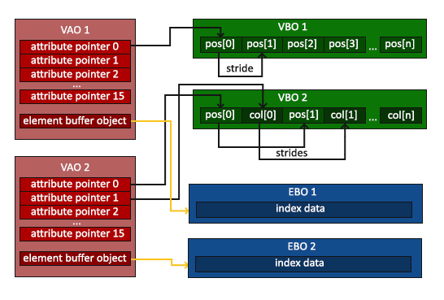

*// гэту цудоўную рэпрэзентацыю я зразумеў //*

A VAO stores the glBindBuffer calls when the target is GL\_ELEMENT\_ARRAY\_BUFFER. This also means it stores its unbind calls so make sure you don't unbind the element array buffer before unbinding your VAO, otherwise it doesn't have an EBO configured. *// важная заўвага //*

The resulting initialization and drawing code now looks something like this:

// ..:: Initialization code :: ..

// 1. bind Vertex Array Object

glBindVertexArray(VAO);

// 2. copy our vertices array in a vertex buffer for OpenGL to use

glBindBuffer(GL\_ARRAY\_BUFFER, VBO);

glBufferData(GL\_ARRAY\_BUFFER, **sizeof**(vertices), vertices, GL\_STATIC\_DRAW);

// 3. copy our index array in a element buffer for OpenGL to use

glBindBuffer(GL\_ELEMENT\_ARRAY\_BUFFER, EBO);

glBufferData(GL\_ELEMENT\_ARRAY\_BUFFER, **sizeof**(indices), indices, GL\_STATIC\_DRAW);

// 4. then set the vertex attributes pointers

glVertexAttribPointer(0, 3, GL\_FLOAT, GL\_FALSE, 3 \* **sizeof**(**float**), (**void**\*)0);

glEnableVertexAttribArray(0);

[...]

// ..:: Drawing code (in render loop) :: ..

glUseProgram(shaderProgram);

glBindVertexArray(VAO);

glDrawElements(GL\_TRIANGLES, 6, GL\_UNSIGNED\_INT, 0)

glBindVertexArray(0);

Running the program should give an image as depicted below. The left image should look familiar and the right image is the rectangle drawn in wireframe mode. The wireframe rectangle shows that the rectangle indeed consists of two triangles.

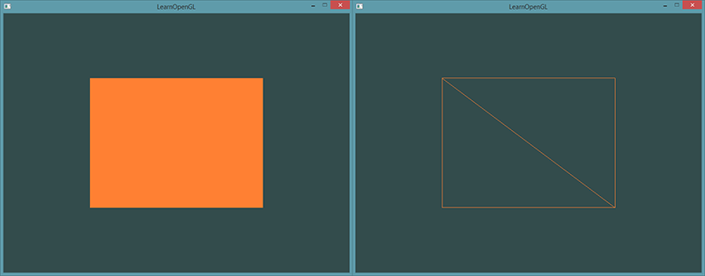**Wireframe mode**

To draw your triangles in wireframe mode, you can configure how OpenGL draws its primitives via glPolygonMode(GL\_FRONT\_AND\_BACK, GL\_LINE). The first argument says we want to apply it to the front and back of all triangles and the second line tells us to draw them as lines. Any subsequent drawing calls will render the triangles in wireframe mode until we set it back to its default using glPolygonMode(GL\_FRONT\_AND\_BACK, GL\_FILL).

If you have any errors, work your way backwards and see if you missed anything. Also, you can find the complete source code [here](https://learnopengl.com/code_viewer_gh.php?code=src/1.getting_started/2.2.hello_triangle_indexed/hello_triangle_indexed.cpp) and feel free to ask any question in the comments section below.

If you managed to draw a triangle or a rectangle just like we did then congratulations, you managed to make it past one of the hardest parts of modern OpenGL: drawing your first triangle. This is a difficult part since there is a large chunk of knowledge required before being able to draw your first triangle. Thankfully, we now made it past that barrier and the upcoming tutorials will hopefully be much easier to understand. *// тнав. Цудоўная арыентацыя чытача постфактум //*

### Additional resources

* [antongerdelan.net/hellotriangle](http://antongerdelan.net/opengl/hellotriangle.html): Anton Gerdelan's take on rendering the first triangle.
* [open.gl/drawing](https://open.gl/drawing): Alexander Overvoorde's take on rendering the first triangle.
* [antongerdelan.net/vertexbuffers](http://antongerdelan.net/opengl/vertexbuffers.html): some extra insights into vertex buffer objects.
* [learnopengl.com/#!In-Practice/Debugging](https://learnopengl.com/#!In-Practice/Debugging): there are a lot of steps involved in this tutorial; if you're stuck it might be worthwhile to read a bit on debugging in OpenGL (up until the debug output section). *// яшчэ адна цудоўная арыентацыя чытача. Гэта сіла дадзенага цьютарала //*

### Exercises

To really get a good grasp of the concepts discussed a few exercises were set up. It is advised to work through them before continuing to the next subject to make sure you get a good grasp of what's going on. *// арыентацыя чытача //*

1. Try to draw 2 triangles next to each other using glDrawArrays by adding more vertices to your data: [solution](https://learnopengl.com/code_viewer_gh.php?code=src/1.getting_started/2.3.hello_triangle_exercise1/hello_triangle_exercise1.cpp). *// выканаў //*
2. Now create the same 2 triangles using two different VAOs and VBOs for their data: [solution](https://learnopengl.com/code_viewer_gh.php?code=src/1.getting_started/2.4.hello_triangle_exercise2/hello_triangle_exercise2.cpp). *// выканаў //*
3. Create two shader programs where the second program uses a different fragment shader that outputs the color yellow; draw both triangles again where one outputs the color yellow: [solution](https://learnopengl.com/code_viewer_gh.php?code=src/1.getting_started/2.5.hello_triangle_exercise3/hello_triangle_exercise3.cpp). *// выканаў //*

Want to help?

Enjoyed the tutorial? Consider becoming a [patron](https://www.patreon.com/learnopengl) of LearnOpenGL.  
  
Your support helps me create new and better tutorials, improve existing content and enables me to improve the website wherever I can.

[*https://learnopengl.com/#!Getting-started/Shaders*](https://learnopengl.com/#!Getting-started/Shaders)

## Shaders

As mentioned in the [Hello Triangle](https://learnopengl.com/#!Getting-started/Hello-Triangle) tutorial, shaders are little programs that rest on the GPU. These programs are run for each specific section of the graphics pipeline. In a basic sense, shaders are nothing more than programs transforming inputs to outputs. Shaders are also very isolated programs in that they're not allowed to communicate with each other; the only communication they have is via their inputs and outputs. *// рэалізацыя і структура тэхналогіі //*

In the previous tutorial we briefly touched the surface of shaders and how to properly use them. We will now explain shaders, and specifically the OpenGL Shading Language, in a more general fashion. *// ступені разумення. Траз. Структура крыніцы і цудоўная арыентацыя чытача ў ёй. Тнав. трэпр //*

### GLSL

Shaders are written in the C-like language GLSL. GLSL is tailored for use with graphics and contains useful features specifically targeted at vector and matrix manipulation. *// структура тэхналогіі //*

Shaders always begin with a version declaration, followed by a list of input and output variables, uniforms and its mainfunction. Each shader's entry point is at its main function where we process any input variables and output the results in its output variables. Don't worry if you don't know what uniforms are, we'll get to those shortly.

A shader typically has the following structure:

#version version\_number

**in** type in\_variable\_name;

**in** type in\_variable\_name;

**out** type out\_variable\_name;

**uniform** type uniform\_name;

**void** main()

{

// process input(s) and do some weird graphics stuff

...

// output processed stuff to output variable

out\_variable\_name = weird\_stuff\_we\_processed;

}

When we're talking specifically about the vertex shader each input variable is also known as a vertex attribute. There is a maximum number of vertex attributes we're allowed to declare limited by the hardware. *// абмежаванне тэхналогіі //* OpenGL guarantees there are always at least 16 4-component vertex attributes available, but some hardware might allow for more which you can retrieve by querying GL\_MAX\_VERTEX\_ATTRIBS:

**int** nrAttributes;

glGetIntegerv(GL\_MAX\_VERTEX\_ATTRIBS, &nrAttributes);

std::cout << "Maximum nr of vertex attributes supported: " << nrAttributes << std::endl;

This often returns the minimum of 16 which should be more than enough for most purposes.

### Types

GLSL has like any other programming language data types for specifying what kind of variable we want to work with. GLSL has most of the default basic types we know from languages like C: int, float, double, uint and bool. GLSL also features two container types that we'll be using a lot throughout the tutorials, namely vectors and matrices. We'll discuss matrices in a later tutorial. *// арыентацыя чытача //*

#### Vectors

A vector in GLSL is a 1, 2, 3 or 4 component container for any of the basic types just mentioned. They can take the following form (n represents the number of components):

* vecn: the default vector of n floats.
* bvecn: a vector of n booleans.
* ivecn: a vector of n integers.
* uvecn: a vector of n unsigned integers.
* dvecn: a vector of n double components.

Most of the time we will be using the basic vecn since floats are sufficient for most of our purposes.

Components of a vector can be accessed via vec.x where x is the first component of the vector. You can use .x, .y, .z and .w to access their first, second, third and fourth component respectively. GLSL also allows you to use rgba for colors or stpq for texture coordinates, accessing the same components.

The vector datatype allows for some interesting and flexible component selection called swizzling. Swizzling allows for the following syntax:

vec2 someVec;

vec4 differentVec = someVec.xyxx;

vec3 anotherVec = differentVec.zyw;

vec4 otherVec = someVec.xxxx + anotherVec.yxzy;

You can use any combination of up to 4 letters to create a new vector (of the same type) as long as the original vector has those components; it is not allowed to access the .z component of a vec2 for example. *// палезная і унікальная ўласцівасць мовы //*

We can also pass vectors as arguments to different vector constructor calls, reducing the number of arguments required:

vec2 vect = vec2(0.5, 0.7);

vec4 result = vec4(vect, 0.0, 0.0);

vec4 otherResult = vec4(result.xyz, 1.0);

*// яшчэ адна палезнасць //*

Vectors are thus a flexible datatype that we can use for all kinds of input and output. Throughout the tutorials you'll see plenty of examples of how we can creatively manage vectors. *// арыентацыя чытача тыпу: што нас чакае, ці тыпу: чым запоўнены цьютарал //*

### Ins and outs

Shaders are nice little programs on their own, but they are part of a whole and for that reason we want to have inputs and outputs on the individual shaders so that we can move stuff around. GLSL defined the in and out keywords specifically for that purpose. Each shader can specify inputs and outputs using those keywords and wherever an output variable matches with an input variable of the next shader stage they're passed along. *// структура тэхналогіі //* The vertex and fragment shader differ a bit though. *// адрозненне паняццяў //*

The vertex shader should receive some form of input otherwise it would be pretty ineffective. The vertex shader differs in its input, in that it receives its input straight from the vertex data. To define how the vertex data is organized we specify the input variables with location metadata so we can configure the vertex attributes on the CPU. We've seen this in the previous tutorial as layout (location = 0). The vertex shader thus requires an extra layout specification for its inputs so we can link it with the vertex data.

It is also possible to omit the layout (location = 0) specifier and query for the attribute locations in your OpenGL code via glGetAttribLocation, but I'd prefer to set them in the vertex shader. It is easier to understand and saves you (and OpenGL) some work. *// я згаджуся з цудоўным аўтарам гэтага цьютарала //*

The other exception is that the fragment shader requires a vec4 color output variable, since the fragment shaders needs to generate a final output color. If you'd fail to specify an output color in your fragment shader OpenGL will render your object black (or white). *// у маім выпадку – чорным //*

So if we want to send data from one shader to the other we'd have to declare an output in the sending shader and a similar input in the receiving shader. When the types and the names are equal on both sides OpenGL will link those variables together and then it is possible to send data between shaders (this is done when linking a program object). *// рэалізацыя тэхналогіі //* To show you how this works in practice we're going to alter the shaders from the previous tutorial to let the vertex shader decide the color for the fragment shader.

#### **Vertex shader**

#version 330 core

**layout** (location = 0) **in** vec3 aPos; // the position variable has attribute position 0

**out** vec4 vertexColor; // specify a color output to the fragment shader

**void** main()

{

gl\_Position = vec4(aPos, 1.0); // see how we directly give a vec3 to vec4's constructor

vertexColor = vec4(0.5, 0.0, 0.0, 1.0); // set the output variable to a dark-red color

}

**Fragment shader**

#version 330 core

**out** vec4 FragColor;

**in** vec4 vertexColor; // the input variable from the vertex shader (same name and same type)

**void** main()

{

FragColor = vertexColor;

}

*// усё атрымалася проста цудоўна! //*

You can see we declared a vertexColor variable as a vec4 output that we set in the vertex shader and we declare a similar vertexColor input in the fragment shader. Since they both have the same type and name, the vertexColor in the fragment shader is linked to the vertexColor in the vertex shader. Because we set the color to a dark-red color in the vertex shader, the resulting fragments should be dark-red as well. The following image shows the output:

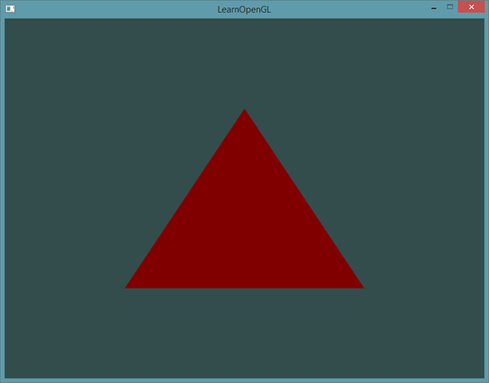

There we go! We just managed to send a value from the vertex shader to the fragment shader. Let's spice it up a bit and see if we can send a color from our application to the fragment shader! *// пастаноўка задачы. Структура цьютарала //*

### Uniforms

07.08.2017

Uniforms are another way to pass data from our application on the CPU to the shaders on the GPU, but uniforms are slightly different compared to vertex attributes. First of all, uniforms are global. Global, meaning that a uniform variable is unique per shader program object, and can be accessed from any shader at any stage in the shader program. Second, whatever you set the uniform value to, uniforms will keep their values until they're either reset or updated. *// а чым гэта адрозніваецца ад звычайных пераменных? //*

To declare a uniform in GLSL we simply add the uniform keyword to a shader with a type and a name. From that point on we can use the newly declared uniform in the shader. Let's see if this time we can set the color of the triangle via a uniform:

#version 330 core

**out** vec4 FragColor;

**uniform** vec4 ourColor; // we set this variable in the OpenGL code.

**void** main()

{

FragColor = ourColor;

}

We declared a uniform vec4 ourColor in the fragment shader and set the fragment's output color to the content of this uniform value. Since uniforms are global variables, we can define them in any shader we'd like so no need to go through the vertex shader again to get something to the fragment shader. We're not using this uniform in the vertex shader so there's no need to define it there.

If you declare a uniform that isn't used anywhere in your GLSL code the compiler will silently remove the variable from the compiled version which is the cause for several frustrating errors; keep this in mind! *// важны нюанс. Рэалізацыя тэхналогіі //*

The uniform is currently empty; we haven't added any data to the uniform yet so let's try that. We first need to find the index/location of the uniform attribute in our shader. Once we have the index/location of the uniform, we can update its values. Instead of passing a single color to the fragment shader, let's spice things up by gradually changing color over time:

**float** timeValue = glfwGetTime();

**float** greenValue = (sin(timeValue) / 2.0f) + 0.5f;

**int** vertexColorLocation = glGetUniformLocation(shaderProgram, "ourColor");

glUseProgram(shaderProgram);

glUniform4f(vertexColorLocation, 0.0f, greenValue, 0.0f, 1.0f);

*// усё працуе //*

First, we retrieve the running time in seconds via glfwGetTime(). Then we vary the color in the range of 0.0 - 1.0 by using the sin function and store the result in greenValue.

Then we query for the location of the ourColor uniform using glGetUniformLocation. We supply the shader program and the name of the uniform (that we want to retrieve the location from) to the query function. If glGetUniformLocation returns -1, it could not find the location. Lastly we can set the uniform value using the glUniform4f function. Note that finding the uniform location does not require you to use the shader program first, but updating a uniform **does** require you to first use the program (by calling glUseProgram), because it sets the uniform on the currently active shader program. *// рэалізацыя і патрабаванне тэхналогіі //*

Because OpenGL is in its core a C library it does not have native support for type overloading, so wherever a function can be called with different types OpenGL defines new functions for each type required; glUniform is a perfect example of this. The function requires a specific postfix for the type of the uniform you want to set. A few of the possible postfixes are:

* f: the function expects a float as its value
* i: the function expects an int as its value
* ui: the function expects an unsigned int as its value
* 3f: the function expects 3 floats as its value
* fv: the function expects a float vector/array as its value

*// рэалізацыя тэхналогіі і яе недахоп, як і мовы С у цэлым //*

Whenever you want to configure an option of OpenGL simply pick the overloaded function that corresponds with your type. In our case we want to set 4 floats of the uniform individually so we pass our data via glUniform4f(note that we also could've used the fv version).

Now that we know how to set the values of uniform variables, we can use them for rendering. If we want the color to gradually change, we want to update this uniform every game loop iteration (so it changes per-frame) otherwise the triangle would maintain a single solid color if we only set it once. So we calculate the greenValue and update the uniform each render iteration:

**while**(!glfwWindowShouldClose(window))

{

// input

processInput(window);

// render

// clear the colorbuffer

glClearColor(0.2f, 0.3f, 0.3f, 1.0f);

glClear(GL\_COLOR\_BUFFER\_BIT);

// be sure to activate the shader

glUseProgram(shaderProgram);

// update the uniform color

**float** timeValue = glfwGetTime();

**float** greenValue = sin(timeValue) / 2.0f + 0.5f;

**int** vertexColorLocation = glGetUniformLocation(shaderProgram, "ourColor");

glUniform4f(vertexColorLocation, 0.0f, greenValue, 0.0f, 1.0f);

// now render the triangle

glBindVertexArray(VAO);

glDrawArrays(GL\_TRIANGLES, 0, 3);

// swap buffers and poll IO events

glfwSwapBuffers(window);

glfwPollEvents();

}

The code is a relatively straightforward adaptation of the previous code. This time, we update a uniform value each iteration before drawing the triangle. If you update the uniform correctly you should see the color of your triangle gradually change from green to black and back to green.

Check out the source code [here](https://learnopengl.com/code_viewer_gh.php?code=src/1.getting_started/3.1.shaders_uniform/shaders_uniform.cpp) if you're stuck.

As you can see, uniforms are a useful tool for setting attributes that might change in render iterations, or for interchanging data between your application and your shaders, *// прызначэнне паняцця //* but what if we want to set a color for each vertex? *// пытанне кнігі //* In that case we'd have to declare as many uniforms as we have vertices. A better solution would be to include more data in the vertex attributes which is what we're going to do. *// структура цьютарала //*

### More attributes!

We saw in the previous tutorial how we can fill a VBO, configure vertex attribute pointers and store it all in a VAO. *// арыентацыя чытача //* This time, we also want to add color data to the vertex data. We're going to add color data as 3 floats to the vertices array. We assign a red, green and blue color to each of the corners of our triangle respectively:

**float** vertices[] = {

// positions // colors

0.5f, -0.5f, 0.0f, 1.0f, 0.0f, 0.0f, // bottom right

-0.5f, -0.5f, 0.0f, 0.0f, 1.0f, 0.0f, // bottom left

0.0f, 0.5f, 0.0f, 0.0f, 0.0f, 1.0f // top

};

Since we now have more data to send to the vertex shader, it is necessary to adjust the vertex shader to also receive our color value as a vertex attribute input. Note that we set the location of the aColor attribute to 1 with the layout specifier:

#version 330 core

**layout** (location = 0) **in** vec3 aPos; // the position variable has attribute position 0

**layout** (location = 1) **in** vec3 aColor; // the color variable has attribute position 1

**out** vec3 ourColor; // output a color to the fragment shader

**void** main()

{

gl\_Position = vec4(aPos, 1.0);

ourColor = aColor; // set ourColor to the input color we got from the vertex data

}

Since we no longer use a uniform for the fragment's color, but now use the ourColor output variable we'll have to change the fragment shader as well:

#version 330 core

**out** vec4 FragColor;

**in** vec3 ourColor;

**void** main()

{

FragColor = vec4(ourColor, 1.0);

}

Because we added another vertex attribute and updated the VBO's memory we have to re-configure the vertex attribute pointers. The updated data in the VBO's memory now looks a bit like this:

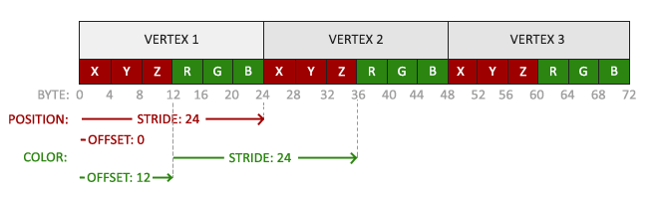

*// з гэтай рэпрэзентацыі я цудоўна зразумеў неясную мне калісьці функцыю //*

Knowing the current layout we can update the vertex format with glVertexAttribPointer:

// position attribute

glVertexAttribPointer(0, 3, GL\_FLOAT, GL\_FALSE, 6 \* **sizeof**(**float**), (**void**\*)0);

glEnableVertexAttribArray(0);

// color attribute

glVertexAttribPointer(1, 3, GL\_FLOAT, GL\_FALSE, 6 \* **sizeof**(**float**), (**void**\*)(3\* **sizeof**(**float**)));

glEnableVertexAttribArray(1);

The first few arguments of glVertexAttribPointer are relatively straightforward. This time we are configuring the vertex attribute on attribute location 1. The color values have a size of 3 floats and we do not normalize the values.

Since we now have two vertex attributes we have to re-calculate the stride value. To get the next attribute value (e.g. the next x component of the position vector) in the data array we have to move 6 floats to the right, three for the position values and three for the color values. This gives us a stride value of 6 times the size of a float in bytes (= 24 bytes).   
Also, this time we have to specify an offset. For each vertex, the position vertex attribute is first so we declare an offset of 0. The color attribute starts after the position data so the offset is 3 \* sizeof(float) in bytes (= 12 bytes).

Running the application should result in the following image:

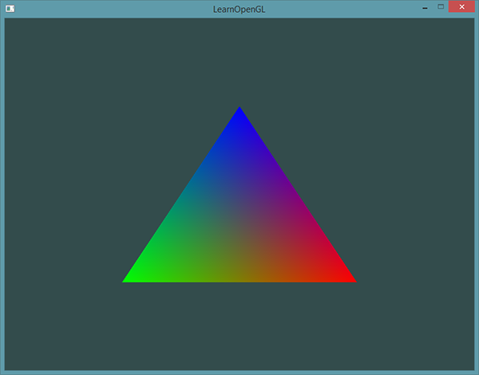

Check out the source code [here](https://learnopengl.com/code_viewer_gh.php?code=src/1.getting_started/3.2.shaders_interpolation/shaders_interpolation.cpp) if you're stuck.

*// УСЁ АТРЫМАЛАСЯ!!! //*

*13.08.2017*

The image might not be exactly what you would expect, since we only supplied 3 colors, not the huge color palette we're seeing right now. This is all the result of something called fragment interpolation in the fragment shader. When rendering a triangle the rasterization stage usually results in a lot more fragments than vertices originally specified. The rasterizer then determines the positions of each of those fragments based on where they reside on the triangle shape. *// рэалізацыя тэхналогіі //*  
Based on these positions, it interpolates all the fragment shader's input variables. Say for example we have a line where the upper point has a green color and the lower point a blue color. If the fragment shader is run at a fragment that resides around a position at 70% of the line its resulting color input attribute would then be a linear combination of green and blue; to be more precise: 30% blue and 70% green. *// алгарытм рэалізацыя градыента //*

This is exactly what happened at the triangle. We have 3 vertices and thus 3 colors and judging from the triangle's pixels it probably contains around 50000 fragments, where the fragment shader interpolated the colors among those pixels. If you take a good look at the colors you'll see it all makes sense: red to blue first gets to purple and then to blue. Fragment interpolation is applied to all the fragment shader's input attributes. *// рэалізацыя тэхналогіі //*

### Our own shader class

Writing, compiling and managing shaders can be quite cumbersome. As a final touch on the shader subject we're going to make our life a bit easier by building a shader class that reads shaders from disk, compiles and links them, checks for errors and is easy to use. This also gives you a bit of an idea how we can encapsulate some of the knowledge we learned so far into useful abstract objects. *// я зрабіў гэта самастойна!!! //*

We will create the shader class entirely in a header file, mainly for learning purposes and portability. Let's start by adding the required includes and by defining the class structure:

#ifndef SHADER\_H

#define SHADER\_H

#include <glad/glad.h> // include glad to get all the required OpenGL headers

#include <string>

#include <fstream>

#include <sstream>

#include <iostream>

**class** Shader

{

**public**:

// the program ID

**unsigned** **int** ID;

// constructor reads and builds the shader

Shader(**const** **GLchar**\* vertexPath, **const** **GLchar**\* fragmentPath);

// use/activate the shader

**void** use();

// utility uniform functions

**void** setBool(**const** std::string &name, **bool** value) **const**;

**void** setInt(**const** std::string &name, **int** value) **const**;

**void** setFloat(**const** std::string &name, **float** value) **const**;

};

#endif

We used several preprocessor directives at the top of the header file. Using these little lines of code informs your compiler to only include and compile this header file if it hasn't been included yet, even if multiple files include the shader header. This prevents linking conflicts.

The shader class holds the ID of the shader program. Its constructor requires the file paths of the source code of the vertex and fragment shader respectively that we can store on disk as simple text files. To add a little extra we also add several utility functions to ease our lifes a little: use activates the shader program, and all set... functions query a uniform location and set its value.

#### Reading from file

We're using C++ filestreams to read the content from the file into several string objects:

Shader(**const** **char**\* vertexPath, **const** **char**\* fragmentPath)

{

// 1. retrieve the vertex/fragment source code from filePath

std::string vertexCode;

std::string fragmentCode;

std::ifstream vShaderFile;

std::ifstream fShaderFile;

// ensure ifstream objects can throw exceptions:

vShaderFile.exceptions (std::ifstream::failbit | std::ifstream::badbit);

fShaderFile.exceptions (std::ifstream::failbit | std::ifstream::badbit);

**try**

{

// open files

vShaderFile.open(vertexPath);

fShaderFile.open(fragmentPath);

std::stringstream vShaderStream, fShaderStream;

// read file's buffer contents into streams

vShaderStream << vShaderFile.rdbuf();

fShaderStream << fShaderFile.rdbuf();

// close file handlers

vShaderFile.close();

fShaderFile.close();

// convert stream into string

vertexCode = vShaderStream.str();

fragmentCode = fShaderStream.str();

}

**catch**(std::ifstream::failure e)

{

std::cout << "ERROR::SHADER::FILE\_NOT\_SUCCESFULLY\_READ" << std::endl;

}

**const** **char**\* vShaderCode = vertexCode.c\_str();

**const** **char**\* fShaderCode = fragmentCode.c\_str();

[...]

Next we need to compile and link the shaders. Note that we're also reviewing if compilation/linking failed and if so, print the compile-time errors which is extremely useful when debugging (you are going to need those error logs eventually):

// 2. compile shaders

**unsigned** **int** vertex, fragment;

**int** success;

**char** infoLog[512];

// vertex Shader

vertex = glCreateShader(GL\_VERTEX\_SHADER);

glShaderSource(vertex, 1, &vShaderCode, NULL);

glCompileShader(vertex);

// print compile errors if any

glGetShaderiv(vertex, GL\_COMPILE\_STATUS, &success);

**if**(!success)

{

glGetShaderInfoLog(vertex, 512, NULL, infoLog);

std::cout << "ERROR::SHADER::VERTEX::COMPILATION\_FAILED\n" << infoLog << std::endl;

};

// similiar for Fragment Shader

[...]

// shader Program

ID = glCreateProgram();

glAttachShader(ID, vertex);

glAttachShader(ID, fragment);

glLinkProgram(ID);

// print linking errors if any

glGetProgramiv(ID, GL\_LINK\_STATUS, &success);

**if**(!success)

{

glGetProgramInfoLog(**this**->Program, 512, NULL, infoLog);

std::cout << "ERROR::SHADER::PROGRAM::LINKING\_FAILED\n" << infoLog << std::endl;

}

// delete the shaders as they're linked into our program now and no longer necessery

glDeleteShader(vertex);

glDeleteShader(fragment);

The use function is straightforward:

**void** use()

{

glUseProgram(ID);

}

Similarly for any of the uniform setter functions:

**void** setBool(**const** std::string &name, **bool** value) **const**

{

glUniform1i(glGetUniformLocation(ID, name.c\_str()), (**int**)value);

}

**void** setInt(**const** std::string &name, **int** value) **const**

{

glUniform1i(glGetUniformLocation(ID, name.c\_str()), value);

}

**void** setFloat(**const** std::string &name, **float** value) **const**

{

glUniform1f(glGetUniformLocation(ID, name.c\_str()), value);

}

And there we have it, a completed [shader class](https://learnopengl.com/code_viewer_gh.php?code=includes/learnopengl/shader_s.h). Using the shader class is fairly easy; we create a shader object once and from that point on simply start using it:

Shader ourShader("path/to/shaders/shader.vs", "path/to/shaders/shader.fs");

...

**while**(...)

{

ourShader.use();

ourShader.setFloat("someUniform", 1.0f);

DrawStuff();

}

Here we stored the vertex and fragment shader source code in two files called shader.vs and shader.fs. You're free to name your shader files however you like; I personally find the extensions .vs and .fs quite intuitive.

You can find the source code [here](https://learnopengl.com/code_viewer_gh.php?code=src/1.getting_started/3.3.shaders_class/shaders_class.cpp) using our newly created [shader class](https://learnopengl.com/code_viewer_gh.php?code=includes/learnopengl/shader_s.h). Note that you can click the shader file paths to find each shader's source code.

*// я скарыстаўся для счытвання файла націўнымі сродкамі Qt – QFile. //*

# Exercises

1. Adjust the vertex shader so that the triangle is upside down: [solution](https://learnopengl.com/code_viewer.php?code=getting-started/shaders-exercise1).
2. Specify a horizontal offset via a uniform and move the triangle to the right side of the screen in the vertex shader using this offset value: [solution](https://learnopengl.com/code_viewer.php?code=getting-started/shaders-exercise2).
3. Output the vertex position to the fragment shader using the out keyword and set the fragment's color equal to this vertex position (see how even the vertex position values are interpolated across the triangle). Once you managed to do this; try to answer the following question: why is the bottom-left side of our triangle black?: [solution](https://learnopengl.com/code_viewer.php?code=getting-started/shaders-exercise3).

*// не рабіў практыкаванняў… хаця трэцяе цікавае… //*

[*https://learnopengl.com/#!Getting-started/Textures*](https://learnopengl.com/#!Getting-started/Textures)

## ***Textures***

*We learned that to add more detail to our objects we can use colors for each vertex to create some interesting images. However, to get a fair bit of realism we'd have to have many vertices so we could specify a lot of colors. This takes up a considerable amount of extra overhead, since each models needs a lot more vertices and for each vertex a color attribute as well. // праблема графікі //*

*What artists and programmers generally prefer is to use a texture. A texture is a 2D image (even 1D and 3D textures exist) used to add detail to an object; think of a texture as a piece of paper with a nice brick image (for example) on it neatly folded over your 3D house so it looks like your house has a stone exterior. Because we can insert a lot of detail in a single image, we can give the illusion the object is extremely detailed without having to specify extra vertices. // перавага тэкстур і цудоўная аналогія для іх разумення //*

*Aside from images, textures can also be used to store a large collection of data to send to the shaders, but we'll leave that for a different topic. // арыентацыя чытача //*

*Below you'll see a texture image of a*[*brick wall*](https://learnopengl.com/img/textures/wall.jpg)*mapped to the triangle from the previous tutorial.*

*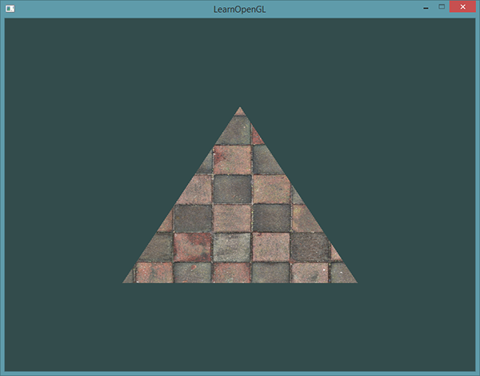*

*In order to map a texture to the triangle we need to tell each vertex of the triangle which part of the texture it corresponds to. Each vertex should thus have a texture coordinate associated with them that specifies what part of the texture image to sample from. Fragment interpolation then does the rest for the other fragments. // выкарыстанне і рэалізацыя тэхналогіі. Фрагментная інтэрпаляцыя ў тэкстурах //*

*Texture coordinates range from 0 to 1 in the x and y axis (remember that we use 2D texture images). Retrieving the texture color using texture coordinates is called sampling. Texture coordinates start at (0,0) for the lower left corner of a texture image to (1,1) for the upper right corner of a texture image. The following image shows how we map texture coordinates to the triangle: // цудоўнейшая рэпрэзентацыя. Граматнейшы цьютарал //*

*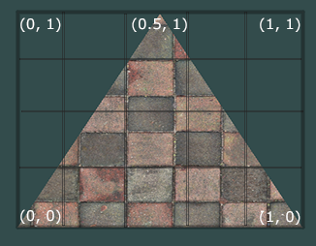*

*We specify 3 texture coordinate points for the triangle. We want the bottom-left side of the triangle to correspond with the bottom-left side of the texture so we use the (0,0) texture coordinate for the triangle's bottom-left vertex. The same applies to the bottom-right side with a (1,0) texture coordinate. The top of the triangle should correspond with the top-center of the texture image so we take (0.5,1.0) as its texture coordinate. We only have to pass 3 texture coordinates to the vertex shader, which then passes those to the fragment shader that neatly interpolates all the texture coordinates for each fragment.*

*The resulting texture coordinates would then look like this:*

***float*** *texCoords[] = {*

*0.0f, 0.0f, // lower-left corner*

*1.0f, 0.0f, // lower-right corner*

*0.5f, 1.0f // top-center corner*

*};*

*Texture sampling has a loose interpretation and can be done in many different ways. It is thus our job to tell OpenGL how it should sample its textures. // задача ў графічных прылажэннях //*

### ***Texture Wrapping***

*Texture coordinates usually range from (0,0) to (1,1) but what happens if we specify coordinates outside this range? The default behavior of OpenGL is to repeat the texture images (we basically ignore the integer part of the floating point texture coordinate), but there are more options OpenGL offers: // рэалізацыя OpenGL //*

* *GL\_REPEAT: The default behavior for textures. Repeats the texture image.*
* *GL\_MIRRORED\_REPEAT: Same as GL\_REPEAT but mirrors the image with each repeat.*
* *GL\_CLAMP\_TO\_EDGE: Clamps the coordinates between 0 and 1. The result is that higher coordinates become clamped to the edge, resulting in a stretched edge pattern.*
* *GL\_CLAMP\_TO\_BORDER: Coordinates outside the range are now given a user-specified border color.*

*Each of the options have a different visual output when using texture coordinates outside the default range. Let's see what these look like on a sample texture image:*

*// з рэпрэзентацыя мне сталі зразумелыя гэтыя патэрны! //*

*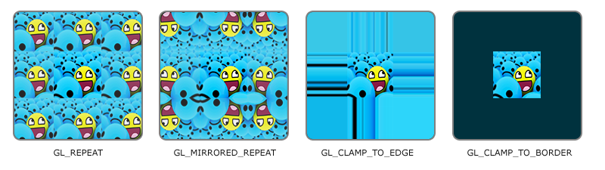*

*Each of the aforementioned options can be set per coordinate axis (s, t (and r if you're using 3D textures) equivalent to x,y,z) with the glTexParameter\* function:*

*glTexParameteri(GL\_TEXTURE\_2D, GL\_TEXTURE\_WRAP\_S, GL\_MIRRORED\_REPEAT);*

*glTexParameteri(GL\_TEXTURE\_2D, GL\_TEXTURE\_WRAP\_T, GL\_MIRRORED\_REPEAT);*

*The first argument specifies the texture target; we're working with 2D textures so the texture target is GL\_TEXTURE\_2D. The second argument requires us to tell what option we want to set and for which texture axis. We want to configure the WRAPoption and specify it for both the S and T axis. The last argument requires us to pass in the texture wrapping mode we'd like and in this case OpenGL will set its texture wrapping option on the currently active texture with GL\_MIRRORED\_REPEAT.*

*If we choose the GL\_CLAMP\_TO\_BORDER option we should also specify a border color. This is done using the fv equivalent of the glTexParameter function with GL\_TEXTURE\_BORDER\_COLOR as its option where we pass in a float array of the border's color value:*

***float*** *borderColor[] = { 1.0f, 1.0f, 0.0f, 1.0f };*

*glTexParameterfv(GL\_TEXTURE\_2D, GL\_TEXTURE\_BORDER\_COLOR, borderColor);*

### ***Texture Filtering***

*Texture coordinates do not depend on resolution but can be any floating point value, thus OpenGL has to figure out which texture pixel (also known as a texel ) to map the texture coordinate to. This becomes especially important if you have a very large object and a low resolution texture. You probably guessed by now that OpenGL has options for this texture filtering as well. There are several options available but for now we'll discuss the most important options: GL\_NEAREST and GL\_LINEAR.*

*GL\_NEAREST (also known as nearest neighbor filtering) is the default texture filtering method of OpenGL. When set to GL\_NEAREST, OpenGL selects the pixel which center is closest to the texture coordinate. // праблема ў тым, што выява на кампутары захавана як набор пікселаў, тады як каардынаты тэкстуры ў OpenGL мы задаем праз флоаты. І нам важна вызначыць з канкрэтнага флоата, які піксель выявы выкарыстоўваць // Below you can see 4 pixels where the cross represents the exact texture coordinate. The upper-left texel has its center closest to the texture coordinate and is therefore chosen as the sampled color: // цудоўная графічная рэпрэзентацыя дадзенай фільтрацыі //*

*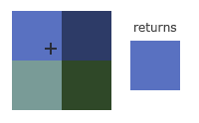*

*GL\_LINEAR (also known as (bi)linear filtering) takes an interpolated value from the texture coordinate's neighboring texels, approximating a color between the texels. The smaller the distance from the texture coordinate to a texel's center, the more that texel's color contributes to the sampled color. Below we can see that a mixed color of the neighboring pixels is returned: // цудоўная рэпрэзентацыя //*

*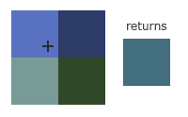*

*But what is the visual effect of such a texture filtering method? Let's see how these methods work when using a texture with a low resolution on a large object (texture is therefore scaled upwards and individual texels are noticeable):*

**

*// вельмі цудоўная рэпрэзентацыя, якая тлумачыць розніцу //*

*GL\_NEAREST results in blocked patterns where we can clearly see the pixels that form the texture while GL\_LINEAR produces a smoother pattern where the individual pixels are less visible. GL\_LINEAR produces a more realistic output, but some developers prefer a more 8-bit look and as a result pick the GL\_NEAREST option.*

*Texture filtering can be set for magnifying and minifying operations (when scaling up or downwards) so you could for example use nearest neighbor filtering when textures are scaled downwards and linear filtering for upscaled textures. // кантэкст выкарыстання паняцця // We thus have to specify the filtering method for both options via glTexParameter\*. The code should look similar to setting the wrapping method:*

*glTexParameteri(GL\_TEXTURE\_2D, GL\_TEXTURE\_MIN\_FILTER, GL\_NEAREST);*

*glTexParameteri(GL\_TEXTURE\_2D, GL\_TEXTURE\_MAG\_FILTER, GL\_LINEAR);*

### ***Mipmaps***

*Imagine if we had a large room with thousands of objects, each with an attached texture. There will be objects far away that have the same high resolution texture attached as the objects close to the viewer. Since the objects are far away and probably only produce a few fragments, OpenGL has difficulties retrieving the right color value for its fragment from the high resolution texture, since it has to pick a texture color for a fragment that spans a large part of the texture. // калі, напрыклад, выява захоўваецца з дазваленнем 1000\*1000 пікселяў, а на экране яна займае толькі пару пікселяў. Праблема зразумела // This will produce visible artifacts on small objects, not to mention the waste of memory to use high resolution textures on small objects. // важная праблема OpenGL //*

*To solve this issue OpenGL uses a concept called mipmaps that is basically a collection of texture images where each subsequent texture is twice as small compared to the previous one. The idea behind mipmaps should be easy to understand: after a certain distance threshold from the viewer, OpenGL will use a different mipmap texture that best suits the distance to the object. Because the object is far away, the smaller resolution will not be noticeable to the user. Also, mipmaps have the added bonus feature that they're good for performance as well. Let's take a closer look at what a mipmapped texture looks like: // цудоўны прыклад праз рэпрэзентацыю //*

*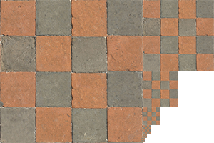*

*Creating a collection of mipmapped textures for each texture image is cumbersome to do manually, but luckily OpenGL is able to do all the work for us with a single call to glGenerateMipmaps after we've created a texture. Later in the texture tutorial you'll see use of this function. // структура OpenGL //*

*When switching between mipmaps levels during rendering OpenGL might show some artifacts like sharp edges visible between the two mipmap layers. Just like normal texture filtering, it is also possible to filter between mipmap levels using NEAREST and LINEAR filtering for switching between mipmap levels. To specify the filtering method between mipmap levels we can replace the original filtering methods with one of the following four options:*

* *GL\_NEAREST\_MIPMAP\_NEAREST: takes the nearest mipmap to match the pixel size and uses nearest neighbor interpolation for texture sampling.*
* *GL\_LINEAR\_MIPMAP\_NEAREST: takes the nearest mipmap level and samples using linear interpolation.*
* *GL\_NEAREST\_MIPMAP\_LINEAR: linearly interpolates between the two mipmaps that most closely match the size of a pixel and samples via nearest neighbor interpolation.*
* *GL\_LINEAR\_MIPMAP\_LINEAR: linearly interpolates between the two closest mipmaps and samples the texture via linear interpolation. // мне было бы цікава ўбачыць гэтыя артэфакты пры пераключэнні між міпмапамі… //*

*Just like texture filtering we can set the filtering method to one of the 4 aforementioned methods using glTexParameteri:*

*glTexParameteri(GL\_TEXTURE\_2D, GL\_TEXTURE\_MIN\_FILTER, GL\_LINEAR\_MIPMAP\_LINEAR);*

*glTexParameteri(GL\_TEXTURE\_2D, GL\_TEXTURE\_MAG\_FILTER, GL\_LINEAR);*

*A common mistake is to set one of the mipmap filtering options as the magnification filter. This doesn't have any effect since mipmaps are primarily used for when textures get downscaled: texture magnification doesn't use mipmaps and giving it a mipmap filtering option will generate an OpenGL GL\_INVALID\_ENUM error code. // заўвага і патэнцыйная памылка //*

### ***Loading and creating textures***

*The first thing we need to do to actually use textures is to load them into our application. Texture images can be stored in dozens of file formats, each with their own structure and ordering of data, so how do we get those images in our application? One solution would be to choose a file format we'd like to use, say .PNG and write our own image loader to convert the image format into a large array of bytes. While it's not very hard to write your own image loader, it's still cumbersome and what if you want to support more file formats? You'd then have to write an image loader for each format you want to support.*

*Another solution, and probably a good one, is to use an image-loading library that supports several popular formats and does all the hard work for us. A library like stb\_image.h.*

***stb\_image.h***

*stb\_image.h is a very popular single header image loading library by*[*Sean Barrett*](https://github.com/nothings)*that is able to load most popular file formats and is easy to integrate in your project(s). stb\_image.h can be downloaded from*[*here*](https://github.com/nothings/stb/blob/master/stb_image.h)*. // яшчэ адзін інструмент // Simply download the single header file, add it to your project as stb\_image.h and create an additional C++ file with the following code:*

*#define STB\_IMAGE\_IMPLEMENTATION*

*#include "stb\_image.h"*

*By defining STB\_IMAGE\_IMPLEMENTATION the preprocessor modifies the header file such that it only contains the relevant definition source code, effectively turning the header file into a .cpp file, and that's about it. Now simply include stb\_image.h somewhere in your program and compile.*

*For the following texture sections we're going to use an image of a*[*wooden container*](https://learnopengl.com/img/textures/container.jpg)*. To load an image using stb\_image.hwe use its stbi\_load function:*

***int*** *width, height, nrChannels;*

***unsigned******char*** *\*data = stbi\_load("container.jpg", &width, &height, &nrChannels, 0);*

*The function first takes as input the location of an image file. It then expects you to give three ints as its second, third and fourth argument that stb\_image.h will fill with the resulting image's width, height and number of color channels. We need the image's width and height for generating textures later on.*

### ***Generating a texture***

*Like any of the previous objects in OpenGL, textures are referenced with an ID; let's create one:*

***unsigned******int*** *texture;*

*glGenTextures(1, &texture);*

*The glGenTextures function first takes as input how many textures we want to generate and stores them in a unsigned int array given as its second argument (in our case just a single unsigned int). Just like other objects we need to bind it so any subsequent texture commands will configure the currently bound texture: // разнавіднасць аб’екта OpenGL. Паслядоўнасць работы з бібліятэкай. //*

*glBindTexture(GL\_TEXTURE\_2D, texture);*

*Now that the texture is bound, we can start generating a texture using the previously loaded image data. Textures are generated with glTexImage2D:*

*glTexImage2D(GL\_TEXTURE\_2D, 0, GL\_RGB, width, height, 0, GL\_RGB, GL\_UNSIGNED\_BYTE, data);*

*glGenerateMipmap(GL\_TEXTURE\_2D);*

*This is a large function with quite a few parameters so we'll walk through them step-by-step:*

* *The first argument specifies the texture target; setting this to GL\_TEXTURE\_2D means this operation will generate a texture on the currently bound texture object at the same target (so any textures bound to targets GL\_TEXTURE\_1D or GL\_TEXTURE\_3D will not be affected).*
* *The second argument specifies the mipmap level for which we want to create a texture for if you want to set each mipmap level manually, but we'll leave it at the base level which is 0.*
* *The third argument tells OpenGL in what kind of format we want to store the texture. Our image has only RGB values so we'll store the texture with RGB values as well.*
* *The 4th and 5th argument sets the width and height of the resulting texture. We stored those earlier when loading the image so we'll use the corresponding variables.*
* *The next argument should always be 0 (some legacy stuff). // не самы лепшы прыклад бібліятэкі //*
* *The 7th and 8th argument specify the format and datatype of the source image. We loaded the image with RGB values and stored them as chars (bytes) so we'll pass in the corresponding values.*
* *The last argument is the actual image data.*

*Once glTexImage2D is called, the currently bound texture object now has the texture image attached to it. However, currently it only has the base-level of the texture image loaded and if we want to use mipmaps we have to specify all the different images manually (by continually incrementing the second argument) or, we could call glGenerateMipmap after generating the texture. This will automatically generate all the required mipmaps for the currently bound texture.*

*After we're done generating the texture and its corresponding mipmaps, it is good practice to free the image memory:*

*stbi\_image\_free(data);*

*The whole process of generating a texture thus looks something like this:*

***unsigned******int*** *texture;*

*glGenTextures(1, &texture);*

*glBindTexture(GL\_TEXTURE\_2D, texture);*

*// set the texture wrapping/filtering options (on the currently bound texture object)*

*glTexParameteri(GL\_TEXTURE\_2D, GL\_TEXTURE\_WRAP\_S, GL\_REPEAT);*

*glTexParameteri(GL\_TEXTURE\_2D, GL\_TEXTURE\_WRAP\_T, GL\_REPEAT);*

*glTexParameteri(GL\_TEXTURE\_2D, GL\_TEXTURE\_MIN\_FILTER, GL\_LINEAR);*

*glTexParameteri(GL\_TEXTURE\_2D, GL\_TEXTURE\_MAG\_FILTER, GL\_LINEAR);*

*// load and generate the texture*

***int*** *width, height, nrChannels;*

***unsigned******char*** *\*data = stbi\_load("container.jpg", &width, &height, &nrChannels, 0);*

***if*** *(data)*

*{*

*glTexImage2D(GL\_TEXTURE\_2D, 0, GL\_RGB, width, height, 0, GL\_RGB, GL\_UNSIGNED\_BYTE, data);*

*glGenerateMipmap(GL\_TEXTURE\_2D);*

*}*

***else***

*{*

*std::cout << "Failed to load texture" << std::endl;*

*}*

*stbi\_image\_free(data);*

### ***Applying textures***

*For the upcoming sections we will use the rectangle shape drawn with glDrawElements from the final part of the*[*Hello Triangle*](https://learnopengl.com/#!Getting-started/Hello-Triangle)*tutorial. We need to inform OpenGL how to sample the texture so we'll have to update the vertex data with the texture coordinates:*

***float*** *vertices[] = {*

*// positions // colors // texture coords*

*0.5f, 0.5f, 0.0f, 1.0f, 0.0f, 0.0f, 1.0f, 1.0f, // top right*

*0.5f, -0.5f, 0.0f, 0.0f, 1.0f, 0.0f, 1.0f, 0.0f, // bottom right*

*-0.5f, -0.5f, 0.0f, 0.0f, 0.0f, 1.0f, 0.0f, 0.0f, // bottom left*

*-0.5f, 0.5f, 0.0f, 1.0f, 1.0f, 0.0f, 0.0f, 1.0f // top left*

*};*

*Since we've added an extra vertex attribute we again have to notify OpenGL of the new vertex format:*

*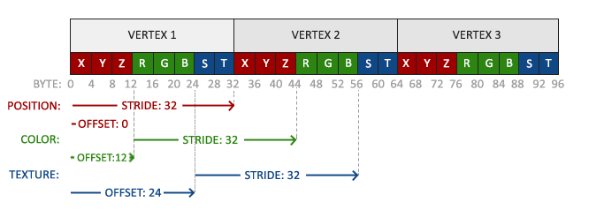*

*// цудоўная рэпрэзентацыя, якая дазваляе добра зразумець тэхналогію //*

*glVertexAttribPointer(2, 2, GL\_FLOAT, GL\_FALSE, 8 \** ***sizeof****(****float****), (****void****\*)(6 \** ***sizeof****(****float****)));*

*glEnableVertexAttribArray(2);*

*Note that we have to adjust the stride parameter of the previous two vertex attributes to 8 \* sizeof(float) as well.*

*Next we need to alter the vertex shader to accept the texture coordinates as a vertex attribute and then forward the coordinates to the fragment shader:*

*#version 330 core*

***layout*** *(location = 0)* ***in*** *vec3 aPos;*

***layout*** *(location = 1)* ***in*** *vec3 aColor;*

***layout*** *(location = 2)* ***in*** *vec2 aTexCoord;*

***out*** *vec3 ourColor;*

***out*** *vec2 TexCoord;*

***void*** *main()*

*{*

*gl\_Position = vec4(aPos, 1.0);*

*ourColor = aColor;*

*TexCoord = aTexCoord;*

*}*

*The fragment shader should then accept the TexCoord output variable as an input variable.*

*The fragment shader should also have access to the texture object, but how do we pass the texture object to the fragment shader? GLSL has a built-in data-type for texture objects called a sampler that takes as a postfix the texture type we want e.g. sampler1D, sampler3D or in our case sampler2D. We can then add a texture to the fragment shader by simply declaring a uniform sampler2D that we later assign our texture to.*

*#version 330 core*

***out*** *vec4 FragColor;*

***in*** *vec3 ourColor;*

***in*** *vec2 TexCoord;*

***uniform*** *sampler2D ourTexture;*

***void*** *main()*

*{*

*FragColor = texture(ourTexture, TexCoord);*

*}*

*To sample the color of a texture we use GLSL's built-in texture function that takes as its first argument a texture sampler and as its second argument the corresponding texture coordinate. The texture function then samples the corresponding color value using the texture parameters we set earlier. // кантэкст выкарыстання і рэалізацыя тэхналогіі // The output of this fragment shader is then the (filtered) color of the texture at the (interpolated) texture coordinate.*

*All that's left to do now is to bind the texture before calling the glDrawElements and it will then automatically assign the texture to the fragment shader's sampler:*

*glBindTexture(GL\_TEXTURE\_2D, texture);*

*glBindVertexArray(VAO);*

*glDrawElements(GL\_TRIANGLES, 6, GL\_UNSIGNED\_INT, 0);*

*If you did everything right you should see the following image:*

*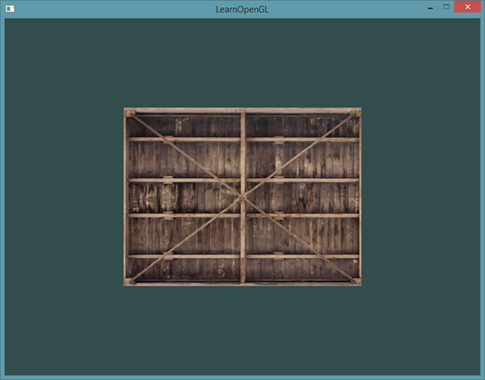*

*If your rectangle is completely white or black you probably made an error along the way. Check your shader logs and try to compare your code with the application's*[*source code*](https://learnopengl.com/code_viewer_gh.php?code=src/1.getting_started/4.1.textures/textures.cpp)*.*

*// З ГОРАМ ДЫ ПАПАЛАМ У МЯНЕ ЎСЁ АТРЫМАЛАСЯ, АЛЕ ТОЛЬКІ З ВЫКАРЫСТАННЕМ СПАМПАВАНАЙ БІБЛІЯТЭКІ. ПРЫ ДАПАМОЗЕ QImage я не змог рэалізаваць задуманнае. Тэкстура атрымалася нейкай не такой… Трэба будзе лепей разбірацца ў гэтым класе //*

*If your texture code doesn't work or shows up as completely black, continue reading and work your way to the last example that****should****work. On some drivers it is always required to assign a texture unit to each sampler uniform which we'll discuss further in this tutorial.*

*To get a little funky we can also mix the resulting texture color with the vertex colors. We simply multiply the resulting texture color with the vertex color in the fragment shader to mix both colors:*

*FragColor = texture(ourTexture, TexCoord) \* vec4(ourColor, 1.0);*

*The result should be a mixture of the vertex's color and the texture's color:*

*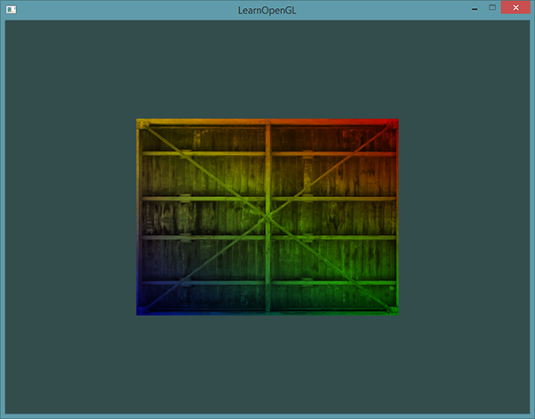*

*I guess you could say our container likes to disco.*

### ***Texture Units***

*You probably wondered why the sampler2D variable is a uniform if we didn't even assign it some value with glUniform. Using glUniform1i we can actually assign a location value to the texture sampler so we can set multiple textures at once in a fragment shader. This location of a texture is more commonly known as a texture unit. The default texture unit for a texture is 0 which is the default active texture unit so we did not had to assign a location in the previous section; note that not all graphics drivers assign a default texture unit so the previous section might not've rendered for you. // нюанс розных графічных картак //*

*The main purpose of texture units is to allow us to use more than 1 texture in our shaders. By assigning texture units to the samplers, we can bind to multiple textures at once as long as we activate the corresponding texture unit first. Just like glBindTexture we can activate texture units using glActiveTexture passing in the texture unit we'd like to use:*

*glActiveTexture(GL\_TEXTURE0); // activate the texture unit first before binding texture*

*glBindTexture(GL\_TEXTURE\_2D, texture);*

*After activating a texture unit, a subsequent glBindTexture call will bind that texture to the currently active texture unit. Texture unit GL\_TEXTURE0 is always by default activated, so we didn't have to activate any texture units in the previous example when using glBindTexture.*

*OpenGL should have a at least a minimum of 16 texture units for you to use which you can activate using GL\_TEXTURE0 to GL\_TEXTURE15. They are defined in order so we could also get GL\_TEXTURE8 via GL\_TEXTURE0 + 8 for example, which is useful when we'd have to loop over several texture units. // рэалізацыя тэхналогіі і яе выкарыстанне // //*

*We still however need to edit the fragment shader to accept another sampler. This should be relatively straightforward now:*

*#version 330 core*

*...*

***uniform*** *sampler2D texture1;*

***uniform*** *sampler2D texture2;*

***void*** *main()*

*{*

*FragColor = mix(texture(texture1, TexCoord), texture(texture2, TexCoord), 0.2);*

*}*

*The final output color is now the combination of two texture lookups. GLSL's built-in mix function takes two values as input and linearly interpolates between them based on its third argument. If the third value is 0.0 it returns the first input; if it's 1.0 it returns the second input value. A value of 0.2 will return 80% of the first input color and 20% of the second input color, resulting in a mixture of both our textures.*

*We now want to load and create another texture; you should be familiar with the steps now. Make sure to create another texture object, load the image and generate the final texture using glTexImage2D. For the second texture we'll use an image of your*[*facial expression while learning OpenGL*](https://learnopengl.com/img/textures/awesomeface.png)*.*

*To use the second texture (and the first texture) we'd have to change the rendering procedure a bit by binding both textures to the corresponding texture unit:*

*glActiveTexture(GL\_TEXTURE0);*

*glBindTexture(GL\_TEXTURE\_2D, texture1);*

*glActiveTexture(GL\_TEXTURE1);*

*glBindTexture(GL\_TEXTURE\_2D, texture2);*

*glBindVertexArray(VAO);*

*glDrawElements(GL\_TRIANGLES, 6, GL\_UNSIGNED\_INT, 0);*

*We also have to tell OpenGL to which texture unit each shader sampler belongs to by setting each sampler using glUniform1i. We only have to set this once, so we can do this before we enter the render loop:*

*ourShader.use(); // don't forget to activate the shader before setting uniforms!*

*glUniform1i(glGetUniformLocation(ourShader.ID, "texture1"), 0); // set it manually*

*ourShader.setInt("texture2", 1); // or with shader class*

***while****(...)*

*{*

*[...]*

*}*

*By setting the samplers via glUniform1i we make sure each uniform sampler corresponds to the proper texture unit. You should get the following result:*

*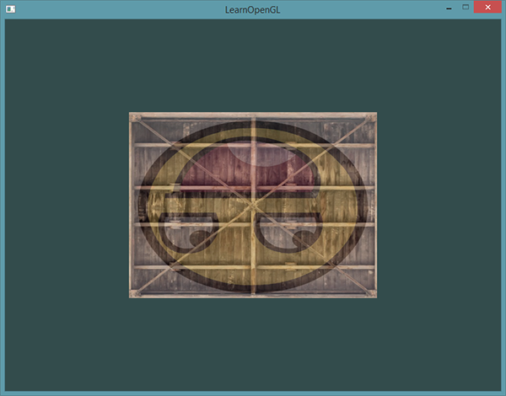*

*You probably noticed that the texture is flipped upside-down! This happens because OpenGL expects the 0.0 coordinate on the y-axis to be on the bottom side of the image, but images usually have 0.0 at the top of the y-axis. Luckily for us, stb\_image.h can flip the y-axis during image loading by adding the following statment before loading any image:*

*stbi\_set\_flip\_vertically\_on\_load(****true****);*

*After telling stb\_image.h to flip the y-axis when loading images you should get the following result:*

*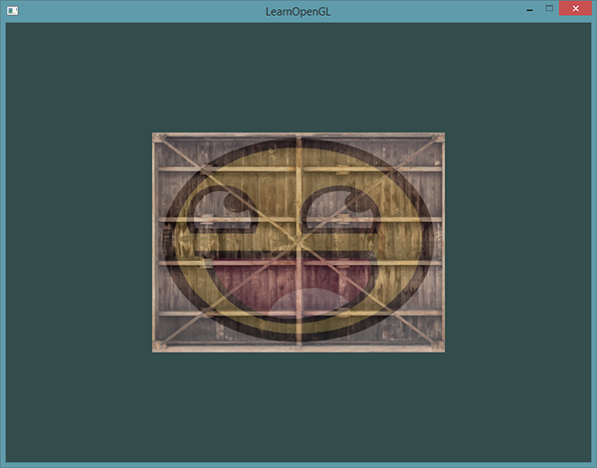*

*If you see one happy container, you did things right. You can compare it with the*[*source code*](https://learnopengl.com/code_viewer_gh.php?code=src/1.getting_started/4.2.textures_combined/textures_combined.cpp)*.*

*// у мяне ўсё атрымалася! Але гэта было няпроста! //*

### ***Exercises***

*To get more comfortable with textures it is advised to work through these exercises before continuing.*

* *Make sure****only****the happy face looks in the other/reverse direction by changing the fragment shader:*[*solution*](https://learnopengl.com/code_viewer.php?code=getting-started/textures-exercise1)*. // я тут не зразумеў заданне //*
* *Experiment with the different texture wrapping methods by specifying texture coordinates in the range 0.0f to 2.0f instead of 0.0f to 1.0f. See if you can display 4 smiley faces on a single container image clamped at its edge:*[*solution*](https://learnopengl.com/code_viewer_gh.php?code=src/1.getting_started/4.3.textures_exercise2/textures_exercise2.cpp)*,*[*result*](https://learnopengl.com/img/getting-started/textures_exercise2.png)*. See if you can experiment with other wrapping methods as well. // пабалаваўся і павыконваў //*
* *Try to display only the center pixels of the texture image on the rectangle in such a way that the individual pixels are getting visible by changing the texture coordinates. Try to set the texture filtering method to GL\_NEAREST to see the pixels more clearly:*[*solution*](https://learnopengl.com/code_viewer_gh.php?code=src/1.getting_started/4.4.textures_exercise3/textures_exercise3.cpp)*. // зроблена //*
* *Use a uniform variable as the mix function's third parameter to vary the amount the two textures are visible. Use the up and down arrow keys to change how much the container or the smiley face is visible:*[*solution*](https://learnopengl.com/code_viewer_gh.php?code=src/1.getting_started/4.5.textures_exercise4/textures_exercise4.cpp)*. // я вырашыў, але за адно націсканне стрэлкі ў мяне функцыя апрацоўкі інпута выклікаецца шмат разоў – каля ста. Так што прыйшлося паставіць вельмі малы інкрэмент. Дужа хутка працавала праграма. Такое ж самае вырашэнне прапанаваў і аўтар цьютарала. //*

[*https://learnopengl.com/#!Getting-started/Transformations*](https://learnopengl.com/#!Getting-started/Transformations)

*14.08.2017*

## ***Transformations***

*We now know how to create objects, color them and/or give them a detailed appearance using textures, but they're still not that interesting since they're all static objects. We could try and make them move by changing their vertices and re-configuring their buffers each frame, but that's cumbersome and costs quite some processing power. There are much better ways to transform an object and that's by using (multiple) matrix objects. This doesn't mean we're going to talk about kungfu and a large digital artificial world. // арыентацыя чытача. Перавага выкарыстання матрыц. Апошні сказ я не зразумеў… //*

*Matrices are very powerful mathematical constructs that seem scary at first, but once you'll grow accustomed to them they'll prove extremely useful. When discussing matrices, we'll have to make a small dive into some mathematics and for the more mathematically inclined readers I'll post additional resources for further reading.*

*However, to fully understand transformations we first have to delve a bit deeper into vectors before discussing matrices. The focus of this chapter is to give you a basic mathematical background in topics we will require later on. If the subjects are difficult, try to understand them as much as you can and come back to this page later to review the concepts whenever you need them. // фантастычная арыентацыя чытача. Тнав. //*

### ***Vectors***

*In its most basic definition, vectors are directions and nothing more. A vector has a direction and a magnitude (also known as its strength or length). You can think of vectors like directions on a treasure map: 'go left 10 steps, now go north 3 steps and go right 5 steps'; here 'left' is the direction and '10 steps' is the magnitude of the vector. The directions for the treasure map thus contains 3 vectors. Vectors can have any dimension, but we usually work with dimensions of 2 to 4. If a vector has 2 dimensions it represents a direction on a plane (think of 2D graphs) and when it has 3 dimensions it can represent any direction in a 3D world.*

*Below you'll see 3 vectors where each vector is represented with (x,y) as arrows in a 2D graph. Because it is more intuitive to display vectors in 2D (than in 3D) you can think of the 2D vectors as 3D vectors with a z coordinate of 0. Since vectors represent directions, the origin of the vector does not change its value. In the graph below we can see that the vectors v¯v¯ and w¯w¯ are equal even though their origin is different: // разнавіднасці вектараў //*

*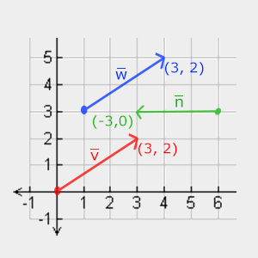*

*When describing vectors mathematicians generally prefer to describe vectors as character symbols with a little bar over their head like v¯v¯. Also, when displaying vectors in formulas they are generally displayed as follows:*

*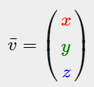*

*Because vectors are specified as directions it is sometimes hard to visualize them as positions. What we basically visualize is we set the origin of the direction to (0,0,0) and then point towards a certain direction that specifies the point, making it a position vector (we could also specify a different origin and then say: 'this vector points to that point in space from this origin'). The position vector (3,5) would then point to (3,5) on the graph with an origin of (0,0). Using vectors we can thus describe directions****and****positions in 2D and 3D space.*

*Just like with normal numbers we can also define several operations on vectors (some of which you've already seen).*

#### **Scalar vector operations**

*A scalar is a single digit (or a vector with 1 component if you'd like stay in vector-land). When adding/subtracting/multiplying or dividing a vector with a scalar we simply add/subtract/multiply or divide each element of the vector by the scalar. For addition it would look like this:*

*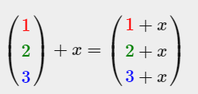*

*Where ++ can be ++,−−,⋅⋅ or ÷÷ where ⋅⋅ is the multiplication operator. Keep in mind that for the −− and ÷÷ operator order the reverse order is not defined. // intbu better //*

#### **Vector negation**

*Negating a vector results in a vector in the reversed direction. A vector pointing north-east would point south-west after negation. To negate a vector we add a minus-sign to each component (you can also represent it as a scalar-vector multiplication with a scalar value of -1):*

*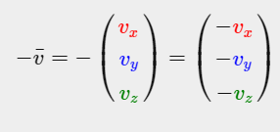*

#### **Addition and subtraction**

*Addition of two vectors is defined as component-wise addition, that is each component of one vector is added to the same component of the other vector like so:*

*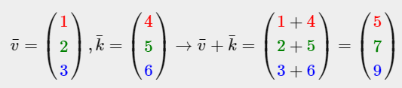*

*Visually, it looks like this on vectors v=(4,2) and k=(1,2):*

*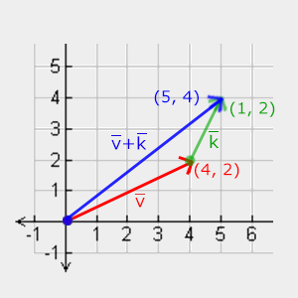*

*Just like normal addition and subtraction, vector subtraction is the same as addition with a negated second vector:*

*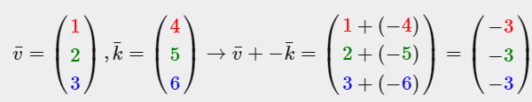*

*// вельмі крута, што розныя кампаненты паказаны розным колерам. Тнав. //*

*Subtracting two vectors from each other results in a vector that's the difference of the positions both vectors are pointing at. This proves useful in certain cases where we need to retrieve a vector that's the difference between two points. // кантэкст выкарыстання аперацыі аднімання вектараў //*

*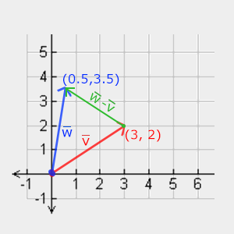*

#### **Length**

*To retrieve the length/magnitude of a vector we use the Pythagoras theorem that you might remember from your math classes. A vector forms a triangle when you visualize its individual x and y component as two sides of a triangle:*

*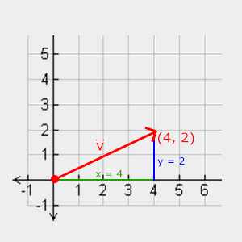*

*Since the length of the two sides (x, y) are known and we want to know the length of the tilted side v¯v¯ we can calculate it using the Pythagoras theorem as:*

*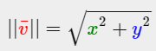*

*Where ||v¯||||v¯|| is denoted as the length of vector v¯v¯. This is easily extended to 3D by adding z2z2 to the equation.*

*In this case the length of vector (4, 2) equals:*

**

*Which is 4.47.*

*There is also a special type of vector that we call a unit vector. A unit vector has one extra property and that is that its length is exactly 1. We can calculate a unit vector n^n^ from any vector by dividing each of the vector's components by its length:*

*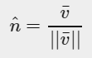*

*We call this normalizing a vector. Unit vectors are displayed with a little roof over their head and are generally easier to work with, especially when we only care about their directions (the direction does not change if we change a vector's length).*

#### **Vector-vector multiplication**

*Multiplying two vectors is a bit of a weird case. Normal multiplication isn't really defined on vectors since it has no visual meaning, but we have two specific cases that we could choose from when multiplying: one is the dot product denoted as v¯⋅k¯v¯⋅k¯and the other is the cross product denoted as v¯×k¯v¯×k¯.*

##### ***Dot product***

*The dot product of two vectors is equal to the scalar product of their lengths times the cosine of the angle between them. If this sounds confusing take a look at its formula: // аўтар цьюторыяла – вялікі спец па навучанні! Тнав. //*

*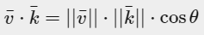*

*Where the angle between them is represented as theta (θθ). Why is this interesting? Well, imagine if v¯v¯ and k¯k¯ are unit vectors then their length would be equal to 1. This would effectively reduce the formula to:*

*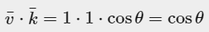*

*Now the dot product****only****defines the angle between both vectors. You might remember that the cosine or cos function becomes 0 when the angle is 90 degrees or 1 when the angle is 0. This allows us to easily test if the two vectors are orthogonal or parallel to each other using the dot product (orthogonal means the vectors are at a right-angle to each other). In case you want to know more about the sin or the cosine functions I'd suggest the following*[*Khan Academy videos*](https://www.khanacademy.org/math/trigonometry/basic-trigonometry/basic_trig_ratios/v/basic-trigonometry)*about basic trigonometry. // цудоўная спасылка аўтара на адукацыйныя рэсурсы. Гэта фантастыка! //*

*You can also calculate the angle between two non-unit vectors, but then you'd have to divide the lengths of both vectors from the result to be left with cosθ.*

*So how do we calculate the dot product? The dot product is a component-wise multiplication where we add the results together. It looks like this with two unit vectors (you can verify that both their lengths are exactly 1):*

*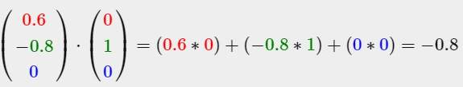*

*To calculate the degree between both these unit vectors we use the inverse of the cosine function cos−1 and this results in 143.1 degrees. We now effectively calculated the angle between these two vectors. The dot product proves very useful when doing lighting calculations. // кантэкст выкарыстання паняцця //*

##### ***Cross product***

*The cross product is only defined in 3D space and takes two non-parallel vectors as input and produces a third vector that is orthogonal to both the input vectors. If both the input vectors are orthogonal to each other as well, a cross product would result in 3 orthogonal vectors. This will prove useful in the upcoming tutorials. The following image shows what this looks like in 3D space:*

*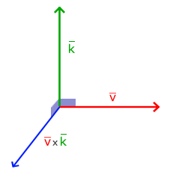*

*Unlike the other operations, the cross product isn't really intuitive without delving into linear algebra so it's best to just memorize the formula and you'll be fine (or don't, you'll probably be fine as well). Below you'll see the cross product between two orthogonal vectors A and B:*

*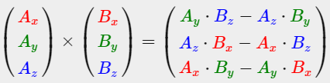*

*As you can see, it doesn't really seem to make sense. However, if you just follow these steps you'll get another vector that is orthogonal to your input vectors.*

### ***Matrices***

*Now that we've discussed almost all there is to vectors it is time to enter the matrix! A matrix is basically a rectangular array of numbers, symbols and/or expressions. Each individual item in a matrix is called an element of the matrix. An example of a 2x3 matrix is shown below:*

*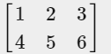*

*Matrices are indexed by (i,j) where i is the row and j is the column, that is why the above matrix is called a 2x3 matrix (3 columns and 2 rows, also known as the dimensions of the matrix). This is the opposite of what you're used to when indexing 2D graphs as (x,y). To retrieve the value 4 we would index it as (2,1) (second row, first column).*

*Matrices are basically nothing more than that, just rectangular arrays of mathematical expressions. They do have a very nice set of mathematical properties and just like vectors we can define several operations on matrices, namely: addition, subtraction and multiplication.*

#### Addition and subtraction

*Addition and subtraction between a matrix and a scalar is defined as follows:*

*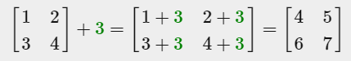*

The scalar value is basically added to each individual element of the matrix. The same applies for matrix-scalar subtraction:

*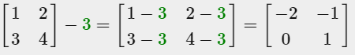*

*Matrix addition and subtraction between two matrices is done on a per-element basis. So the same general rules apply that we're familiar with for normal numbers, but done on the elements of both matrices with the same index. This does mean that addition and subtraction is only defined for matrices of the same dimensions. A 3x2 matrix and a 2x3 matrix (or a 3x3 matrix and a 4x4 matrix) cannot be added or subtracted together. Let's see how matrix addition works on two 2x2 matrices:*

*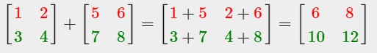*

*The same rules apply for matrix subtraction:*

*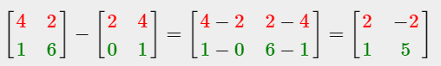*

#### **Matrix-scalar products**

*Just like addition and subtraction, a matrix-scalar product multiples each element of the matrix by a scalar. The following example illustrates the multiplication:*

*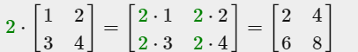*

*Now it also makes sense as to why those single numbers are called scalars. A scalar basically scales all the elements of the matrix by its value. In the previous example, all elements were scaled by 2. // цудоўная этымалогія назвы. З разраду “ніколі не задумваўся” //*

*So far so good, all of our cases weren't really too complicated. That is, until we start on matrix-matrix multiplication.*

#### **Matrix-matrix multiplication**

*Multiplying matrices is not necessarily complex, but rather difficult to get comfortable with. Matrix multiplication basically means to follow a set of pre-defined rules when multiplying. There are a few restrictions though:*

1. *You can only multiply two matrices if the number of columns on the left-hand side matrix is equal to the number of rows on the right-hand side matrix.*
2. *Matrix multiplication is not commutative that is A⋅B≠B⋅A.*

*Let's get started with an example of a matrix multiplication of 2 2x2 matrices:*

*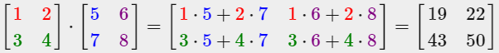*

*Right now you're probably trying to figure out what the hell just happened? Matrix multiplication is a combination of normal multiplication and addition using the left-matrix's rows with the right-matrix's columns. Let's try discussing this with the following image:*

*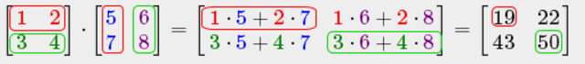*

*We first take the upper row of the left matrix and then take a column from the right matrix. The row and column that we picked decides which output value of the resulting 2x2 matrix we're going to calculate. If we take the first row of the left matrix the resulting value will end up in the first row of the result matrix, then we pick a column and if it's the first column the result value will end up in the first column of the result matrix. This is exactly the case of the red pathway. To calculate the bottom-right result we take the bottom row of the first matrix and the rightmost column of the second matrix.*

*To calculate the resulting value we multiply the first element of the row and column together using normal multiplication, we do the same for the second elements, third, fourth etc. The results of the individual multiplications are then summed up and we have our result. Now it also makes sense that one of the requirements is that the size of the left-matrix's columns and the right-matrix's rows are equal, otherwise we can't finish the operations!*

*The result is then a matrix that has dimensions of (n,m) where n is equal to the number of rows of the left-hand side matrix and m is equal to the columns of the right-hand side matrix.*

*Don't worry if you have difficulties imagining the multiplications inside your head. Just keep trying to do the calculations by hand and return to this page whenever you have difficulties. Over time, matrix multiplication becomes second nature to you. // цудоўная арыентацыя чытача. Тнав. //*

*Let's finish the discussion of matrix-matrix multiplication with a larger example. Try to visualize the pattern using the colors. As a useful exercise, see if you can come up with your own answer of the multiplication and then compare them with the resulting matrix (once you try to do a matrix multiplication by hand you'll quickly get the grasp of them).*

*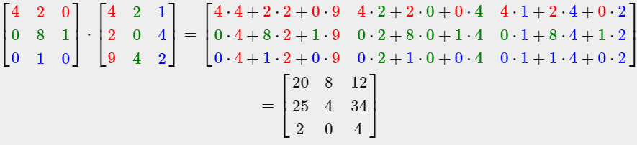*

*As you can see, matrix-matrix multiplication is quite a cumbersome process and very prone to errors (which is why we usually let computers do this) and this gets problematic real quick when the matrices become larger. If you're still thirsty for more and you're curious about some more of the mathematical properties of matrices I strongly suggest you take a look at these*[*Khan Academy videos*](https://www.khanacademy.org/math/algebra2/algebra-matrices)*about matrices.*

*Anyways, now that we know how to multiply matrices together, we can start getting to the good stuff.*

#### **Matrix-Vector multiplication**

*Up until now we've had our fair share of vectors these tutorials. We used vectors to represent positions, colors and even texture coordinates. Let's move a bit further down the rabbit hole and tell you that a vector is basically a Nx1 matrix where Nis the vector's number of components (also known as an N-dimensional vector). If you think about it, it makes a lot of sense. Vectors are just like matrices an array of numbers, but with only 1 column. So, how does this new piece of information help us? Well, if we have a MxN matrix we can multiply this matrix by our Nx1 vector, since the columns of our matrix are equal to the number of rows of our vector, thus matrix multiplication is defined.*

*But why do we care if we can multiply matrices with a vector? // цудоўная арыентацыя чытача. Пытанні, якія ўзнікаюць у самога навучэнца. Тнав. // Well, it just so happens that there are lots of interesting 2D/3D transformations we can place inside a matrix and multiplying that matrix with our vector basically transforms our vector. In case you're still a bit confused, let's start with some examples and you'll soon see what we mean. // кантэкст выкарыстання тэхналогіі //*

##### ***Identity matrix***

*In OpenGL we usually work with 4x4 transformation matrices for several reasons and one of them is that most of the vectors are of size 4. // структура тэхналогіі // The most simple transformation matrix that we can think of is the identity matrix. The identity matrix is an NxNmatrix with only 0s except on its diagonal. As you'll see, this transformation matrix leaves a vector completely unharmed:*

*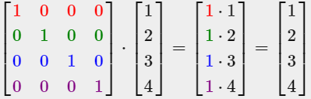  
The vector seems completely untouched. This becomes obvious from the rules of multiplication: the first result element is each individual element of the first row of the matrix multiplied with each element of the vector. Since each of the row's elements are 0 except the first one, we get: 1⋅1+0⋅2+0⋅3+0⋅4=11⋅1+0⋅2+0⋅3+0⋅4=1 and the same applies for the other 3 elements of the vector.*

*You might be wondering what the use is of a transformation matrix that does not transform? The identity matrix is usually a starting point for generating other transformation matrices and if we dig even deeper into linear algebra, a very useful matrix for proving theorems and solving linear equations.*

##### ***Scaling***

*When we're scaling a vector we are increasing the length of the arrow by amount we'd like to scale, keeping its direction the same. Since we're working in either 2 or 3 dimensions we can define scaling by a vector of 2 or 3 scaling variables, each scaling one axis (x, y or z).*

*Let's try scaling the vector v¯=(3,2). We will scale the vector along the x-axis by 0.5, thus making it twice as narrow; and we'll scale the vector by 2 along the y-axis, making it twice as high. Let's see what it looks like if we scale the vector by (0.5,2) as s¯:*

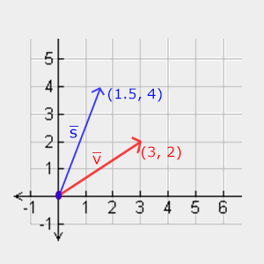

*// з гэтай рэпрэзентацыяй я не разабраўся, але тэма мне ясна. Тут пры скэйлінгу накірунак змяняецца… //*

*Keep in mind that OpenGL usually operates in 3D space so for this 2D case we could set the z-axis scale to 1 thus leaving it unharmed. The scaling operation we just performed is a non-uniform scale, because the scaling factor is not the same for each axis. If the scalar would be equal on all axes it would be called a uniform scale. // вось тут накірунак захоўваецца //*

*Let's start building a transformation matrix that does the scaling for us. We saw from the identity matrix that each of the diagonal elements were multiplied with its corresponding vector element. What if we were to change the 1s in the identity matrix to 3s? In that case, we would be multiplying each of the vector elements by a value of 3 and thus effectively scale the vector by 3. If we represent the scaling variables as (S1,S2,S3)(S1,S2,S3) we can define a scaling matrix on any vector (x,y,z)(x,y,z) as:*

*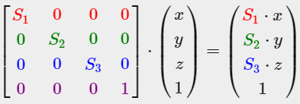  
Note that the 4th scaling vector stays 1, since it's undefined to scale the w component in a 3D space. The w component is used for other purposes as we'll see later on.*

*// матрыца маштабіравання мне зразумела //*

##### ***Translation***

*19.08.2017*

*Translation is the process of adding another vector on top of the original vector to return a new vector with a different position, thus moving the vector based on a translation vector. We've already discussed vector addition so this shouldn't be too new.*

*Just like the scaling matrix there are several locations on a 4-by-4 matrix that we can use to perform certain operations and for translation those are the top-3 values of the 4th column. If we represent the scaling vector as (Tx,Ty,Tz)(Tx,Ty,Tz) we can define the translation matrix by:*

*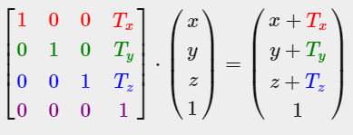*

*This works because all of the translation values are multiplied by the vector's w column and added to the vector's original values (remember the matrix-multiplication rules). This wouldn't have been possible with a 3-by-3 matrix. // вось чаму у вектара ёсць чацвёртая каардыната //*

##### ***Homogeneous coordinates***

*The w component of a vector is also known as a homogeneous coordinate. To get the 3D vector from a homogeneous vector we divide the x, y and z coordinate by its w coordinate. We usually do not notice this since the w component is 1.0 most of the time. Using homogeneous coordinates has several advantages: it allows us to do translations on 3D vectors (without a w component we can't translate vectors) and in the next chapter we'll use the w value to create 3D visuals.  
  
Also, whenever the homogeneous coordinate is equal to 0 the vector is specifically known as a direction vector since a vector with a w coordinate of 0 cannot be translated.*

*With a translation matrix we could move objects in any of the 3 directions (x, y, z) we'd like, making it a very useful transformation matrix for our transformation toolkit.*

#### **Rotation**

*The last few transformations were relatively easy to understand and visualize in 2D or 3D space, but rotations are a bit trickier. If you want to know exactly how these matrices are constructed I'd recommend that you watch the rotation items of Khan Academy's*[*linear algebra*](https://www.khanacademy.org/math/linear-algebra/matrix_transformations)*videos. // складаная тэма і спасылка на тлумачэнне. Аспекты тнав. Выпадак, дзе грунтоўнае тлумачэнне з-за складанасці тэмы лепей апусціць //*

*First let's define what a rotation of a vector actually is // структура цьютарала //. A rotation in 2D or 3D is represented with an angle. An angle could be in degrees or radians where a whole circle has 360 degrees or 2*[*PI*](http://en.wikipedia.org/wiki/Pi)*radians. I personally prefer to work in degrees, since they seem to make more sense to me. Most rotation functions require an angle in radians, but luckily degrees are easily converted to radians:   
angle in degrees = angle in radians \* (180.0f / PI)   
angle in radians = angle in degrees \* (PI / 180.0f)   
Where PI equals (sort of) 3.14159265359. Rotating half a circle would rotate us 360/2 = 180 degrees and rotating 1/5th to the right means we rotate 360/5 = 72 degrees to the right. This is demonstrated for a basic 2D vector where v¯ is rotated 72 degrees to the right from k¯:*

*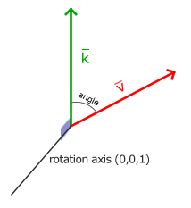*

*Rotations in 3D are specified with an angle****and****a rotation axis. The angle specified will rotate the object along the rotation axis given. Try to visualize this by spinning your head a certain degree while continually looking down a single rotation axis. When rotating 2D vectors in a 3D world for example, we set the rotation axis to the z-axis (try to visualize this).*

*Using trigonometry it is possible to transform vectors to new rotated vectors given an angle. This is usually done via a smart combination of the sine and cosine function (commonly abbreviated to sin and cos). A discussion of how the transformation matrices are generated is out of the scope of this tutorial.*

*A rotation matrix is defined for each unit axis in 3D space where the angle is represented as the theta symbol θ.*

*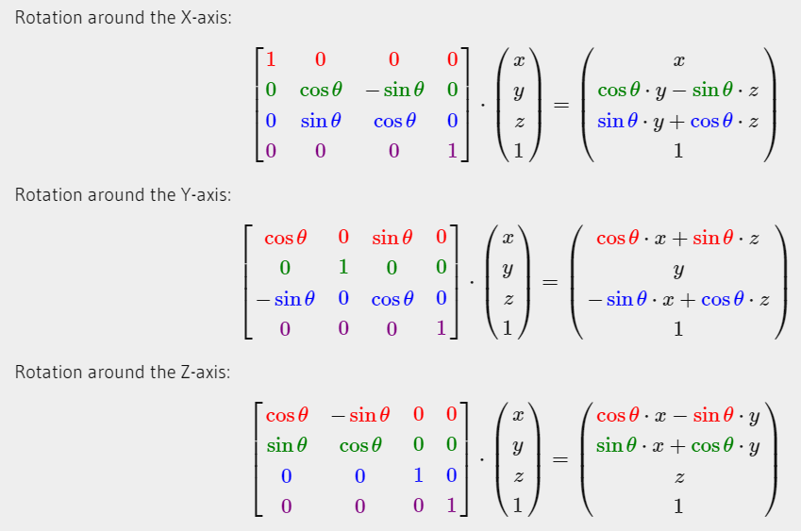*

*Using the rotation matrices we can transform our position vectors around one of the three unit axes. It is also possible to combine them by first rotating around the X-axis and then the Y-axis for example. However, this quickly introduces a problem called Gimbal lock. // intbu this problem // We won't discuss the details, but a better solution is to rotate around an arbitrary unit axis e.g. (0.662, 0.2, 0.722) (note that this is a unit vector) right away instead of combining the rotation matrices. Such a (nasty) matrix exists and is given below with (Rx,Ry,Rz) as the arbitrary rotation axis:*

*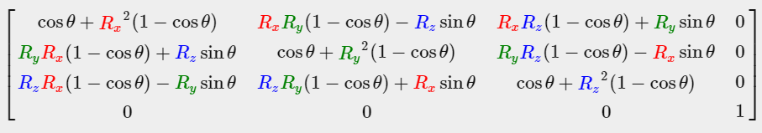  
A mathematical discussion of generating such a matrix is out of the scope of this tutorial. // тнав. Важна указваць, што выходзіць за рамкі таго ці іншага цьюторыяла // Keep in mind that even this matrix does not completely prevent gimbal lock (although it gets a lot harder). To truly prevent Gimbal locks we have to represent rotations using quaternions, that are not only safer, but also more computationally friendly. However, a discussion of quaternions is reserved for a later tutorial. // магчыма, там і пра гэту праблему скажуць //*

#### **Combining matrices**

*The true power from using matrices for transformations is that we can combine multiple transformations in a single matrix thanks to matrix-matrix multiplication. Let's see if we can generate a transformation matrix that combines several transformations. Say we have a vector (x,y,z) and we want to scale it by 2 and then translate it by (1,2,3). We need a translation and a scaling matrix for our required steps. The resulting transformation matrix would then look like:*

*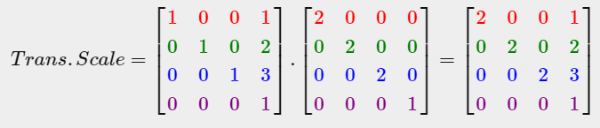*

*Note that we first do a translation and then a scale transformation when multiplying matrices. Matrix multiplication is not commutative, which means their order is important. When multiplying matrices the right-most matrix is first multiplied with the vector so you should read the multiplications from right to left. It is advised to first do scaling operations, then rotations and lastly translations when combining matrices otherwise they might (negatively) affect each other. For example, if you would first do a translation and then scale, the translation vector would also scale!*

*Running the final transformation matrix on our vector results in the following vector:*

*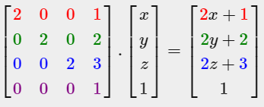*

Great! The vector is first scaled by two and then translated by (1,2,3).

### In practice

Now that we've explained all the theory behind transformations, it's time to see how we can actually use this knowledge to our advantage. *// цудоўнейшая арыентацыя навучэнца. тнав //* OpenGL does not have any form of matrix or vector knowledge built in, so we have to define our own mathematics classes and functions. In the tutorials we'd rather abstract from all the tiny mathematical details and simply use pre-made mathematics libraries. Luckily, there is an easy-to-use and tailored-for-OpenGL mathematics library called GLM.

### GLM



GLM stands for Open**GL** **M**athematics and is a header-only library, which means that we only have to include the proper header files and we're done; *// разнавіднасць бібліятэцы. Аспекты вылічальных тэхналогій //* no linking and compiling necessary. GLM can be downloaded from their [website](http://glm.g-truc.net/). Copy the root directory of the header files into your includes folder and let's get rolling. *// цудоўная простасць тэхналогій для выкарыстання OpenGL //*

Most of GLM's functionality that we need can be found in only 3 headers files that we'll include as follows:

#include <glm/glm.hpp>

#include <glm/gtc/matrix\_transform.hpp>

#include <glm/gtc/type\_ptr.hpp>

Let's see if we can put our transformation knowledge to good use by translating a vector of (1,0,0) by (1,1,0) (note that we define it as a glm::vec4 with its homogenous coordinate set to 1.0:

glm::vec4 vec(1.0f, 0.0f, 0.0f, 1.0f);

glm::mat4 trans;

trans = glm::translate(trans, glm::vec3(1.0f, 1.0f, 0.0f));

vec = trans \* vec;

std::cout << vec.x << vec.y << vec.z << std::endl;

We first define a vector named vec using GLM's built-in vector class. Next we define a mat4 which is a 4-by-4 identity matrix by default. The next step is to create a transformation matrix by passing our identity matrix to the glm::translatefunction, together with a translation vector (the given matrix is then multiplied with a translation matrix and the resulting matrix is returned).   
Then we multiply our vector by the transformation matrix and output the result. If we still remember how matrix translation works then the resulting vector should be (1+1,0+1,0+0) which is (2,1,0). This snippet of code outputs 210 so the translation matrix did its job.

Let's do something more interesting and scale and rotate the container object from the previous tutorial. First we'll rotate the container by 90 degrees counter-clockwise. Then we scale it by 0.5, thus making it twice as small. Let's create the transformation matrix first:

glm::mat4 trans;

trans = glm::rotate(trans, glm::radians(90.0f), glm::vec3(0.0, 0.0, 1.0));

trans = glm::scale(trans, glm::vec3(0.5, 0.5, 0.5));

First we scale the container by 0.5 on each axis and then rotate the container 90 degrees around the Z-axis. GLM expects its angles in radians so we convert the degrees to radians using glm::radians. Note that the textured rectangle is on the XY plane so we want to rotate around the Z-axis. Because we pass the matrix to each of GLM's functions, GLM automatically multiples the matrices together, resulting in a transformation matrix that combines all the transformations.

The next big question is: how do we get the transformation matrix to the shaders? We shortly mentioned before that GLSL also has a mat4 type. So we'll adapt the vertex shader to accept a mat4 uniform variable and multiply the position vector by the matrix uniform:

#version 330 core

**layout** (location = 0) **in** vec3 aPos;

**layout** (location = 1) **in** vec2 aTexCoord;

**out** vec2 TexCoord;

**uniform** mat4 transform;

**void** main()

{

gl\_Position = transform \* vec4(aPos, 1.0f);

TexCoord = vec2(aTexCoord.x, 1.0 - aTexCoord.y);

}

GLSL also has mat2 and mat3 types that allow for swizzling-like operations just like vectors. All the aforementioned math operations (like scalar-matrix multiplication, matrix-vector multiplication and matrix-matrix multiplication) are allowed on the matrix types. *// glsl structure //* Wherever special matrix operations are used we'll be sure to explain what's happening. *// арыентацыя чытача. тнав //*

We added the uniform and multiplied the position vector with the transformation matrix before passing it to gl\_Position. Our container should now be twice as small and rotated 90 degrees (tilted to the left). We still need to pass the transformation matrix to the shader though:

**unsigned** **int** transformLoc = glGetUniformLocation(ourShader.ID, "transform");

glUniformMatrix4fv(transformLoc, 1, GL\_FALSE, glm::value\_ptr(trans));

We first query the location of the uniform variable and then send the matrix data to the shaders via glUniform function with Matrix4fv as its postfix. The first argument should be familiar by now which is the uniform's location. The second argument tells OpenGL how many matrices we'd like to send, which is 1. The third argument asks us if we want to transpose our matrix, that is to swap the columns and rows. OpenGL developers often use an internal matrix layout called column-major ordering which is the default matrix layout in GLM so there is no need to transpose the matrices; we can keep it at GL\_FALSE. The last parameter is the actual matrix data, but GLM stores their matrices not in the exact way that OpenGL likes to receive them so we first transform them with GLM's built-in function value\_ptr.

We created a transformation matrix, declared a uniform in the vertex shader and sent the matrix to the shaders where we transform our vertex coordinates. The result should look something like this:

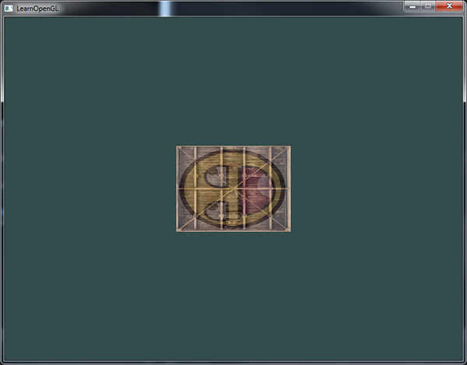

*// усё спрацавала //*

Perfect! Our container is indeed tilted to the left and twice as small so the transformation was successful. Let's get a little more funky and see if we can rotate the container over time and for fun we'll also reposition the container at the bottom-right side of the window. To rotate the container over time we have to update the transformation matrix in the game loop because it needs to update each render iteration. We use GLFW's time function to get some angle over time:

glm::mat4 trans;

trans = glm::translate(trans, glm::vec3(0.5f, -0.5f, 0.0f));

trans = glm::rotate(trans, (**float**)glfwGetTime(), glm::vec3(0.0f, 0.0f, 1.0f));

Keep in mind that in the previous case we could declare the transformation matrix anywhere, but now we have to create it every iteration so we continuously update the rotation. This means we have to re-create the transformation matrix in each iteration of the game loop. Usually when rendering scenes we have several transformation matrices that are re-created with new values each render iteration. *// тыповая практыка графічнага праектавання //*

Here we first rotate the container around the origin (0,0,0) and once it's rotated, we translate its rotated version to the bottom-right corner of the screen. Remember that the actual transformation order should be read in reverse: even though in code we first translate and then later rotate, the actual transformations first apply a rotation and then a translation. Understanding all these combinations of transformations and how they apply to objects is difficult to understand. Try and experiment with transformations like these and you'll quickly get a grasp of it. *// важнасць і складанасць задачы //*

If you did things right you should get the following result:

And there you have it. A translated container that's rotated over time, all done by a single transformation matrix! Now you can see why matrices are such a powerful construct in graphics land. We can define an infinite amount of transformations and combine them all in a single matrix that we can re-use as often as we'd like. Using transformations like this in the vertex shader saves us the effort of re-defining the vertex data and saves us some processing time as well, since we don't have to re-send our data all the time (which is quite slow).

If you didn't get the right result or you're stuck somewhere else, take a look at the [source code](https://learnopengl.com/code_viewer_gh.php?code=src/1.getting_started/5.1.transformations/transformations.cpp).

In the next tutorial we'll discuss how we can use matrices to define different coordinate spaces for our vertices. This will be our first step into real-time 3D graphics! *// зацікаўліванне навучэнцаў наступным цьютаралам. Добрая практыка тнав. //*

### Further reading

* [Essence of Linear Algebra](https://www.youtube.com/playlist?list=PLZHQObOWTQDPD3MizzM2xVFitgF8hE_ab): great video tutorial series by Grant Sanderson about the underlying mathematics of transformations and linear algebra.

### Exercises

* Using the last transformation on the container, try switching the order around by first rotating and then translating. See what happens and try to reason why this happens: [solution](https://learnopengl.com/code_viewer.php?code=getting-started/transformations-exercise1). *// я трапіў на гэта па ходу выканання практыкавання… Мы фіксуем вось – і верцім адносна яе. Таму і не вельмі адэкватны вынік атрымліваецца. //*
* Try drawing a second container with another call to glDrawElements but place it at a different position using transformations **only**. Make sure this second container is placed at the top-left of the window and instead of rotating, scale it over time (using the sin function is useful here; note that using sin will cause the object to invert as soon as a negative scale is applied): [solution](https://learnopengl.com/code_viewer_gh.php?code=src/1.getting_started/5.2.transformations_exercise2/transformations_exercise2.cpp). *// зроблена – і гэта цудоўна //*

[*https://learnopengl.com/#!Getting-started/Coordinate-Systems*](https://learnopengl.com/#!Getting-started/Coordinate-Systems)

## ***Coordinate Systems***

*In the last tutorial we learned how we can use matrices to our advantage by transforming all vertices with transformation matrices. OpenGL expects all the vertices, that we want to become visible, to be in normalized device coordinates after each vertex shader run. That is, the x, y and z coordinates of each vertex should be between -1.0 and 1.0; coordinates outside this range will not be visible. What we usually do, is specify the coordinates in a range we configure ourselves and in the vertex shader transform these coordinates to NDC. These NDC coordinates are then given to the rasterizer to transform them to 2D coordinates/pixels on your screen. // рэалізацыя тэхналогіі. Работа растэрайзэйшн шэйдэра. Звычайная практыка напісання праграм з выкарыстаннем OpenGL //*

*Transforming coordinates to NDC and then to screen coordinates is usually accomplished in a step-by-step fashion where we transform an object's vertices to several coordinate systems before finally transforming them to screen coordinates. The advantage of transforming them to several intermediate coordinate systems is that some operations/calculations are easier in certain coordinate systems as will soon become apparent. // канцэптуальнае значэнне розных каардынатных сістэм // There are a total of 5 different coordinate systems that are of importance to us:*

* *Local space (or Object space)*
* *World space*
* *View space (or Eye space)*
* *Clip space*
* *Screen space*

*Those are all a different state at which our vertices will be transformed in before finally ending up as fragments. // рэалізацыя тэхналогіі //*

*You're probably quite confused by now by what a space or coordinate system actually is so we'll explain them in a more understandable fashion by showing the total picture and what each specific space actually does.*

### ***The global picture***

*To transform the coordinates in one space to the next coordinate space we'll use several transformation matrices of which the most important are the model, view and projection matrix. Our vertex coordinates first start in local space as local coordinates and are then further processed to world coordinates, view coordinates, clip coordinates and eventually end up as screen coordinates. The following image displays the process and shows what each transformation does:*

**

1. *Local coordinates are the coordinates of your object relative to its local origin; they're the coordinates your object begins in.*
2. *The next step is to transform the local coordinates to world-space coordinates which are coordinates in respect of a larger world. These coordinates are relative to a global origin of the world, together with many other objects also placed relative to the world's origin.*
3. *Next we transform the world coordinates to view-space coordinates in such a way that each coordinate is as seen from the camera or viewer's point of view.*
4. *After the coordinates are in view space we want to project them to clip coordinates. Clip coordinates are processed to the -1.0 and 1.0 range and determine which vertices will end up on the screen.*
5. *And lastly we transform the clip coordinates to screen coordinates in a process we call viewport transform that transforms the coordinates from -1.0 and 1.0 to the coordinate range defined by glViewport. The resulting coordinates are then sent to the rasterizer to turn them into fragments. // рэалізацыя тэхналогіі //*

*You probably got a slight idea what each individual space is used for. // цудоўнейшая арыентацыя чытача. Тнав. // The reason we're transforming our vertices into all these different spaces is that some operations make more sense or are easier to use in certain coordinate systems. For example, when modifying your object it makes most sense to do this in local space, while calculating certain operations on the object with respect to the position of other objects makes most sense in world coordinates and so on. If we want, we could define one transformation matrix that goes from local space to clip space all in one go, but that leaves us with less flexibility.*

*We'll discuss each coordinate system in more detail below.*

### ***Local space***

*Local space is the coordinate space that is local to your object, i.e. where your object begins in. Imagine that you've created your cube in a modeling software package (like Blender). The origin of your cube is probably at (0,0,0) even though your cube might end up at a different location in your final application. Probably all the models you've created all have (0,0,0) as their initial position. All the vertices of your model are therefore in local space: they are all local to your object. // цудоўнае тлумачэнне на прыкладзе паняцця “лакальная прастора” //*

*The vertices of the container we've been using were specified as coordinates between -0.5 and 0.5 with 0.0 as its origin. These are local coordinates.*

### ***World space***

*If we would import all our objects directly in the application they would probably all be somewhere stacked on each other around the world's origin of (0,0,0) which is not what we want. We want to define a position for each object to position them inside a larger world. The coordinates in world space are exactly what they sound like: the coordinates of all your vertices relative to a (game) world. This is the coordinate space where you want your objects transformed to in such a way that they're all scattered around the place (preferably in a realistic fashion). The coordinates of your object are transformed from local to world space; this is accomplished with the model matrix.*

*The model matrix is a transformation matrix that translates, scales and/or rotates your object to place it in the world at a location/orientation they belong to. Think of it as transforming a house by scaling it down (it was a bit too large in local space), translating it to a suburbia town and rotating it a bit to the left on the y-axis so that it neatly fits with the neighboring houses. You could think of the matrix in the previous tutorial to position the container all over the scene as a sort of model matrix as well; we transformed the local coordinates of the container to some different place in the scene/world. // цудоўны патэрн тнав. Невыяўнае выкарыстанне новага паняцця раней: падыходзячы да разумення гэтага паняцця, мы яго ўжо ведаем //*

### ***View space***

*The view space is what people usually refer to as the camera of OpenGL (it is sometimes also known as the camera space or eye space). The view space is the result of transforming your world-space coordinates to coordinates that are in front of the user's view. The view space is thus the space as seen from the camera's point of view. This is usually accomplished with a combination of translations and rotations to translate/rotate the scene so that certain items are transformed to the front of the camera. These combined transformations are generally stored inside a view matrix that transforms world coordinates to view space. In the next tutorial we'll extensively discuss how to create such a view matrix to simulate a camera. // структура цьютарала //*

### ***Clip space***

*At the end of each vertex shader run, OpenGL expects the coordinates to be within a specific range and any coordinate that falls outside this range is clipped. Coordinates that are clipped are discarded, so the remaining coordinates will end up as fragments visible on your screen. This is also where clip space gets its name from. // рэалізацыя тэхналогіі //*

*Because specifying all the visible coordinates to be within the range -1.0 and 1.0 isn't really intuitive, we specify our own coordinate set to work in and convert those back to NDC as OpenGL expects them.*

*To transform vertex coordinates from view to clip-space we define a so called projection matrix that specifies a range of coordinates e.g. -1000 and 1000 in each dimension. The projection matrix then transforms coordinates within this specified range to normalized device coordinates (-1.0, 1.0). All coordinates outside this range will not be mapped between -1.0 and 1.0 and therefore be clipped. With this range we specified in the projection matrix, a coordinate of (1250, 500, 750) would not be visible, since the x coordinate is out of range and thus gets converted to a coordinate higher than 1.0 in NDC and is therefore clipped.*

*Note that if only a part of a primitive e.g. a triangle is outside the clipping volume OpenGL will reconstruct the triangle as one or more triangles to fit inside the clipping range. // рэалізацыя тэхналогіі. Дарагавізна кліпінга //*

*This viewing box a projection matrix creates is called a frustum and each coordinate that ends up inside this frustum will end up on the user's screen. The total process to convert coordinates within a specified range to NDC that can easily be mapped to 2D view-space coordinates is called projection since the projection matrix projects 3D coordinates to the easy-to-map-to-2D normalized device coordinates. // рэалізацыя тэхналогіі //*

*Once all the vertices are transformed to clip space a final operation called perspective division is performed where we divide the x, y and z components of the position vectors by the vector's homogeneous w component; perspective division is what transforms the 4D clip space coordinates to 3D normalized device coordinates. This step is performed automatically at the end of each vertex shader run. // рэалізацыя тэхналогіі //*

*It is after this stage where the resulting coordinates are mapped to screen coordinates (using the settings of glViewport) and turned into fragments.*

*The projection matrix to transform view coordinates to clip coordinates can take two different forms, where each form defines its own unique frustum. We can either create an orthographic projection matrix or a perspective projection matrix.*

#### **Orthographic projection**

*An orthographic projection matrix defines a cube-like frustum box that defines the clipping space where each vertex outside this box is clipped. When creating an orthographic projection matrix we specify the width, height and length of the visible frustum. All the coordinates that end up inside this frustum after transforming them to clip space with the orthographic projection matrix won't be clipped. The frustum looks a bit like a container:*

*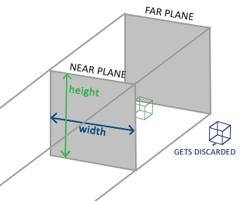*

*The frustum defines the visible coordinates and is specified by a width, a height and a near and far plane. Any coordinate in front of the near plane is clipped and the same applies to coordinates behind the far plane. The orthographic frustum directly maps all coordinates inside the frustum to normalized device coordinates since the w component of each vector is untouched; if the w component is equal to 1.0 perspective division doesn't change the coordinates.*

*To create an orthographic projection matrix we make use of GLM's built-in function glm::ortho:*

*glm::ortho(0.0f, 800.0f, 0.0f, 600.0f, 0.1f, 100.0f);*

*The first two parameters specify the left and right coordinate of the frustum and the third and fourth parameter specify the bottom and top part of the frustum. With those 4 points we've defined the size of the near and far planes and the 5th and 6th parameter then define the distances between the near and far plane. This specific projection matrix transforms all coordinates between these x, y and z range values to normalized device coordinates.*

*An orthographic projection matrix directly maps coordinates to the 2D plane that is your screen, but in reality a direct projection produces unrealistic results since the projection doesn't take perspective into account. That is something the perspective projection matrix fixes for us. // недахоп паняцця //*

#### **Perspective projection**

*If you ever were to enjoy the graphics the real life has to offer you'll notice that objects that are farther away appear much smaller. This weird effect is something we call perspective. Perspective is especially noticeable when looking down the end of an infinite motorway or railway as seen in the following image:*

*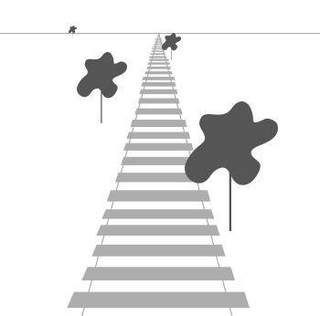*

*As you can see, due to perspective the lines seem to coincide the farther they're away. This is exactly the effect perspective projection tries to mimic and it does so using a perspective projection matrix. The projection matrix maps a given frustum range to clip space, but also manipulates the w value of each vertex coordinate in such a way that the further away a vertex coordinate is from the viewer, the higher this w component becomes. Once the coordinates are transformed to clip space they are in the range -w to w (anything outside this range is clipped). OpenGL requires that the visible coordinates fall between the range -1.0 and 1.0 as the final vertex shader output, thus once the coordinates are in clip space, perspective division is applied to the clip space coordinates: // рэалізацыя тэхналогіі //*

*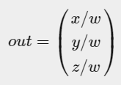*

*Each component of the vertex coordinate is divided by its w component giving smaller vertex coordinates the further away a vertex is from the viewer. This is another reason why the w component is important, since it helps us with perspective projection. // важнасць паняцця: трансляцыі + матрыца перспектывы. Прыклад паняцця з дзвюма нязлучанымі палезнымі ўласцівасцямі // The resulting coordinates are then in normalized device space. If you're interested to figure out how the orthographic and perspective projection matrices are actually calculated (and aren't too scared of mathematics) I can recommend*[*this excellent article*](http://www.songho.ca/opengl/gl_projectionmatrix.html)*by Songho.*

*A perspective projection matrix can be created in GLM as follows:*

*glm::mat4 proj = glm::perspective(glm::radians(45.0f), (****float****)width/(****float****)height, 0.1f, 100.0f);*

*What glm::perspective does is again create a large frustum that defines the visible space, anything outside the frustum will not end up in the clip space volume and will thus become clipped. A perspective frustum can be visualized as a non-uniformly shaped box from where each coordinate inside this box will be mapped to a point in clip space. An image of a perspective frustum is seen below:*

*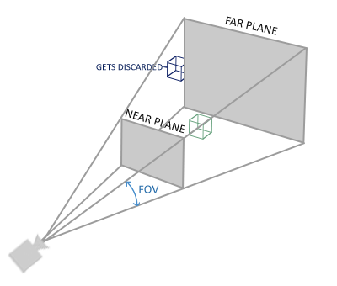*

*Its first parameter defines the fov value, that stands for field of view and sets how large the viewspace is. For a realistic view it is usually set to 45 degrees, but for more doom-style results you could set it to a higher value. The second parameter sets the aspect ratio which is calculated by dividing the viewport's width by its height. The third and fourth parameter set the near and far plane of the frustum. We usually set the near distance to 0.1f and the far distance to 100.0f. All the vertices between the near and far plane and inside the frustum will be rendered.*

*Whenever the near value of your perspective matrix is set a bit too high (like 10.0f), OpenGL will clip all coordinates close to the camera (between 0.0f and 10.0f), which gives a familiar visual result in videogames in that you can see through certain objects if you move too close to them. // прыклад агульна вядомага артэфакта графічных праграм //*

*When using orthographic projection, each of the vertex coordinates are directly mapped to clip space without any fancy perspective division (it still does perspective division, but the w component is not manipulated (it stays 1) and thus has no effect). Because the orthographic projection doesn't use perspective projection, objects farther away do not seem smaller, which produces a weird visual output. For this reason the orthographic projection is mainly used for 2D renderings and for some architectural or engineering applications where we'd rather not have vertices distorted by perspective. Applications like Blender that are used for 3D modelling sometimes use orthographic projection for modelling, because it more accurately depicts each object's dimensions. Below you'll see a comparison of both projection methods in Blender: // прызначэнне кожнага з відаў праекцыйных матрыц //*

*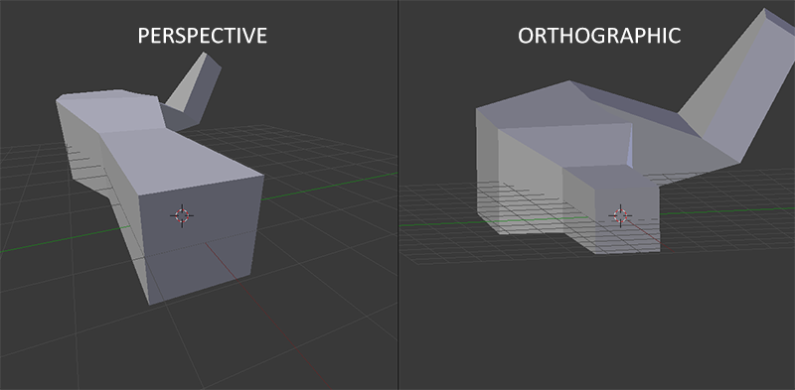*

*You can see that with perspective projection, the vertices farther away appear much smaller, while in orthographic projection each vertex has the same distance to the user.*

### ***Putting it all together***

*We create a transformation matrix for each of the aforementioned steps: model, view and projection matrix. A vertex coordinate is then transformed to clip coordinates as follows:*

*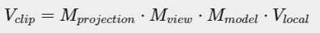*

*Note that the order of matrix multiplication is reversed (remember that we need to read matrix multiplication from right to left). The resulting vertex should then be assigned to gl\_Position in the vertex shader and OpenGL will then automatically perform perspective division and clipping. // рэалізацыя і выкарыстанне тэхналогіі //*

### ***And then?***

*The output of the vertex shader requires the coordinates to be in clip-space which is what we just did with the transformation matrices. OpenGL then performs perspective division on the clip-space coordinates to transform them to normalized-device coordinates. OpenGL then uses the parameters from glViewPort to map the normalized-device coordinates to screen coordinates where each coordinate corresponds to a point on your screen (in our case a 800x600 screen). This process is called the viewport transform.*

*This is a difficult topic to understand so if you're still not exactly sure about what each space is used for you don't have to worry. // Цудоўная арыентацыя чытача, якая супакойвае // Below you'll see how we can actually put these coordinate spaces to good use and enough examples will follow in these tutorials. // структура цьютарала //*

### ***Going 3D***

*Now that we know how to transform 3D coordinates to 2D coordinates we can start showing our objects as real 3D objects instead of a lame 2D plane we've been showing so far.*

*To start drawing in 3D we'll first create a model matrix. The model matrix consists of translations, scaling and/or rotations we'd like to apply to transform all object's vertices it to the global world space. Let's transform our plane a bit by rotating it on the x-axis so it looks like it's laying on the floor. The model matrix then looks like this:*

*glm::mat4 model;*

*model = glm::rotate(model, glm::radians(-55.0f), glm::vec3(1.0f, 0.0f, 0.0f));*

*By multiplying the vertex coordinates with this model matrix we're transforming the vertex coordinates to world coordinates. Our plane that is slightly on the floor thus represents the plane in the global world.*

*Next we need to create a view matrix. We want to move slightly backwards in the scene so the object becomes visible (when in world space we're located at the origin (0,0,0)). To move around the scene, think about the following:*

* *To move a camera backwards, is the same as moving the entire scene forward.*

*That is exactly what a view matrix does, we move the entire scene around inversed to where we want the camera to move.  
Because we want to move backwards and since OpenGL is a right-handed system we have to move in the positive z-axis. We do this by translating the scene towards the negative z-axis. This gives the impression that we are moving backwards. // рэалізацыя тэхналогіі //*

#### **Right-handed system**

*By convention, OpenGL is a right-handed system. What this basically says is that the positive x-axis is to your right, the positive y-axis is up and the positive z-axis is backwards. Think of your screen being the center of the 3 axes and the positive z-axis going through your screen towards you. The axes are drawn as follows: // структура тэхналогіі //*

*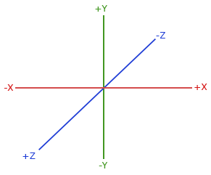*

*To understand why it's called right-handed do the following:*

* *Stretch your right-arm along the positive y-axis with your hand up top.*
* *Let your thumb point to the right.*
* *Let your pointing finger point up.*
* *Now bend your middle finger downwards 90 degrees.*

*If you did things right, your thumb should point towards the positive x-axis, the pointing finger towards the positive y-axis and your middle finger towards the positive z-axis. If you were to do this with your left-arm you would see the z-axis is reversed. This is known as a left-handed system and is commonly used by DirectX. Note that in normalized device coordinates OpenGL actually uses a left-handed system (the projection matrix switches the handedness). // рэалізацыя тэхналогіі. Лепей зразумець //*

*We'll discuss how to move around the scene in more detail in the next tutorial. For now the view matrix looks like this:*

*glm::mat4 view;*

*// note that we're translating the scene in the reverse direction of where we want to move*

*view = glm::translate(view, glm::vec3(0.0f, 0.0f, -3.0f));*

*The last thing we need to define is the projection matrix. We want to use perspective projection for our scene so we'll declare the projection matrix like this:*

*glm::mat4 projection;*

*projection = glm::perspective(glm::radians(45.0f), screenWidth / screenHeight, 0.1f, 100.0f);*

*Now that we created the transformation matrices we should pass them to our shaders. First let's declare the transformation matrices as uniforms in the vertex shader and multiply them with the vertex coordinates:*

*#version 330 core*

***layout*** *(location = 0)* ***in*** *vec3 aPos;*

*...*

***uniform*** *mat4 model;*

***uniform*** *mat4 view;*

***uniform*** *mat4 projection;*

***void*** *main()*

*{*

*// note that we read the multiplication from right to left*

*gl\_Position = projection \* view \* model \* vec4(aPos, 1.0);*

*...*

*}*

*We should also send the matrices to the shader (this is usually done each render iteration since transformation matrices tend to change a lot):*

***int*** *modelLoc = glGetUniformLocation(ourShader.ID, "model"));*

*glUniformMatrix4fv(modelLoc, 1, GL\_FALSE, glm::value\_ptr(model));*

*... // same for View Matrix and Projection Matrix*

*Now that our vertex coordinates are transformed via the model, view and projection matrix the final object should be:*

* *Tilted backwards to the floor.*
* *A bit farther away from us.*
* *Be displayed with perspective (it should get smaller, the further its vertices are).*

*Let's check if the result actually does fulfill these requirements:*

*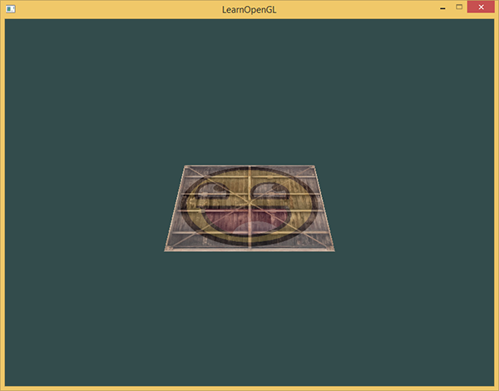*

*It does indeed look like the plane is a 3D plane that's resting at some imaginary floor. If you're not getting the same result check the complete*[*source code*](https://learnopengl.com/code_viewer_gh.php?code=src/1.getting_started/6.1.coordinate_systems/coordinate_systems.cpp)*.*

*// у мяне ўсё атрымалася з першага разу! //*

### ***More 3D***

*So far we've been working with a 2D plane, even in 3D space, so let's take the adventurous route and extend our 2D plane to a 3D cube. To render a cube we need a total of 36 vertices (6 faces \* 2 triangles \* 3 vertices each). 36 vertices are a lot to sum up so you can retrieve them from*[*here*](https://learnopengl.com/code_viewer.php?code=getting-started/cube_vertices)*.*

*For fun, we'll let the cube rotate over time:*

*model = glm::rotate(model, (****float****)glfwGetTime() \* glm::radians(50.0f), glm::vec3(0.5f, 1.0f, 0.0f));*

*And then we'll draw the cube using glDrawArrays, but this time with a count of 36 vertices.*

*glDrawArrays(GL\_TRIANGLES, 0, 36);*

*You should get something similar to the following:*

*…*

*It does resemble a cube slightly but something's off. Some sides of the cubes are being drawn over other sides of the cube. This happens because when OpenGL draws your cube triangle-by-triangle, it will overwrite its pixels even though something else might've been drawn there before. Because of this, some triangles are drawn on top of each other while they're not supposed to overlap. // праблема оверлэпінга //*

*Luckily, OpenGL stores depth information in a buffer called the z-buffer that allows OpenGL to decide when to draw over a pixel and when not to. Using the z-buffer we can configure OpenGL to do depth-testing. // яшчэ адзін важны аб’ект тэхналогіі //*

### ***Z-buffer***

*OpenGL stores all its depth information in a z-buffer, also known as a depth buffer. GLFW automatically creates such a buffer for you (just like it has a color-buffer that stores the colors of the output image). The depth is stored within each fragment (as the fragment's z value) and whenever the fragment wants to output its color, OpenGL compares its depth values with the z-buffer and if the current fragment is behind the other fragment it is discarded, otherwise overwritten. This process is called depth testing and is done automatically by OpenGL. // рэалізацыя тэхналогіі //*

*However, if we want to make sure OpenGL actually performs the depth testing we first need to tell OpenGL we want to enable depth testing; it is disabled by default. We can enable depth testing using glEnable. The glEnable and glDisable functions allow us to enable/disable certain functionality in OpenGL. // структура тэхналогіі // That functionality is then enabled/disabled until another call is made to disable/enable it. Right now we want to enable depth testing by enabling GL\_DEPTH\_TEST:*

*glEnable(GL\_DEPTH\_TEST);*

*Since we're using a depth buffer we also want to clear the depth buffer before each render iteration (otherwise the depth information of the previous frame stays in the buffer). Just like clearing the color buffer, we can clear the depth buffer by specifying the DEPTH\_BUFFER\_BIT bit in the glClear function:*

*glClear(GL\_COLOR\_BUFFER\_BIT | GL\_DEPTH\_BUFFER\_BIT);*

*Let's re-run our program and see if OpenGL now performs depth testing:*

*There we go! A fully textured cube with proper depth testing that rotates over time. Check the source code*[*here*](https://learnopengl.com/code_viewer_gh.php?code=src/1.getting_started/6.2.coordinate_systems_depth/coordinate_systems_depth.cpp)*.*

### ***More cubes!***

*Say we wanted to display 10 of our cubes on screen. Each cube will look the same but will only differ in where it's located in the world with each a different rotation. The graphical layout of the cube is already defined so we don't have to change our buffers or attribute arrays when rendering more objects. The only thing we have to change for each object is its model matrix where we transform the cubes into the world.*

*First, let's define a translation vector for each cube that specifies its position in world space. We'll define 10 cube positions in a glm::vec3 array:*

*glm::vec3 cubePositions[] = {*

*glm::vec3( 0.0f, 0.0f, 0.0f),*

*glm::vec3( 2.0f, 5.0f, -15.0f),*

*glm::vec3(-1.5f, -2.2f, -2.5f),*

*glm::vec3(-3.8f, -2.0f, -12.3f),*

*glm::vec3( 2.4f, -0.4f, -3.5f),*

*glm::vec3(-1.7f, 3.0f, -7.5f),*

*glm::vec3( 1.3f, -2.0f, -2.5f),*

*glm::vec3( 1.5f, 2.0f, -2.5f),*

*glm::vec3( 1.5f, 0.2f, -1.5f),*

*glm::vec3(-1.3f, 1.0f, -1.5f)*

*};*

*Now, within the game loop we want to call the glDrawArrays function 10 times, but this time send a different model matrix to the vertex shader each time before we render. We will create a small loop within the game loop that renders our object 10 times with a different model matrix. Note that we also add a small rotation to each container.*

*glBindVertexArray(VAO);*

***for****(****unsigned******int*** *i = 0; i < 10; i++)*

*{*

*glm::mat4 model;*

*model = glm::translate(model, cubePositions[i]);*

***float*** *angle = 20.0f \* i;*

*model = glm::rotate(model, glm::radians(angle), glm::vec3(1.0f, 0.3f, 0.5f));*

*ourShader.setMat4("model", model);*

*glDrawArrays(GL\_TRIANGLES, 0, 36);*

*}*

*This snippet of code will update the model matrix each time a new cube is drawn and do this 10 times in total. Right now we should be looking into a world filled with 10 oddly rotated cubes:*

*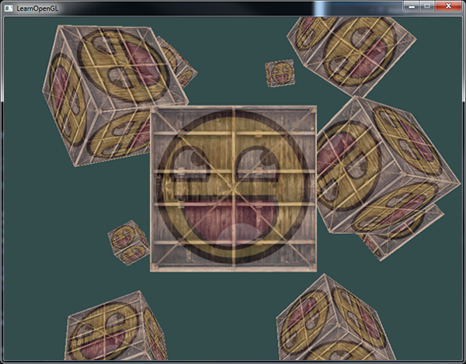*

*Perfect! It looks like our container found some likeminded friends. If you're stuck see if you can compare your code with the* [*source code*](https://learnopengl.com/code_viewer_gh.php?code=src/1.getting_started/6.3.coordinate_systems_multiple/coordinate_systems_multiple.cpp)*.*

*// у кодзе напісана, што матрыца праекцыі часта не змяняецца і таму яе не імкнуцца стварыць унутры цыкла малявання //*

*// усё атрымалася проста цудоўна! //*

***Exercises***

* *Try experimenting with the FoV and aspect-ratio parameters of GLM's projection function. See if you can figure out how those affect the perspective frustum.*
* *Play with the view matrix by translating in several directions and see how the scene changes. Think of the view matrix as a camera object.*
* *Try to make every 3rd container (including the 1st) rotate over time, while leaving the other containers static using just the model matrix:*[*solution*](https://learnopengl.com/code_viewer.php?code=getting-started/coordinate_systems-exercise3)*.*

*// першыя два практыкаванні я выконваў і раней. Трэцяе – не буду, бо гэта лёгка робіцца даданнем спецыяльнай умовы ў целе цыкла //*

***Want to help?***

*Enjoyed the tutorial? Consider becoming a*[*patron*](https://www.patreon.com/learnopengl)*of LearnOpenGL.  
  
Your support helps me create new and better tutorials, improve existing content and enables me to improve the website wherever I can.*

[*https://learnopengl.com/#!Getting-started/Camera*](https://learnopengl.com/#!Getting-started/Camera)

*22.08.2017*

## ***Camera***

*In the previous tutorial we discussed the view matrix and how we can use the view matrix to move around the scene (we moved backwards a little). OpenGL by itself is not familiar with the concept of a camera, but we can try to simulate one by moving all objects in the scene in the reverse direction, giving the illusion that****we****are moving. // рэалізацыя тэхналогіі і праграміраванне на OpenGL //*

*In this tutorial we'll discuss how we can set up a camera in OpenGL. We will discuss an FPS-style camera that allows you to freely move around in a 3D scene. In this tutorial we'll also discuss keyboard and mouse input and finish with a custom camera class.*

### ***Camera/View space***

*26.08.2017*

*When we're talking about camera/view space we're talking about all the vertex coordinates as seen from the camera's perpective as the origin of the scene: the view matrix transforms all the world coordinates into view coordinates that are relative to the camera's position and direction. To define a camera we need its position in world space, the direction it's looking at, a vector pointing to the right and a vector pointing upwards from the camera. A careful reader might notice that we're actually going to create a coordinate system with 3 perpendicular unit axes with the camera's position as the origin.*

*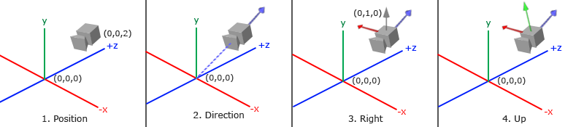*

#### **1. Camera position**

*Getting a camera position is easy. The camera position is basically a vector in world space that points to the camera's position. We set the camera at the same position we've set the camera in the previous tutorial:*

*glm::vec3 cameraPos = glm::vec3(0.0f, 0.0f, 3.0f);*

*Don't forget that the positive z-axis is going through your screen towards you so if we want the camera to move backwards, we move along the positive z-axis.*

#### **2. Camera direction**

*The next vector required is the camera's direction e.g. at what direction it is pointing at. For now we let the camera point to the origin of our scene: (0,0,0). Remember that if we subtract two vectors from each other we get a vector that's the difference of these two vectors? Subtracting the camera position vector from the scene's origin vector thus results in the direction vector. Since we know that the camera points towards the negative z direction we want the direction vector to point towards the camera's positive z-axis. If we switch the subtraction order around we now get a vector pointing towards the camera's positive z-axis:*

*glm::vec3 cameraTarget = glm::vec3(0.0f, 0.0f, 0.0f);*

*glm::vec3 cameraDirection = glm::normalize(cameraPos - cameraTarget);*

*The name direction vector is not the best chosen name, since it is actually pointing in the reverse direction of what it is targeting. // я намаляваў – гэта, сапраўды, так //*

#### **3. Right axis**

*The next vector that we need is a right vector that represents the positive x-axis of the camera space. To get the right vector we use a little trick by first specifying an up vector that points upwards (in world space). Then we do a cross product on the up vector and the direction vector from step 2. Since the result of a cross product is a vector perpendicular to both vectors, we will get a vector that points in the positive x-axis's direction (if we would switch the vectors we'd get a vector that points in the negative x-axis):*

*glm::vec3 up = glm::vec3(0.0f, 1.0f, 0.0f);*

*glm::vec3 cameraRight = glm::normalize(glm::cross(up, cameraDirection)); // цудоўны кантэкст выкарыстання вектарнай алгебры //*

#### **4. Up axis**

*Now that we have both the x-axis vector and the z-axis vector, retrieving the vector that points in the camera's positive y-axis is relatively easy: we take the cross product of the right and direction vector:*

*glm::vec3 cameraUp = glm::cross(cameraDirection, cameraRight);*

*With the help of the cross product and a few tricks we were able to create all the vectors that form the view/camera space. For the more mathematically inclined readers, this process is known as the*[*Gram-Schmidt*](http://en.wikipedia.org/wiki/Gram%E2%80%93Schmidt_process)*process in linear algebra. Using these camera vectors we can now create a LookAt matrix that proves very useful for creating a camera.*

#### **Look At**

*A great thing about matrices is that if you define a coordinate space using 3 perpendicular (or non-linear) axes you can create a matrix with those 3 axes plus a translation vector and you can transform any vector to that coordinate space by multiplying it with this matrix. This is exactly what the LookAt matrix does and now that we have 3 perpendiclar axes and a position vector to define the camera space we can create our own LookAt matrix:*

*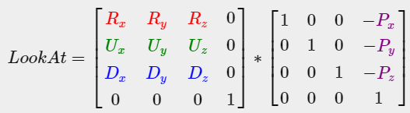*

*Where R is the right vector, U is the up vector, D is the direction vector and P is the camera's position vector. Note that the position vector is inverted since we eventually want to translate the world in the opposite direction of where we want to move. Using this LookAt matrix as our view matrix effectively transforms all the world coordinates to the view space we just defined. The LookAt matrix then does exactly what it says: it creates a view matrix that looks at a given target.*

*Luckily for us, GLM already does all this work for us. We only have to specify a camera position, a target position and a vector that represents the up vector in world space (the up vector we used for calculating the right vector). GLM then creates the LookAt matrix that we can use as our view matrix:*

*glm::mat4 view;*

*view = glm::lookAt(glm::vec3(0.0f, 0.0f, 3.0f),*

*glm::vec3(0.0f, 0.0f, 0.0f),*

*glm::vec3(0.0f, 1.0f, 0.0f));*

*The glm::LookAt function requires a position, target and up vector respectively. This creates a view matrix that is the same as the one used in the previous tutorial.*

*Before delving into user input, let's get a little funky first by rotating the camera around our scene. We keep the target of the scene at (0,0,0).*

*We use a little bit of trigonometry to create an x and z coordinate each frame that represents a point on a circle and we'll use these for our camera position. By re-calculating the x and y coordinate we're traversing all the points in a circle and thus the camera rotates around the scene. We enlarge this circle by a pre-defined radius and create a new view matrix each render iteration using GLFW's glfwGetTime function:*

***float*** *radius = 10.0f;*

***float*** *camX = sin(glfwGetTime()) \* radius;*

***float*** *camZ = cos(glfwGetTime()) \* radius;*

*glm::mat4 view;*

*view = glm::lookAt(glm::vec3(camX, 0.0, camZ), glm::vec3(0.0, 0.0, 0.0), glm::vec3(0.0, 1.0, 0.0));*

*If you run this code you should get something like this:*

*…*

*// у мяне ўсё атрымалася //*

*With this little snippet of code the camera now circles around the scene over time. Feel free to experiment with the radius and position/direction parameters to get the feel of how this LookAt matrix works. Also, check the*[*source code*](https://learnopengl.com/code_viewer_gh.php?code=src/1.getting_started/7.1.camera_circle/camera_circle.cpp)*if you're stuck.*

### ***Walk around***

*Swinging the camera around a scene is fun, but it's more fun to do all the movement by ourselves! First we need to set up a camera system, so it is useful to define some camera variables at the top of our program:*

*glm::vec3 cameraPos = glm::vec3(0.0f, 0.0f, 3.0f);*

*glm::vec3 cameraFront = glm::vec3(0.0f, 0.0f, -1.0f);*

*glm::vec3 cameraUp = glm::vec3(0.0f, 1.0f, 0.0f);*

*The LookAt function now becomes:*

*view = glm::lookAt(cameraPos, cameraPos + cameraFront, cameraUp);*

*First we set the camera position to the previously defined cameraPos. The direction is the current position + the direction vector we just defined. This ensures that however we move, the camera keeps looking at the target direction. Let's play a bit with these variables by updating the cameraPos vector when we press some keys.*

*We already defined a processInput function to manage any of GLFW's keyboard input so let's add some new key commands to check for:*

***void*** *processInput(GLFWwindow \*window)*

*{*

*...*

***float*** *cameraSpeed = 0.05f; // adjust accordingly*

***if*** *(glfwGetKey(window, GLFW\_KEY\_W) == GLFW\_PRESS)*

*cameraPos += cameraSpeed \* cameraFront;*

***if*** *(glfwGetKey(window, GLFW\_KEY\_S) == GLFW\_PRESS)*

*cameraPos -= cameraSpeed \* cameraFront;*

***if*** *(glfwGetKey(window, GLFW\_KEY\_A) == GLFW\_PRESS)*

*cameraPos -= glm::normalize(glm::cross(cameraFront, cameraUp)) \* cameraSpeed;*

***if*** *(glfwGetKey(window, GLFW\_KEY\_D) == GLFW\_PRESS)*

*cameraPos += glm::normalize(glm::cross(cameraFront, cameraUp)) \* cameraSpeed;*

*}*

*// цудоўнае выкарыстанне вектарнай алгебры //*

*Whenever we press one of the WASD keys, the camera's position is updated accordingly. If we want to move forward or backwards we add or subtract the direction vector from the position vector. If we want to move sidewards we do a cross product to create a right vector and we move along the right vector accordingly. This creates the familiar strafe effect when using the camera.*

*Note that we normalize the resulting right vector. If we wouldn't normalize this vector, the resulting cross product might return differently sized vectors based on the cameraFront variable. If we would not normalize the vector we would either move slow or fast based on the camera's orientation instead of at a consistent movement speed.*

*By now, you should already be able to move the camera somewhat, albeit at a speed that's system-specific at which you may need to adjust cameraSpeed.*

### ***Movement speed***

*Currently we used a constant value for movement speed when walking around. In theory this seems fine, but in practice people have different processing powers and the result of that is that some people are able to draw much more frames than others each second. Whenever a user draws more frames than another user he also calls processInput more often. The result is that some people move really fast and some really slow depending on their setup. When shipping your application you want to make sure it runs the same on all kinds of hardware. // лепей зразумець дадзены факт кнігі. і важнейшая задача пры распрацоўцы графічных прылажэнняў //*

*Graphics applications and games usually keep track of a deltatime variable that stores the time it takes to render the last frame. We then multiply all velocities with this deltaTime value. The result is that when we have a large deltaTime in a frame, meaning that the last frame took longer than average, the velocity for that frame will also be a bit higher to balance it all out. When using this approach it does not matter if you have a very fast or slow pc, the velocity of the camera will be balanced out accordingly so each user will have the same experience. // цудоўная практыка, якая забяспечвае плюс-мінус аднолькавую карцінку незалежна ад жалеза //*

*To calculate the deltaTime value we keep track of 2 global variables:*

***float*** *deltaTime = 0.0f; // Time between current frame and last frame*

***float*** *lastFrame = 0.0f; // Time of last frame*

*Within each frame we then calculate the new deltaTime value for later use:*

***float*** *currentFrame = glfwGetTime();*

*deltaTime = currentFrame - lastFrame;*

*lastFrame = currentFrame;*

*Now that we have deltaTime we can take it into account when calculating the velocities:*

***void*** *processInput(GLFWwindow \*window)*

*{*

***float*** *cameraSpeed = 2.5f \* deltaTime;*

*...*

*}*

*// усё атрымалася, але я злавіў баг. Калі я выдаляюся ад кубікаў вельмі-вельмі далёка, то яны знікаюць. Аднак, вяртаючыся назад, кубікі ўжо не адлюстроўваюцца з тэкстурай, але суцэльна белыя. Выява са смайлікам па-мінуламу прысутнічае //*

*Together with the previous section we should now have a much smoother and more consistent camera system for moving around the scene:*

*And now we have a camera that walks and looks equally fast on any system. Again, check the*[*source code*](https://learnopengl.com/code_viewer_gh.php?code=src/1.getting_started/7.2.camera_keyboard_dt/camera_keyboard_dt.cpp)*if you're stuck. We'll see the deltaTime value frequently return with anything movement related.*

### ***Look around***

*Only using the keyboard keys to move around isn't that interesting. Especially since we can't turn around making the movement rather restricted. That's where the mouse comes in!*

*To look around the scene we have to change the cameraFront vector based on the input of the mouse. However, changing the direction vector based on mouse rotations is a little complicated and requires some trigonemetry. If you do not understand the trigonemetry, don't worry. You can just skip to the code sections and paste them in your code; you can always come back later if you want to know more. // цудоўная арыентацыя чытача //*

#### **Euler angles**

*Euler angles are 3 values that can represent any rotation in 3D, defined by Leonhard Euler somewhere in the 1700s. There are 3 Euler angles: pitch, yaw and roll. The following image gives them a visual meaning:*

*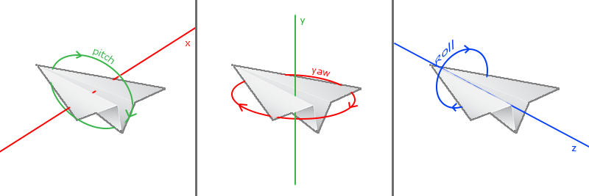*

*The pitch is the angle that depicts how much we're looking up or down as seen in the first image. The second image shows the yaw value which represents the magnitude we're looking to the left or to the right. The roll represents how much we rollas mostly used in space-flight cameras. Each of the Euler angles are represented by a single value and with the combination of all 3 of them we can calculate any rotation vector in 3D.*

*For our camera system we only care about the yaw and pitch values so we won't discuss the roll value here. Given a pitch and a yaw value we can convert them into a 3D vector that represents a new direction vector. The process of converting yaw and pitch values to a direction vector requires a bit of trigonemetry and we start with a basic case:*

*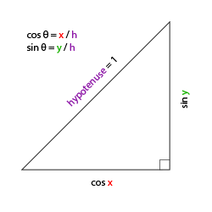*

*If we define the hypotenuse to be of length 1 we know from trigonometry (soh cah toa) that the adjacant side's length is cos x/h=cos x/1=cos xcos⁡ x/h=cos⁡ x/1=cos⁡ x and that the opposing side's length is sin y/h=sin y/1=sin ysin⁡ y/h=sin⁡ y/1=sin⁡ y. This gives us some general formulas for retrieving the length in both the x and y directions, depending on the given angle. Let's use this to calculate the components of the direction vector:*

*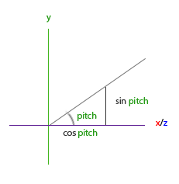*

*This triangle looks similar to the previous triangle so if we visualize that we are sitting on the xz plane and look towards the y axis we can calculate the length / strength of the y direction (how much we're looking up or down) based on the first triangle. From the image we can see that the resulting y value for a given pitch equals sin θ:*

*direction.y = sin(glm::radians(pitch)); // Note that we convert the angle to radians first*

*Here we only update the y value is affected, but if you look carefully you can also that the x and z components are affected. From the triangle we can see that their values equal:*

*direction.x = cos(glm::radians(pitch));*

*direction.z = cos(glm::radians(pitch));*

*Let's see if we can find the required components for the yaw value as well:*

*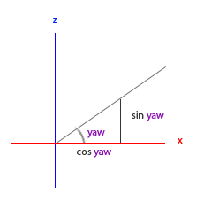*

*Just like the pitch triangle we can see that the x component depends on the cos(yaw) value and the z value also depends on the sin of the yaw value. Adding this to the previous values results in a final direction vector based on the pitch and yaw values:*

*direction.x = cos(glm::radians(pitch)) \* cos(glm::radians(yaw));*

*direction.y = sin(glm::radians(pitch));*

*direction.z = cos(glm::radians(pitch)) \* sin(glm::radians(yaw));*

*This gives us a formula to convert yaw and pitch values to a 3-dimensional direction vector that we can use for looking around. You probably wondered by now: how do we get these yaw and pitch values?*

*// матэматыку зараз не зразумеў. Потым зразумею //*

### ***Mouse input***

*The yaw and pitch values are obtained from mouse (or controller/joystick) movement where horizontal mouse-movement affects the yaw and vertical mouse-movement affects the pitch. The idea is to store the last frame's mouse positions and in the current frame we calculate how much the mouse values changed in comparrison with last frame's value. The higher the horizontal/vertical difference, the more we update the pitch or yaw value and thus the more the camera should move.*

*First we will tell GLFW that it should hide the cursor and capture it. Capturing a cursor means that once the application has focus the mouse cursor stays within the window (unless the application loses focus or quits). We can do this with one simple configuration call:*

*glfwSetInputMode(window, GLFW\_CURSOR, GLFW\_CURSOR\_DISABLED);*

*After this call, wherever we move the mouse it won't be visible and it should not leave the window. This is perfect for an FPS camera system.*

*To calculate the pitch and yaw values we need to tell GLFW to listen to mouse-movement events. We do this by creating a callback function with the following prototype:*

***void*** *mouse\_callback(GLFWwindow\* window,* ***double*** *xpos,* ***double*** *ypos);*

*Here xpos and ypos represent the current mouse positions. As soon as we register the callback function with GLFW each time the mouse moves, the mouse\_callback function is called:*

*glfwSetCursorPosCallback(window, mouse\_callback);*

*When handling mouse input for an FPS style camera there are several steps we have to take before eventually retrieving the direction vector:*

1. *Calculate the mouse's offset since the last frame.*
2. *Add the offset values to the camera's yaw and pitch values.*
3. *Add some constraints to the maximum/minimum yaw/pitch values*
4. *Calculate the direction vector*

*The first step is to calculate the offset of the mouse since the last frame. We first have to store the last mouse positions in the application, which we set to the center of the screen (screen size is 800 by 600) initially:*

***float*** *lastX = 400, lastY = 300;*

*Then in the mouse's callback function we calculate the offset movement between the last and current frame:*

***float*** *xoffset = xpos - lastX;*

***float*** *yoffset = lastY - ypos; // reversed since y-coordinates range from bottom to top*

*lastX = xpos;*

*lastY = ypos;*

***float*** *sensitivity = 0.05f;*

*xoffset \*= sensitivity;*

*yoffset \*= sensitivity;*

*Note that we multiply the offset values by a sensitivity value. If we omit this multiplication the mouse movement would be way too strong; fiddle around with the sensitivity value to your liking. // я з гэтай праблемай раней сутыкаўся неаднаразова //*

*Next we add the offset values to globally declared pitch and yaw values:*

*yaw += xoffset;*

*pitch += yoffset;*

*In the third step we'd like to add some constraints to the camera so users won't be able to make weird camera movements (also prevents a few weird issues). The pitch will be constrained in such a way that users won't be able to look higher than 89 degrees (at 90 degrees the view tends to reverse, so we stick to 89 as our limit) and also not below -89 degrees. This ensures the user will be able to look up to the sky and down to his feet but not further. The constraint works by just replacing the resulting value with its constraint value whenever it breaches the constraint:*

***if****(pitch > 89.0f)*

*pitch = 89.0f;*

***if****(pitch < -89.0f)*

*pitch = -89.0f;*

*Note that we set no constraint on the yaw value since we don't want to constrain the user in horizontal rotation. However, it's just as easy to add a constraint to the yaw as well if you feel like it.*

*The fourth and last step is to calculate the actual direction vector from the resulting yaw and pitch value as discussed in the previous section:*

*glm::vec3 front;*

*front.x = cos(glm::radians(pitch)) \* cos(glm::radians(yaw));*

*front.y = sin(glm::radians(pitch));*

*front.z = cos(glm::radians(pitch)) \* sin(glm::radians(yaw));*

*cameraFront = glm::normalize(front);*

*This computed direction vector then contains all the rotations calculated from the mouse's movement. Since the cameraFront vector is already included in glm's lookAt function we're set to go.*

*If you would now run the code you will notice that the camera makes a large sudden jump whenever the window first receives focus of your mouse cursor. The cause for the sudden jump is that as soon as your cursor enters the window the mouse callback function is called with an xpos and ypos position equal to the location your mouse entered the screen. This is usually a position that is quite a distance away from the center of the screen resulting in large offsets and thus a large movement jump. // тлумачэнне прычыны гэтага шкоднага эфекта // We can circumvent this issue by simply defining a global bool variable to check if this is the first time we receive mouse input and if so, we first update the initial mouse positions to the new xpos and ypos values; the resulting mouse movements will then use the entered mouse's position coordinates to calculate its offsets:*

***if****(firstMouse) // this bool variable is initially set to true*

*{*

*lastX = xpos;*

*lastY = ypos;*

*firstMouse =* ***false****;*

*}*

*The final code then becomes:*

***void*** *mouse\_callback(GLFWwindow\* window,* ***double*** *xpos,* ***double*** *ypos)*

*{*

***if****(firstMouse)*

*{*

*lastX = xpos;*

*lastY = ypos;*

*firstMouse =* ***false****;*

*}*

***float*** *xoffset = xpos - lastX;*

***float*** *yoffset = lastY - ypos;*

*lastX = xpos;*

*lastY = ypos;*

***float*** *sensitivity = 0.05;*

*xoffset \*= sensitivity;*

*yoffset \*= sensitivity;*

*yaw += xoffset;*

*pitch += yoffset;*

***if****(pitch > 89.0f)*

*pitch = 89.0f;*

***if****(pitch < -89.0f)*

*pitch = -89.0f;*

*glm::vec3 front;*

*front.x = cos(glm::radians(yaw)) \* cos(glm::radians(pitch));*

*front.y = sin(glm::radians(pitch));*

*front.z = sin(glm::radians(yaw)) \* cos(glm::radians(pitch));*

*cameraFront = glm::normalize(front);*

*}*

*There we go! Give it a spin and you'll see that we can now freely move through our 3D scene!*

*// усё працуе //*

### ***Zoom***

*As a little extra to the camera system we'll also implement a zooming interface. In the previous tutorial we said the Field of view or fov defines how much we can see of the scene. When the field of view becomes smaller the scene's projected space gets smaller giving the illusion of zooming in. // асноўная ідэя рэалізацыі зума. Зноў ілюзія // To zoom in, we're going to use the mouse's scroll-wheel. Similar to mouse movement and keyboard input we have a callback function for mouse-scrolling:*

***void*** *scroll\_callback(GLFWwindow\* window,* ***double*** *xoffset,* ***double*** *yoffset)*

*{*

***if****(fov >= 1.0f && fov <= 45.0f)*

*fov -= yoffset;*

***if****(fov <= 1.0f)*

*fov = 1.0f;*

***if****(fov >= 45.0f)*

*fov = 45.0f;*

*}*

*When scrolling, the yoffset value represents the amount we scrolled vertically. When the scroll\_callback function is called we change the content of the globally declared fov variable. Since 45.0f is the default fov value we want to constrain the zoom level between 1.0f and 45.0f.*

*We now have to upload the perspective projection matrix to the GPU each render iteration but this time with the fov variable as its field of view:*

*projection = glm::perspective(glm::radians(fov), 800.0f / 600.0f, 0.1f, 100.0f);*

*And lastly don't forget to register the scroll callback function:*

*glfwSetScrollCallback(window, scroll\_callback);*

*And there you have it. We implemented a simple camera system that allows for free movement in a 3D environment.*

*Feel free to experiment a little and if you're stuck compare your code with the*[*source code*](https://learnopengl.com/code_viewer_gh.php?code=src/1.getting_started/7.3.camera_mouse_zoom/camera_mouse_zoom.cpp)*.*

*Note that a camera system using Euler angles is still not a perfect system. Depending on your constraints and your setup you could still introduce a*[*Gimbal lock*](http://en.wikipedia.org/wiki/Gimbal_lock)*. The best camera system would be developed using quaternions but we'll leave that to a later topic. // недахоп дадзенай сістэмы камеры, які я пакуль што не вельмі добра адчуваю //*

*// усё працуе //*

### ***Camera class***

*In the upcoming tutorials we will always use a camera to easily look around the scenes and see the results from all angles. However, since a camera can take up quite some space on each tutorial we'll abstract a little from the details and create our own camera object that does most of the work for us with some neat little extras. Unlike the Shader tutorial we won't walk you through creating the camera class, but just provide you with the (fully commented) source code if you want to know the inner workings.*

*Just like the Shader object we create it entirely in a single header file. You can find the camera object*[*here*](https://learnopengl.com/code_viewer_gh.php?code=includes/learnopengl/camera.h)*. You should be able to understand all the code by now. It is advised to at least check the class out once to see how you could create a camera object like this.*

*The camera system we introduced is an FPS-like camera that suits most purposes and works well with Euler angles, but be careful when creating different camera systems like a flight simulation camera. Each camera system has its own tricks and quirks so be sure to read up on them. // характарыстыка дадзенай сістэмы ведаў // For example, this FPS camera doesn't allow for pitch values higher than 90 degrees and a static up vector of (0,1,0) doesn't work when we take roll values into account. // intbu better these limitations //*

*The updated version of the source code using the new camera object can be found*[*here*](https://learnopengl.com/code_viewer_gh.php?code=src/1.getting_started/7.4.camera_class/camera_class.cpp)*.*

***Exercises***

* *See if you can transform the camera class in such a way that it becomes a****true****fps camera where you cannot fly; you can only look around while staying on the xz plane:*[*solution*](https://learnopengl.com/code_viewer.php?code=getting-started/camera-exercise1)*. // трывіяльнае заданне, у якім трэба абясточыць пэўныя клавішы, здаецца. Хаця, шчыра сказаць, я грунтоўна гэта не вывучаў пакуль што //*
* *Try to create your own LookAt function where you manually create a view matrix as discussed at the start of this tutorial. Replace glm's LookAt function with your own implementation and see if it still acts the same:*[*solution*](https://learnopengl.com/code_viewer.php?code=getting-started/camera-exercise2)*. // таксама не выконваў, але заданне з большага не цяжкае //*

[*https://learnopengl.com/#!Getting-started/Review*](https://learnopengl.com/#!Getting-started/Review)

## *Review*

*Congratulations on reaching the end of the Getting started section. // добры тон у тнав // By now you should be able to create a window, create and compile shaders, send vertex data to your shaders via buffer objects or uniforms, draw objects, use textures, understand vectors and matrices and combine all that knowledge to create a full 3D scene with a camera to play around with. // цудоўнейшае абагульненне навыкаў, якія набыў навучэнец. Добрая практыка тнав //*

*Phew, that is a lot that we learned these last few chapters. Try to play around with the tutorials, experiment a bit or come up with your own ideas and solutions to some of the problems. // цудоўны прызыў да творчасці. Добрая практыка тнав // As soon as you feel you got the hang of all the materials we've discussed it's time to move on to the*[*next*](https://learnopengl.com/#!Lighting/Colors)*tutorials. // арыентацыя навучэнца тнав. Той выпадак, калі важна добра засвоіць ужо вывучанае, каб эфектыўна засваіваць наступнае. У такой сісвед, як гісторыя ці літаратура – гэта не так выяўна важна. Сувязь тсісвед і тнав – фундаментальная сувязь //*

### ***Glossary***

* *OpenGL: a formal specification of a graphics API that defines the layout and output of each function.*
* *GLAD: an extension loading library that loads and sets all OpenGL's function pointers for us so we can use all (modern) OpenGL's functions.*
* *Viewport: the window where we render to.*
* *Graphics Pipeline: the entire process a vertex has to walk through before ending up as a pixel on your screen.*
* *Shader: a small program that runs on the graphics card. Several stages of the graphics pipeline can use user-made shaders to replace existing functionality.*
* *Vertex: a collection of data that represent a single point.*
* *Normalized Device Coordinates: the coordinate system your vertices end up in after clipping and perspective division is performed on clip coordinates. All vertex positions in NDC between -1.0 and 1.0 will not be discarded and end up visible.*
* *Vertex Buffer Object: a buffer object that allocates memory and stores all the vertex data for the graphics card to use.*
* *Vertex Array Object: stores buffer and vertex attribute state information.*
* *Element Buffer Object: a buffer object that stores indices for indexed drawing.*
* *Uniform: a special type of GLSL variable that is global (each shader in a shader program can access this uniform variable) and only has to be set once.*
* *Texture: a special type of image wrapped around objects, giving the illusion an object is extremely detailed.*
* *Texture Wrapping: defines the mode that specifies how OpenGL should sample textures when texture coordinates are outside the range: (0, 1).*
* *Texture Filtering: defines the mode that specifies how OpenGL should sample the texture when there are several texels (texture pixels) to choose from. This usually occurs when a texture is magnified. // вось гэту тэму мне варта прыгадаць грунтоўней //*
* *Mipmaps: stored smaller versions of a texture where the appropriate sized version is chosen based on the distance to the viewer.*
* *stb\_image: image loading library.*
* *Texture Units: allows for multiple textures on a single object by binding multiple textures each to a different texture unit.*
* *Vector: a mathematical entity that defines directions and/or positions in any dimension.*
* *Matrix: a rectangular array of mathematical expressions.*
* *GLM: a mathematics library tailored for OpenGL.*
* *Local Space: the space an object begins in. All coordinates relative to an object's origin.*
* *World Space: all coordinates relative to a global origin.*
* *View Space: all coordinates as viewed from a camera's perspective.*
* *Clip Space: all coordinates as viewed from the camera's perspective but with projection applied. This is the space the vertex coordinates should end up in, as output of the vertex shader. OpenGL does the rest (clipping/perspective division).*
* *Screen Space: all coordinates as viewed from the screen. Coordinates range from 0 to screen width/height.*
* *LookAt: a special type of view matrix that creates a coordinate system where all coordinates are rotated and translated in such a way that the user is looking at a given target from a given position.*
* *Euler Angles: defined as yaw, pitch and roll that allow us to form any 3D direction vector from these 3 values.*

# *Lightning*

[*https://learnopengl.com/#!Lighting/Colors*](https://learnopengl.com/#!Lighting/Colors)

## ***Colors***

*We briefly mentioned how to work with colors in OpenGL in the previous tutorials, but so far only touched the surface of colors. Here we'll extensively discuss what colors are and start building the scene for the upcoming lighting tutorials. // структура цьютарала. Цудоўная арыентацыя чытача. Тнав. //*

*In the real world, colors can take practically any known color value with each object having its own color(s). In the digital world we need to map the (infinite) real colors to (limited) digital values and therefore not all real-world colors can be represented digitally. We can however represent so many colors that you probably won't notice the difference anyways. Colors are digitally represented using a red, green and blue component commonly abbreviated as RGB. Using different combinations of just those 3 values we can represent almost any color there is. For example, to get a coral color we define a color vector as:*

*glm::vec3 coral(1.0f, 0.5f, 0.31f);*

*The colors we see in real life are not the colors the objects actually have, but are the colors reflected from the object; the colors that are not absorbed (rejected) by the objects are the colors we perceive of them. For example, the light of the sun is perceived as a white light that is the combined sum of many different colors (as you can see in the image). So if we would shine the white light on a blue toy, it absorbs all the white color's sub-colors except the blue color. Since the toy does not absorb the blue value, it is reflected and this reflected light enters our eye, making it look like the toy has a blue color. The following image shows this for a coral colored toy where it reflects several colors with varying intensity: // оптыка – аснова колераў. Сувязь фізікі і графічнага праграмавання. Канвергенцыя //*

*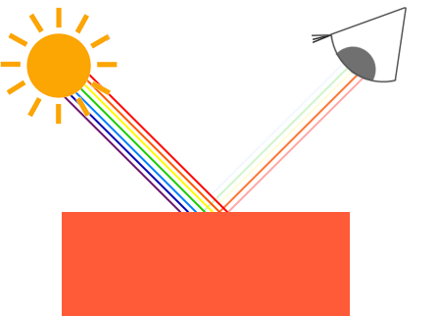*

*You can see that the white sunlight is actually a collection of all the visible colors and the object absorbs a large portion of those colors. It only reflects those colors that represent the object's color and the combination of those is what we perceive (in this case a coral color).*

*These rules of color reflection apply directly in graphics-land. When we define a light source in OpenGL we want to give this light source a color. In the previous paragraph we had a white color so we'll give the light source a white color as well. If we would then multiply the light source's color with an object's color value, the resulting color is the reflected color of the object (and thus its perceived color). Let's revisit our toy (this time with a coral value) and see how we would calculate its perceivable color in graphics-land. We retrieve the resulting color vector by doing a component-wise multiplication on both color vectors: // чаму ў дадзеным выпадку працуе менавіта пакампанентнае перамнажэнне? //*

*// чым больш у святле, напрыклад, чырвонай кампаненты. Тым больш будзе адлюстроўвацца чырвонай кампаненты ад прадмета. Такім чынам, мы памножым яго чырвоную кампаненту на кампаненту святла. Рацыянальнае зерне тут ёсць. //*

*glm::vec3 lightColor(1.0f, 1.0f, 1.0f);*

*glm::vec3 toyColor(1.0f, 0.5f, 0.31f);*

*glm::vec3 result = lightColor \* toyColor; // = (1.0f, 0.5f, 0.31f);*

*We can see that the toy's color absorbs a large portion of the white light, but reflects several red, green and blue values based on its own color value. This is a representation of how colors would work in real life. We can thus define an object's color as the amount of each color component it reflects from a light source. Now what would happen if we used a green light? // пытанне кнігі, якое я ўжо раней у сваіх развагах задаў ))) //*

*glm::vec3 lightColor(0.0f, 1.0f, 0.0f);*

*glm::vec3 toyColor(1.0f, 0.5f, 0.31f);*

*glm::vec3 result = lightColor \* toyColor; // = (0.0f, 0.5f, 0.0f);*

*As we can see, the toy has no red and blue light to absorb and/or reflect The toy also absorbs half of the light's green value, but also still reflects half of the light's green value. The toy's color we perceive would then be a dark-greenish color. We can see that if we use a green light, only the green color components can be reflected and thus perceived; no red and blue colors are perceived. The result is that the coral object suddenly becomes a dark-greenish object. Let's try one more example with a dark olive-green light: // да тлумачэння таго, чаму чорны колер абазначаецца нулямі ў rgb-натацыі //*

*glm::vec3 lightColor(0.33f, 0.42f, 0.18f);*

*glm::vec3 toyColor(1.0f, 0.5f, 0.31f);*

*glm::vec3 result = lightColor \* toyColor; // = (0.33f, 0.21f, 0.06f);*

*As you can see, we can get unexpected colors from objects by using different light colors. It's not hard to get creative with colors. // цікавая вобласць ведаў, дзе нецяжка быць крэатыўным //*

*But enough about colors, let's start building a scene where we can experiment in. // структура цьютарала //*

### ***A lighting scene***

*In the upcoming tutorials we'll be creating interesting visuals by simulating real-world lighting making extensive use of colors. Since now we'll be using light sources we want to display them as visual objects in the scene and add at least one object to simulate the lighting on. // структура цьютарала //*

*The first thing we need is an object to cast the light on and we'll use the infamous container cube from the previous tutorials. We will also be needing a light object to show where the light source is located in the 3D scene. For simplicity's sake we'll represent the light source with a cube as well (we already have the*[*vertex data*](https://learnopengl.com/code_viewer.php?code=getting-started/cube_vertices)*right?).*

*So, filling a vertex buffer object, setting vertex attribute pointers and all that weird stuff should be easy for you by now so we won't walk you through those steps. If you still have difficulties with those items I suggest you review the*[*previous tutorials*](https://learnopengl.com/#!Getting-started/Hello-Triangle) *and work through the exercises if possible before continuing. // вось чаму раілася раней грунтоўна вывучыць мінулыя цьютаралы //*

*So, the first thing we will actually need is a vertex shader to draw the container. The vertex positions of the container remain the same (although we won't be needing texture coordinates this time) so the code should be nothing new. We'll be using a stripped down version of the vertex shader from the last tutorials:*

*#version 330 core*

***layout*** *(location = 0)* ***in*** *vec3 aPos;*

***uniform*** *mat4 model;*

***uniform*** *mat4 view;*

***uniform*** *mat4 projection;*

***void*** *main()*

*{*

*gl\_Position = projection \* view \* model \* vec4(aPos, 1.0);*

*}*

*Make sure to update your vertex data and attribute pointers to correspond with the new vertex shader (if you want you can actually keep the texture data and attribute pointers active; we're just not using them right now, but it's not a bad idea to start from a fresh start).*

*Because we are also going to create a lamp cube, we want to generate a new VAO specifically for the lamp. We could also represent a lamp using the same VAO and then simply do some transformations on the model matrix, but in the upcoming tutorials we'll be changing the vertex data and attribute pointers of the container object quite often and we don't want these changes to propagate to the lamp object (we only care about the lamp's vertex positions), so we'll create a new VAO: // кантэкст выкарыстання VAO //*

***unsigned******int*** *lightVAO;*

*glGenVertexArrays(1, &lightVAO);*

*glBindVertexArray(lightVAO);*

*// we only need to bind to the VBO, the container's VBO's data already contains the correct data.*

*glBindBuffer(GL\_ARRAY\_BUFFER, VBO);*

*// set the vertex attributes (only position data for our lamp)*

*glVertexAttribPointer(0, 3, GL\_FLOAT, GL\_FALSE, 3 \** ***sizeof****(****float****), (****void****\*)0);*

*glEnableVertexAttribArray(0);*

*The code should be relatively straightforward. Now that we created both the container and the lamp cube there is one thing left to define and that is the fragment shader:*

*#version 330 core*

***out*** *vec4 FragColor;*

***uniform*** *vec3 objectColor;*

***uniform*** *vec3 lightColor;*

***void*** *main()*

*{*

*FragColor = vec4(lightColor \* objectColor, 1.0);*

*}*

*// відаць, у GLSL па змоўчанні рэалізавана пакампанентнае перамнажэнне вектароў //*

*The fragment shader accepts both an object color and a light color from a uniform variable. Here we multiply the light's color with the object's (reflected) color just like we discussed at the beginning of this tutorial. Again, this shader should be easy to understand. Let's set the object's color to the last section's coral color with a white light:*

*// don't forget to 'use' the corresponding shader program first (to set the uniform)*

*lightingShader.use();*

*lightingShader.setVec3("objectColor", 1.0f, 0.5f, 0.31f);*

*lightingShader.setVec3("lightColor", 1.0f, 1.0f, 1.0f);*

*One thing left to note is that when we start to change the vertex and fragment shaders, the lamp cube will change as well and this is not what we want. We don't want the lamp object's color to be affected by the lighting calculations in the upcoming tutorials, but rather keep the lamp isolated from the rest. We want the lamp to have a constant bright color, unaffected by other color changes (this makes it look like the lamp really is the source of the light).*

*To accomplish this we actually need to create a second set of shaders that we will use to draw the lamp, thus being safe from any changes to the lighting shaders. // кантэкст выкарыстання розных шэйдэраў для розных графічных прымітываў // The vertex shader is the same as the current vertex shader so you can simply copy the source code for the lamp's vertex shader. The fragment shader of the lamp ensures the lamp's color stays bright by defining a constant white color on the lamp:*

*#version 330 core*

***out*** *vec4 FragColor;*

***void*** *main()*

*{*

*FragColor = vec4(1.0); // set all 4 vector values to 1.0*

*}*

*When we want to draw our objects, we want to draw the container object (or possibly many other objects) using the lighting shader we just defined and when we want to draw the lamp, we use the lamp's shaders. During the tutorials we'll gradually be updating the lighting shaders to slowly achieve more realistic results. // трэпр структура цьютарала. Трэпр, тнав. Выдатнейшы цьютарал //*

*The main purpose of the lamp cube is to show where the light comes from. We usually define a light source's position somewhere in the scene, but this is simply a position that has no visual meaning. To show the actual lamp we draw the lamp cube at the same location of the light source. This is accomplished by drawing the lamp object with the lamp shader, ensuring the lamp cube always stays white, regardless of the light conditions of the scene.*

*So let's declare a global vec3 variable that represents the light source's location in world-space coordinates:*

*glm::vec3 lightPos(1.2f, 1.0f, 2.0f);*

*We then want to translate the lamp's cube to the light source's position before drawing it and we'll also scale it down a bit to make sure the lamp isn't too dominant:*

*model = glm::mat4();*

*model = glm::translate(model, lightPos);*

*model = glm::scale(model, glm::vec3(0.2f));*

*The resulting drawing code for the lamp should then look something like this:*

*lampShader.use();*

*// set the model, view and projection matrix uniforms*

*...*

*// draw the lamp object*

*glBindVertexArray(lightVAO);*

*glDrawArrays(GL\_TRIANGLES, 0, 36);*

*Injecting all the code fragments at their appropriate locations would then result in a clean OpenGL application properly configured for experimenting with lighting. If everything compiles it should look like this:*

*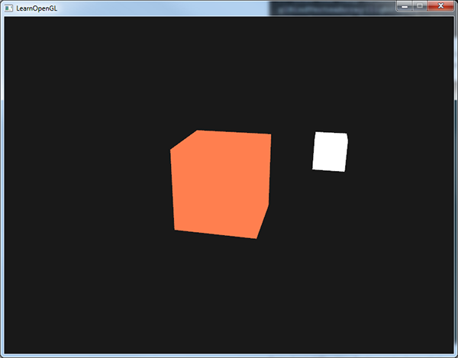*

*Not really much to look at right now, but I'll promise it will get more interesting in the upcoming tutorials.*

*If you have difficulties finding out where all the code snippets fit together in the application as a whole, check the source code*[*here*](https://learnopengl.com/code_viewer_gh.php?code=src/2.lighting/1.colors/colors.cpp)*and carefully work your way through the code/comments.*

*// у мяне ўсё атрымалася //*

*Now that we have a fair bit of knowledge about colors and created a basic scene for some sexy lighting stuff we can jump to the*[*next*](https://learnopengl.com/#!Lighting/Basic-Lighting)*tutorial where the real magic begins. // і арыентацыя чытача, і яго эмацыянальнае інтрыгаванне. Усё ў адным флаконе. Гэта магія трэпр і тнав //*

[*https://learnopengl.com/#!Lighting/Basic-Lighting*](https://learnopengl.com/#!Lighting/Basic-Lighting)

## ***Basic Lighting***

*Lighting in the real world is extremely complicated and depends on way too many factors, something we can't afford to calculate on the limited processing power we have. Lighting in OpenGL is therefore based on approximations of reality using simplified models that are much easier to process and look relatively similar. These lighting models are based on the physics of light as we understand it. One of those models is called the Phong lighting model. // стан галіны і разнавіднасць мадэлі асвятлення // The major building blocks of the Phong model consist of 3 components: ambient, diffuse and specular lighting. Below you can see what these lighting components actually look like: // цудоўная рэпрэзентацыя для разумення //*

*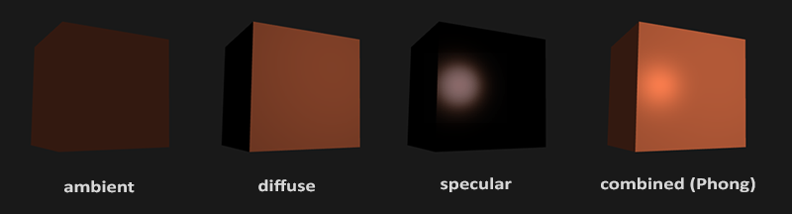*

* *Ambient lighting: even when it is dark there is usually still some light somewhere in the world (the moon, a distant light) so objects are almost never completely dark. To simulate this we use an ambient lighting constant that always gives the object some color.*
* *Diffuse lighting: simulates the directional impact a light object has on an object. This is the most visually significant component of the lighting model. The more a part of an object faces the light source, the brighter it becomes.*
* *Specular lighting: simulates the bright spot of a light that appears on shiny objects. Specular highlights are often more inclined to the color of the light than the color of the object.*

*To create visually interesting scenes we want to at least simulate these 3 lighting components. We'll start with the simplest one: ambient lighting.*

### ***Ambient lighting***

*Light usually does not come from a single light source, but from many light sources scattered all around us, even when they're not immediately visible. One of the properties of light is that it can scatter and bounce in many directions reaching spots that aren't in its direct vicinity; light can thus reflect on other surfaces and have an indirect impact on the lighting of an object. Algorithms that take this into consideration are called global illumination algorithms, but these are expensive and/or complicated. // разнавіднасць алгарытмаў асвятлення і іх недахоп //*

*Since we're not big fans of complicated and expensive algorithms we'll start by using a very simplistic model of global illumination, namely ambient lighting. As you've seen in the previous section we use a small constant (light) color that we add to the final resulting color of the object's fragments, thus making it look like there is always some scattered light even when there's not a direct light source.*

*Adding ambient lighting to the scene is really easy. We take the light's color, multiply it with a small constant ambient factor, multiply this with the object's color and use it as the fragment's color:*

***void*** *main()*

*{*

***float*** *ambientStrength = 0.1;*

*vec3 ambient = ambientStrength \* lightColor;*

*vec3 result = ambient \* objectColor;*

*FragColor = vec4(result, 1.0);*

*}*

*If you'd now run your program, you'll notice that the first stage of lighting is now successfully applied to your object. The object is quite dark, but not completely since ambient lighting is applied (note that the light cube is unaffected because we use a different shader). It should look something like this:*

*// усё працуе //*

*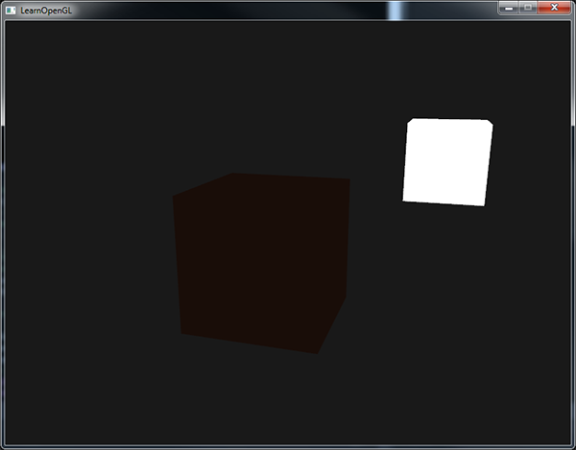*

### ***Diffuse lighting***

*Ambient lighting by itself does not produce the most interesting results, but diffuse lighting will start to give a significant visual impact on the object. Diffuse lighting gives the object more brightness the closer its fragments are aligned to the light rays from a light source. To give you a better understanding of diffuse lighting take a look at the following image:*

*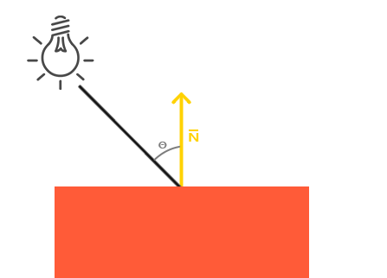*

*To the left we find a light source with a light ray targeted at a single fragment of our object. We then need to measure at what angle the light ray touches the fragment. If the light ray is perpendicular to the object's surface the light has the greatest impact. To measure the angle between the light ray and the fragment we use something called a normal vector that is a vector perpendicular to the fragment's surface (here depicted as a yellow arrow); we'll get to that later. The angle between the two vectors can then easily be calculated with the dot product.*

*You might remember from the*[*transformations*](https://learnopengl.com/#!Getting-started/Transformations)*tutorial that the lower the angle between two unit vectors, the more the dot product is inclined towards a value of 1. When the angle between both vectors is 90 degrees, the dot product becomes 0. The same applies to θ: the larger θ becomes, the less of an impact the light should have on the fragment's color.*

*Note that to get (only) the cosine of the angle between both vectors we will work with unit vectors (vectors of length 1) so we need to make sure all the vectors are normalized, otherwise the dot product returns more than just the cosine (see*[*Transformations*](https://learnopengl.com/#!Getting-started/Transformations)*). // важнасць нармалізацыі //*

*The resulting dot product thus returns a scalar that we can use to calculate the light's impact on the fragment's color, resulting in differently lit fragments, based on their orientation towards the light. // структура мадэлі //*

*So, what do we need to calculate diffuse lighting?*

* *Normal vector: a vector that is perpendicular to the vertex' surface.*
* *The directed light ray: a direction vector that is the difference vector between the light's position and the fragment's position. To calculate this light ray we need the light's position vector and the fragment's position vector.*

#### **Normal vectors**

*A normal vector is a (unit) vector that is perpendicular to the surface of a vertex. Since a vertex by itself has no surface (it's just a single point in space) we retrieve a normal vector by using its surrounding vertices to figure out the surface of the vertex. We can use a little trick to calculate the normal vectors for all the cube's vertices by using the cross product, but since a 3D cube is not a complicated shape we can simply manually add them to the vertex data. The updated vertex data array can be found*[*here*](https://learnopengl.com/code_viewer.php?code=lighting/basic_lighting_vertex_data)*. Try to visualize that the normals are indeed vectors perpendicular to the plane's surfaces of the cube (a cube consists of 6 planes).*

*// нармалі ідуць як часткі вертэксаў //*

*Since we added extra data to the vertex array we should update the lighting's vertex shader:*

*#version 330 core*

***layout*** *(location = 0)* ***in*** *vec3 aPos;*

***layout*** *(location = 1)* ***in*** *vec3 aNormal;*

*...*

*02.09.2017*

*Now that we added a normal vector to each of the vertices and updated the vertex shader we should update the vertex attribute pointers as well. Note that the lamp object uses the same vertex array for its vertex data, but the lamp shader has no use of the newly added normal vectors. We don't have to update the lamp's shaders or attribute configurations, but we have to at least modify the vertex attribute pointers to reflect the new vertex array's size:*

*glVertexAttribPointer(0, 3, GL\_FLOAT, GL\_FALSE, 6 \** ***sizeof****(****float****), (****void****\*)0);*

*glEnableVertexAttribArray(0);*

*We only want to use the first 3 floats of each vertex and ignore the last 3 floats so we only need to update the strideparameter to 6 times the size of a float and we're done.*

*It may look inefficient using vertex data that is not completely used by the lamp shader, but the vertex data is already stored in the GPU's memory from the container object so we don't have to store new data into the GPU's memory. This actually makes it more efficient compared to allocating a new VBO specifically for the lamp. // аптымізацыя ў тэхналогіі //*

*All the lighting calculations are done in the fragment shader so we need to forward the normal vectors from the vertex shader to the fragment shader. Let's do that:*

***out*** *vec3 Normal;*

***void*** *main()*

*{*

*gl\_Position = projection \* view \* model \* vec4(aPos, 1.0);*

*Normal = aNormal;*

*}*

*What's left to do is declare the corresponding input variable in the fragment shader:*

***in*** *vec3 Normal;*

#### **Calculating the diffuse color**

*We now have the normal vector for each vertex, but we still need the light's position vector and the fragment's position vector. Since the light's position is just a single static variable we can simply declare it as a uniform in the fragment shader:*

***uniform*** *vec3 lightPos;*

*And then update the uniform in the game loop (or outside since it doesn't change). We use the lightPos vector declared in the previous tutorial as the location of the light source:*

*lightingShader.setVec3("lightPos", lightPos);*

*Then the last thing we need is the actual fragment's position. We're going to do all the lighting calculations in world space so we want a vertex position that is in world space. We can accomplish this by multiplying the vertex position attribute with the model matrix only (not the view and projection matrix) to transform it to world space coordinates. This can easily be accomplished in the vertex shader so let's declare an output variable and calculate its world space coordinates:*

***out*** *vec3 FragPos;*

***out*** *vec3 Normal;*

***void*** *main()*

*{*

*gl\_Position = projection \* view \* model \* vec4(aPos, 1.0);*

*FragPos = vec3(model \* vec4(aPos, 1.0));*

*Normal = aNormal;*

*}*

*And lastly add the corresponding input variable to the fragment shader:*

***in*** *vec3 FragPos;*

*Now that all the required variables are set we can start with the lighting calculations in the fragment shader.*

*The first thing we need to calculate is the direction vector between the light source and the fragment's position. We mentioned that the light's direction vector is the difference vector between the light's position vector and the fragment's position vector. As you might remember from the*[*transformations*](https://learnopengl.com/#!Getting-started/Transformations)*tutorial we can easily calculate this difference by subtracting both vectors. We also want to make sure all the relevant vectors end up as unit vectors so we normalize both the normal and the resulting direction vector:*

*vec3 norm = normalize(Normal);*

*vec3 lightDir = normalize(lightPos - FragPos);*

*When calculating lighting we usually do not care about the magnitude of a vector or their position; we only care about their direction. Because we only care about their direction almost all the calculations are done with unit vectors since it simplifies most calculations (like the dot product). // перавага нармалізацыі // So when doing lighting calculations, make sure you always normalize the relevant vectors to ensure they're actual unit vectors. Forgetting to normalize a vector is a popular mistake. // рэкамендацыя і папулярныя памылкі //*

*Next we want to calculate the actual diffuse impact the light has on the current fragment by taking the dot product of the norm and lightDir vector. The resulting value is then multiplied with the light's color to get the diffuse component, resulting in a darker diffuse component the greater the angle is between both vectors:*

***float*** *diff = max(dot(norm, lightDir), 0.0);*

*vec3 diffuse = diff \* lightColor;*

*If the angle between both vectors is greater than 90 degrees then the result of the dot product will actually become negative and we end up with a negative diffuse component. For that reason we use the max function that returns the highest of both its parameters to make sure the diffuse component (and thus the colors) never become negative. Lighting for negative colors is not really defined so it's best to stay away from that, unless you're one of those eccentric artists. // Лепей зразумець, якая праблема тут маецца на ўвазе??? //*

*Now that we have both an ambient and a diffuse component we add both colors to each other and then multiply the result with the color of the object to get the resulting fragment's output color:*

*vec3 result = (ambient + diffuse) \* objectColor;*

*FragColor = vec4(result, 1.0);*

*If your application (and shaders) compiled successfully you should see something like this:*

*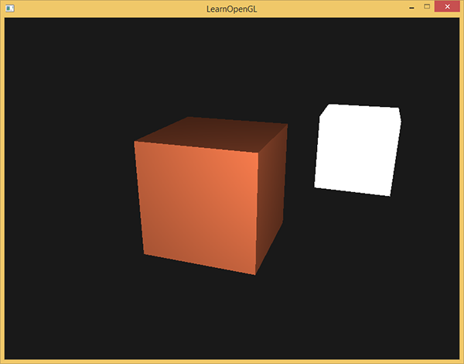*

*You can see that with diffuse lighting the cube starts to look like an actual cube again. Try visualizing the normal vectors in your head and move around the cube to see that the larger the angle between them and the light's direction, the darker a fragment becomes.*

*// Доўга не атрымлівалася – і я не разумеў, у чым праблема. Аказалася, што забыў уключыць depth-тэст праз наступны радок:* glEnable(GL\_DEPTH\_TEST); *//*

*// зараз усё працуе //*

*Feel free to compare your source code with the complete source code*[*here*](https://learnopengl.com/code_viewer_gh.php?code=src/2.lighting/2.1.basic_lighting_diffuse/basic_lighting_diffuse.cpp)*if you're stuck.*

### ***One last thing***

*As of now we've been passing the normal vectors directly from the vertex shader to the fragment shader. However, the calculations we've been doing in the fragment shader are all done in world space coordinates, so shouldn't we transform the normal vectors to world space coordinates as well? Basically yes, but it's not as simple as simply multiplying it with a model matrix. // важная задача праектавання праграмных сістэм //*

*First of all, normal vectors are only direction vectors and do not represent a specific position in space. Also, normal vectors do not have a homogeneous coordinate (the w component of a vertex position). This means that translations do and should not have any effect on the normal vectors. // абгрунтаванне таго, чаму ў нармальных вектараў толькі тры каардынаты // So if we want to multiply the normal vectors with a model matrix we want to remove the translation part of the matrix by taking the upper-left 3x3 matrix of the model matrix (note that we could also set the wcomponent of a normal vector to 0 and multiply with the 4x4 matrix; this removes translation as well). The only transformations we want to apply to normal vectors are scale and rotation transformations.*

*Second, if the model matrix would perform a non-uniform scale, the vertices would be changed in such a way that the normal vector is not perpendicular to the surface anymore, so we can't transform the normal vectors with such a model matrix. The following image shows the effect such a model matrix (with non-uniform scaling) has on a normal vector: // важны нюанс //*

*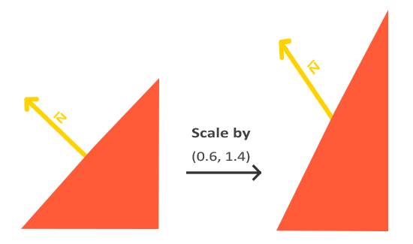*

*Whenever we apply a non-uniform scale (note: uniform scales won't hurt the normals since their directions do not change, just their magnitude which is easily fixed by normalizing them) the normal vectors are not perpendicular to the corresponding surface anymore which distorts the lighting. // праблема графічнага праграмавання //*

*The trick of fixing this behavior is to use a different model matrix specifically tailored for normal vectors. This matrix is called the normal matrix and uses a few linear algebraic operations to remove the effect of wrongly scaling the normal vectors. If you want to know how this matrix is actually calculated I suggest the following*[*article*](http://www.lighthouse3d.com/tutorials/glsl-tutorial/the-normal-matrix/)*.*

*The normal matrix is defined as 'the transpose of the inverse of the upper-left corner of the model matrix'. Phew, that's a mouthful and if you don't really understand what that means, don't worry; we haven't discussed inverse and transpose matrices yet. // цудоўная арыентацыя чытача. Але я гэта ведаю. // Note that most resources define the normal matrix as these operations applied to the model-view matrix, but since we're working in world space (and not in view space) we only use the model matrix. // лепей зразумець сэнс апошняга сказу //*

*In the vertex shader we can generate this normal matrix ourselves by using the inverse and transpose functions in the vertex shader that work on any matrix type. Note that we also cast the matrix to a 3x3 matrix to ensure it loses its translation properties and that it can multiply with the vec3 normal vector:*

*Normal = mat3(transpose(inverse(model))) \* aNormal;*

*In the diffuse lighting section the lighting was just fine because we did not perform any scaling operation on the object itself so there was not really a need to use a normal matrix and could've just multiplied the normals with the model matrix. If you are doing a non-uniform scale however, it is essential that you multiply your normal vector with the normal matrix.*

*Inversing matrices is a costly operation even for shaders so wherever possible, try to avoid doing inverse operations in shaders since they have to be done on each vertex of your scene. // рэкамендацыя. Праблема. // For learning purposes this is fine, but for an efficient application you'll likely want to calculate the normal matrix on the CPU and send it to the shaders via a uniform before drawing (just like the model matrix). // вырашэнне праблемы //*

### ***Specular Lighting***

*If you're not already exhausted by all the lighting calculations we can start finishing the Phong lighting model by adding specular highlights.*

*Just like diffuse lighting, specular lighting is based on the light's direction vector and the object's normal vectors, but this time it is also based on the view direction e.g. from what direction the player is looking at the fragment. Specular lighting is based on the reflective properties of light. If we think of the object's surface as a mirror, the specular lighting is the strongest wherever we would see the light reflected on the surface. You can see this effect in the following image:*

*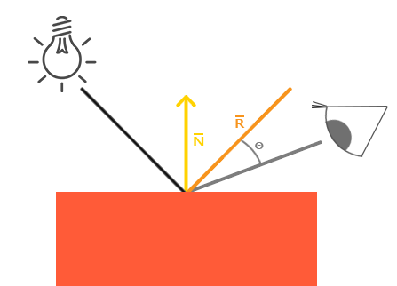*

*// цудоўная рэпрэзентацыя //*

*We calculate a reflection vector by reflecting the light direction around the normal vector. Then we calculate the angular distance between this reflection vector and the view direction and the closer the angle between them, the greater the impact of the specular light. The resulting effect is that we see a bit of a highlight when we're looking at the light's direction reflected via the object.*

*The view vector is the one extra variable we need for specular lighting which we can calculate using the viewer's world space position and the fragment's position. Then we calculate the specular's intensity, multiply this with the light color and add this to the resulting ambient and diffuse components.*

*We chose to do the lighting calculations in world space, but most people tend to prefer doing lighting in view space. The added advantage of calculating in view space is that the viewer's position is always at (0,0,0) so you already got the position of the viewer for free. However, I find calculating lighting in world space more intuitive for learning purposes. If you still want to calculate lighting in view space you want to transform all the relevant vectors with the view matrix as well (don't forget to change the normal matrix too). // мне падабаецца варыянт аўтара, бо гэта інтуітыўна зразумелей //*

*To get the world space coordinates of the viewer we simply take the position vector of the camera object (which is the viewer of course). So let's add another uniform to the fragment shader and pass the corresponding camera position vector to the fragment shader:*

***uniform*** *vec3 viewPos;*

*lightingShader.setVec3("viewPos", camera.Position);*

*Now that we have all the required variables we can calculate the specular intensity. First we define a specular intensity value to give the specular highlight a medium-bright color so that it doesn't have too much of an impact:*

***float*** *specularStrength = 0.5;*

*If we would set this to 1.0f we'd get a really bright specular component which is a bit too much for a coral cube. In the*[*next*](https://learnopengl.com/#!Lighting/Materials) *tutorial we'll talk about properly setting all these lighting intensities and how they affect the objects. // структура цьютарала паступова раскрываецца. Гэта цудоўная перавага кнігі. Патэрн тнав. Чалавек усё лепей і лепей разумее структуру кнігі. Прычым загадзя раскрываюцца найбольш часта параграфы, якія будуць ісці не так далёка ад тэмы. Можна параўнаць з кнігай Дэмінга, які раскрывае, па крайняй меры імкнецца, раскрыць усе графавыя спасылкі // Next we calculate the view direction vector and the corresponding reflect vector along the normal axis:*

*vec3 viewDir = normalize(viewPos - FragPos);*

*vec3 reflectDir = reflect(-lightDir, norm);*

*Note that we negate the lightDir vector. The reflect function expects the first vector to point****from****the light source towards the fragment's position, but the lightDir vector is currently pointing the other way around from the fragment* ***towards****the light source (depends on the order of subtraction earlier on when we calculated the lightDir vector). // які цудоўны і грунтоўны цьютарал // To make sure we get the correct reflect vector we reverse its direction by negating the lightDir vector first. The second argument expects a normal vector so we supply the normalized norm vector.*

*Then what's left to do is to actually calculate the specular component. This is accomplished with the following formula:*

***float*** *spec = pow(max(dot(viewDir, reflectDir), 0.0), 32);*

*vec3 specular = specularStrength \* spec \* lightColor;*

*We first calculate the dot product between the view direction and the reflect direction (and make sure it's not negative) and then raise it to the power of 32. This 32 value is the shininess value of the highlight. The higher the shininess value of an object, the more it properly reflects the light instead of scattering it all around and thus the smaller the highlight becomes. Below you can see an image that shows the visual impact of different shininess values: // параметр тэхналогіі //*

*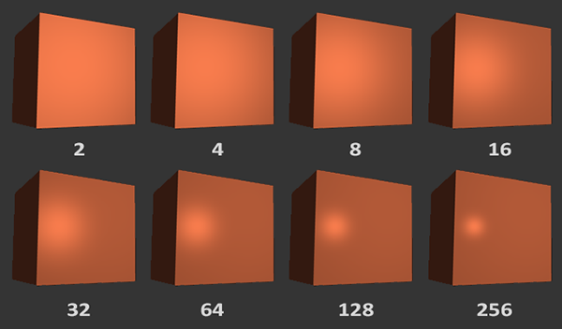*

*We don't want the specular component to be too dominant so we keep the exponent at 32. The only thing left to do is to add it to the ambient and diffuse components and multiply the combined result with the object's color:*

*vec3 result = (ambient + diffuse + specular) \* objectColor;*

*FragColor = vec4(result, 1.0);*

*We now calculated all the lighting components of the Phong lighting model. Based on your point of view you should see something like this:*

*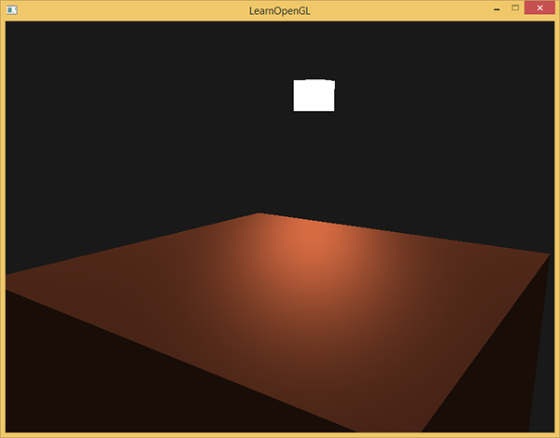*

*You can find the complete source code of the application*[*here*](https://learnopengl.com/code_viewer_gh.php?code=src/2.lighting/2.2.basic_lighting_specular/basic_lighting_specular.cpp)*.*

*// усё атрымалася проста выдатнейшым чынам! Люблю такія цьютаралы //*

*In the earlier days of lighting shaders, developers used to implement the Phong lighting model in the vertex shader. The advantage of doing lighting in the vertex shader is that it is a lot more efficient since there are generally a lot less vertices than fragments, so the (expensive) lighting calculations are done less frequently. However, the resulting color value in the vertex shader is the resulting lighting color of that vertex only and the color values of the surrounding fragments are then the result of interpolated lighting colors. The result was that the lighting was not very realistic unless large amounts of vertices were used: // гісторыя тэхналогіі і менш якасная альтэрнатыва //*

*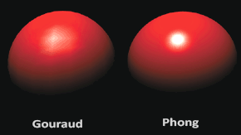*

*When the Phong lighting model is implemented in the vertex shader it is called Gouraud shading instead of Phong shading. Note that due to the interpolation the lighting looks a bit off. The Phong shading gives much smoother lighting results. // параўнанне мадэляў асвятлення //*

*By now you should be starting to see just how powerful shaders are. With little information shaders are able to calculate how lighting affects the fragment's colors for all our objects. // моца тэхналогіі // In the*[*next*](https://learnopengl.com/#!Lighting/Materials)*tutorials we'll be delving much deeper into what we can do with the lighting model. // цудоўная арыентацыя чытачат тыпу “накірунак разумення без указання канкрэтнай семантыкі”. Даследваць. //*

### ***Exercises***

* *Right now the light source is a boring static light source that doesn't move. Try to move the light source around the scene over time using either sin or cos. Watching the lighting change over time gives you a good understanding of Phong's lighting model:*[*solution*](https://learnopengl.com/code_viewer.php?code=lighting/basic_lighting-exercise1)*. // вырашыў, змяняючы каардынаты лямпы ўручную. Нешта не атрымалася з матрыцай вярэчння glm //*

*// праўда, вырашэнне прапануецца падобнае //*

* *Play around with different ambient, diffuse and specular strengths and see how they impact the result. Also experiment with the shininess factor. Try to comprehend why certain values have a certain visual output. // потым займуся //*
* *Do Phong shading in view space instead of world space:*[*solution*](https://learnopengl.com/code_viewer.php?code=lighting/basic_lighting-exercise2)*. // пакуль што не рабіў, але вырашэнне зразумеў. Тут варта пераўтвараць каардынаты і нармалі ў вертэкс шэйдэры праз дзве матрыцы: model і view. //*

*// усё менавіта так, як я і сказаў. Код змяняецца толькі ў шэйдэрах //*

* *Implement Gouraud shading instead of Phong shading. If you did things right the lighting should*[*look a bit off*](https://learnopengl.com/img/lighting/basic_lighting_exercise3.png) *(especially the specular highlights) with the cube object. Try to reason why it looks so weird:*[*solution*](https://learnopengl.com/code_viewer.php?code=lighting/basic_lighting-exercise3)*. // не вырашаў. Шмат работы. А я хачу рухацца далей. //*

*// але вырашэнне атрымалася такім, як я і меркаваў. Проста для гэтага трэба шмат кода правіць. //*

[*https://learnopengl.com/#!Lighting/Materials*](https://learnopengl.com/#!Lighting/Materials)

## ***Materials***

*In the real world, each object reacts differently to light. Steel objects are often shinier than a clay vase for example and a wooden container does not react the same to light as a steel container. Each object also responds differently to specular highlights. Some objects reflect the light without too much scattering resulting in a small highlights and others scatter a lot giving the highlight a larger radius. If we want to simulate several types of objects in OpenGL we have to define material properties specific to each object.*

*In the previous tutorial we specified an object and light color to define the visual output of the object, combined with an ambient and specular intensity component. When describing objects we can define a material color for each of the 3 lighting components: ambient, diffuse and specular lighting. By specifying a color for each of the components we have fine-grained control over the color output of the object. Now add a shininess component to those 3 colors and we have all the material properties we need:*

*#version 330 core*

***struct*** *Material {*

*vec3 ambient;*

*vec3 diffuse;*

*vec3 specular;*

***float*** *shininess;*

*};*

***uniform*** *Material material; // юніформамі могуць быць уласна створаныя структуры //*

*In the fragment shader we create a struct to store the material properties of the object. We can also store them as individual uniform values, but storing them as a struct keeps it more organized. We first define the layout of the struct and then simply declare a uniform variable with the newly created struct as its type.*

*As you can see, we define a color vector for each of the Phong lighting's components. The ambient material vector defines what color this object reflects under ambient lighting; this is usually the same as the object's color. The diffuse material vector defines the color of the object under diffuse lighting. The diffuse color is (just like ambient lighting) set to the desired object's color. The specular material vector sets the color impact a specular light has on the object (or possibly even reflect an object-specific specular highlight color). Lastly, the shininess impacts the scattering/radius of the specular highlight.*

*With these 4 components that define an object's material we can simulate many real-world materials. A table as found at*[*devernay.free.fr*](http://devernay.free.fr/cours/opengl/materials.html)*shows several material properties that simulate real materials found in the outside world. // цудоўная табліца матэрыялаў для выкарыстання ў графічных прылажэннях // The following image shows the effect several of these real world materials have on our cube:*

*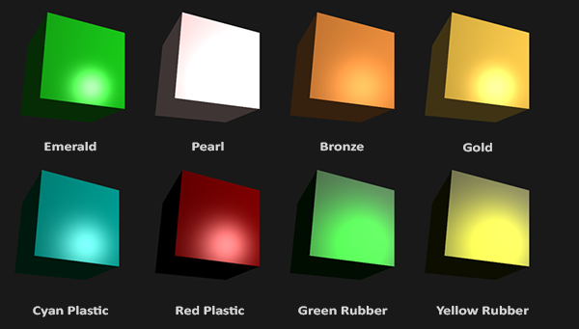*

*// цудоўнейшая рэпрэзентацыя //*

*As you can see, by correctly specifying the material properties of an object it seems to change the perception we have of the object. The effects are clearly noticeable, but for the most realistic results we will eventually need more complicated shapes than a cube. In the*[*following tutorial sections*](https://learnopengl.com/#!Model-Loading/Assimp)*we'll discuss more complicated shapes. // важнасць матэрыялаў. Арыентацыя чытача. Тнав. Арыентацыя тыпу: “набліжэнне да вырашэння рэалістычных задач” //*

*Getting the right materials for an object is a difficult feat that mostly requires experimentation and a lot of experience so it's not that uncommon to completely destroy the visual quality of an object by a misplaced material. // складанасць задачы і крыніца частых памылак. Я ўжо спрабаваў займацца падборам колераў – вельмі складана //*

*Let's try implementing such a material system in the shaders. // пастаноўка задачы //*

### ***Setting materials***

*We created a uniform material struct in the fragment shader so next we want to change the lighting calculations to comply with the new material properties. Since all the material variables are stored in a struct we can access them from the material uniform:*

***void*** *main()*

*{*

*// ambient*

*vec3 ambient = lightColor \* material.ambient; // тут ужо ўлічана яркасць амбіента? //*

*// diffuse*

*vec3 norm = normalize(Normal);*

*vec3 lightDir = normalize(lightPos - FragPos);*

***float*** *diff = max(dot(norm, lightDir), 0.0);*

*vec3 diffuse = lightColor \* (diff \* material.diffuse);*

*// specular*

*vec3 viewDir = normalize(viewPos - FragPos);*

*vec3 reflectDir = reflect(-lightDir, norm);*

***float*** *spec = pow(max(dot(viewDir, reflectDir), 0.0), material.shininess);*

*vec3 specular = lightColor \* (spec \* material.specular);*

*vec3 result = ambient + diffuse + specular;*

*FragColor = vec4(result, 1.0);*

*}*

*// мы фактычна замянілі адзін колер прадмета трыма колерамі і яскравасцю. Усе яны залежаць ад яго фізічнай структуры і аптычных уласцівасцяў, але разлічваць іх напрамую складана-складана. Гэта цудоўнейшы прыклад рэалістычнай імітацыі //*

*As you can see we now access all of the material struct's properties wherever we need them and this time calculate the resulting output color with the help of the material's colors. Each of the object's material attributes are multiplied with their respective lighting components.*

*We can set the material of the object in the application by setting the appropriate uniforms. A struct in GLSL however is not special in any regard when setting uniforms. A struct only acts as an encapsulation of uniform variables so if we want to fill the struct we still have to set the individual uniforms, but this time prefixed with the struct's name: // структура glsl //*

*lightingShader.setVec3("material.ambient", 1.0f, 0.5f, 0.31f);*

*lightingShader.setVec3("material.diffuse", 1.0f, 0.5f, 0.31f);*

*lightingShader.setVec3("material.specular", 0.5f, 0.5f, 0.5f);*

*lightingShader.setFloat("material.shininess", 32.0f);*

*We set the ambient and diffuse component to the color we'd like the object to have and set the specular component of the object to a medium-bright color; we don't want the specular component to be too strong on this specific object. We also keep the shininess at 32. We can now easily influence the object's material from the application.*

*Running the program gives you something like this:*

*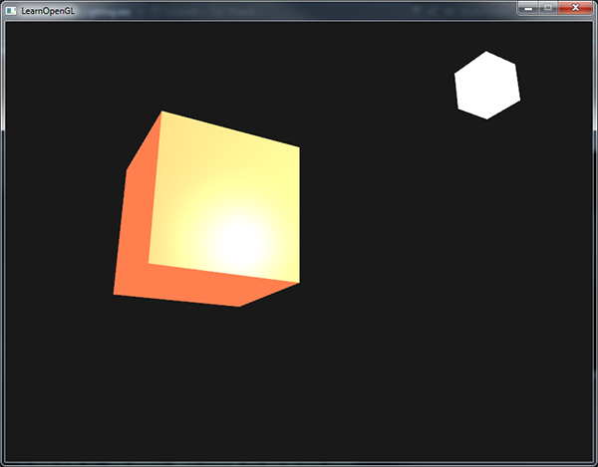*

*It doesn't really look right though?*

*// нешта падобнае атрымалася і ў мяне зараз //*

### ***Light properties***

*The object is way too bright. The reason for the object being too bright is that the ambient, diffuse and specular colors are reflected with full force from any light source. Light sources also have different intensities for their ambient, diffuse and specular components respectively. In the previous tutorial we solved this by varying the ambient and specular intensities with a strength value. We want to do something similar, but this time by specifying intensity vectors for each of the lighting components. If we'd visualize lightColor as vec3(1.0) the code would look like this:*

*vec3 ambient = vec3(1.0) \* material.ambient;*

*vec3 diffuse = vec3(1.0) \* (diff \* material.diffuse);*

*vec3 specular = vec3(1.0) \* (spec \* material.specular);*

*So each material property of the object is returned with full intensity for each of the light's components. These vec3(1.0) values can be influenced individually as well for each light source and this is usually what we want. Right now the ambient component of the object is fully influencing the color of the cube, but the ambient component shouldn't really have such a big impact on the final color so we can restrict the ambient color by setting the light's ambient intensity to a lower value:*

*vec3 ambient = vec3(0.1) \* material.ambient;*

*We can influence the diffuse and specular intensity of the light source in the same way. This is closely similar to what we did in the previous*[*previous*](https://learnopengl.com/#!Lighting/Basic-Lighting)*tutorial; you could say we already created some light properties to influence each lighting component individually. We'll want to create something similar to the material struct for the light properties:*

***struct*** *Light {*

*vec3 position;*

*vec3 ambient;*

*vec3 diffuse;*

*vec3 specular;*

*};*

***uniform*** *Light light;*

*A light source has a different intensity for its ambient, diffuse and specular light. The ambient light is usually set to a low intensity because we don't want the ambient color to be too dominant. The diffuse component of a light source is usually set to the exact color we'd like a light to have; often a bright white color. The specular component is usually kept at vec3(1.0) shining at full intensity. Note that we also added the light's position vector to the struct. // тыповая практыка тэхналогіі //*

*Just like with the material uniform we need to update the fragment shader:*

*vec3 ambient = light.ambient \* material.ambient;*

*vec3 diffuse = light.diffuse \* (diff \* material.diffuse);*

*vec3 specular = light.specular \* (spec \* material.specular);*

*We then want to set the light intensities in the application:*

*lightingShader.setVec3("light.ambient", 0.2f, 0.2f, 0.2f);*

*lightingShader.setVec3("light.diffuse", 0.5f, 0.5f, 0.5f); // darken the light a bit to fit the scene*

*lightingShader.setVec3("light.specular", 1.0f, 1.0f, 1.0f);*

*Now that we modulated how the light influences all the objects' materials we get a visual output that looks much like the output from the previous tutorial. This time however we got full control over the lighting and the material of the object:*

*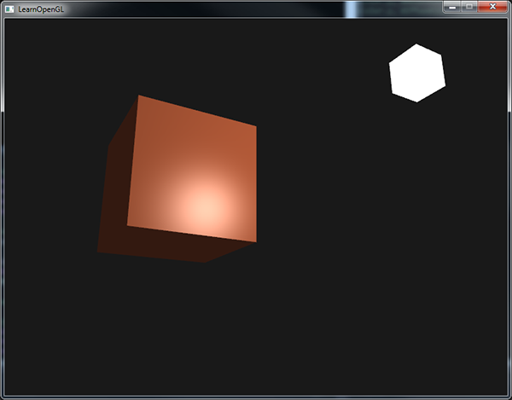*

*// усё цудоўна атрымалася //*

*Changing the visual aspects of objects is relatively easy right now. Let's spice things up a bit!*

### ***Different light colors***

*So far we used light colors to only vary the intensity of their individual components by choosing colors that range from white to gray to black, not affecting the actual colors of the object (only its intensity). Since we now have easy access to the light's properties we can change their colors over time to get some really interesting effects. Since everything is already set up in the fragment shader, changing the light's colors is easy and immediately creates some funky effects: // перавага абстрагіравання ад шэйдэраў. Лепей зразумець гэты эфект //*

*As you can see, a different light color greatly influences the object's color output. Since the light color directly influences what colors the object can reflect (as you might remember from the*[*Colors*](https://learnopengl.com/#!Lighting/Colors)*tutorial) it has a significant impact on the visual output.*

*We can easily change the light's colors over time by changing the light's ambient and diffuse colors via sin and glfwGetTime:*

*glm::vec3 lightColor;*

*lightColor.x = sin(glfwGetTime() \* 2.0f);*

*lightColor.y = sin(glfwGetTime() \* 0.7f);*

*lightColor.z = sin(glfwGetTime() \* 1.3f);*

*glm::vec3 diffuseColor = lightColor \* glm::vec3(0.5f); // decrease the influence*

*glm::vec3 ambientColor = diffuseColor \* glm::vec3(0.2f); // low influence*

*lightingShader.setVec3("light.ambient", ambientColor);*

*lightingShader.setVec3("light.diffuse", diffuseColor);*

*Try and experiment with several lighting and material values and see how they affect the visual output. You can find the source code of the application*[*here*](https://learnopengl.com/code_viewer_gh.php?code=src/2.lighting/3.1.materials/materials.cpp)*.*

*// клас! Усё працуе! //*

***Exercises***

* *Can you simulate some of the real-world objects by defining their respective materials like we've seen at the start of this tutorial? Note that the*[*table*](http://devernay.free.fr/cours/opengl/materials.html)*'s ambient values are not the same as the diffuse values; they didn't take light intensities into account. To correctly set their values you'd have to set all the light intensities to vec3(1.0) to get the same output:*[*solution*](https://learnopengl.com/code_viewer_gh.php?code=src/2.lighting/3.2.materials_exercise1/materials_exercise1.cpp)*of cyan plastic container. // я не вырашаў, але гэта задача не цяжкая //*

[*https://learnopengl.com/#!Lighting/Lighting-maps*](https://learnopengl.com/#!Lighting/Lighting-maps)

## ***Lighting maps***

*In the*[*previous*](https://learnopengl.com/#!Lighting/Materials)*tutorial we discussed the possibility of each object having a unique material of its own that reacts differently to light. // тнав. Арыентацыя чытача тыпу прыгадванне зместу // This is great for giving each object a unique look in comparison with other objects in a lighted scene, but still doesn't offer too much flexibility on the visual output of an object. // што маецца на ўвазе пад гінкасцю? //*

*In the previous tutorial we defined a material for an entire object as a whole, but objects in the real world usually do not consist of a single material, but consist of several materials. Think of a car: its exterior consists of a shiny fabric, it has windows that partly reflect the surrounding environment, its tires are all but shiny so they don't have specular highlights and it has rims that are super shiny (if you actually washed your car alright). // наступны крок ускладнення. Факт тэхналогіі і рэальнага свету // The car also has diffuse and ambient colors that are not the same for the entire object; a car displays many different ambient/diffuse colors. All by all, such an object has different material properties for each of its different parts.*

*So the material system in the previous tutorial isn't sufficient for all but the simplest models so we need to extend the previous system by introducing diffuse and specular maps. These allow us to influence the diffuse (and indirectly the ambient component since they're almost always the same anyways // цікавы факт цьютарала //) and the specular component of an object with much more precision. // пастаноўка задачы //*

### ***03.09.2017***

### ***Diffuse maps***

*What we want is some way to set the diffuse color of an object for each individual fragment. Some sort of system where we can retrieve a color value based on the fragment's position on the object? // intbu question //*

*This should probably all sound extremely familiar and to be honest we've been using such a system for a while now. This sounds a lot like textures we've extensively discussed in one of the*[*earlier*](https://learnopengl.com/#!Getting-started/Textures)*tutorials and it basically is just that: a texture. We're just using a different name for the same underlying principle: using an image wrapped around an object that we can index for unique color values per fragment. In lighted scenes this is usually called a diffuse map (this is generally how 3D artists call them) since a texture image represents all of the object's diffuse colors. // intbu better terminology difference //*

*To demonstrate diffuse maps we're going to use the*[*following image*](https://learnopengl.com/img/textures/container2.png)*of a wooden container with a steel border:*

*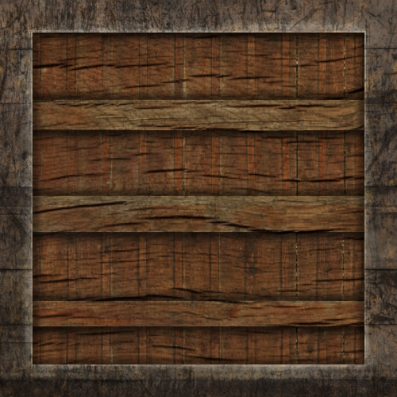*

*Using a diffuse map in shaders is exactly the same as with the texture tutorials. // цудоўная аналогія // This time however we store the texture as a sampler2D inside the Material struct. We replace the earlier defined vec3 diffuse color vector with the diffuse map.*

*Keep in mind that sampler2D is a so called opaque type which means we can't instantiate these types, but only define them as uniforms. // лепей зразумець гэта паняцце: opaque type // If we would instantiate this struct other than as a uniform (like a function parameter) GLSL could throw strange errors; the same thus applies to any struct holding such opaque types. // лепей зразумець, што такое інстанцыраванне //*

*We also remove the ambient material color vector since the ambient color is in almost all cases equal to the diffuse color so there's no need to store it separately: // практыка тэхналогіі //*

***struct*** *Material {*

*sampler2D diffuse;*

*vec3 specular;*

***float*** *shininess;*

*};*

*...*

***in*** *vec2 TexCoords;*

*If you're a bit stubborn and still want to set the ambient colors to a different value (other than the diffuse value) you can keep the ambient vec3, but then the ambient colors would still remain the same for the entire object. To get different ambient values for each fragment you'd have to use another texture for ambient values alone.*

*Note that we are going to need texture coordinates again in the fragment shader, so we declared an extra input variable. Then we simply sample from the texture to retrieve the fragment's diffuse color value:*

*vec3 diffuse = light.diffuse \* diff \* vec3(texture(material.diffuse, TexCoords));*

*Also, don't forget to set the ambient material's color equal to the diffuse material's color as well:*

*vec3 ambient = light.ambient \* vec3(texture(material.diffuse, TexCoords));*

*And that's all it takes to use a diffuse map. As you can see it is nothing new, but it does provide a dramatic increase in visual quality. To get it working we do need to update the vertex data with texture coordinates, transfer them as vertex attributes to the fragment shader, load the texture and bind the texture to the appropriate texture unit.*

*The updated vertex data can be found*[*here*](https://learnopengl.com/code_viewer.php?code=lighting/vertex_data_textures)*. The vertex data now includes vertex positions, normal vectors and texture coordinates for each of the cube's vertices. Let's update the vertex shader to accept texture coordinates as a vertex attribute and forward them to the fragment shader:*

*#version 330 core*

***layout*** *(location = 0)* ***in*** *vec3 aPos;*

***layout*** *(location = 1)* ***in*** *vec3 aNormal;*

***layout*** *(location = 2)* ***in*** *vec2 aTexCoords;*

*...*

***out*** *vec2 TexCoords;*

***void*** *main()*

*{*

*...*

*TexCoords = aTexCoords;*

*}*

*Be sure to update the vertex attribute pointers of both VAOs to match the new vertex data and load the container image as a texture. Before drawing the container we want to assign the preferred texture unit to the material.diffuse uniform sampler and bind the container texture to this texture unit:*

*lightingShader.setInt("material.diffuse", 0);*

*...*

*glActiveTexture(GL\_TEXTURE0);*

*glBindTexture(GL\_TEXTURE\_2D, diffuseMap);*

*Now using a diffuse map we get an enormous boost in detail again and this time with added lighting the container really starts to shine (quite literally). Your container now probably looks something like this:*

*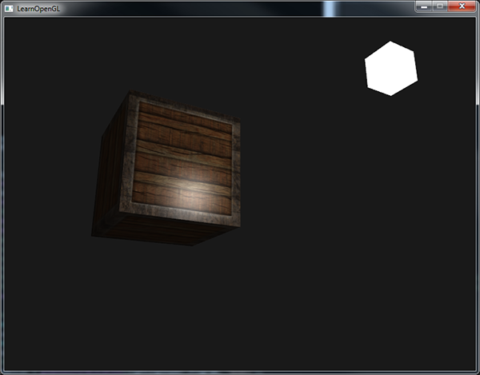*

*You can find the full source code of the application*[*here*](https://learnopengl.com/code_viewer_gh.php?code=src/2.lighting/4.1.lighting_maps_diffuse_map/lighting_maps_diffuse.cpp)*.*

*// усё атрымалася, прычым самастойна //*

### ***Specular maps***

*You probably noticed that the specular highlight looks a bit off since our object is a container that mostly consists of wood and we know that wood doesn't give such specular highlights. We can fix this by setting the specular material of the object to vec3(0.0) but that would mean that the steel borders of the container would stop showing specular highlights as well and we also know that steel****should****show some specular highlights. Again, we would like to control what parts of the object should show a specular highlight with varying intensity. This is a problem that looks really familiar to the diffuse maps discussion. Coincidence? I think not. // пра важнасць спек’юлярных мапаў, бо розныя элемнеты прадметаў па-рознаму адлюстроўваюць святло //*

*We can also use a texture map just for specular highlights. This means we need to generate a black and white (or colors if you feel like it) texture that defines the specular intensities of each part of the object. An example of a*[*specular map*](https://learnopengl.com/img/textures/container2_specular.png)*is the following image:*

**

*The intensity of a specular highlight is retrieved by the brightness of each pixel in the image. Each pixel of the specular map can be displayed as a color vector where black represents the color vector vec3(0.0) and gray the color vector vec3(0.5) for example. In the fragment shader we then sample the corresponding color value and multiply this value with the light's specular intensity. The more 'white' a pixel thus is, the higher the result of the multiplication and thus the brighter the specular component of an object becomes. // рэалізацыя спек’юлярнага мэпа //*

*Because the container mostly consists of wood, and wood as a material should have no specular highlights, the entire wooden section of the diffuse texture was converted to black: black sections do not have any specular highlight. The steel border of the container has varying specular intensities with the steel itself being relatively susceptible to specular highlights while the cracks are not.*

*Technically wood also has specular highlights although with a much lower shininess value (more light scattering) and less impact, but for learning purposes we can just pretend wood doesn't have any reaction to specular light.*

*Using tools like Photoshop or Gimp it is relatively easy to transform a diffuse texture to a specular image like this by cutting out some parts, transforming it to black and white and increasing the brightness/contrast. // тэхніка стварэння спекьюлярных мапаў //*

### ***Sampling specular maps***

*A specular map is just like any other texture so the code is similar to the diffuse map code. Make sure to properly load the image and generate a texture object. Since we're using another texture sampler in the same fragment shader we have to use a different texture unit (see*[*Textures*](https://learnopengl.com/#!Getting-started/Textures)*) for the specular map so let's bind it to the appropriate texture unit before rendering:*

*lightingShader.setInt("material.specular", 1);*

*...*

*glActiveTexture(GL\_TEXTURE1);*

*glBindTexture(GL\_TEXTURE\_2D, specularMap);*

*Then update the material properties of the fragment shader to accept a sampler2D as its specular component instead of a vec3:*

***struct*** *Material {*

*sampler2D diffuse;*

*sampler2D specular;*

***float*** *shininess;*

*};*

*And lastly we want to sample the specular map to retrieve the fragment's corresponding specular intensity:*

*vec3 ambient = light.ambient \* vec3(texture(material.diffuse, TexCoords));*

*vec3 diffuse = light.diffuse \* diff \* vec3(texture(material.diffuse, TexCoords));*

*vec3 specular = light.specular \* spec \* vec3(texture(material.specular, TexCoords));*

*FragColor = vec4(ambient + diffuse + specular, 1.0);*

*By using a specular map we can specify with enormous detail what parts of an object actually have shiny properties and we can even set their corresponding intensity. Specular maps thus give us an added layer of control on top of the diffuse map. // слаі кантролю – важнае паняцце тэхналогіі і тстр. Паразважаць. Важная перавага спекьюлярных мапаў //*

*If you don't want to be too mainstream you could also use actual colors in the specular map to not only set the specular intensity of each fragment, but also the color of the specular highlight. Realistically, however, the color of the specular highlight is mostly (to completely) determined by the light source itself // факт тэхналогіі // so it wouldn't generate realistic visuals (that's why the images are usually black and white: we only care about the intensity). // тлумачэнне асаблівасцяў тэхналогіі //*

*If you would now run the application you can clearly see that the container's material now closely resembles that of an actual wooden container with steel frames:*

*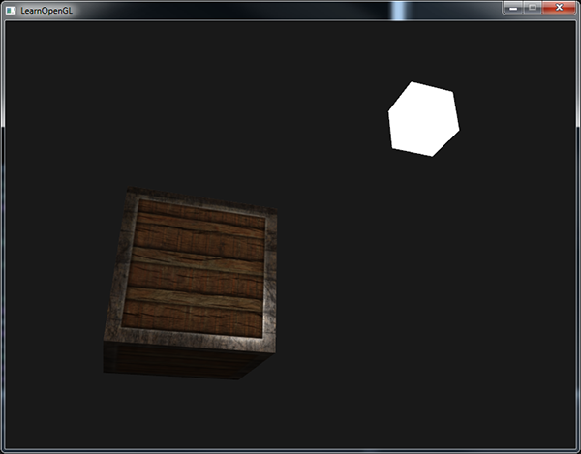*

*You can find the full source code of the application*[*here*](https://learnopengl.com/code_viewer_gh.php?code=src/2.lighting/4.2.lighting_maps_specular_map/lighting_maps_specular.cpp)*.*

*// у мяне ўсё атрымалася, праўда, па-мойму, тэкстура дрэнная, бо стальныя рамкі выглядаюць не зусім так //*

*Using diffuse and specular maps we can really add an enormous amount of detail into relatively simple objects. We can even add more detail into the objects using other texture maps like normal/bump maps and/or reflection maps, but that is something we'll reserve for later tutorials. // арыентацыя чытача праз зацікаўліванне і прадусхваленне наступных тэмаў. Яшчэ два мапы тэхналогіі // Show your container to all your friends and family and be content with the fact that our container can one day become even prettier than it already is! // супер матывацыя навучэнца! Цудоўна, калі пасля практыкавання чалавек можа зрабіць штосьці, што сапраўды здаецца класным. Гэта мацнейшая матывацыя навучэнцаў. Паразважаць аб гэтым болей. //*

### ***Exercises***

* *Fool around with the light source's ambient, diffuse and specular vectors and see how they affect the visual output of the container. // паэксперыментуем потым //*
* *Try inverting the color values of the specular map in the fragment shader so that the wood shows specular highlights and the steel borders do not (note that due to the cracks in the steel border the borders still show some specular highlight, although with less intensity):*[*solution*](https://learnopengl.com/code_viewer.php?code=lighting/lighting_maps-exercise2)*. // гэта я змог хуценька зрабіць //*
* *Try creating a specular map from the diffuse texture that uses actual colors instead of black and white and see that the result doesn't look too realistic. You can use this*[*colored specular map*](https://learnopengl.com/img/lighting/lighting_maps_specular_color.png)*if you can't generate one yourself:*[*result*](https://learnopengl.com/img/lighting/lighting_maps_exercise3.png)*. // не займаўся пакуль… потым паспрабую… //*
* *Also add something they call an emission map which is a texture that stores emission values per fragment. Emission values are colors an object might emit as if it contains a light source itself; this way an object can glow regardless of the light conditions. Emission maps are often what you see when objects in a game glow (like*[*eyes of a robot*](http://www.witchbeam.com.au/unityboard/shaders_enemy.jpg)*, or*[*light strips on a container*](http://www.tomdalling.com/images/posts/modern-opengl-08/emissive.png)*). Add the*[*following*](https://learnopengl.com/img/textures/matrix.jpg)*texture (by creativesam) as an emission map onto the container as if the letters emit light:*[*solution*](https://learnopengl.com/code_viewer_gh.php?code=src/2.lighting/4.3.lighting_maps_exercise4/lighting_maps_exercise4.cpp)*;*[*result*](https://learnopengl.com/img/lighting/lighting_maps_exercise4.png)*. // разнавіднасць мапа. Практыкаванне пакуль не вырашаў. Потым вырашу. //*

[*https://learnopengl.com/#!Lighting/Light-casters*](https://learnopengl.com/#!Lighting/Light-casters)

## ***Light casters***

*09.09.2017*

*All the lighting we've used so far came from a single source that is a single point in space. It gives good results, but in the real world we have several types of light that each act different. // факт кнігі // A light source that casts light upon objects is called a light caster. In this tutorial we'll discuss several different types of light casters. Learning to simulate different light sources is yet another tool in your toolbox to further enrich your environments.*

*We'll first discuss a directional light, then a point light which is an extension of what we had before and lastly we'll discuss spotlights. In the*[*next*](https://learnopengl.com/#!Lighting/Multiple-lights)*tutorial we'll combine several of these different light types into one scene. // структура цьютарала і арыентацыя чытача. Цесна злучаныя цьютаралы. Тнав //*

### ***Directional Light***

*When a light source is far away the light rays coming from the light source are close to parallel to each other. It looks like all the light rays are coming from the same direction, regardless of where the object and/or the viewer is. When a light source is modeled to be infinitely far away it is called a directional light since all its light rays have the same direction; it is independent of the location of the light source.*

*A fine example of a directional light source is the sun as we know it. The sun is not infinitely far away from us, but it is so far away that we can perceive it as being infinitely far away in the lighting calculations. All the light rays from the sun are then modelled as parallel light rays as we can see in the following image:*

*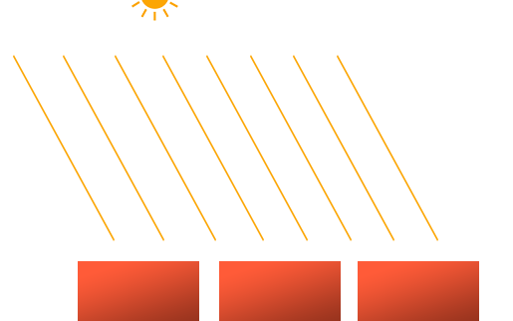*

*Because all the light rays are parallel it does not matter how each object relates to the light source's position since the light direction remains the same for each object in the scene. Because the light's direction vector stays the same, the lighting calculations will be similar for each object in the scene.*

*We can model such a directional light by defining a light direction vector instead of a position vector. The shader calculations remain mostly the same except this time we directly use the light's direction vector instead of calculating the lightDirvector with the light's position vector:*

***struct*** *Light {*

*// vec3 position; // No longer necessery when using directional lights.*

*vec3 direction;*

*vec3 ambient;*

*vec3 diffuse;*

*vec3 specular;*

*};*

*...*

***void*** *main()*

*{*

*vec3 lightDir = normalize(-light.direction);*

*...*

*}*

*Note that we first negate the light.direction vector. The lighting calculations we used so far expect the light direction to be a direction from the fragment****towards****the light source, but people generally prefer to specify a directional light as a global direction pointing****from****the light source. Therefore we have to negate the global light direction vector to switch its direction; it's now a direction vector pointing towards the light source. Also, be sure to normalize the vector since it is unwise to assume the input vector to be a unit vector.*

*The resulting lightDir vector is then used as before in the diffuse and specular computations.*

*To clearly demonstrate that a directional light has the same effect on all multiple objects we revisit the container party scene from the end of the*[*Coordinate systems*](https://learnopengl.com/#!Getting-started/Coordinate-Systems)*tutorial. In case you missed the party we first defined 10 different*[*container positions*](https://learnopengl.com/code_viewer.php?code=lighting/light_casters_container_positions) *and generated a different model matrix per container where each model matrix contained the appropriate local-to-world transformations:*

***for****(****unsigned******int*** *i = 0; i < 10; i++)*

*{*

*glm::mat4 model;*

*model = glm::translate(model, cubePositions[i]);*

***float*** *angle = 20.0f \* i;*

*model = glm::rotate(model, glm::radians(angle), glm::vec3(1.0f, 0.3f, 0.5f));*

*lightingShader.setMat4("model", model);*

*glDrawArrays(GL\_TRIANGLES, 0, 36);*

*}*

*Also, don't forget to actually specify the direction of the light source (note that we define the direction as a direction****from****the light source; you can quickly see the light's direction is pointing downwards):*

*lightingShader.setVec3("light.direction", -0.2f, -1.0f, -0.3f);*

*We've been passing the light's position and direction vectors as vec3s for a while now, but some people tend to prefer to keep all the vectors defined as vec4. When defining position vectors as a vec4 it is important to set the w component to 1.0 so translation and projections are properly applied. However, when defining a direction vector as a vec4 we don't want translations to have an effect (since they just represent directions, nothing more) so then we define the w component to be 0.0.*

*Direction vectors are then represented like: vec4(0.2f, 1.0f, 0.3f, 0.0f). This can also function as an easy check for light types: you could check if the w component is equal to 1.0 to see that we now have a light's position vector and if w is equal to 0.0 we have a light's direction vector so adjust the calculations based on that:*

***if****(lightVector.w == 0.0) // note: be careful for floating point errors*

*// do directional light calculations*

***else******if****(lightVector.w == 1.0)*

*// do light calculations using the light's position (like last tutorial)*

*Fun fact: this is actually how the old OpenGL (fixed-functionality) determined if a light source was a directional light or a positional light source and adjusted its lighting based on that. // гісторыя тэхналогіі //*

*If you'd now compile the application and fly through the scene it looks like there is a sun-like light source casting light on all the objects. Can you see that the diffuse and specular components all react as if there was a light source somewhere in the sky? It'll look something like this:*

*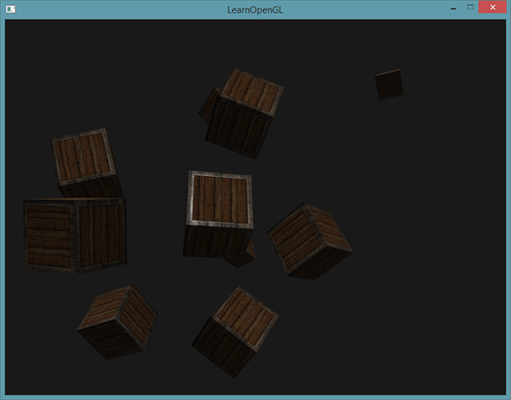*

*You can find the full source code of the application*[*here*](https://learnopengl.com/code_viewer_gh.php?code=src/2.lighting/5.1.light_casters_directional/light_casters_directional.cpp)*.*

*// у мяне не ўсё атрымалася. Пры абыходзе вакол кубікаў пачынаюць ззяць некаторыя заднія грані. Хаця яны ўвесь час павінны заставацца цёмнымі. Але гэта мы разгледзем потым. Зараз рухаемся далей. //*

### ***Point lights***

*Directional lights are great for global lights that illuminate the entire scene, but aside from a directional light we usually also want several point lights scattered throughout the scene. A point light is a light source with a given position somewhere in a world that illuminates in all directions where the light rays fade out over distance. Think of light bulbs and torches as light casters that act as a point light.*

**

*In the earlier tutorials we've been working with a (simplistic) point light all along. We had a light source at a given position that scatters light in all directions from that given light position. However, the light source we defined simulated light rays that never fade out thus making it look like the light source is extremely strong. // не ўлічваецца затуханне? // In most 3D simulations we'd like to simulate a light source that only illuminates a certain area close to the light source and not the entire scene. // пастаноўка задачы. Факт цьютарала //*

*If you'd add the 10 containers to the lighting scene of the previous tutorial you'd notice that the container all the way in the back is lit with the same intensity as the container in front of the lamp; there is no formula defined that diminishes light over distance. We want the container in the back to only be slightly lit in comparison to the containers close to the light source.*

#### **Attenuation**

*To reduce the intensity of light, over the distance a light ray travels, is generally called attenuation. One way to reduce the light intensity over distance is to simply use a linear equation. Such an equation would linearly reduce the light intensity over the distance thus making sure that objects at a distance are less bright. However, such a linear function tends to look a bit fake. In the real world, lights are generally quite bright standing close by, but the brightness of a light source diminishes quickly at the start and the remaining light intensity more slowly diminishes over distance. We are thus in need of a different formula for reducing the light's intensity.*

*Luckily some smart people already figured this out for us. The following formula calculates an attenuation value based on a fragment's distance to the light source which we later multiply with the light's intensity vector:*

*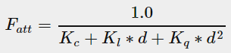*

*Here d represents the distance from the fragment to the light source. Then to calculate the attenuation value we define 3 (configurable) terms: a constant term Kc, a linear term Kl and a quadratic term Kq.*

* *The constant term is usually kept at 1.0 which is mainly there to make sure the resulting denominator never gets smaller than 1 since it would otherwise boost the intensity with certain distances, which is not the effect we're looking for.*
* *The linear term is multiplied with the distance value that reduces the intensity in a linear fashion.*
* *The quadratic term is multiplied with the quadrant of the distance and sets a quadratic decrease of intensity for the light source. The quadratic term will be less significant compared to the linear term when the distance is small, but gets much larger than the linear term as the distance grows.*

*Due to the quadratic term the light will diminish mostly at a linear fashion until the distance becomes large enough for the quadratic term to surpass the linear term and then the light intensity will decrease a lot faster. The resulting effect is that the light is quite intense when at a close range, but quickly loses it brightness over distance and eventually loses its brightness at a more slower pace. The following graph shows the effect such an attenuation has over a distance of 100:*

*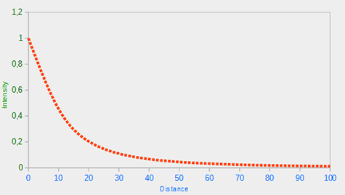*

*// апісанне мадэлі затухання святла //*

*You can see that the light has the highest intensity when the distance is small, but as soon as the distance grows its intensity is significantly reduced and slowly reaches 0 intensity at around a distance of 100. This is exactly what we want.*

#### **Choosing the right values**

*10.09.2017*

*But at what values do we set those 3 terms? Setting the right values depends on many factors: the environment, the distance you want a light to cover, the type of light etc. In most cases, it simply is a question of experience and a moderate amount of tweaking. // яшчэ адна сімуляцыя ў графіцы // The following table shows some of the values these terms could take to simulate a realistic (sort of) light source that covers a specific radius (distance). The first column specifies the distance a light will cover with the given terms. These values are good starting points for most lights, with courtesy of*[*Ogre3D's wiki*](http://www.ogre3d.org/tikiwiki/tiki-index.php?page=-Point+Light+Attenuation)*:*

|  |  |  |  |
| --- | --- | --- | --- |
| ***Distance*** | ***Constant*** | ***Linear*** | ***Quadratic*** |
| *7* | *1.0* | *0.7* | *1.8* |
| *13* | *1.0* | *0.35* | *0.44* |
| *20* | *1.0* | *0.22* | *0.20* |
| *32* | *1.0* | *0.14* | *0.07* |
| *50* | *1.0* | *0.09* | *0.032* |
| *65* | *1.0* | *0.07* | *0.017* |
| *100* | *1.0* | *0.045* | *0.0075* |
| *160* | *1.0* | *0.027* | *0.0028* |
| *200* | *1.0* | *0.022* | *0.0019* |
| *325* | *1.0* | *0.014* | *0.0007* |
| *600* | *1.0* | *0.007* | *0.0002* |
| *3250* | *1.0* | *0.0014* | *0.000007* |

*As you can see, the constant term Kc is kept at 1.0 in all cases. The linear term Kl is usually quite small to cover larger distances and the quadratic term Kq is even smaller. Try to experiment a bit with these values to see their effect in your implementation. In our environment a distance of 32 to 100 is generally enough for most lights.*

#### **Implementing attenuation**

*To implement attenuation we'll be needing 3 extra values in the fragment shader: namely the constant, linear and quadratic terms of the formula. These are best stored in the Light struct we defined earlier. Note that we calculate lightDir as we did in the previous tutorial and not as in the earlier Directional Light section.*

***struct*** *Light {*

*vec3 position;*

*vec3 ambient;*

*vec3 diffuse;*

*vec3 specular;*

***float*** *constant;*

***float*** *linear;*

***float*** *quadratic;*

*};*

*Then we set the terms in OpenGL: we want the light to cover a distance of 50 so we'll use the appropriate constant, linear and quadratic terms from the table:*

*lightingShader.setFloat("light.constant", 1.0f);*

*lightingShader.setFloat("light.linear", 0.09f);*

*lightingShader.setFloat("light.quadratic", 0.032f);*

*Implementing attenuation in the fragment shader is relatively straightforward: we simply calculate an attenuation value based on the formula and multiply this with the ambient, diffuse and specular components.*

*We do need the distance to the light source for the formula to work though; remember how we can calculate the length of a vector? We can retrieve the distance term by retrieving the difference vector between the fragment and the light source and take the resulting vector's length. We can use GLSL's built-in length function for that purpose:*

***float*** *distance = length(light.position - FragPos);*

***float*** *attenuation = 1.0 / (light.constant + light.linear \* distance +*

*light.quadratic \* (distance \* distance));*

*Then we include this attenuation value in the lighting calculations by multiplying the attenuation value with the ambient, diffuse and specular colors.*

*We could leave the ambient component alone so ambient lighting is not decreased over distance, but if we were to use more than 1 light source all the ambient components will start to stack up so in that case we want to attenuate ambient lighting as well. Simply play around with what's best for your environment.*

*ambient \*= attenuation;*

*diffuse \*= attenuation;*

*specular \*= attenuation;*

*If you'd run the application you'd get something like this:*

*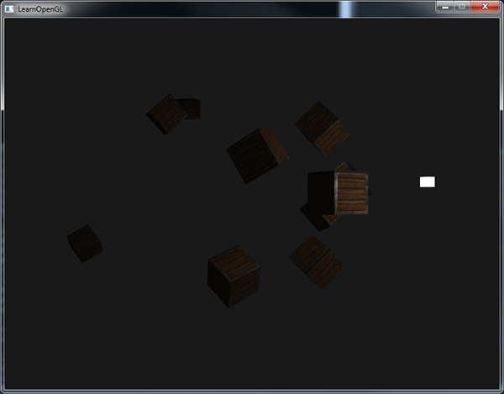*

*// акрамя засветкі задніх граняў усё астатняе працуе годна. Пакуль што не буду разбірацца, у чым праблема. Потым разбяруся падрабязней //*

*You can see that right now only the front containers are lit with the closest container being the brightest. The containers in the back are not lit at all since they're too far from the light source. You can find the source code of the application [here](https://learnopengl.com/code_viewer_gh.php?code=src/2.lighting/5.2.light_casters_point/light_casters_point.cpp" \t "_blank).*

*A point light is thus a light source with a configurable location and attenuation applied to its lighting calculations. Yet another type of light for our lighting arsenal.*

### ***Spotlight***

*The last type of light we're going to discuss is a spotlight. A spotlight is a light source that is located somewhere in the environment that, instead of shooting light rays in all directions, only shoots them in a specific direction. The result is that only the objects within a certain radius of the spotlight's direction are lit and everything else stays dark. A good example of a spotlight would be a street lamp or a flashlight.*

*A spotlight in OpenGL is represented by a world-space position, a direction and a cutoff angle that specifies the radius of the spotlight. For each fragment we calculate if the fragment is between the spotlight's cutoff directions (thus in its cone) and if so, we lit the fragment accordingly. The following image gives you an idea of how a spotlight works: // апісанне святла і прызначэнне графікі. трэпр //*

*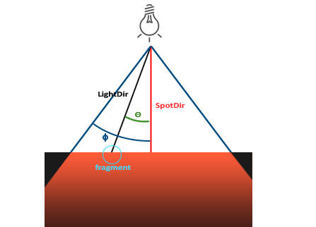*

* *LightDir: the vector pointing from the fragment to the light source.*
* *SpotDir: the direction the spotlight is aiming at.*
* *Phi ϕ: the cutoff angle that specifies the spotlight's radius. Everything outside this angle is not lit by the spotlight.*
* *Theta θ: the angle between the LightDir vector and the SpotDir vector. The θ value should be smaller than the Φ value to be inside the spotlight.*

*So what we basically need to do, is calculate the dot product (returns the cosine of the angle between two unit vectors remember?) between the LightDir vector and the SpotDir vector and compare this with the cutoff angle ϕ. Now that you (sort of) understand what a spotlight is all about we're going to create one in the form of a flashlight.*

#### **Flashlight**

*A flashlight is a spotlight located at the viewer's position and usually aimed straight ahead from the player's perspective. Basically a flashlight is a normal spotlight, but with its position and direction continually updated based on the player's position and orientation. // разнавіднасць крыніцы святла //*

*So, the values we're going to need for the fragment shader are the spotlight's position vector (to calculate the light's direction vector), the spotlight's direction vector and the cutoff angle. We can store these values in the Light struct:*

***struct*** *Light {*

*vec3 position;*

*vec3 direction;*

***float*** *cutOff;*

*...*

*};*

*Next we pass the appropriate values to the shaders:*

*lightingShader.setVec3("light.position", camera.Position);*

*lightingShader.setVec3("light.direction", camera.Front);*

*lightingShader.setFloat("light.cutOff", glm::cos(glm::radians(12.5f)));*

*As you can see we're not setting an angle for the cutoff value but calculate the cosine value based on an angle and pass the cosine result to the fragment shader. The reason for this is that in the fragment shader we're calculating the dot product between the LightDir and the SpotDir vector and the dot product returns a cosine value and not an angle so we can't directly compare an angle with a cosine value. To retrieve the angle we then have to calculate the inverse cosine of the dot product's result which is an expensive operation. So to save some performance we calculate the cosine value of a given cutoff angle and pass this result to the fragment shader. Since both angles are now represented as cosines, we can directly compare between them without any expensive operations. // аспекты вытворчаснасці і аптымізацыі //*

*Now what's left to do is calculate the theta θ value and compare this with the cutoff ϕ value to determine if we're in or outside the spotlight:*

***float*** *theta = dot(lightDir, normalize(-light.direction));*

***if****(theta > light.cutOff)*

*{*

*// do lighting calculations*

*}*

***else*** *// else, use ambient light so scene isn't completely dark outside the spotlight.*

*color = vec4(light.ambient \* vec3(texture(material.diffuse, TexCoords)), 1.0);*

*We first calculate the dot product between the lightDir vector and the negated direction vector (negated, because we want the vectors to point towards the light source, instead of from). Be sure to normalize all the relevant vectors.*

*You might be wondering why there is a > sign instead of a < sign in the if guard. Shouldn't theta be smaller than the light's cutoff value to be inside the spotlight? That is right, but don't forget angle values are represented as cosine values and an angle of 0 is represented as the cosine value of 1.0 while an angle of 90 degrees is represented as the cosine value of 0.0 as you can see here: // аўтар удакладняе, што мы параўноўваем вуглы праз косінусы //*

*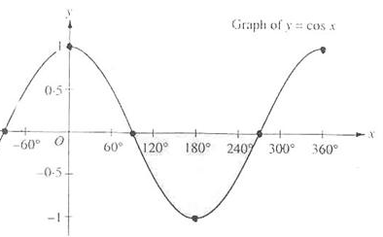*

*You can now see that the closer the cosine value is to 1.0 the smaller its angle. Now it makes sense why theta needs to be larger than the cutoff value. The cutoff value is currently set at the cosine of 12.5 which is equal to 0.9978 so a cosine theta value between 0.9979 and 1.0 would result in the fragment being lit as inside the spotlight.*

*Running the application results in a spotlight that only lights the fragments that are directly inside the cone of the spotlight. It'll look something like this:*

*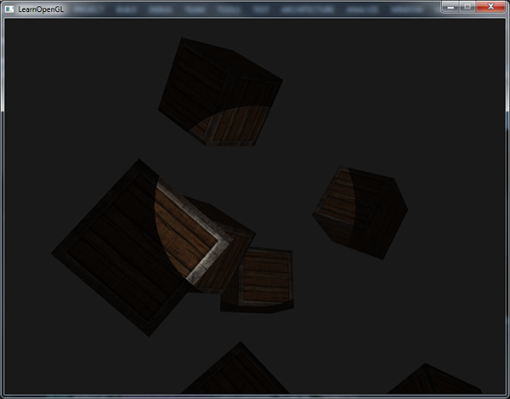*

*You can find the full source code*[*here*](https://learnopengl.com/code_viewer_gh.php?code=src/2.lighting/5.3.light_casters_spot/light_casters_spot.cpp)*.*

*// усё атрымалася, але, сапраўды, края светлавой плямы даволі рэзкія, што не рэалістычна. Акрамя гэтага, здаецца, блікі і таму падобнае бачныя не там, дзе трэба. Потым разабрацца ў прычыне. Але, здаецца, трэба пэўным чынам падбіраць скалярныя памнажэнні і вуглы ў шэйдэрах //*

*It still looks a bit fake though, mostly because the spotlight has hard edges. Wherever a fragment reaches the edge of the spotlight's cone it is shut down completely instead of with a nice smooth fade. A realistic spotlight would reduce the light gradually around its edges. // факт кнігі //*

#### **Smooth/Soft edges**

*To create the effect of a smoothly-edged spotlight we want to simulate a spotlight having an inner and an outer cone. We can set the inner cone as the cone defined in the previous section, but we also want an outer cone that gradually dims the light from the inner to the edges of the outer cone. // асноўная ідэя мадэлі асвятлення //*

*To create an outer cone we simply define another cosine value that represents the angle between the spotlight's direction vector and the outer cone's vector (equal to its radius). Then, if a fragment is between the inner and the outer cone it should calculate an intensity value between 0.0 and 1.0. If the fragment is inside the inner cone its intensity is equal to 1.0 and 0.0 if the fragment is outside the outer cone.*

*We can calculate such a value using the following formula:*

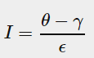

*Here ϵ (epsilon) is the cosine difference between the inner (ϕ) and the outer cone (γ) (ϵ=ϕ−γ). The resulting I value is then the intensity of the spotlight at the current fragment.*

*It is a bit hard to visualize how this formula actually works so let's try it out with a few sample values: // прыклад, калі табліца аказваецца больш інфарматыўнай, чым графіка //*

|  |  |  |  |  |  |  |  |
| --- | --- | --- | --- | --- | --- | --- | --- |
| *θ* | *θ****in degrees*** | *ϕ****(inner cutoff)*** | *ϕ****in degrees*** | *γ****(outer cutoff)*** | *γ****in degrees*** | *ϵ* | *I* |
| *0.87* | *30* | *0.91* | *25* | *0.82* | *35* | *0.91 - 0.82 = 0.09* | *0.87 - 0.82 / 0.09 = 0.56* |
| *0.9* | *26* | *0.91* | *25* | *0.82* | *35* | *0.91 - 0.82 = 0.09* | *0.9 - 0.82 / 0.09 = 0.89* |
| *0.97* | *14* | *0.91* | *25* | *0.82* | *35* | *0.91 - 0.82 = 0.09* | *0.97 - 0.82 / 0.09 = 1.67* |
| *0.83* | *34* | *0.91* | *25* | *0.82* | *35* | *0.91 - 0.82 = 0.09* | *0.83 - 0.82 / 0.09 = 0.11* |
| *0.64* | *50* | *0.91* | *25* | *0.82* | *35* | *0.91 - 0.82 = 0.09* | *0.64 - 0.82 / 0.09 = -2.0* |
| *0.966* | *15* | *0.9978* | *12.5* | *0.953* | *17.5* | *0.966 - 0.953 = 0.0448* | *0.966 - 0.953 / 0.0448 = 0.29* |

*As you can see we're basically interpolating between the outer cosine and the inner cosine based on the θ value. If you still don't really see what's going on, don't worry, you can simply take the formula for granted and return here when you're much older and wiser. // цудоўная арыентацыя чытача. Сувязь тнав і псіхалогіі. Псіхалогія навучання – важная тэма //*

*Since we now have an intensity value that is either negative when outside the spotlight, higher than 1.0 when inside the inner cone and somewhere in between around the edges. If we properly clamp the values we don't need an if-else in the fragment shader anymore and we can simply multiply the light components with the calculated intensity value:*

***float*** *theta = dot(lightDir, normalize(-light.direction));*

***float*** *epsilon = light.cutOff - light.outerCutOff;*

***float*** *intensity = clamp((theta - light.outerCutOff) / epsilon, 0.0, 1.0);*

*...*

*// we'll leave ambient unaffected so we always have a little light.*

*diffuse \*= intensity;*

*specular \*= intensity;*

*...*

*Note that we use the clamp function that clamps its first argument between the values 0.0 and 1.0. This makes sure the intensity values won't end up outside the [0, 1] interval.*

*Make sure you add the outerCutOff value to the Light struct and set its uniform value in the application. For the following image an inner cutoff angle of 12.5 and an outer cutoff angle of 17.5 was used:*

*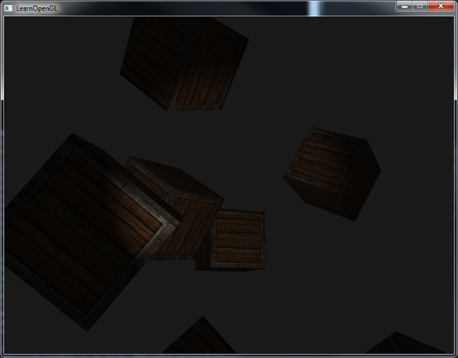*

*Ahhh, that's much better. Play around with the inner and outer cutoff angles and try to create a spotlight that better suits your needs. You can find the source code of the application*[*here*](https://learnopengl.com/code_viewer_gh.php?code=src/2.lighting/5.4.light_casters_spot_soft/light_casters_spot_soft.cpp)*.*

*// усё атрымалася за выключэннем невялікіх недалікаў, пра якія я ўзгадваў раней //*

*Such a flashlight/spotlight type of lamp is perfect for horror games and combined with directional and point lights the environment will really start to light up. // прызначэнне і кантэкст выкарыстання паняцця // In the*[*next*](https://learnopengl.com/#!Lighting/Multiple-lights)*tutorial we'll combine all the lights and tricks we've discussed so far. // структура цьютарала. Не ведаю чаму, але напрыканцы дадзенага цьютарала мне ясна, што будзе далей //*

### ***Exercises***

* *Try experimenting with all the different light types and their fragment shaders. Try inverting some vectors and/or using < instead of >. Try to explain the different visual outcomes. // разнавіднасць практыкаванняў – эксперыментаваць на варыяцыях. Гэта цудоўна. Паразважаць. Тнав. //*

[*https://learnopengl.com/#!Lighting/Multiple-lights*](https://learnopengl.com/#!Lighting/Multiple-lights)

## ***Multip******le lights***

*In the previous tutorials we learned quite a lot about lighting in OpenGL. We learned about Phong shading, materials, lighting maps and different types of light casters. In this tutorial we're going to combine all the previously obtained knowledge by creating a fully lit scene with 6 active light sources. We are going to simulate a sun-like light as a directional light source, 4 point lights scattered throughout the scene and we'll be adding a flashlight as well.*

*To use more than one light source in the scene we want to encapsulate the lighting calculations into GLSL functions. The reason for that is that the code quickly gets nasty when we want to do lighting computations with multiple lights with each light type requiring different computations. If we were to do all these calculations in the main function only, the code quickly becomes difficult to understand.*

*Functions in GLSL are just like C-functions. We have a function name, a return type and we'd have to declare a prototype at the top of the code file if the function hasn't been declared before the main function yet. We'll create a different function for each of the light types: directional lights, point lights and spotlights.*

*When using multiple lights in a scene the approach is usually as follows: we have a single color vector that represents the fragment's output color. For each light, the light's contribution color of the fragment is added to the fragment's output color vector. So each light in the scene will calculate its individual impact on the aforementioned fragment and contribute to the final output color. A general structure would look something like this:*

***out*** *vec4 FragColor;*

***void*** *main()*

*{*

*// define an output color value*

*vec3 output = vec3(0.0);*

*// add the directional light's contribution to the output*

*output += someFunctionToCalculateDirectionalLight();*

*// do the same for all point lights*

***for****(****int*** *i = 0; i < nr\_of\_point\_lights; i++)*

*output += someFunctionToCalculatePointLight();*

*// and add others lights as well (like spotlights)*

*output += someFunctionToCalculateSpotLight();*

*FragColor = vec4(output, 1.0);*

*}*

*The actual code will likely differ per implementation, but the general structure remains the same. We define several functions that calculate the impact per light source and add its resulting color to an output color vector. If for example two light sources are close to the fragment, their combined contribution would result in a more brightly lit fragment than the fragment being lit by a single light source.*

***Directional light***

*What we want to do is define a function in the fragment shader that calculates the contribution a directional light has on the corresponding fragment: a function that takes a few parameters and returns the calculated directional lighting color.*

*First we need to set the required variables that we minimally need for a directional light source. We can store the variables in a struct called DirLight and define it as a uniform. The required variables should be familiar from the*[*previous*](https://learnopengl.com/#!Lighting/Light-casters)*tutorial:*

***struct*** *DirLight {*

*vec3 direction;*

*vec3 ambient;*

*vec3 diffuse;*

*vec3 specular;*

*};*

***uniform*** *DirLight dirLight;*

*We can then pass the dirLight uniform to a function with the following prototype:*

*vec3 CalcDirLight(DirLight light, vec3 normal, vec3 viewDir);*

*Just like C and C++ if we want to call a function (in this case inside the main function) the function should be defined somewhere before the caller's line number. In this case we'd prefer to define the functions below the mainfunction so this requirement doesn't hold. Therefore we declare the function's prototypes somewhere above the main function, just like we would in C.*

*You can see that the function requires a DirLight struct and two other vectors required for its computation. If you successfully completed the previous tutorial then the content of this function should come as no surprise:*

*vec3 CalcDirLight(DirLight light, vec3 normal, vec3 viewDir)*

*{*

*vec3 lightDir = normalize(-light.direction);*

*// diffuse shading*

***float*** *diff = max(dot(normal, lightDir), 0.0);*

*// specular shading*

*vec3 reflectDir = reflect(-lightDir, normal);*

***float*** *spec = pow(max(dot(viewDir, reflectDir), 0.0), material.shininess);*

*// combine results*

*vec3 ambient = light.ambient \* vec3(texture(material.diffuse, TexCoords));*

*vec3 diffuse = light.diffuse \* diff \* vec3(texture(material.diffuse, TexCoords));*

*vec3 specular = light.specular \* spec \* vec3(texture(material.specular, TexCoords));*

***return*** *(ambient + diffuse + specular);*

*}*

*We basically copied the code from the previous tutorial and used the vectors given as function arguments to calculate the directional light's contribution vector. The resulting ambient, diffuse and specular contributions are then returned as a single color vector.*

***Point light***

*Just like with directional lights we also want to define a function that calculates the contribution a point light has on the given fragment, including its attenuation. Just like directional lights we want to define a struct that specifies all the variables required for a point light:*

***struct*** *PointLight {*

*vec3 position;*

***float*** *constant;*

***float*** *linear;*

***float*** *quadratic;*

*vec3 ambient;*

*vec3 diffuse;*

*vec3 specular;*

*};*

*#define NR\_POINT\_LIGHTS 4*

***uniform*** *PointLight pointLights[NR\_POINT\_LIGHTS];*

*As you can see we used a pre-processor directive in GLSL to define the number of point lights we want to have in our scene. We then use this NR\_POINT\_LIGHTS constant to create an array of PointLight structs. Arrays in GLSL are just like C arrays and can be created by the use of two square brackets. Right now we have 4 PointLight structs to fill with data.*

*We could also simply define****one****large struct (instead of different structs per light type) that contains all the necessary variables for****all****the different light types and use that struct for each function, and simply ignore the variables we don't need. However, I personally find the current approach more intuitive and aside from a few extra lines of code it could save up some memory since not all light types need all variables.*

*The prototype of the point light's function is as follows:*

*vec3 CalcPointLight(PointLight light, vec3 normal, vec3 fragPos, vec3 viewDir);*

*The function takes all the data it needs as its arguments and returns a vec3 that represents the color contribution that this specific point light has on the fragment. Again, some intelligent copy-and-pasting results in the following function:*

*vec3 CalcPointLight(PointLight light, vec3 normal, vec3 fragPos, vec3 viewDir)*

*{*

*vec3 lightDir = normalize(light.position - fragPos);*

*// diffuse shading*

***float*** *diff = max(dot(normal, lightDir), 0.0);*

*// specular shading*

*vec3 reflectDir = reflect(-lightDir, normal);*

***float*** *spec = pow(max(dot(viewDir, reflectDir), 0.0), material.shininess);*

*// attenuation*

***float*** *distance = length(light.position - fragPos);*

***float*** *attenuation = 1.0 / (light.constant + light.linear \* distance +*

*light.quadratic \* (distance \* distance));*

*// combine results*

*vec3 ambient = light.ambient \* vec3(texture(material.diffuse, TexCoords));*

*vec3 diffuse = light.diffuse \* diff \* vec3(texture(material.diffuse, TexCoords));*

*vec3 specular = light.specular \* spec \* vec3(texture(material.specular, TexCoords));*

*ambient \*= attenuation;*

*diffuse \*= attenuation;*

*specular \*= attenuation;*

***return*** *(ambient + diffuse + specular);*

*}*

*Abstracting this functionality away in a function like this has the advantage that we can easily calculate the lighting for multiple point lights without the need for nasty duplicated code. In the main function we simply create a loop that iterates over the point light array that calls CalcPointLight for each point light.*

***Putting it all together***

*Now that we defined both a function for directional lights and a function for point lights we can put it all together in the main function.*

***void*** *main()*

*{*

*// properties*

*vec3 norm = normalize(Normal);*

*vec3 viewDir = normalize(viewPos - FragPos);*

*// phase 1: Directional lighting*

*vec3 result = CalcDirLight(dirLight, norm, viewDir);*

*// phase 2: Point lights*

***for****(****int*** *i = 0; i < NR\_POINT\_LIGHTS; i++)*

*result += CalcPointLight(pointLights[i], norm, FragPos, viewDir);*

*// phase 3: Spot light*

*//result += CalcSpotLight(spotLight, norm, FragPos, viewDir);*

*FragColor = vec4(result, 1.0);*

*}*

*Each light type adds its contribution to the resulting output color until all light sources are processed. The resulting color contains the color impact of all the light sources in the scene combined. If you want you could also implement a spotlight and add its effect to the output color as well. We leave the CalcSpotLight function as an exercise for the reader.*

*Setting the uniforms for the directional light struct shouldn't be too unfamiliar, but you might be wondering how we could set the uniform values of the point lights since the point light uniform is now an array of PointLight structs. This isn't something we've discussed before.*

*Luckily for us, it isn't too complicated. To set the uniform of an array of structs works just like setting the uniforms of a single struct, although this time we also have to define the appropriate index when querying the uniform's location:*

*lightingShader.setFloat("pointLights[0].constant", 1.0f);*

*Here we index the first PointLight struct in the pointLights array and retrieve the location of its constant variable. This does mean unfortunately that we have to manually set all the uniforms for each of the 4 point lights, which leads up to 28 uniform calls for the point lights alone which is a bit tedious. You could try to abstract a bit away from this by defining a point light class that sets the uniforms for you, but in the end you'd still have to set the all the lights' uniform values this way.*

*Let's not forget that we also need to define a position vector for each of the point lights so let's spread them up a bit around the scene. We'll define another glm::vec3 array that contains the pointlights' positions:*

*glm::vec3 pointLightPositions[] = {*

*glm::vec3( 0.7f, 0.2f, 2.0f),*

*glm::vec3( 2.3f, -3.3f, -4.0f),*

*glm::vec3(-4.0f, 2.0f, -12.0f),*

*glm::vec3( 0.0f, 0.0f, -3.0f)*

*};*

*Then index the corresponding PointLight struct from the pointLights array and set its position attribute as one of the positions we just defined. Also be sure to now draw 4 light cubes instead of just 1. Simply create a different model matrix for each of the light objects just like we did with the containers.*

*If you'd also use a flashlight the result of all the combined lights looks something like this:*

*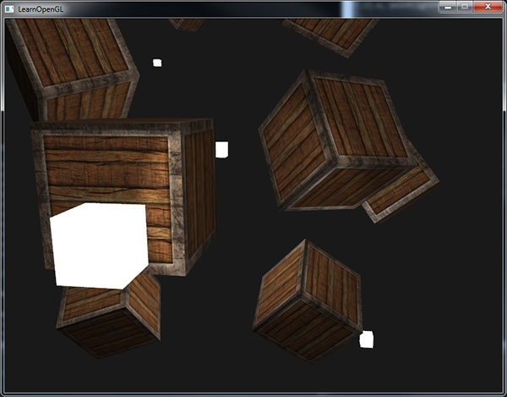*

*As you can see there appears to be some form of a global light (like a sun) somewhere in the sky, we have 4 lights scattered throughout the scene and a flashlight is visible from the player's perspective. Looks pretty neat doesn't it?*

*You can find the full source code of the final application*[*here*](https://learnopengl.com/code_viewer_gh.php?code=src/2.lighting/6.multiple_lights/multiple_lights.cpp)*.*

*The image shows all the light sources set with the default light properties we've used in all the previous tutorials, but if you'd play around with these values you can get pretty interesting results. Artists and level editors generally tweak all these lighting variables in a large editor to make sure the lighting matches the environment. Using the simple lighted environment we just created you can create some interesting visuals by simply tweaking the lights their attributes:*

*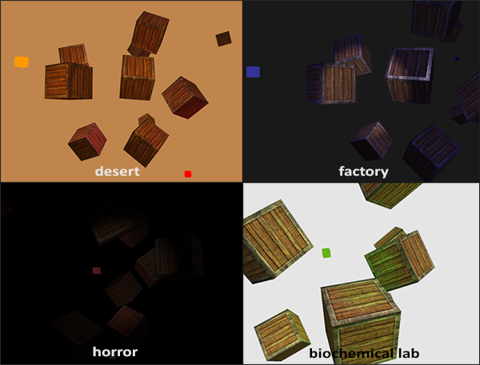*

*We also changed the clear color to better reflect the lighting. You can see that by simply adjusting some of the lighting parameters you can create completely different atmospheres.*

*By now you should have a pretty good understanding of lighting in OpenGL. With the knowledge so far we can already create interesting and visually rich environments and atmospheres. Try playing around with all the different values to create your own atmospheres.*

***Exercises***

* *Can you (sort of) re-create the different atmospheres of the last image by tweaking the light's attribute values?*[*solution*](https://learnopengl.com/code_viewer.php?code=lighting/multiple_lights-exercise2)*.*

***Want to help?***

*Enjoyed the tutorial? Consider becoming a*[*patron*](https://www.patreon.com/learnopengl)*of LearnOpenGL.  
  
Your support helps me create new and better tutorials, improve existing content and enables me to improve the website wherever I can.*

*// //*

1. [↑](#footnote-ref-1)